**2.11 CONVEX HULL**

**AIM**

To write a program that finds the convex hull of a set of 2D points using the brute force approach

**ALGORITHM**

**1**.For every pair of points (p, q) in the set:

* Compute the orientation of all other points relative to the line (p, q).
* If all points lie on the same side or are collinear → the segment (p, q) belongs to the convex hull.

**2**. Collect all unique points that belong to hull edges.

**3**. Sort the hull points in **counter-clockwise (CCW) order** using the polar angle (atan2).

4.List of hull points in CCW order.

**PROGRAM**

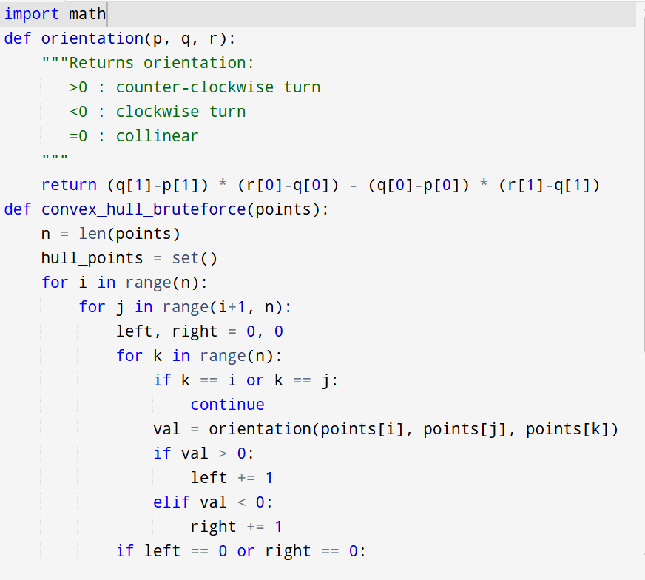

Input: points = [(1, 1), (4, 6), (8, 1), (0, 0), (3, 3)]

Output:

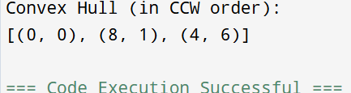

**RESULT:**

Thus the program is successfully executed and the output is verified.

**PERFORMANCE ANALYSIS:**

**Time Complexity:**

* For every pair of points (p, q) → O(n2)O(n^2)O(n2)
* For each pair, check all other points → O(n)O(n)O(n)
* Total = O(n3)O(n^3)O(n3)

**Space Complexity:** O(n)O(n)O(n) (to store hull points).