**2.12 Travelling Salesman Problem (TSP)**

**AIM**

The aim of this program is to solve the Travelling salesman Problem using exhaustive search.

**ALGORITHM**

1.Start

2.Input a list of cities with their coordinates.

3.Fix the first city as the starting point.

4.Generate all possible permutations of the remaining cities using intercools permutations.

5.For each permutation (possible route):

* Construct the complete path including the start city at the beginning and end.
* Compute the total distance of the route by summing the Euclidean distances between consecutive cities.

6. Keep track of the route with the minimum distance encountered so far.

7. After evaluating all permutations, output the shortest distance and the corresponding optimal path.

8.Stop

**PROGRAM**

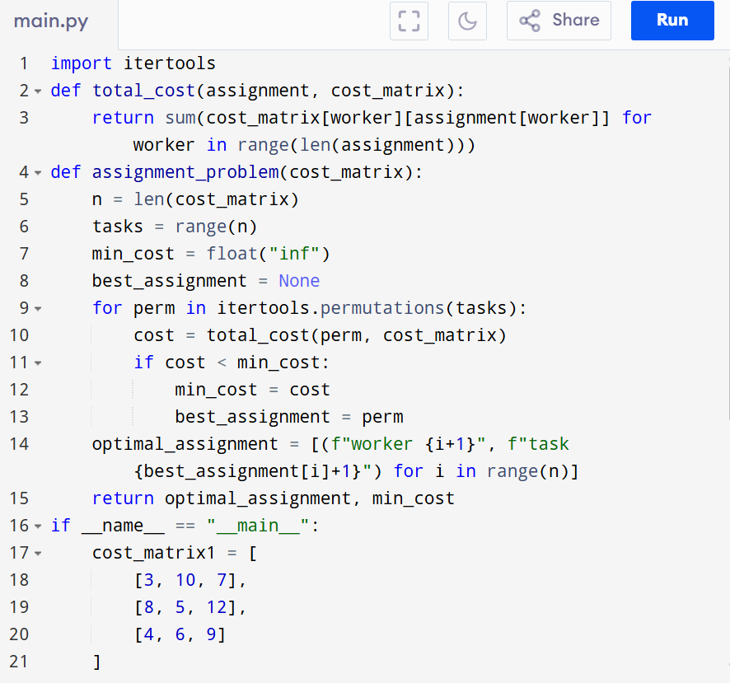

Input: cities1 = [(1, 2), (4, 5), (7, 1), (3, 6)]

cities2 = [(2, 4), (8, 1), (1, 7), (6, 3), (5, 9)]

Output:

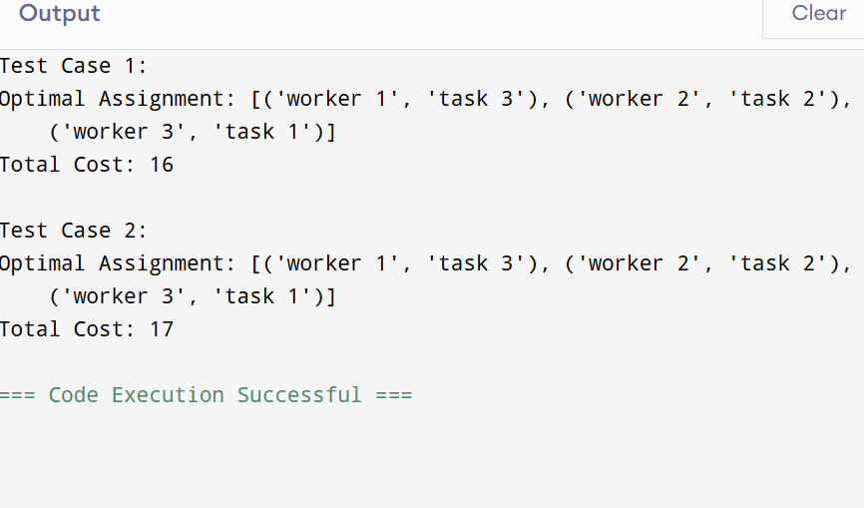

**RESULT:**

Thus the program is successfully executed and the output is verified.

**PERFORMANCE ANALYSIS:**

Time Complexity:

* Generating all permutations: O(n!)
* Computing cost per assignment: O(n)
* Total = O(n! * n)

Space Complexity: O(n) for storing assignment.