**2.13 ASSIGNMENT PROBLEM USING EXHAUSIVE SEARCH**

**AIM**

The aim of this program is to solve the Assignment Problem using exhaustive search.

**ALGORITHM**

1. Start

2.Input the cost matrix, where cost[i][j] represents the cost of assigning worker i to task j.

3. Generate all permutations of task assignments (i.e., all possible ways to assign tasks to workers).

4.For each permutation:

* Compute the total cost by summing the costs of each worker-task pairing.
* Keep track of the minimum cost and its corresponding assignment.

5. Output the optimal assignment and the minimum cost.

6. Stop

**PROGRAM**

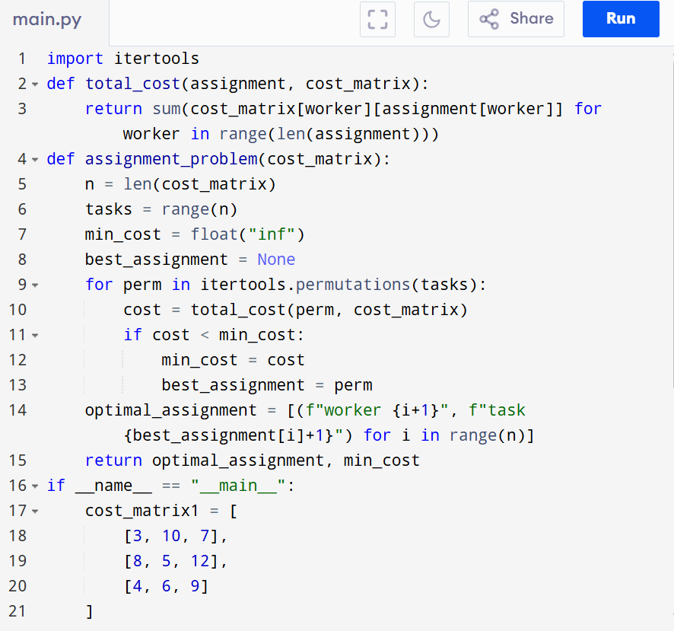

Input: points = cost_matrix1 = [

[3, 10, 7],

[8, 5, 12],

[4, 6, 9]

]

cost_matrix2 = [

[15, 9, 4],

[8, 7, 18],

[6, 12, 11]

]

Output:

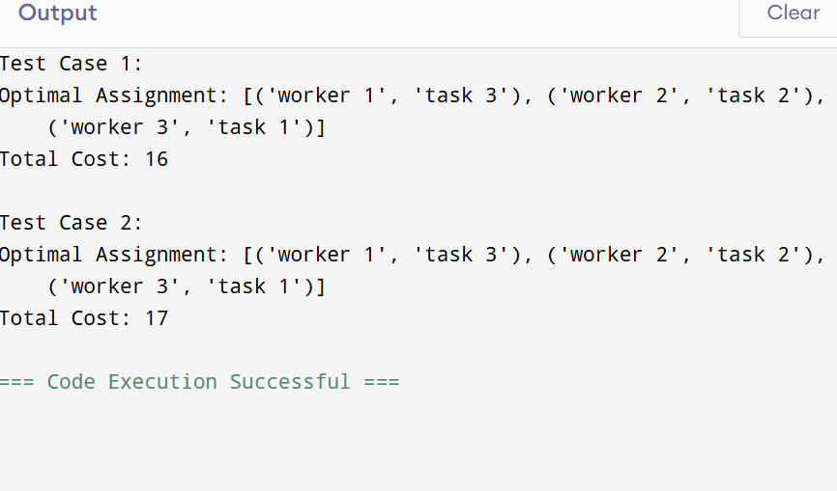

**RESULT:**

Thus the program is successfully executed and the output is verified.

**PERFORMANCE ANALYSIS:**

Time Complexity:

* Generating all permutations: O(n!)
* Computing cost per assignment: O(n)
* Total = O(n! * n)

Space Complexity: O(n) for storing assignment.