**2.9 BRUTE FORCE TECHINQUE**

**AIM**

To write a program that finds the closest pair of points in a set of 2D points using the brute force approach.

**ALGORITHM**

1. A list of points (x, y).

2. Define a function to calculate the **Euclidean distance** between two points.

d=(x2−x1)2+(y2−y1)2d = \sqrt{(x_2 - x_1)^2 + (y_2 - y_1)^2}d=(x2​−x1​)2+(y2​−y1​)2​

3.Compare each pair of points (i, j) where i<ji < ji<j.

4. Track the **minimum distance** and the corresponding pair.

5.Return the pair with the smallest distance and the distance value.

**PROGRAM**

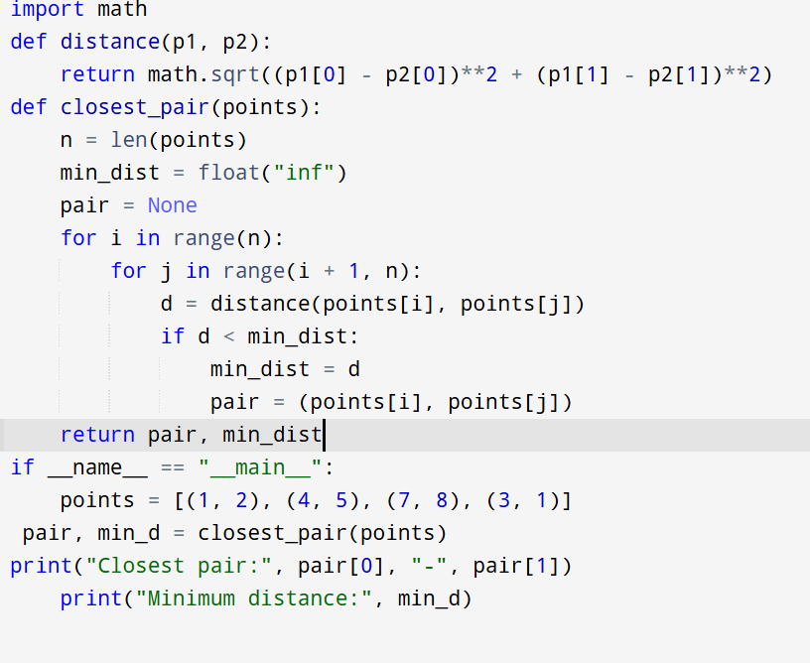

Input:

points = [(1, 2), (4, 5), (7, 8), (3, 1)

Output:

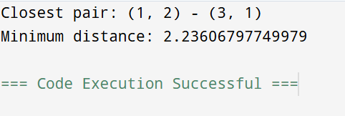

**RESULT:**

Thus the program is successfully executed and the output is verified.

**PERFORMANCE ANALYSIS:**

* **Time Complexity:** O(n2)O(n^2)O(n2) (because we check all pairs)
* **Space Complexity:** O(1)O(1)O(1) (only storing min distance & pair)