**2.10 BRUTE FORCE TECHINQUE**

**AIM**

To write a program that finds the closest pair of points in a set of 2D points using the brute force approach.

**ALGORITHM**

1. For every pair of points (p, q) in the set:

* Form a line equation.
* Check if all other points lie on the same side or on the line.
* If true → (p, q) is part of the convex hull.

2.Collect all such points to form the hull.

3.Handle collinear points: include them if they are extreme (farthest on the same line).

**PROGRAM**

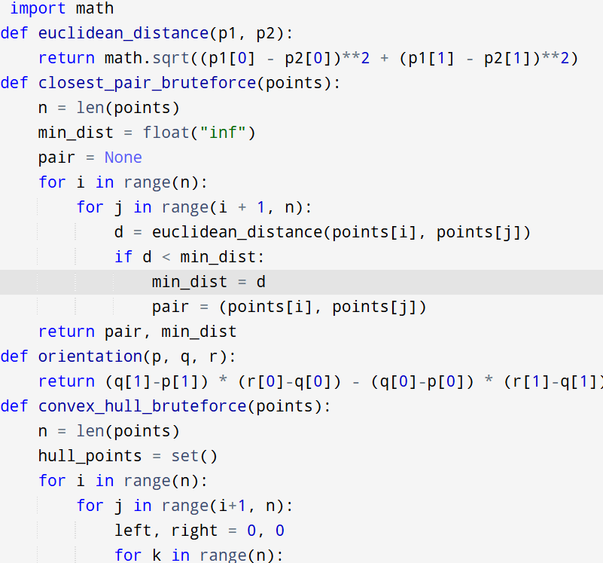

Input:

points = [(1, 2), (4, 5), (7, 8), (3, 1)

Output:

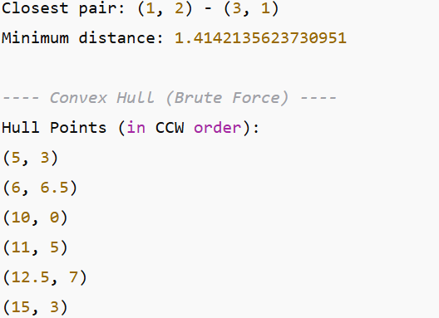

**RESULT:**

Thus the program is successfully executed and the output is verified.

**PERFORMANCE ANALYSIS:**

**Closest Pair**:

* Time: O(n2)O(n^2)O(n2)
* Space: O(1)O(1)O(1)

**Convex Hull (Brute Force)**:

* Time: O(n3)O(n^3)O(n3) (pair selection × point checks)
* Space: O(n)O(n)O(n) (storing hull points)