**4.4 MINIMUM PATH DISTANCE USING MATRIX FORM**

**Question:**

Write a c program to find the minimum path distance by using matrix form.

**AIM**

To implement a C program that calculates the minimum path distance in a matrix using dynamic programming.

**ALGORITHM**

1. Input the number of rows m and columns n.
2. Input the cost matrix cost[m][n].
3. Initialize a DP matrix dp[m][n] where dp[i][j] stores the minimum cost to reach cell (i,j).
4. Set dp[0][0] = cost[0][0].
5. Fill the first row and first column using cumulative sums.
6. For each cell (i,j), compute dp[i][j] = cost[i][j] + min(dp[i-1][j], dp[i][j-1], dp[i-1][j-1]).
7. The final answer is dp[m-1][n-1].

**PROGRAM**

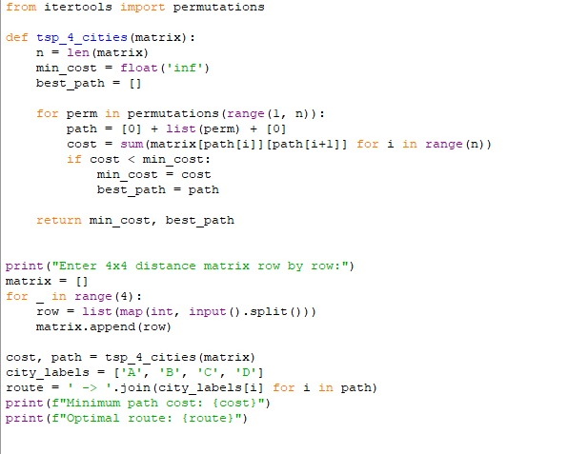

Input:

Enter the cost matrix:

0 10 15 20

10 0 35 25

15 35 0 30

20 20 30 0

Output:

**RESULT:**

Thus the program is successfully executed, and the output is verified.

**PERFORMANCE ANALYSIS:**

* Time Complexity: O(m × n)
* Space Complexity: O(m × n)