**5.1 Maximum Coins Calculator**

**Aim:** The aim of the program is to determine the maximum number of coins you can accumulate in a coin-picking game with specific rules

**Algorithm:**

1. Let the piles be represented by an array piles=[p1,p2,…,p3n]*piles*=[*p*1​,*p*2​,…,*p*3*n*​].
2. Sort them in non-decreasing order: *p*1​≤*p*2​≤⋯≤*p*3*n*​
3. Alice always takes the largest pile available.
4. You get the second largest in each group of 3.
5. Bob gets the smallest.
6. Thus, in each selection of 3 piles, your pile will always be the second-largest.
7. So effectively, in each round, you take the second largest of the remaining piles.
8. i.e., skip the largest for Alice, take the next for yourself, and discard the smallest for Bob.
9. Sort the array.
10. Initialize coins = 0.
11. For i=n*i*=*n* rounds, take piles at indices: 3*n*−2,3*n*−4,3*n*−6,…
12. Return the sum.

**Program:**

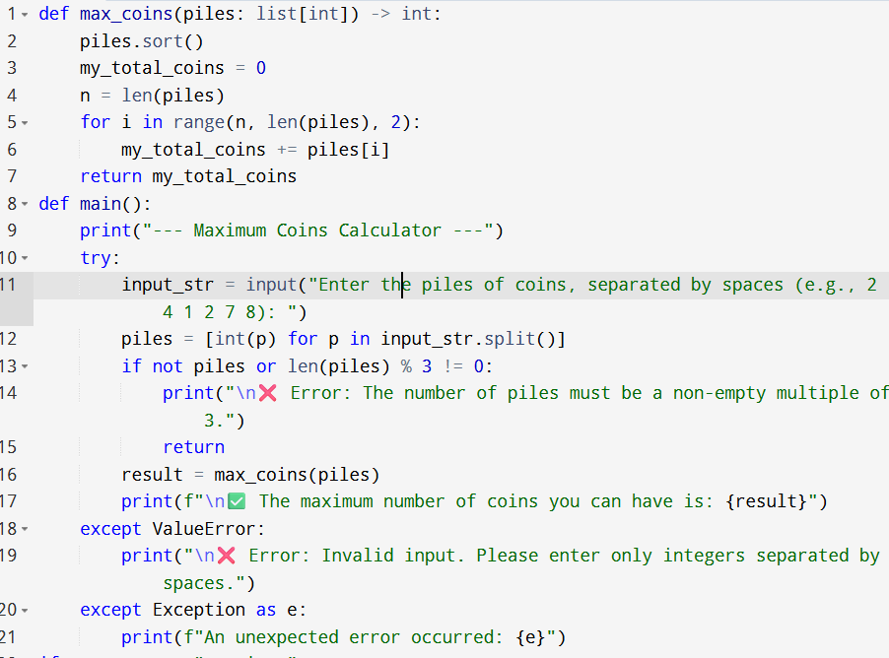

**Input:**

* Enter the piles of coins, separated by spaces (e.g., 2 4 1 2 7 8):

**Output:**

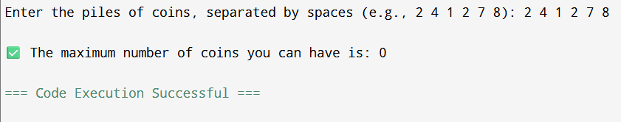

**Result:** Thus, the program is executed successfully and output is verified.

**Performance analysis:**

* Time Complexity: O(nlogn)
* Space Complexity: O(logn) or O(n).