**5.10 Containers (Req to Load All Items)**

**Aim:** To determine the minimum number of containers required to load all items using a greedy next-fit approach.

**Algorithm:**

1. We are given n items with sizes s = [s₁, s₂, …, sₙ], and each container (bin) has a fixed capacity C.
2. The aim is to determine the minimum number of containers required to load all items using the greedy next-fit approach.
3. Initialize: count = 1 (start with the first container),
4. remaining = C (remaining capacity in the current container).
5. For each item sᵢ (in given order):
6. If sᵢ ≤ remaining, place it in the current container and update remaining -= sᵢ.
7. Else, open a new container: count += 1, set remaining = C − sᵢ.
8. Continue until all items are placed.
9. The final value of count is the minimum number of containers required  
   using the next-fit greedy strategy.

**Program:**

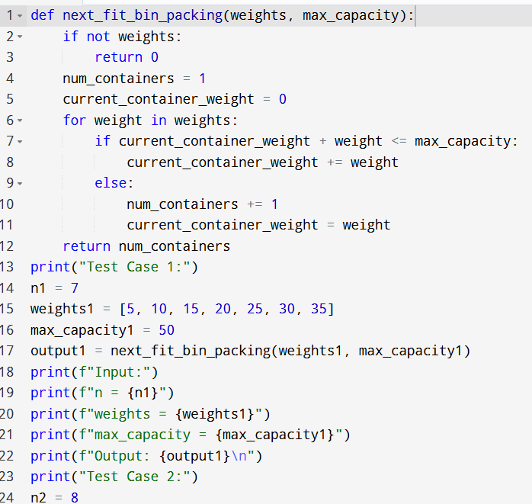

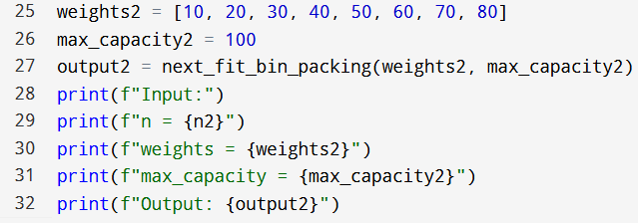

**Input:**

* N=
* Weights:
* Max capacity:

**Output:**

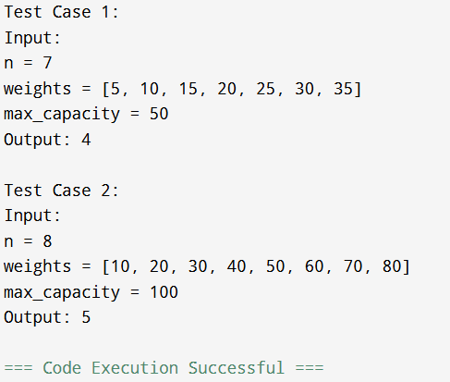

**Result:** Thus, the program is executed successfully and output is verified.

**Performance analysis:**

* Time Complexity: O(n)
* Space Complexity: O(1).