**5.9 Container(Max Weight can Load)**

**Aim:** To determine the maximum weight of items that can be loaded into a container with a limited capacity using a greedy approach.

**Algorithm:**

1. We are given a set of n items, each with weight wᵢ and value vᵢ, and a container with maximum capacity W.
2. The aim is to maximize the total value of items placed in the container without exceeding capacity W.
3. Compute the value-to-weight ratio for each item: rᵢ = vᵢ / wᵢ.
4. Sort the items in non-increasing order of rᵢ.
5. Initialize:

totalWeight = 0

totalValue = 0

1. For each item i in the sorted list:

If wᵢ + totalWeight ≤ W,  
 take the whole item:  
 totalWeight += wᵢ, totalValue += vᵢ.

1. Else, take only the fraction (W − totalWeight)/wᵢ of the item: totalValue += vᵢ × totalWeight)/wᵢ, and stop.
2. The final totalValue is the maximum weight (or value) that can be loaded  
   using the greedy approach.

**Program:**

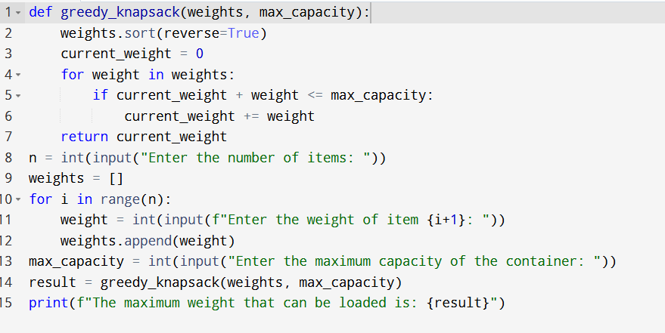

**Input:**

* Enter the number of items:
* Enter the weight of the items:

**Output:**

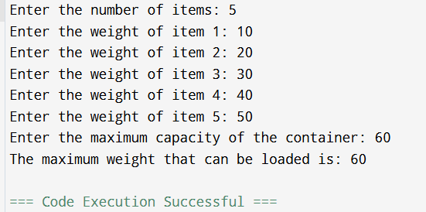

**Result:** Thus, the program is executed successfully and output is verified.

**Performance analysis:**

* Time Complexity: O(nlogn)
* Space Complexity: O(n) or O(1).