**6.2N-QUEENS PROBLEM**

**Aim:** To construct a python code to solve the n queens problem.

**Algorithm:**

1. Start from the first row.
2. Try placing a queen in each column of that row.
3. For each valid placement:
4. Place the queen.
5. Move to the next row and repeat.
6. If no valid position is found in a row:
7. **Backtrack**: Remove the previous queen and try a new position.
8. Repeat until:
9. All N queens are placed (store solution).
10. Or all possibilities are exhausted (no solution)

**Program:**

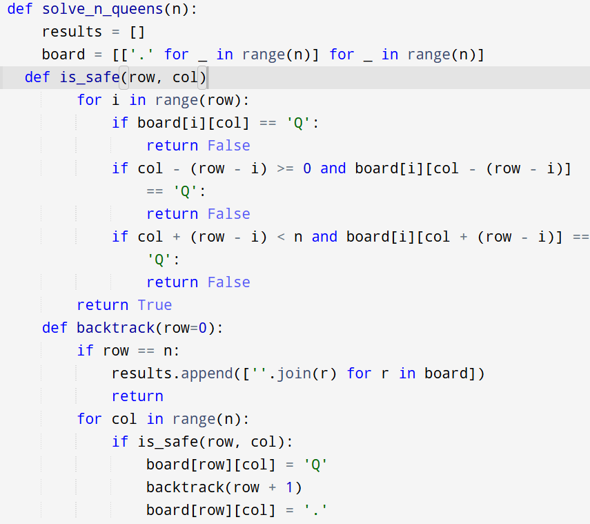

**Input:** n = 4

**Output:**

**Result:** Program is been executed.

**Performance analysis:**

* Time complexity: O(N!)
* Space complexity: O(N²)