**6.4Sudoku puzzle**

**Aim:** To construct a python code to solve the Sudoku puzzle problem.

**Algorithm:**

1. Search for the first empty cell (".").
2. Try placing digits '1' to '9'.
3. Check if the move is valid (row, column, and 3x3 box).
4. If valid, place the number and recurse.
5. If a solution is found, return.
6. If no digit works, backtrack and try the next option.

**Program:**

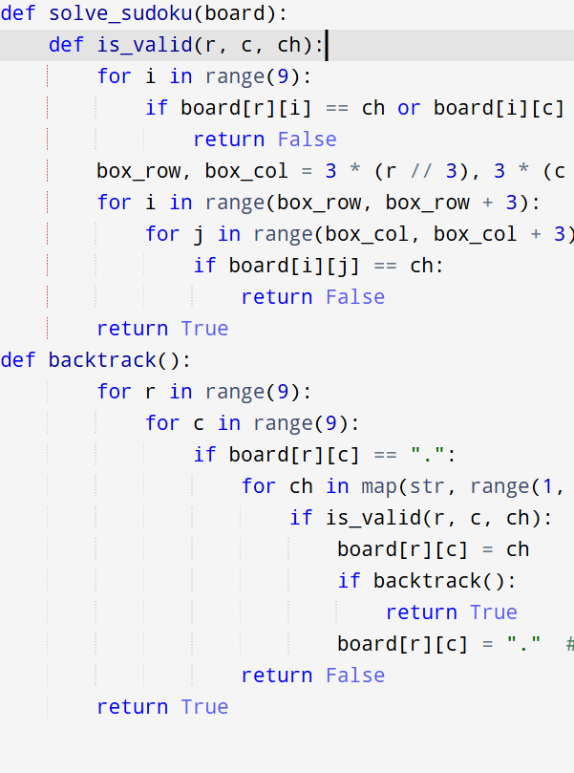

**Input:** board = [

["5","3",".",".","7",".",".",".","."],

["6",".",".","1","9","5",".",".","."],

[".","9","8",".",".",".",".","6","."],

["8",".",".",".","6",".",".",".","3"],

["4",".",".","8",".","3",".",".","1"],

["7",".",".",".","2",".",".",".","6"],

[".","6",".",".",".",".","2","8","."],

[".",".",".","4","1","9",".",".","5"],

[".",".",".",".","8",".",".","7","9"]

]

**Output:**

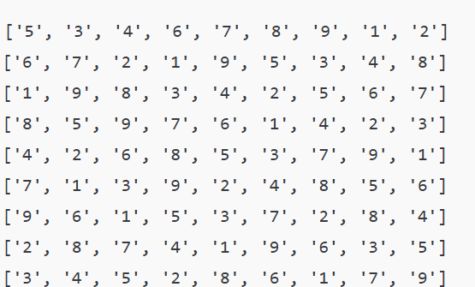

**Result:** Program is been executed.

**Performance analysis:**

* Time complexity: O(9^(empty cells))
* Space complexity: O(1)