**6.5 Target Sum**

**Aim:** To construct a python code to solve the Target Sum problem.

**Algorithm:**

1. Let P be the subset with '+' signs and N be with '-'.
2. Then:  
   sum(P) - sum(N) = target  
   sum(P) + sum(N) = total_sum ⇒ sum(P) = (target + total_sum) / 2

**Program:**

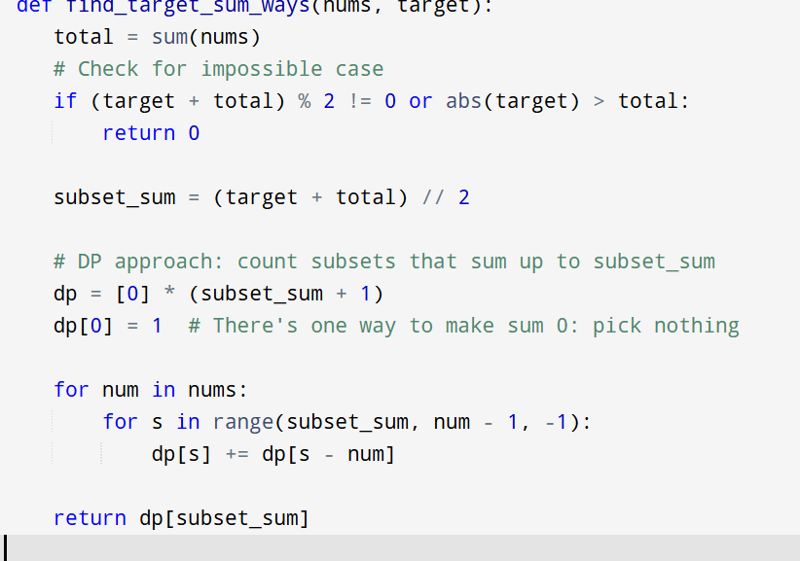

**Input:** nums = [1,1,1,1,1]

**Output:** 5

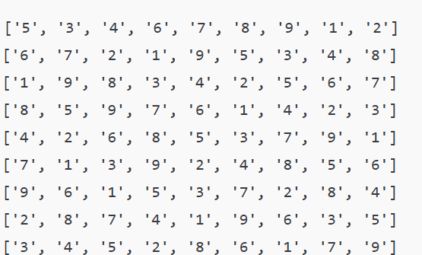

**Result:** Program is been executed.

**Performance analysis:**

* Time complexity: O(n × subset_sum)
* Space complexity: O(subset_sum)