**6.6 Sum of Subarray Minimums**

**Aim:** To construct a python code to solve the Sum of Subarray Minimums problem.

**Algorithm:**

1.Let:

* + left[i] = number of elements to the left where arr[i] is smaller (until a smaller element appears)
  + right[i] = number of elements to the right where arr[i] is smaller or equal (until a smaller element appears)

2.Then, contribution of arr[i] = arr[i] × left[i] × right[i]

**Program:**

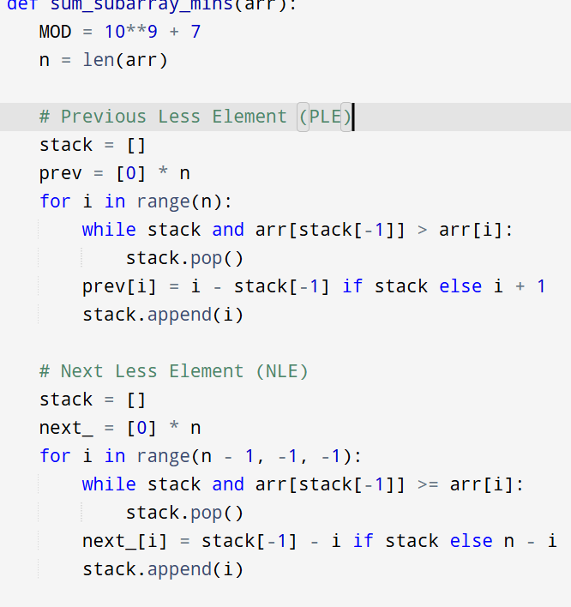

**Input :** arr = [3, 1, 2, 4]

**Output:**

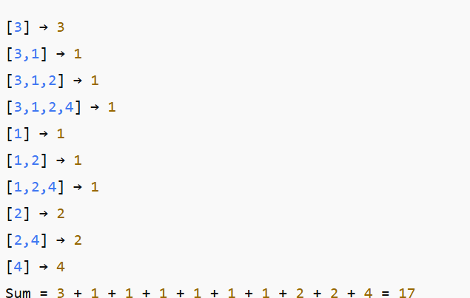

**Result:** Program is been executed.

**Performance analysis:**

* Time complexity: O(n)
* Space complexity: O(n)