**7.2 3-SAT problem**

**Aim:** To construct a python code to solve the **3-SAT** problem.

**Algorithm:**

1. Implement a solver for the 3-SAT problem.
2. Verify NP-completeness by reducing the Vertex Cover problem to 3-SAT.
3. Whether the 3-SAT formula is satisfiable.
4. A valid assignment (if satisfiable).
5. Confirmation that reduction from Vertex Cover was successful.

**Program:**

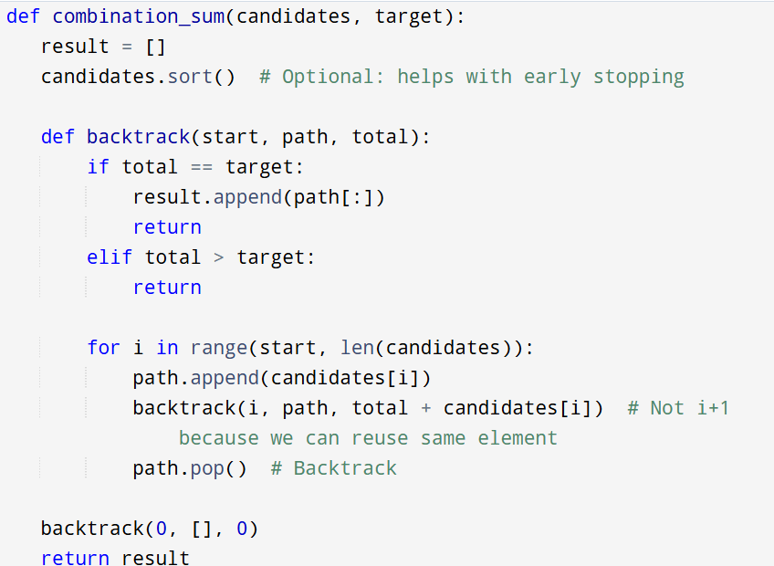

**Input :**

Input 3-SAT Formula:

( x1 ∨ x2 ∨ ¬x3 )

( ¬x1 ∨ x2 ∨ x4 )

( x3 ∨ ¬x4 ∨ x5 )

**Output:**

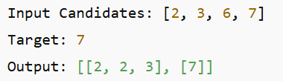

**Result:** Program is been executed.

**Performance analysis:**

* Time complexity: O(2^t)
* Space complexity: O(t)