**7.3 Exact brute-force algorithm**

**Aim:** To construct a python code to solve the exact brute-force algorithmproblem.

**Algorithm:**

1. Initialize cover = empty set.
2. While there are edges not covered:
3. Pick an arbitrary edge (u,v)(u, v)(u,v).
4. Add both uuu and vvv to cover.
5. Remove all edges covered by uuu or vvv.
6. This covers all edges, and is guaranteed to be ≤ 2 * OPT.

**Program:**

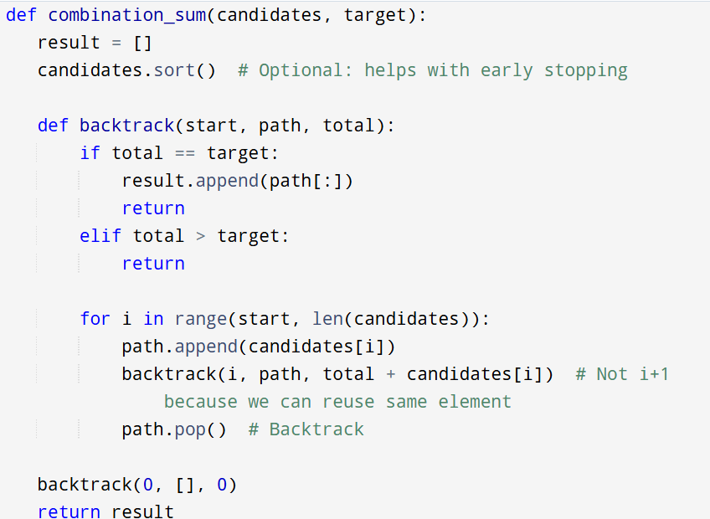

**Input :**

Input 3-SAT Formula:

( x1 ∨ x2 ∨ ¬x3 )

( ¬x1 ∨ x2 ∨ x4 )

( x3 ∨ ¬x4 ∨ x5 )

**Output:**

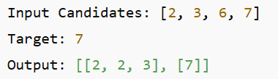

**Result:** Program is been executed.

**Performance analysis:**

* Time complexity: O(2^t)
* Space complexity: O(t)