**7.4 Set Cover**

**Aim:** To construct a python code to solve the Set Coverproblem.

**Algorithm:**

1. Greedy Approximation Algorithm

* Initialize covered = ∅
* While covered ≠ U:
  + Pick the set that covers the most uncovered elements
  + Add it to the cover
  + Update covered

2. Optimal Set Cover (Brute-force)

* Try all combinations of sets
* Return the smallest subset whose union is equal to UUU

**Program:**

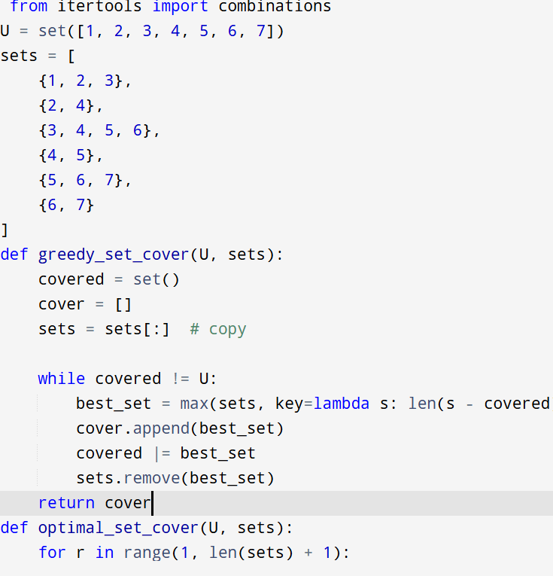

**Input :**

U = set([1, 2, 3, 4, 5, 6, 7])

sets = [

{1, 2, 3},

{2, 4},

{3, 4, 5, 6},

{4, 5},

{5, 6, 7},

{6, 7}

]

**Output:**

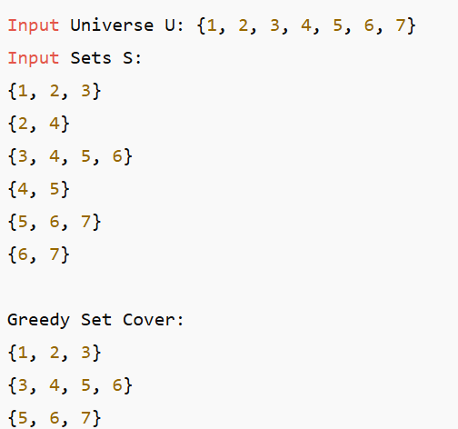

**Result:** Program is been executed.

**Performance analysis:**

* Time complexity: O(2^t)
* Space complexity: O(t)