**7.5 Bin Packing**

**Aim:** To construct a python code to solve the Bin Packing problem.

**Algorithm:**

1. Initialize empty list of bins.
2. For each item:
3. Try placing it in the first bin that has enough remaining capacity.
4. If no such bin exists, open a new bin.
5. Return the list of bins used

**Program:**

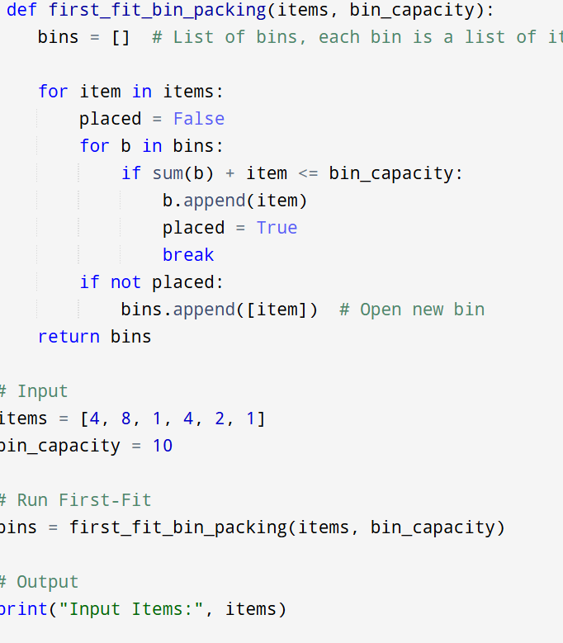

**Input :**  items = [4, 8, 1, 4, 2, 1]

Bin capacity = 10

**Output:**

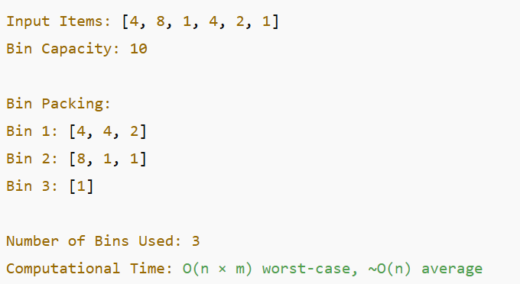

**Result:** Program is been executed.

**Performance analysis:**

* Time complexity: O(n × m)
* Space complexity: O(n)