Basics of Python

1. Open localhost : Jupiter Notebook
2. Create a File : Give an Code > Heading : Click Shift + Enter (1 To 5 # <Heading>)
3. Extension : .ipynb

Reads : only the C drive.

Give Heading

Shortcuts

Escp + DD : Delete Cell

Esc +A : Insert Above

Esc +B : Insert Below

# (comment)

#this is my code. * and space will get you a bullet

Code > Markdown

Markdown is used for inserting text format the description.

Code > RawNBConvert

Download image > copy and paste the image in the markdown .

Esc+M : Markdown

Y : is to go back to pervious stage.

<https://www.dataquest.io/blog/jupyter-notebook-tips-tricks-shortcuts/>

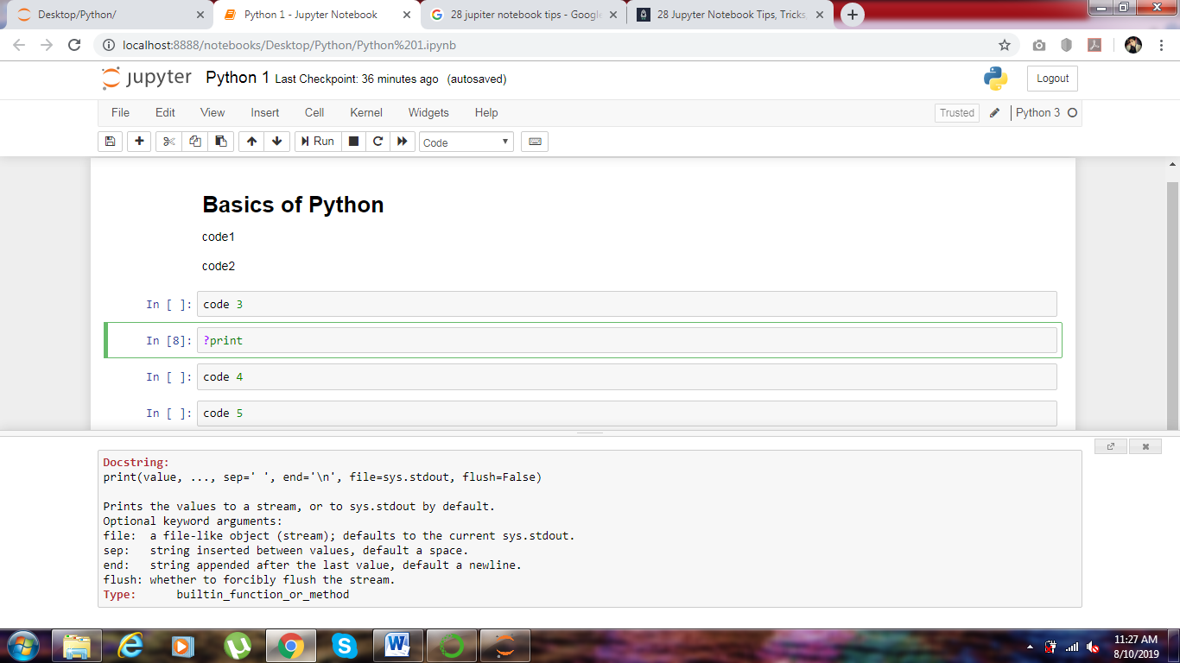

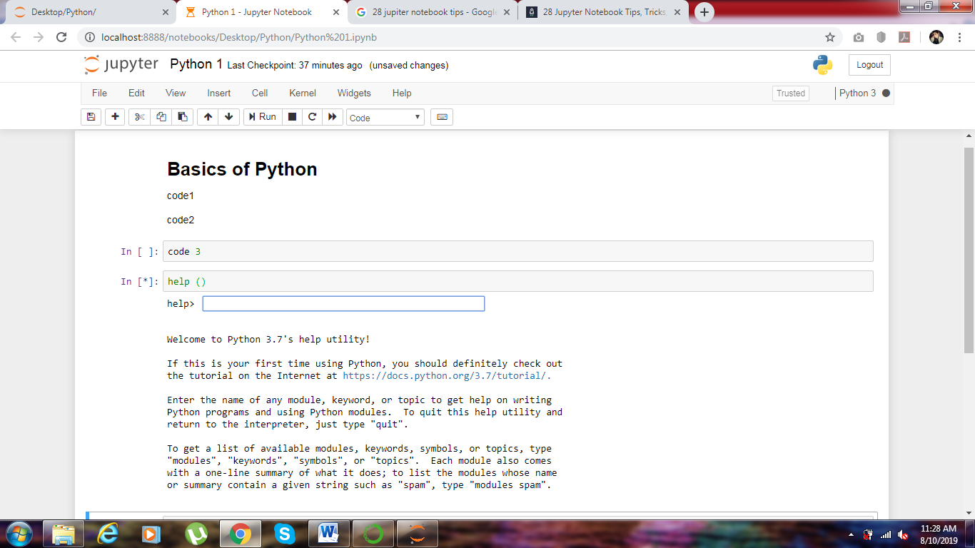

All ebooks

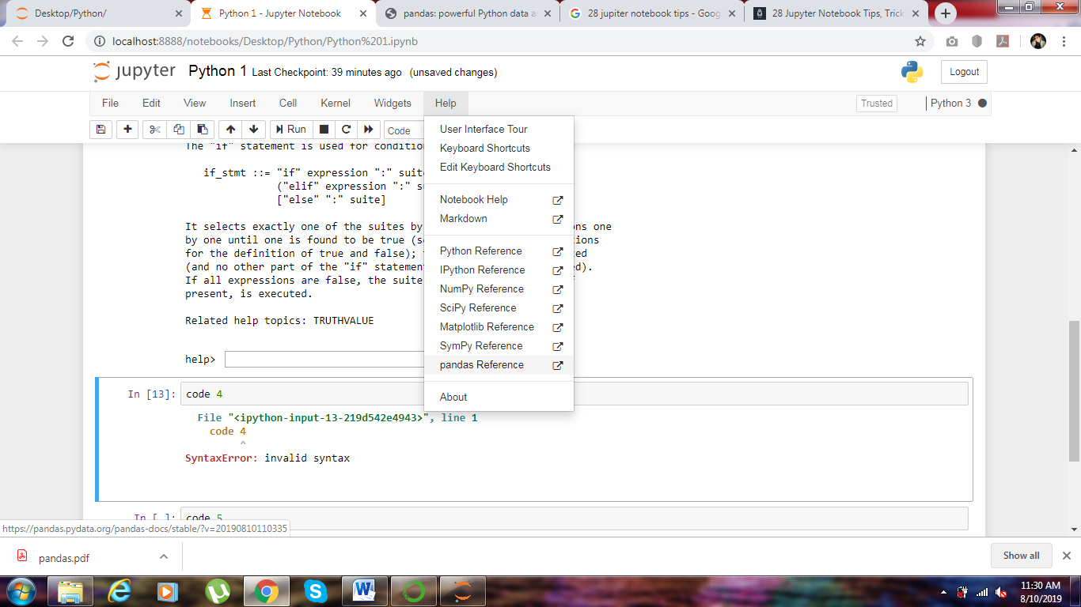

Colab google cloud

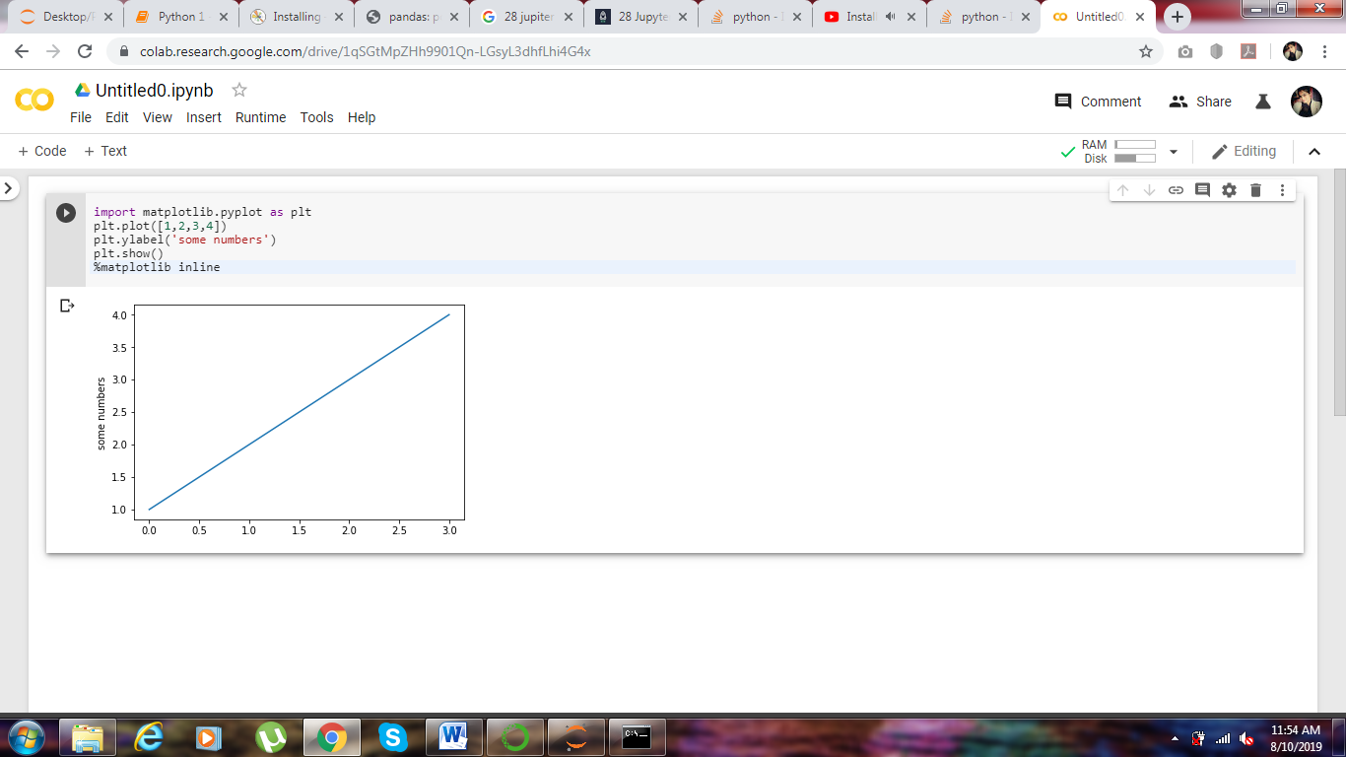

Jupyter

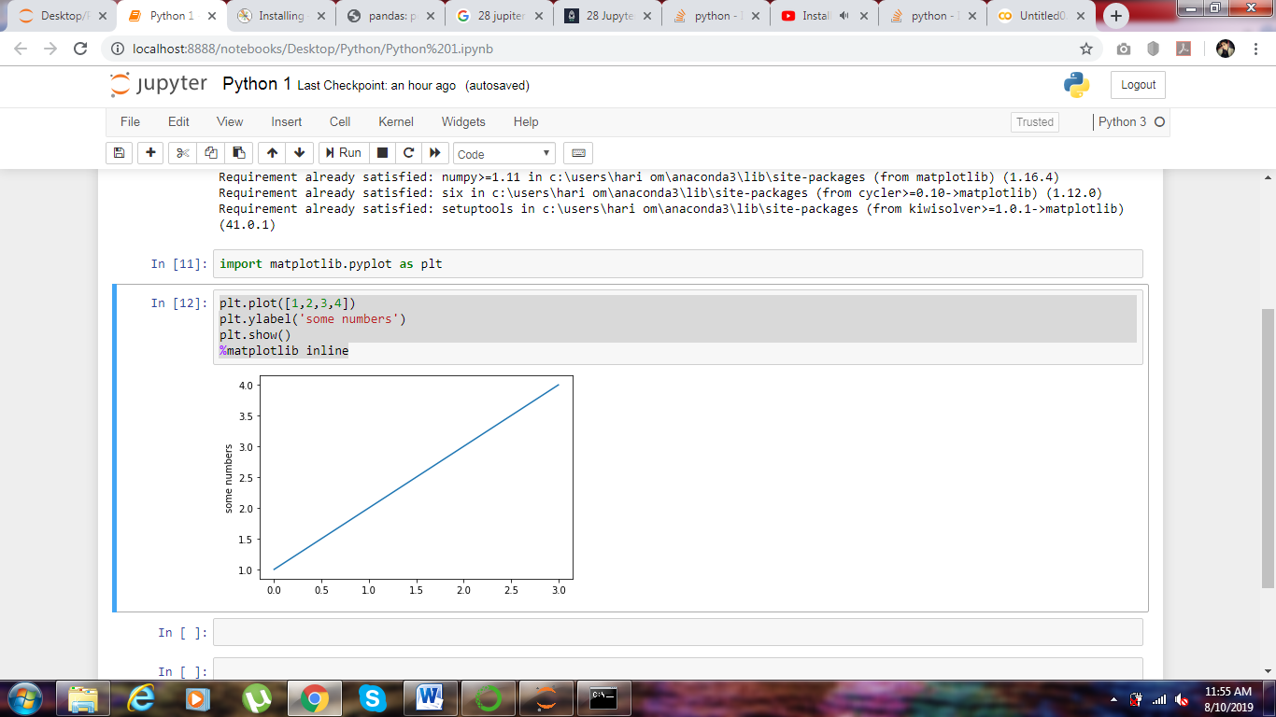

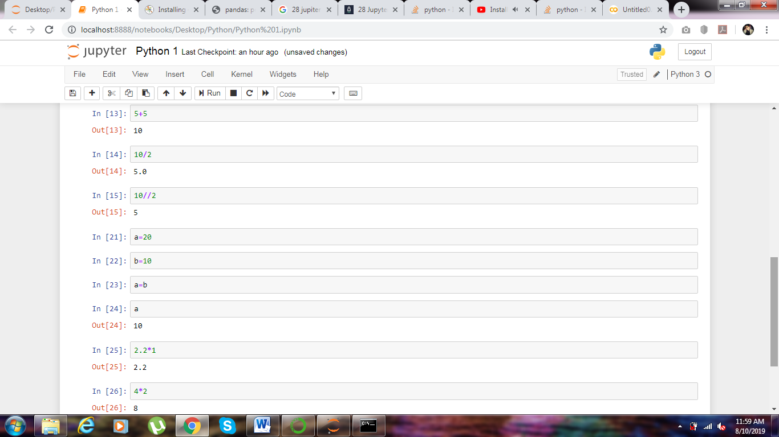

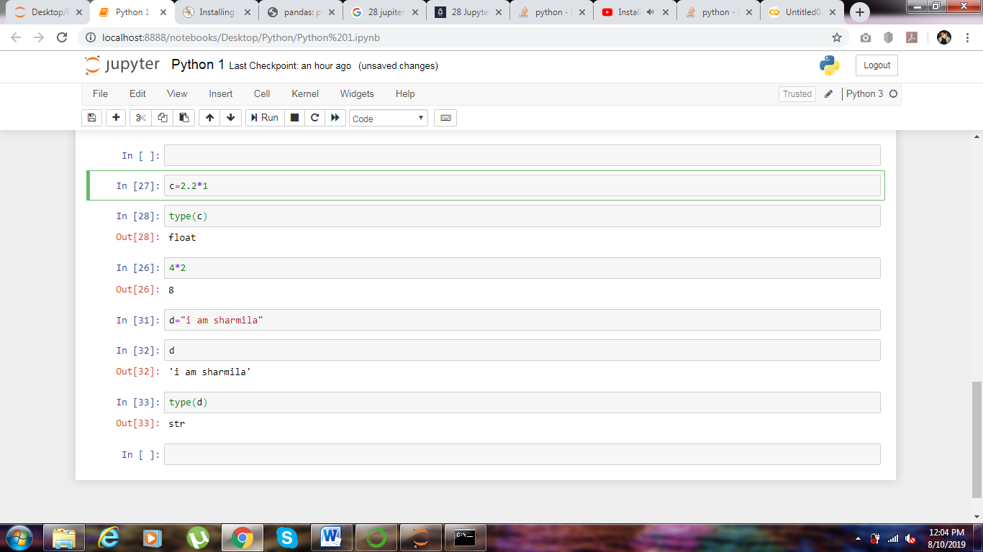

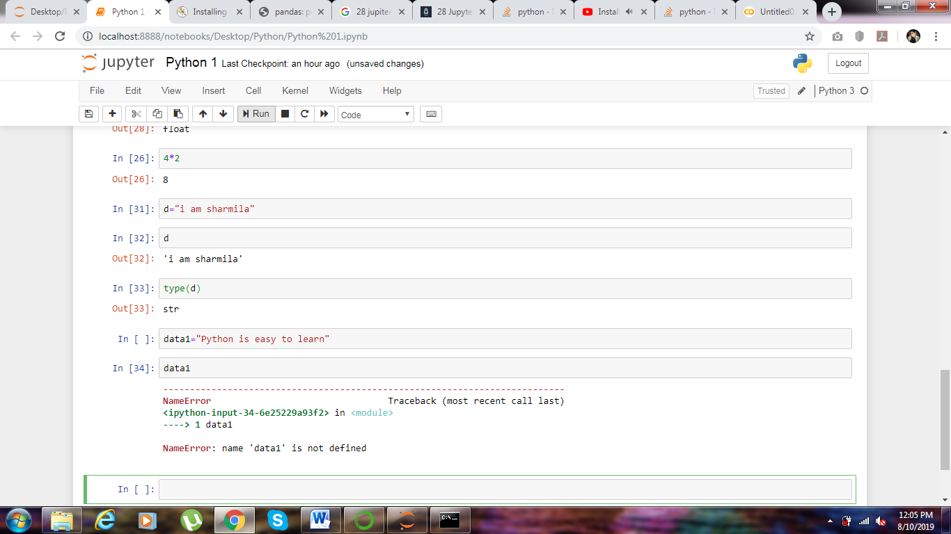

Click shift enter and run

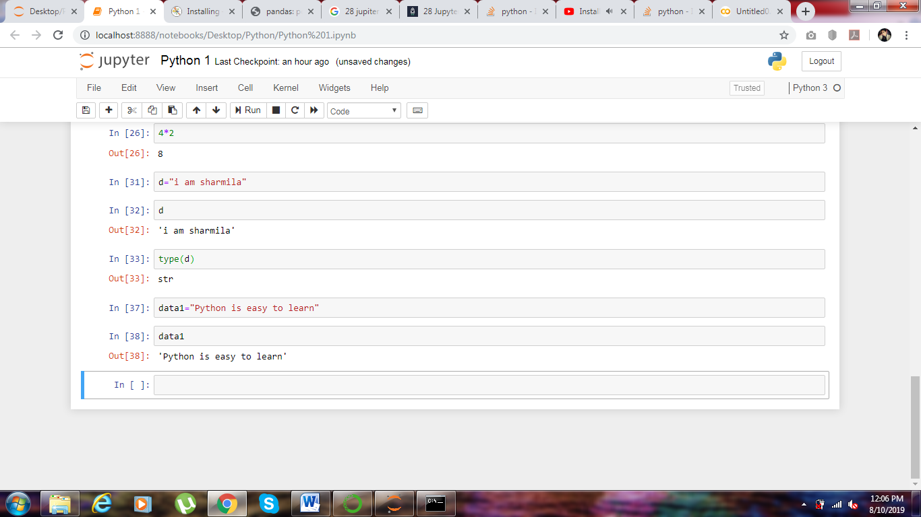

Can’t start name of variable with a number

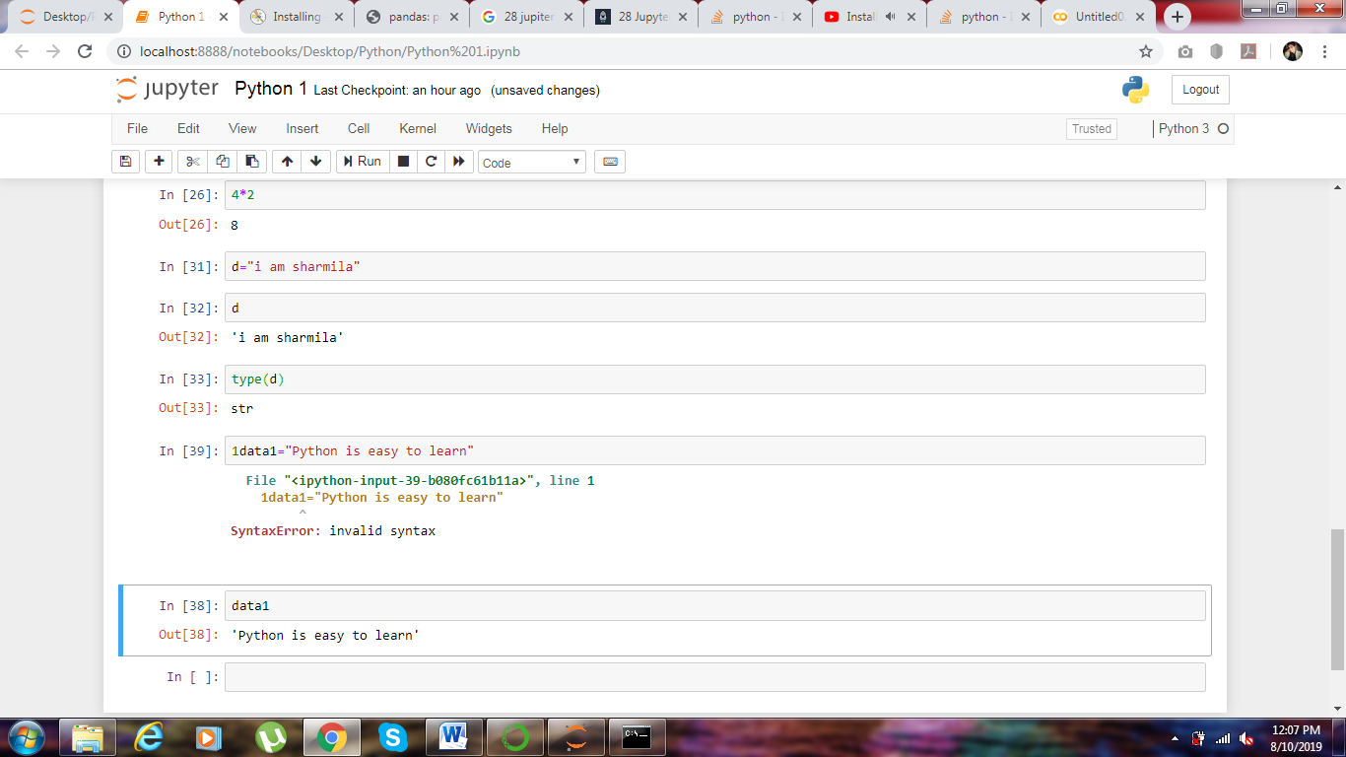

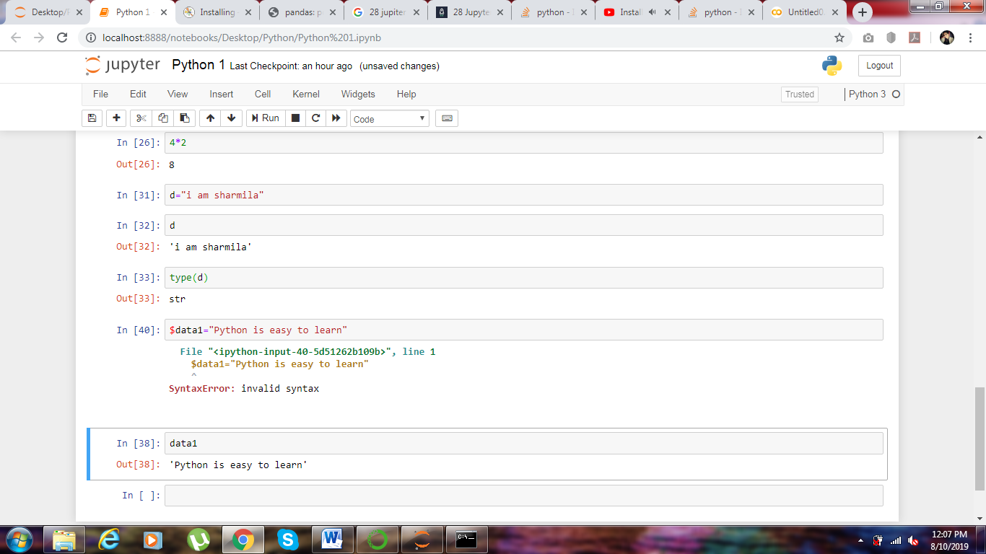

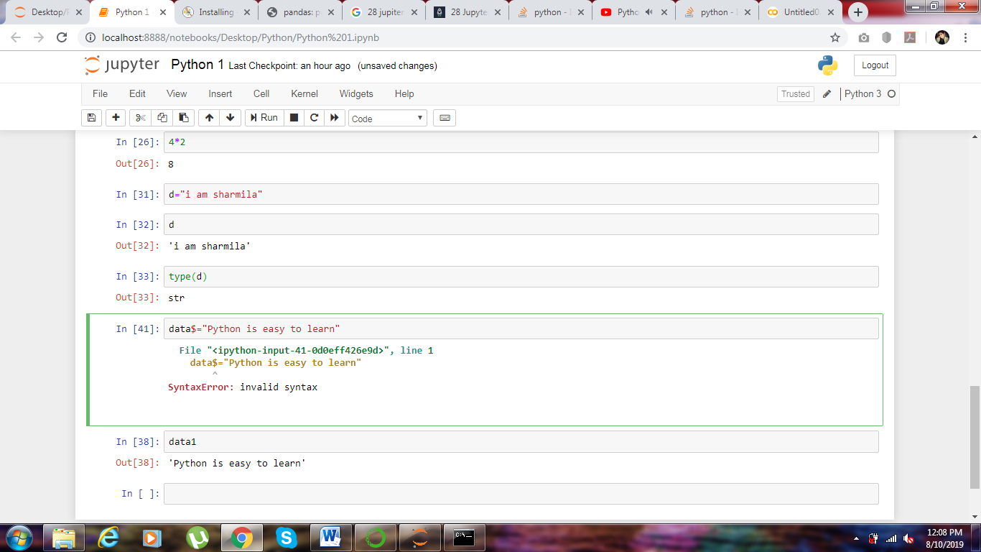

Special characters except the _ underscore

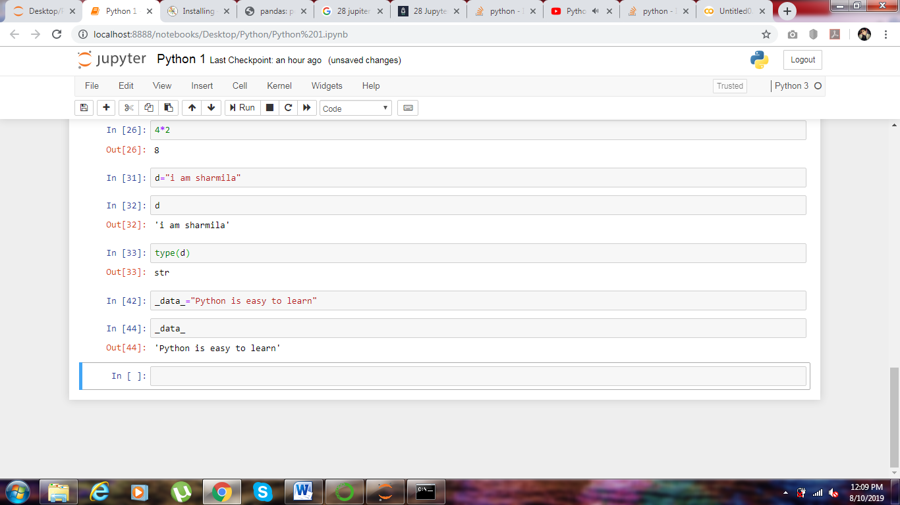

Don’t use reserved keywords for variable name like end, if and, return,true,finally.

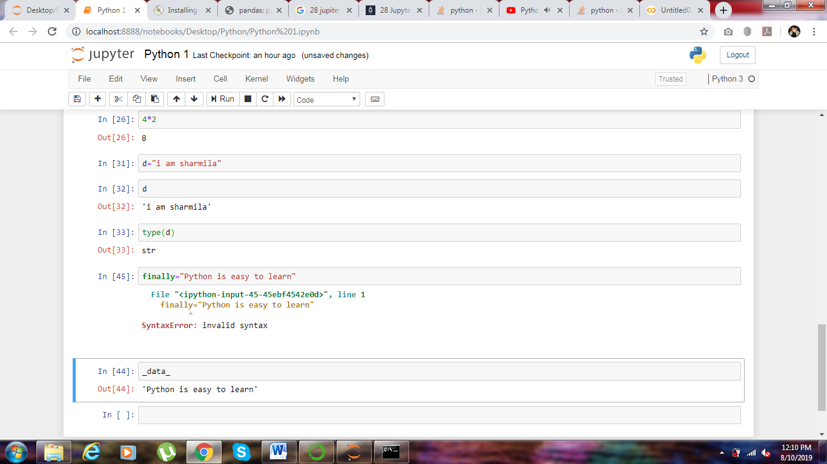

Space should not be given in variable name : data one not allowed.

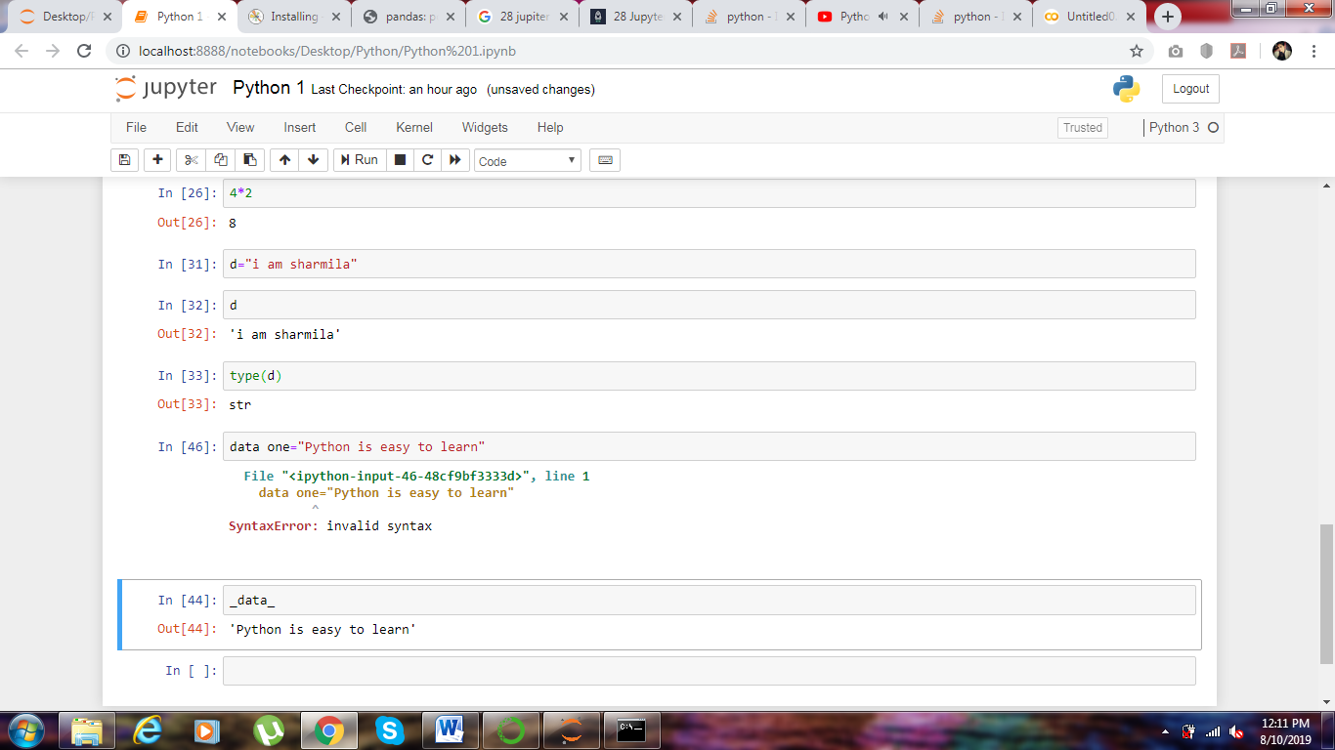

Value will be in j not I in python

e or E expotent

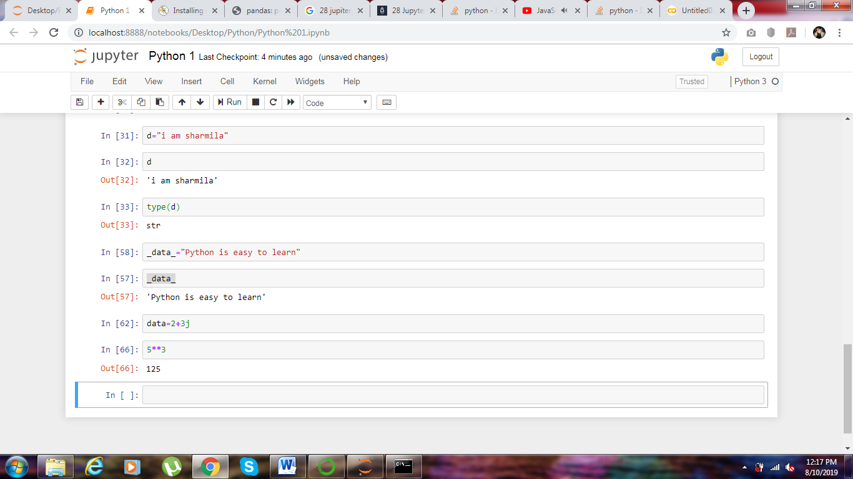

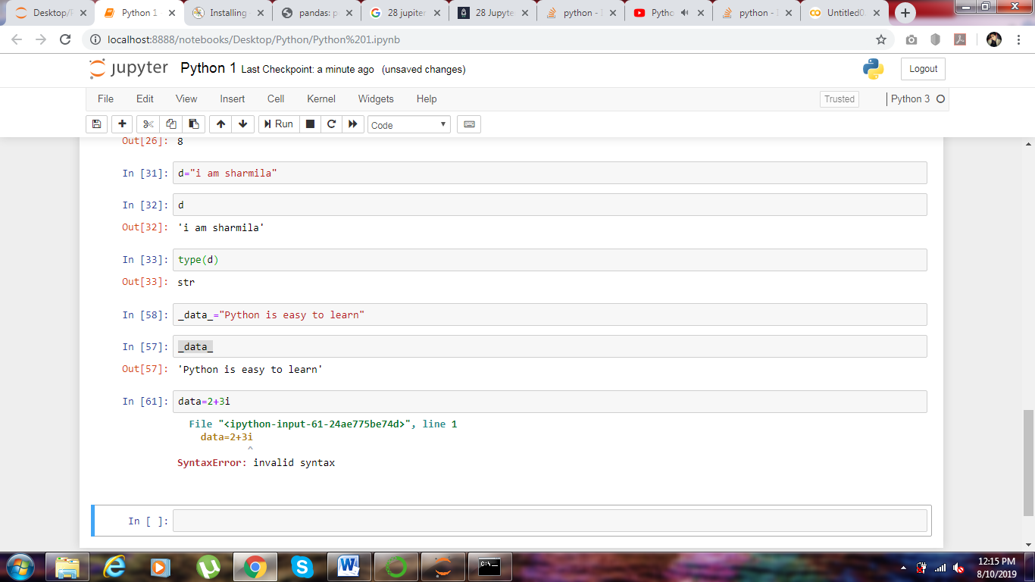

Error

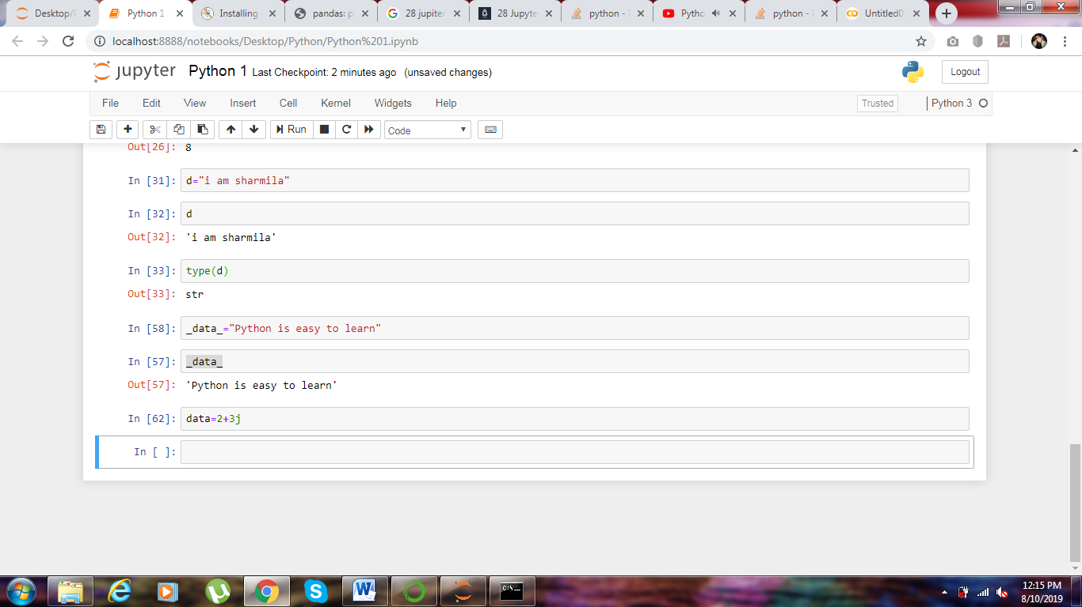

J = success

List

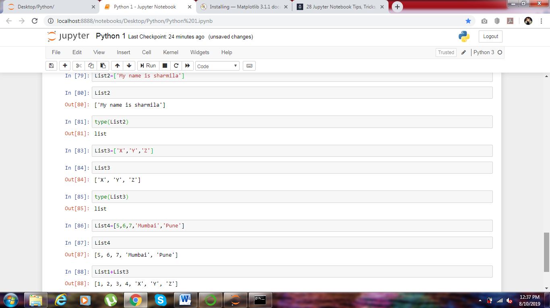

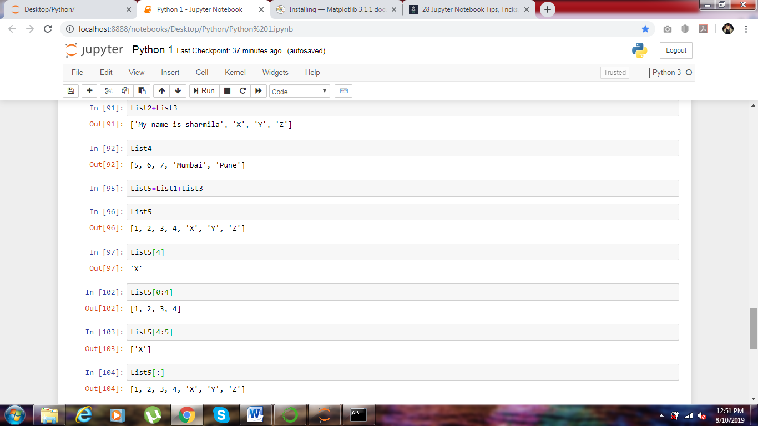

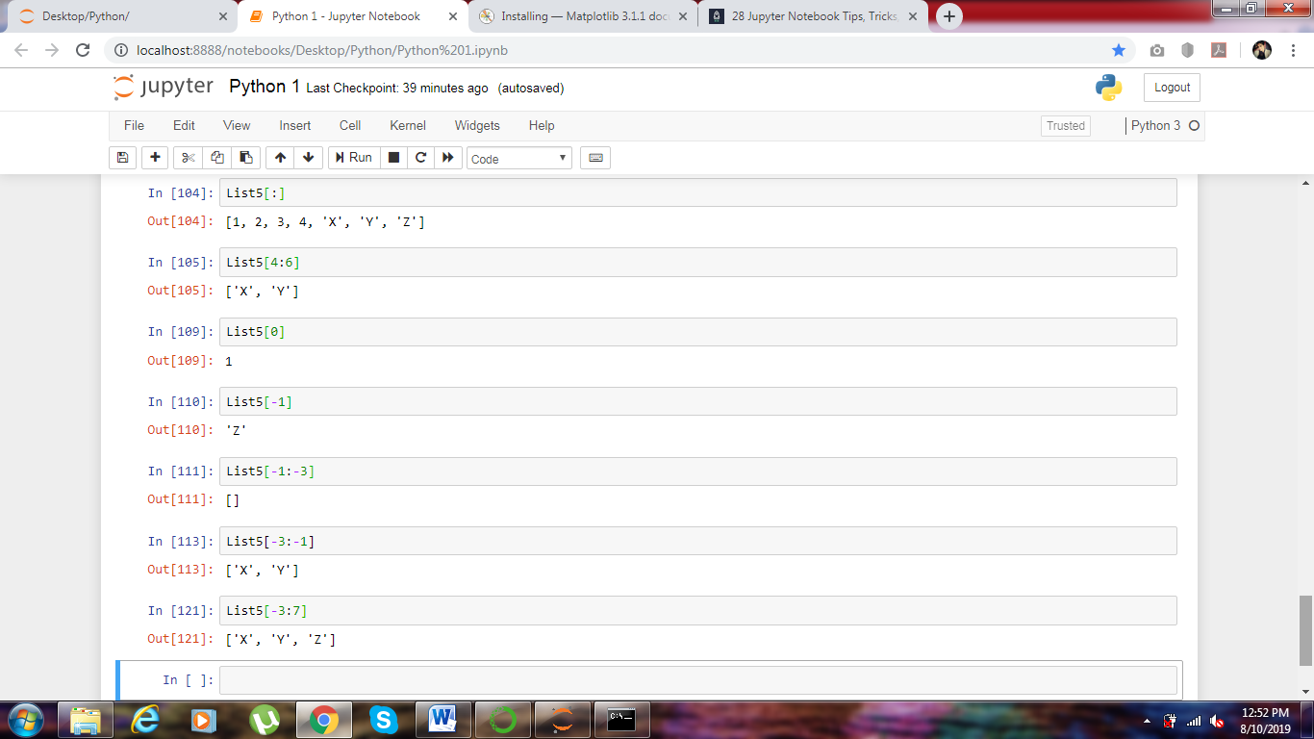

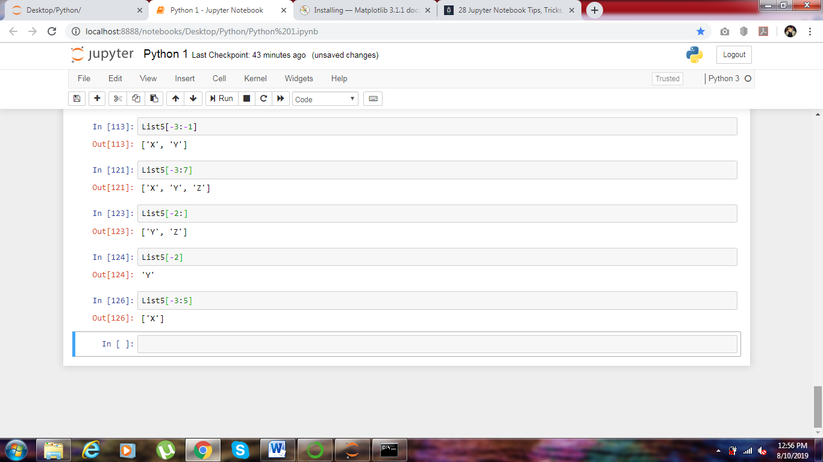

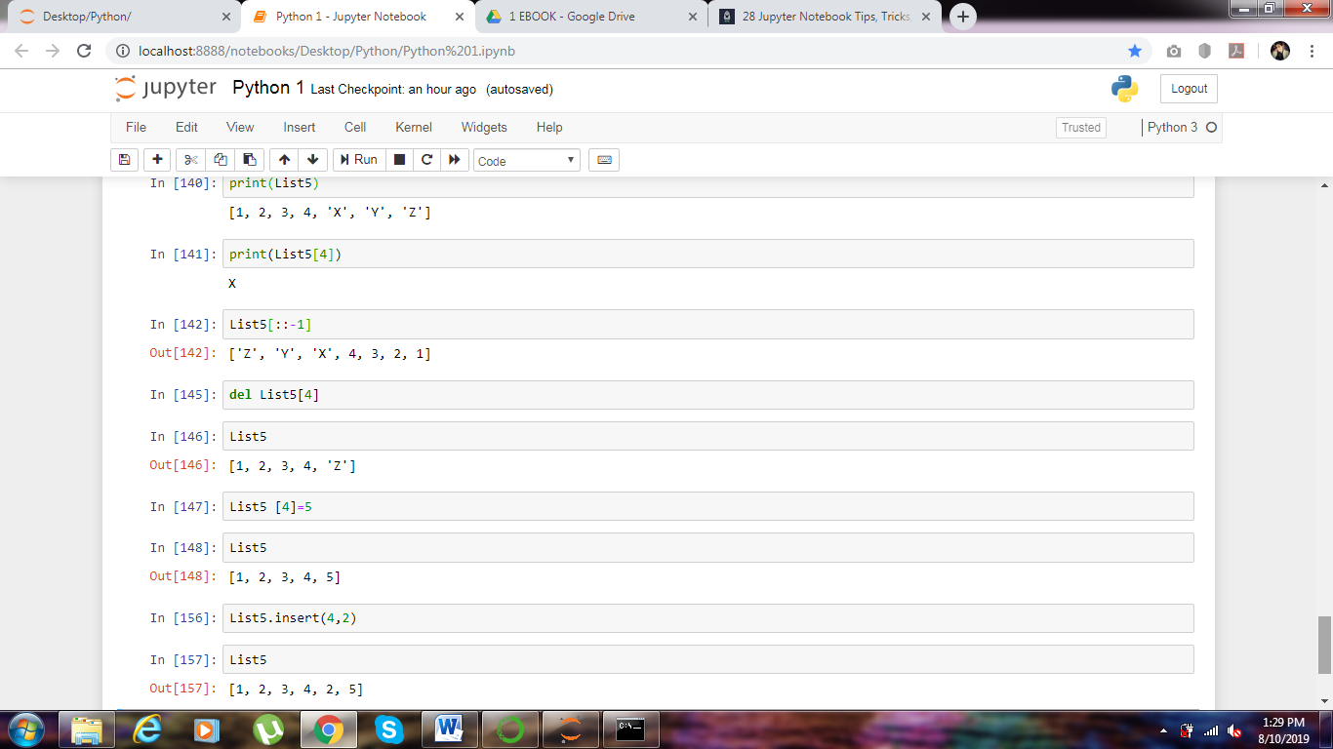

( ) means it’s a function

Python is a case senestive.

