Date : 3/8/2019

Machine Learning : 1st Lecture

Notes :

Download Anaconda : Python 3.7 Version : Platform Windows : 64-bit Graphical Installer

URL : <https://www.anaconda.com/distribution/#download-section>

Different Types of ML :

* Supervised Learning
* Unsupervised Learning
* Reinforcement Learning

Supervised Learning : Also known as Predictive Modeling Predict an outcome based on input data

Eg : Predict whether an email is spam or not.

1. Regression : Linear **Regression** is a **machine learning** algorithm based on supervised **learning**. It performs a **regression** task. **Regression** models a target prediction value based on independent variables. It is mostly used for finding out the relationship between variables and forecasting.

Where final outcome is Continuous output.

Eg : Relation between Age of Employee and his Salary, blood pressure ,price.

|  |  |
| --- | --- |
| X Age | Y Salary |
| 20 | 10k |
| 30 | 20k |
| 40 | 30k |
| 50 | 40k |

Here doesn’t matter its x and y

1. Classification : In **machine learning** and statistics, **classification** is a supervised **learning** approach in which the computer program learns from the data input given to it and then uses this **learning** to **classify** new observation. ... Linear Classifiers: Logistic Regression, Naive Bayes Classifier. Where outcome is categorical.

Eg : Loan should be given or not, Email is spam or not, Cancer or not

|  |  |
| --- | --- |
| X | Y |
| Loan | Yes |
| Loan | No |

Here Y is important as it gives you outcome.

Response which you want will decide whether its Regression and Classification problem.

Unsupervised Learning :

**Unsupervised learning** is a type of **machine learning** algorithm used to draw inferences from datasets consisting of input data without labeled responses. The most common **unsupervised learning** method is cluster analysis, which is used for exploratory data analysis to find hidden patterns or grouping in data.

Unsupervised learning problems can be further grouped into clustering and association problems.

* **Clustering**: A clustering problem is where you want to discover the inherent groupings in the data, such as grouping customers by purchasing behavior.
* **Association**:  An association rule learning problem is where you want to discover rules that describe large portions of your data, such as people that buy X also tend to buy Y.

Some popular examples of unsupervised learning algorithms are:

* k-means for clustering problems.
* Apriori algorithm for association rule learning problems.

K-Means is one of the most important algorithms when it comes to [***Machine learning Certification Training***](https://www.edureka.co/machine-learning-certification-training). In this blog, we will understand the K-Means clustering algorithm with the help of examples.

A Hospital Care chain wants to open a series of Emergency-Care wards within a region. We assume that the hospital knows the location of all the maximum accident-prone areas in the region. They have to decide the number of the Emergency Units to be opened and the location of these Emergency Units, so that all the accident-prone areas are covered in the vicinity of these Emergency Units.

The challenge is to decide the location of these Emergency Units so that the whole region is covered. Here is when K-means Clustering comes to rescue!

Before getting to K-means Clustering, let us first understand what Clustering is.

A cluster refers to a small group of objects. Clustering is grouping those objects into clusters. In order to learn clustering, it is important to understand the scenarios that lead to cluster different objects. Let us identify a few of them.

**What is Clustering?**

Clustering is dividing data points into homogeneous classes or clusters:

* Points in the same group are as similar as possible
* Points in different group are as dissimilar as possible

When a collection of objects is given, we put objects into group based on similarity.

**Application of Clustering:**

Clustering is used in almost all the fields. You can infer some ideas from Example 1 to come up with lot of clustering applications that you would have come across.

Listed here are few more applications, which would add to what you have learnt.

* Clustering helps marketers improve their customer base and work on the target areas. It helps group people (according to different criteria’s such as willingness, purchasing power etc.) based on their similarity in many ways related to the product under consideration.
* Clustering helps in identification of groups of houses on the basis of their value, type and geographical locations.
* Clustering is used to study earth-quake. Based on the areas hit by an earthquake in a region, clustering can help analyse the next probable location where earthquake can occur.

**Clustering Algorithms:**

A Clustering Algorithm tries to analyse natural groups of data on the basis of some similarity. It locates the centroid of the group of data points. To carry out effective clustering, the algorithm evaluates the distance between each point from the centroid of the cluster.

The goal of clustering is to determine the intrinsic grouping in a set of unlabelled data.

[[](https://www.edureka.co/data-science)](https://www.edureka.co/data-science" \t "_blank)

**[Data Science Certification Course using R](https://www.edureka.co/data-science" \t "_blank)**

* *[Instructor-led Sessions](https://www.edureka.co/data-science" \t "_blank)*
* *[Real-life Case Studies](https://www.edureka.co/data-science" \t "_blank)*
* *[Assignments](https://www.edureka.co/data-science" \t "_blank)*
* *[Lifetime Access](https://www.edureka.co/data-science" \t "_blank)*

[Explore Curriculum](https://www.edureka.co/data-science" \t "_blank)



**What is K-means Clustering?**

K-means (Macqueen, 1967) is one of the simplest unsupervised learning algorithms that solve the well-known clustering problem. K-means clustering is a method of vector quantization, originally from signal processing, that is popular for cluster analysis in data mining.

**K-means Clustering – Example 1:**

A pizza chain wants to open its delivery centres across a city. What do you think would be the possible challenges?

* They need to analyse the areas from where the pizza is being ordered frequently.
* They need to understand as to how many pizza stores has to be opened to cover delivery in the area.
* They need to figure out the locations for the pizza stores within all these areas in order to keep the distance between the store and delivery points minimum.

Resolving these challenges includes a lot of analysis and mathematics. We would now learn about how clustering can provide a meaningful and easy method of sorting out such real life challenges. Before that let’s see what clustering is.

**K-means Clustering Method:**

If k is given, the K-means algorithm can be executed in the following steps:

* Partition of objects into k non-empty subsets
* Identifying the cluster centroids (mean point) of the current partition.
* Assigning each point to a specific cluster
* Compute the distances from each point and allot points to the cluster where the distance from the centroid is minimum.
* After re-allotting the points, find the centroid of the new cluster formed.

**The step by step process:**

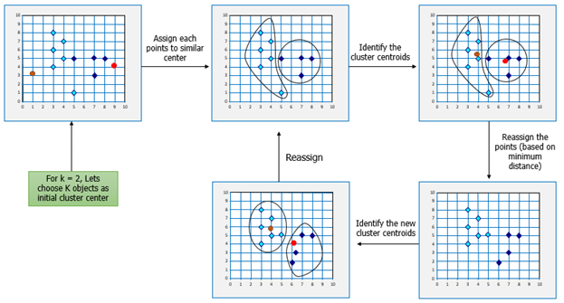

Now, let’s consider the problem in Example 1 and see how we can help the pizza chain to come up with centres based on K-means algorithm.

**Similarly, for opening Hospital Care Wards:**

K-means Clustering will group these locations of maximum prone areas into clusters and define a cluster center for each cluster, which will be the locations where the Emergency Units will open. These Clusters centers are the centroids of each cluster and are at a minimum distance from all the points of a particular cluster, henceforth, the Emergency Units will be at minimum distance from all the accident prone areas within a cluster.

[[](https://www.edureka.co/data-science)](https://www.edureka.co/data-science" \t "_blank)

**[Data Science Certification Course using R](https://www.edureka.co/data-science" \t "_blank)**

[Watch The Course Preview](https://www.edureka.co/data-science" \t "_blank)

Here is another example for you, try and come up with the solution based on your understanding of K-means clustering.

**K-means Clustering – Example 2:**

Let’s consider the data on drug-related crimes in Canada. The data consists of crimes due to various drugs that include, Heroin, Cocaine to prescription drugs, especially by underage people. The crimes resulted due to these substance abuse can be brought down by starting de-addiction centres in areas most afflicted by this kind of crime. With the available data, different objectives can be set. They are:

* Classify the crimes based on the abuse substance to detect prominent cause.
* Classify the crimes based on age groups.
* Analyze the data to determine what kinds of de-addiction centre is required.
* Find out how many de-addiction centres need to be setup to reduce drug related crime rate.

The K-means algorithm can be used to determine any of the above scenarios by analyzing the available data.

Following the K-means Clustering method used in the previous example, we can start off with a given k, following by the execution of the K-means algorithm.

**Mathematical Formulation for K-means Algorithm:**

D= {**x1,x2,…,xi,…,xm**} à data set of m records

**xi**= (xi1,xi2,…,xin) à each record is an n-dimensional vector

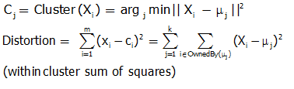

**Finding Cluster Centers that Minimize Distortion:**

Solution can be found by setting the partial derivative of Distortion w.r.t. each cluster center to zero.

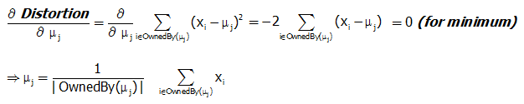

For any k clusters, the value of k should be such that even if we increase the value of k from after several levels of clustering the distortion remains constant. The achieved point is called the “Elbow”.

This is the ideal value of k, for the clusters created.

[[](https://www.edureka.co/data-science)](https://www.edureka.co/data-science" \t "_blank)

**[Data Science Certification Course using R](https://www.edureka.co/data-science" \t "_blank)**

[Weekday / Weekend BatchesSee Batch Details](https://www.edureka.co/data-science" \t "_blank)

