**EXHAUSTIVE ANALYSIS OF INDIAN AGRICULTURE USING POWERBI**

**TASK-1**

**1.Install Power Bi website in your system :** 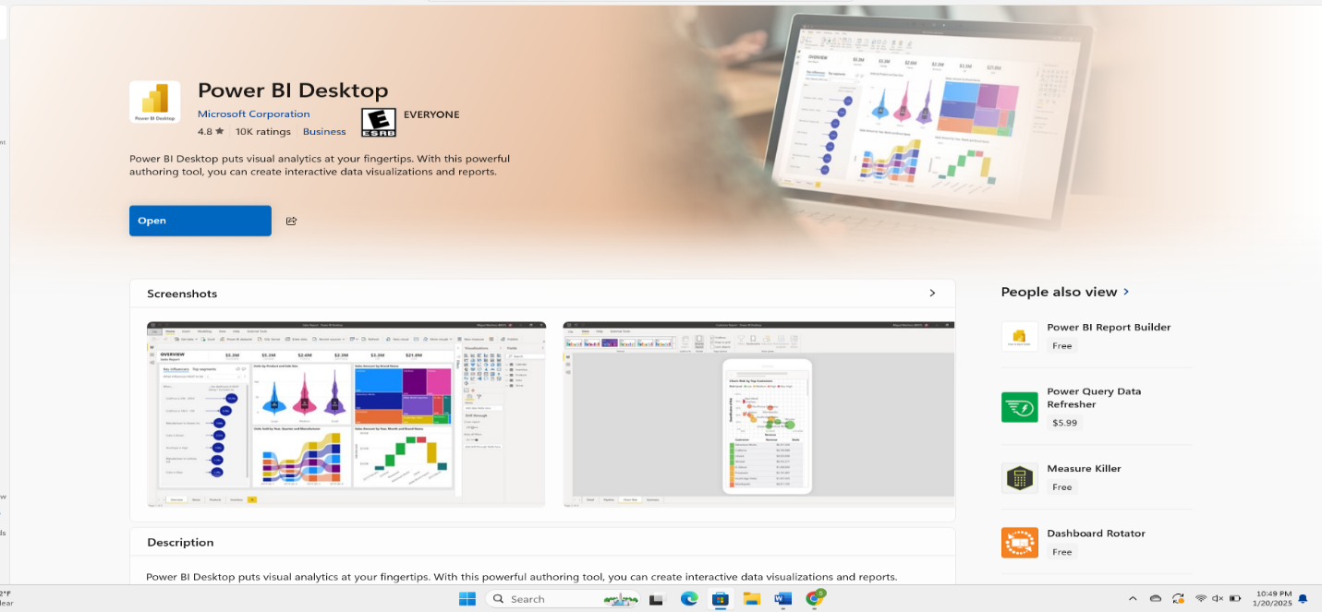

**2.Open Power Bi app after opening this page will be appeared:**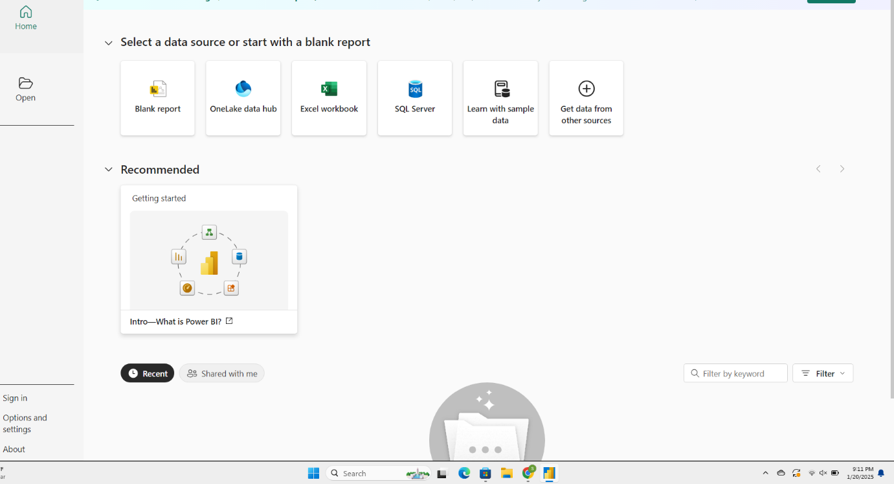

**3.Now we have to select Black report file:**

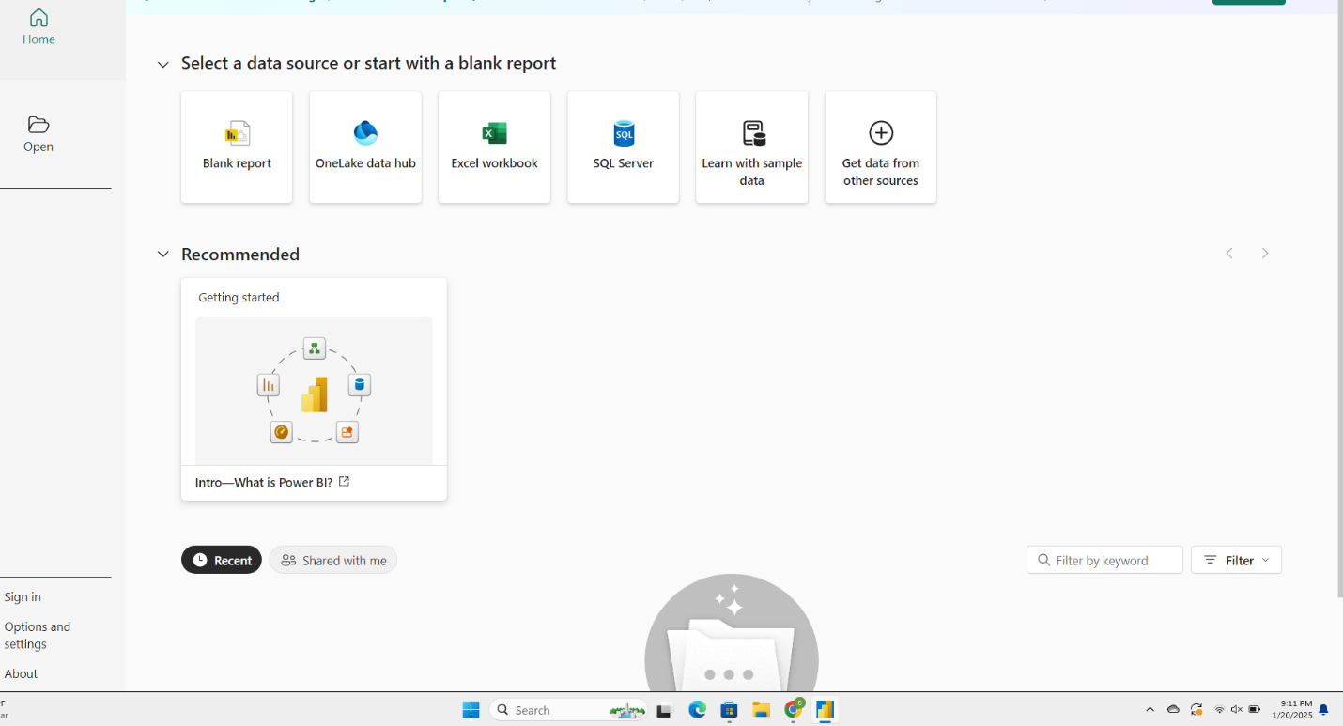

4.After opening the file this page will be appeared:

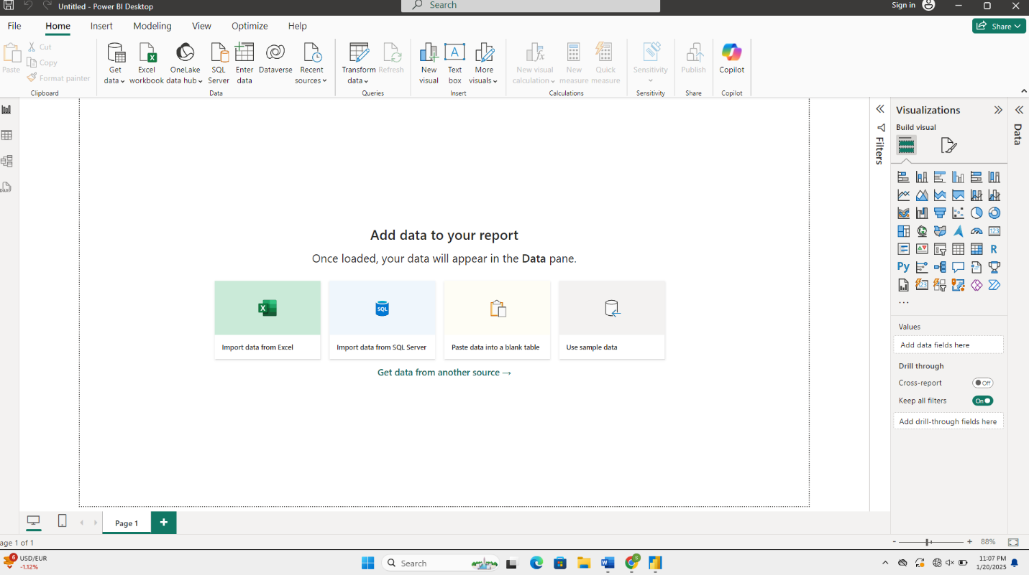

5.In this page left side corner report view is there it is used for graphs:

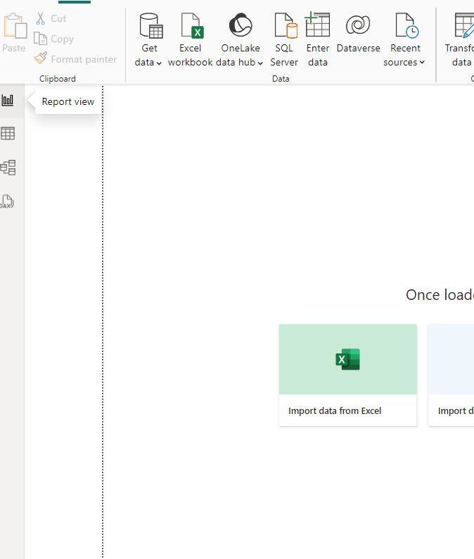

6.Second one is table view it is used for tables format:

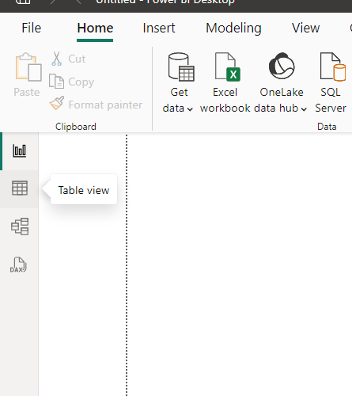

7.Third one is model view it is used for data set :

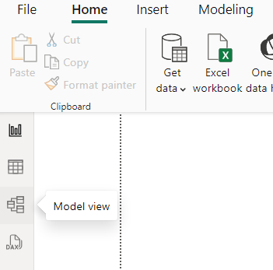

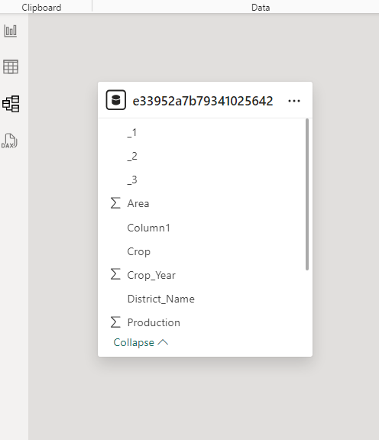

8.Now we have to select get data by selecting it we will get many options like this:

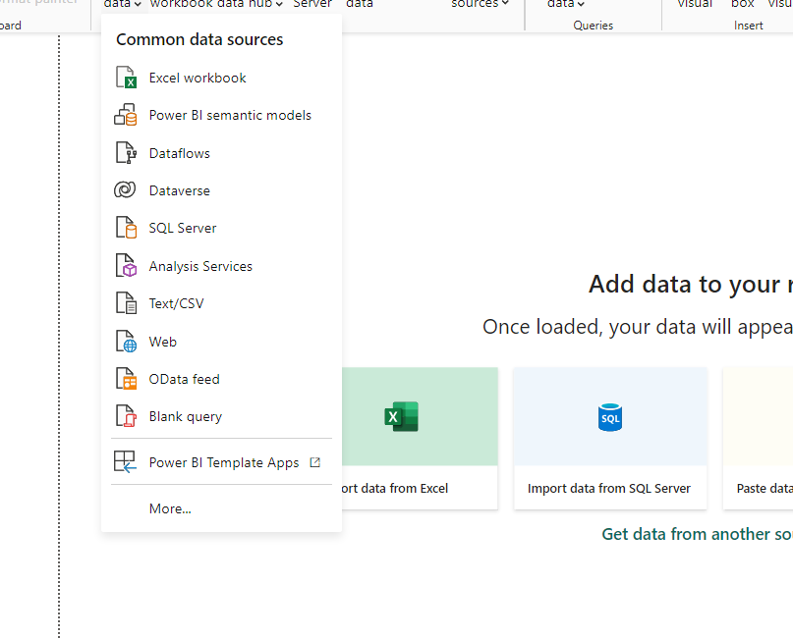

**9**.Now we have to select Text/CSV option on desktop: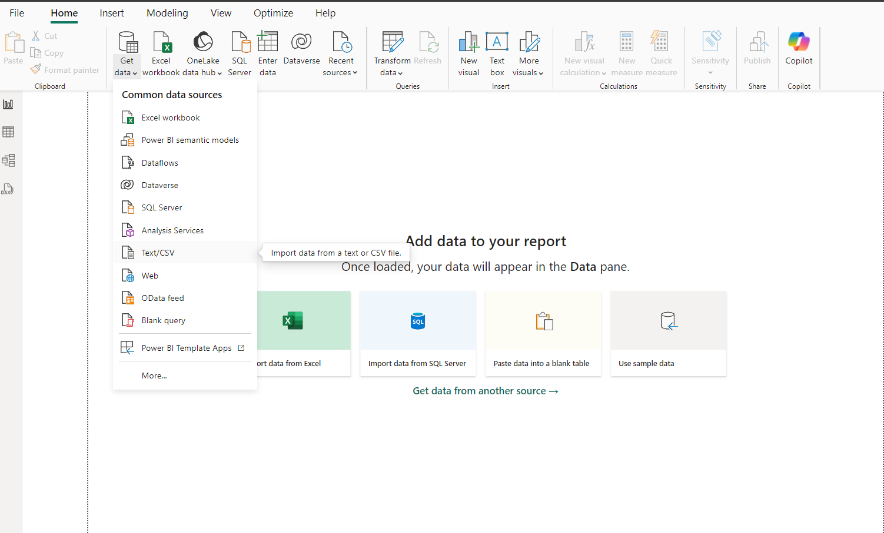

**10.After selecting Text/CSV this page will be appeared:**

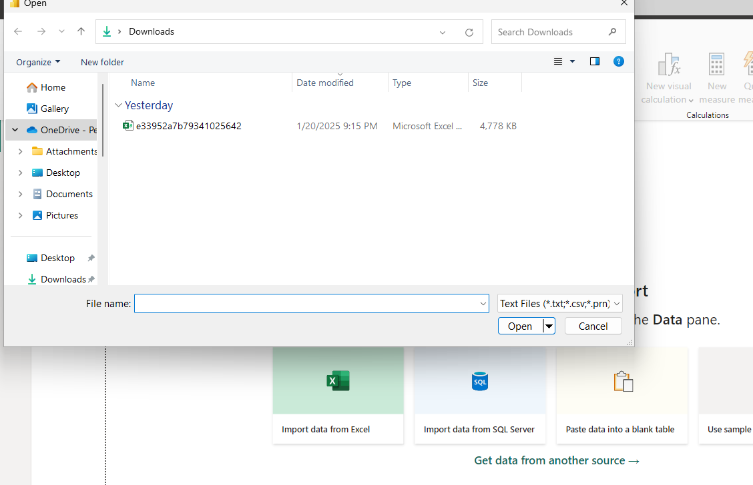

**11.Now we have to open our dataset file from our folder:**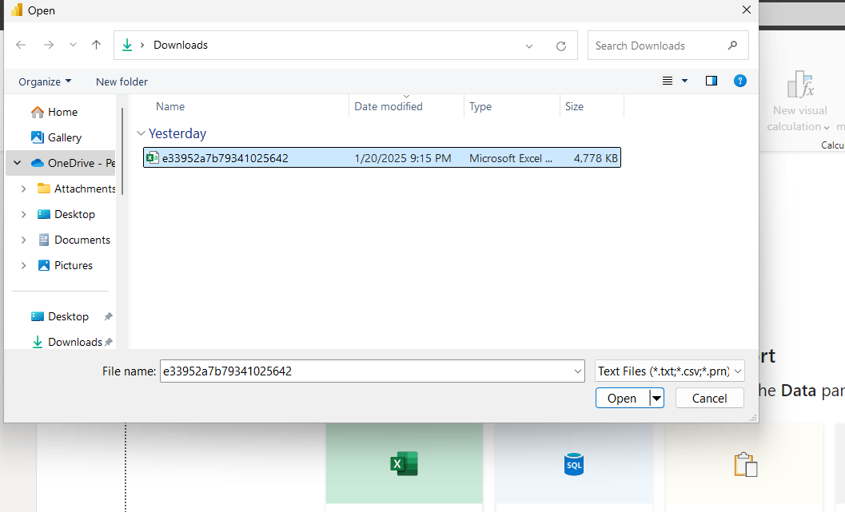

**12.After selecting our dataset file this page will be displayed on your screen:**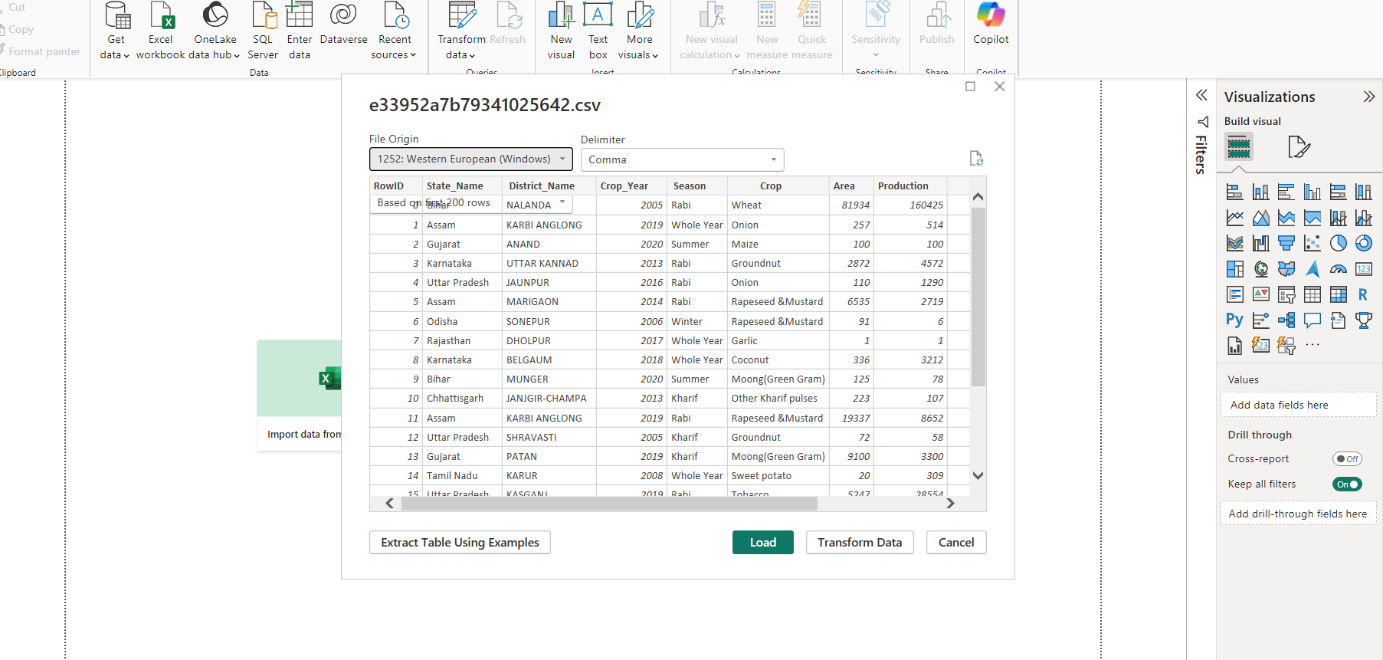

**13.In this page we can see load and transform data ,now we have to select load option for our project:**

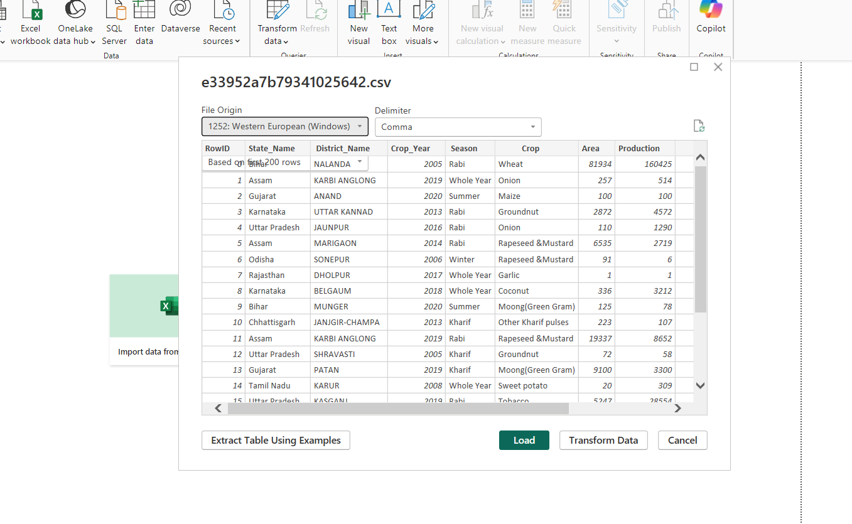

**14.After clicking this option this page will be appeared on your screen:**

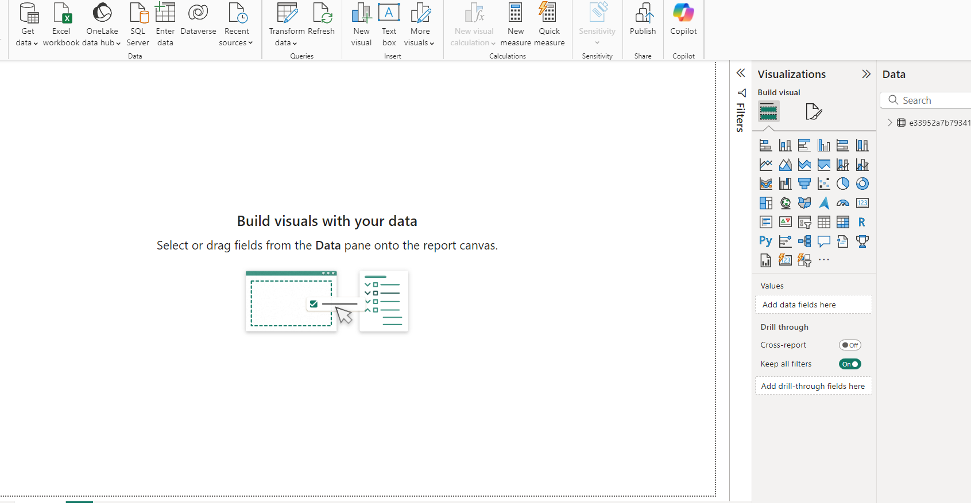

**15.Now we can see many options on the top page click on the transform data , after clicking we can see two options:**

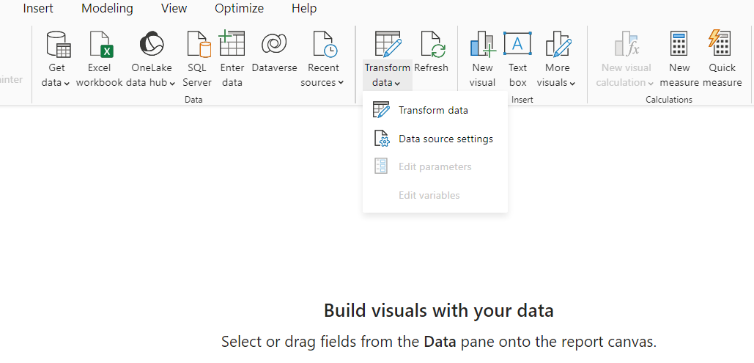

**16.Here we have to select transform data then this page will be displayed:**

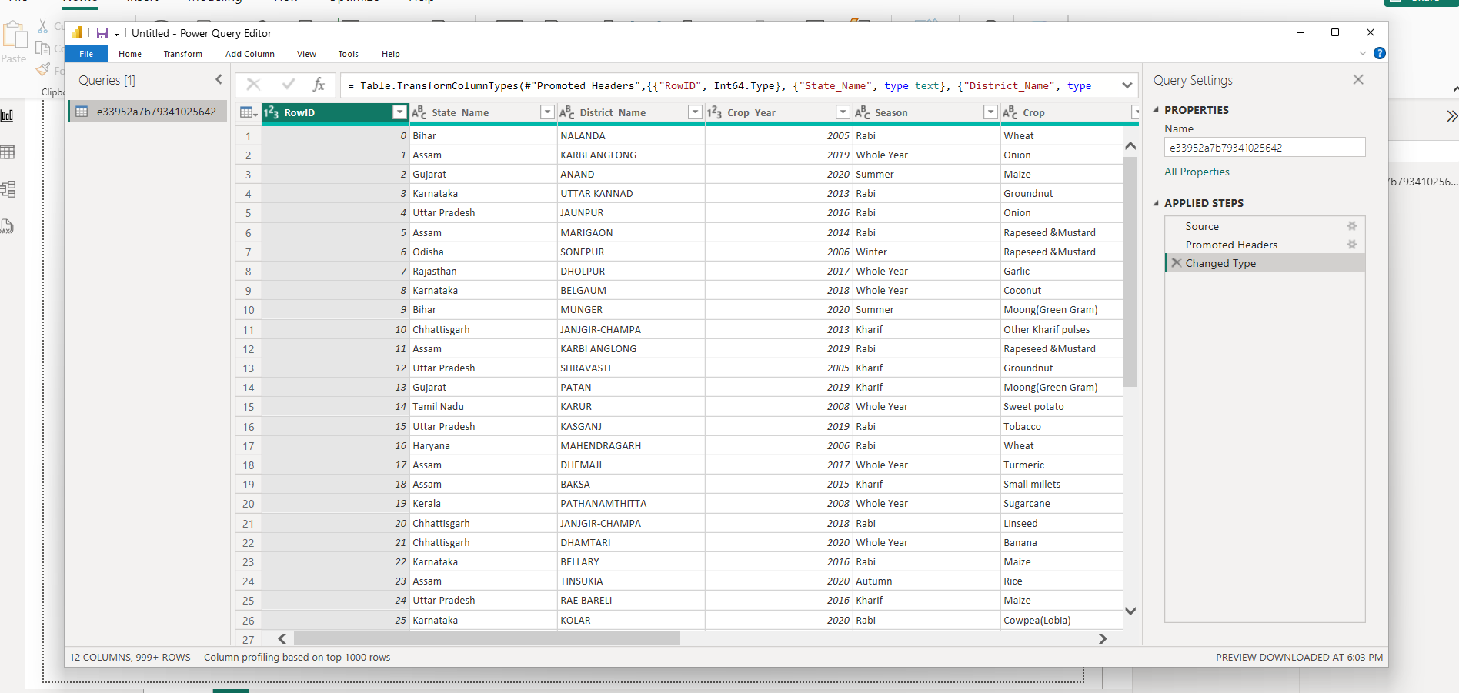

**17.If we want to remove any row then click on home then we will see remove columns option on the top of the screen:**

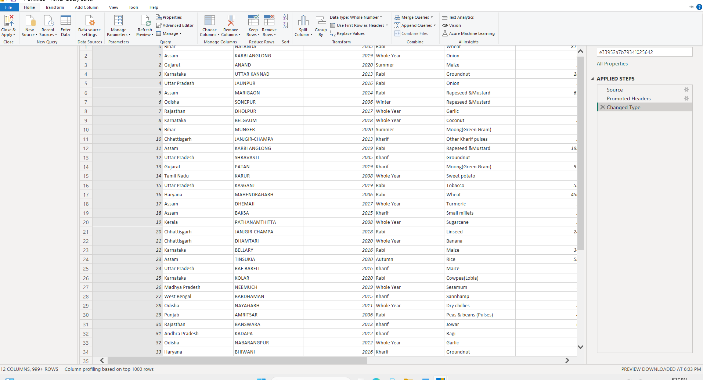

**18.After clicking remove rows option this page will be appeared, here we can remove duplicates, remove blank rows, remove errors:**

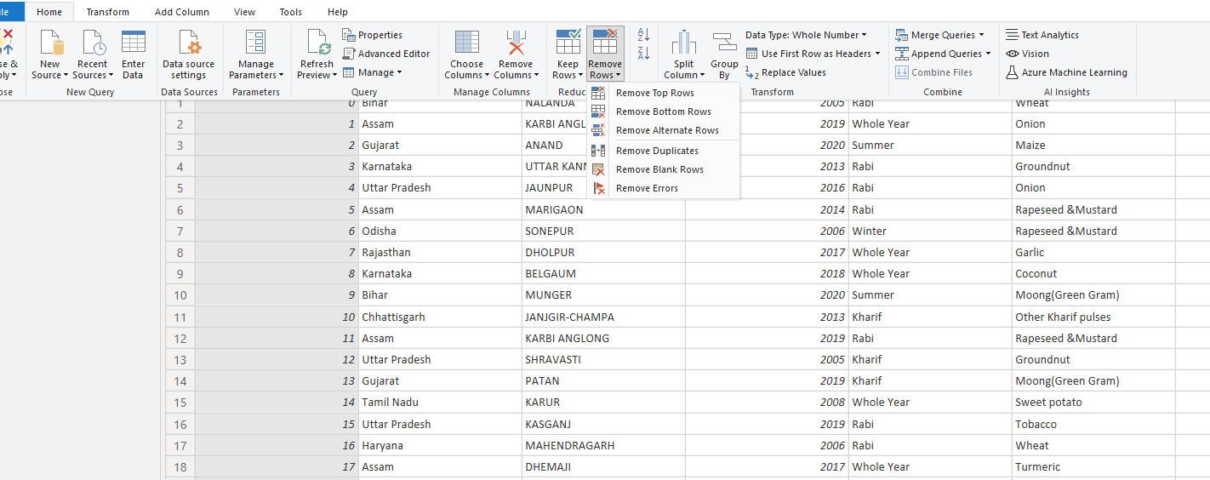

**19.If you want to remove any column then click on remove column option:**

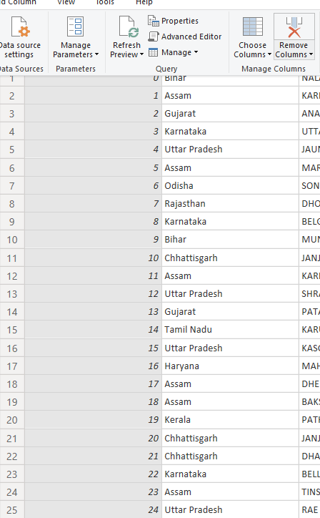

**20.After clicking on remove column we can remove any column , here I want to delete Rowid column .so, I removed that column you can see deleted column from the below figure:**

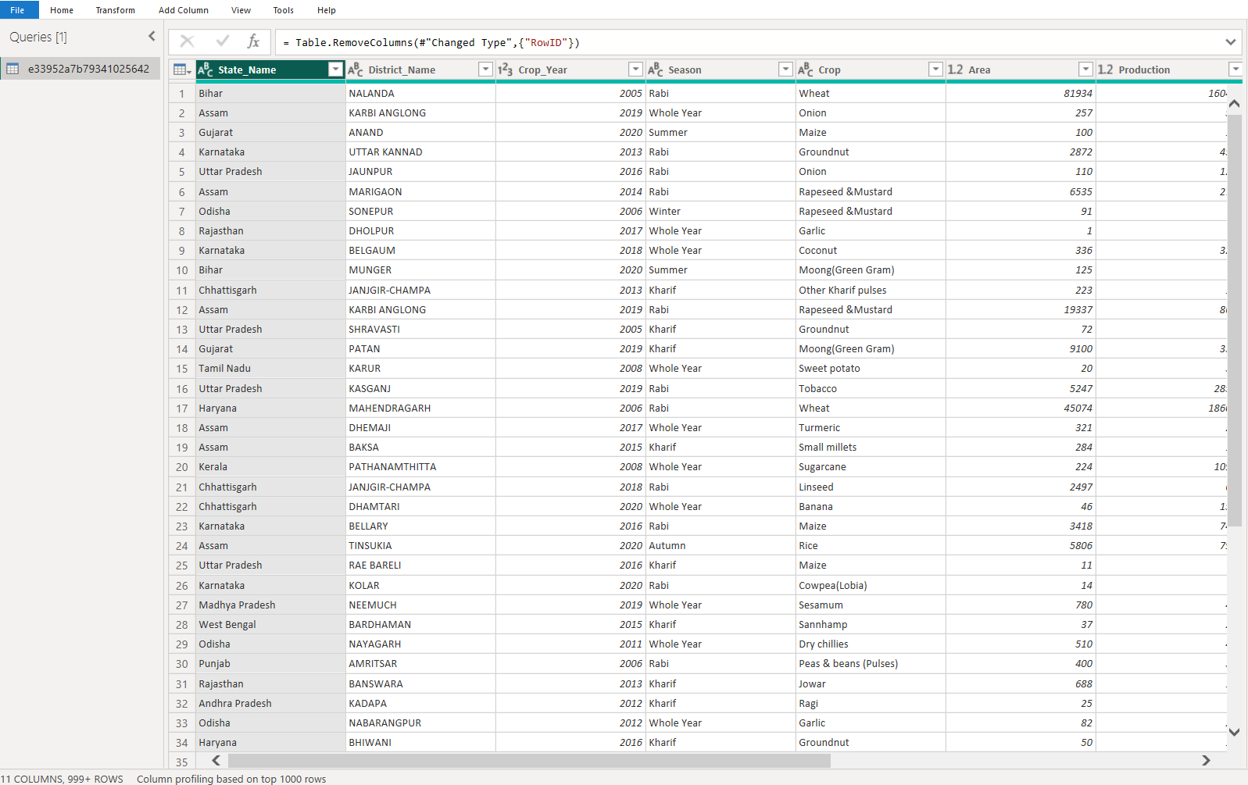

**21.If you want that removed column click into on removed column from applied steps :**

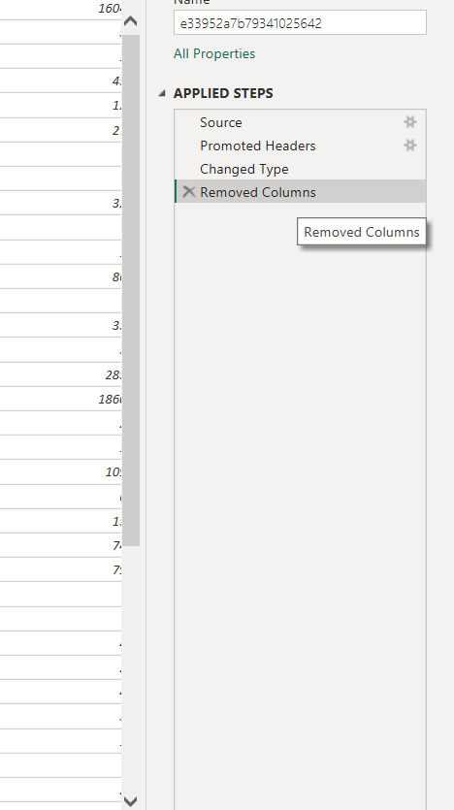

**22.After clicking into again we will get our removed column back:**

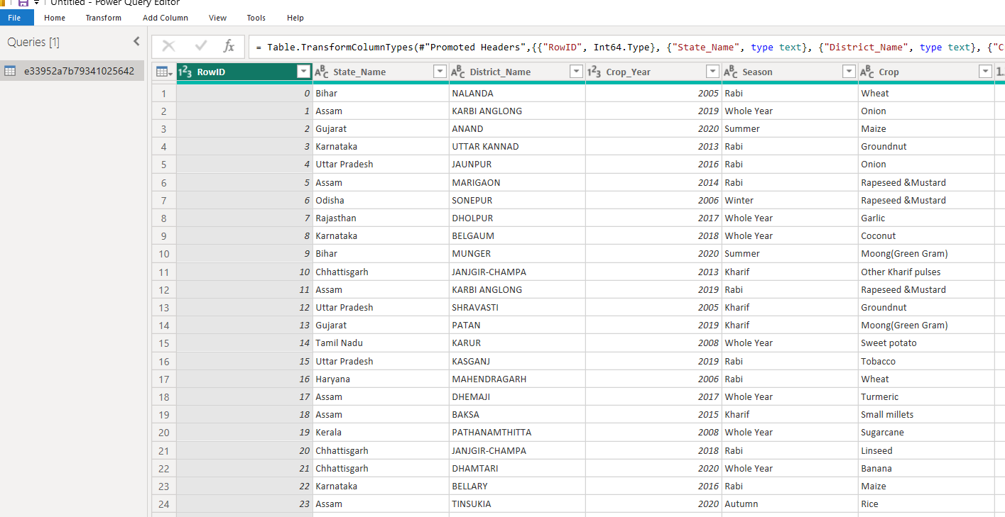

**23.From top menu bar we have to select view option :**

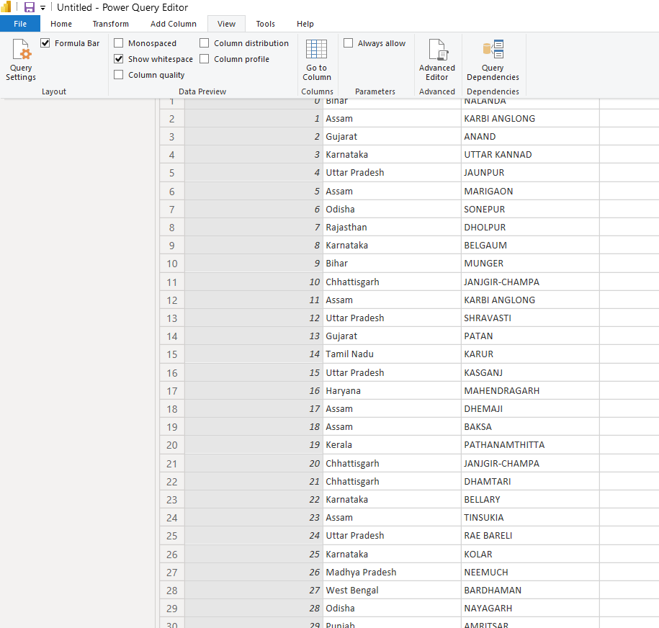

**24.Now, if we click on column quality we have see quality details of that attributes:**

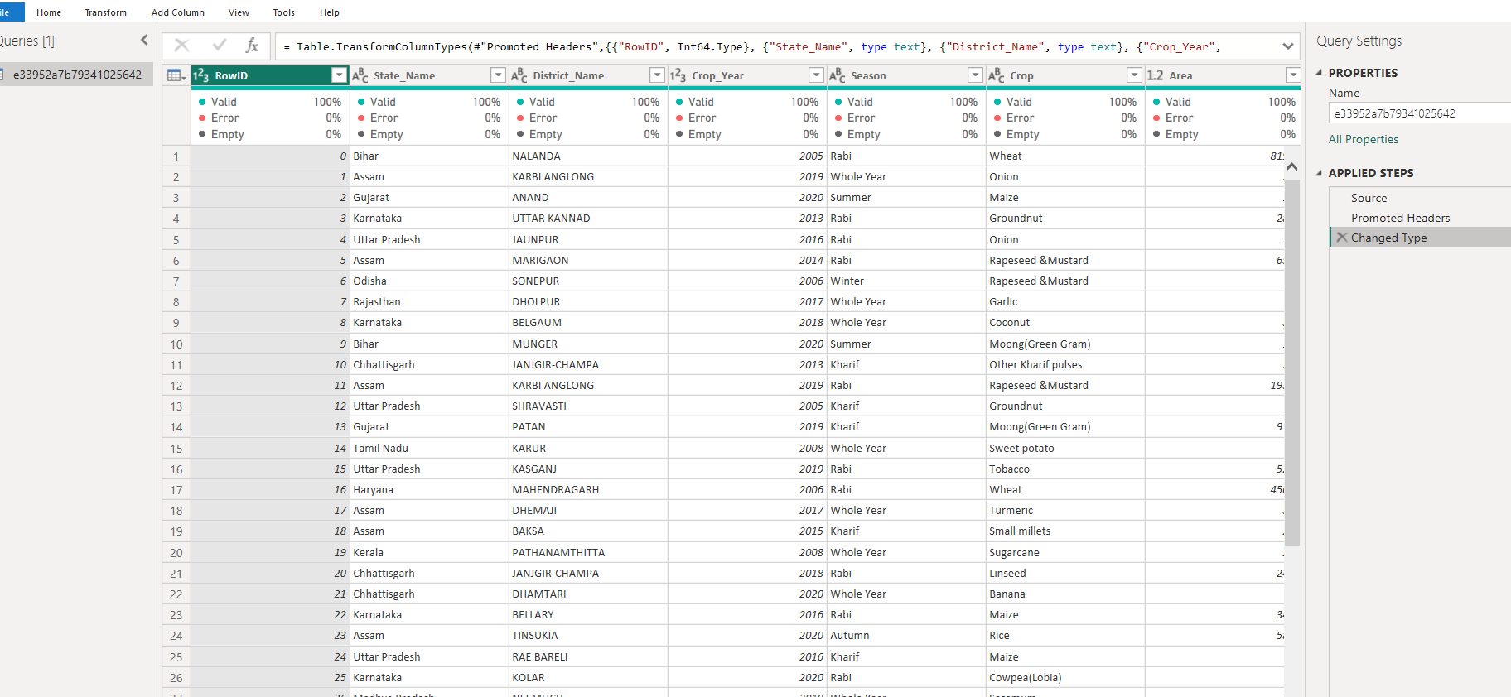

**25.Here we can see detail quality now I have selected one empty column valid. Here we see that empty -1000 because it is an empty column:** 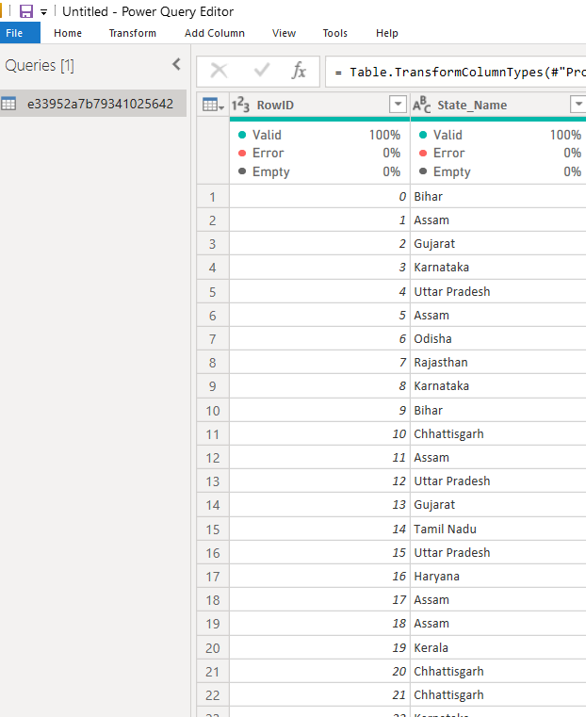

**26.Here 123 means numeric data type:**

**27.Here ABC means alphabetical type:**

