Assessment_module_4

● Write SQL query to solve the problem given below:

In the Customer table attributes are customer ID, customer name, city, grade, and salesman ID

Eg:

Table: Customer

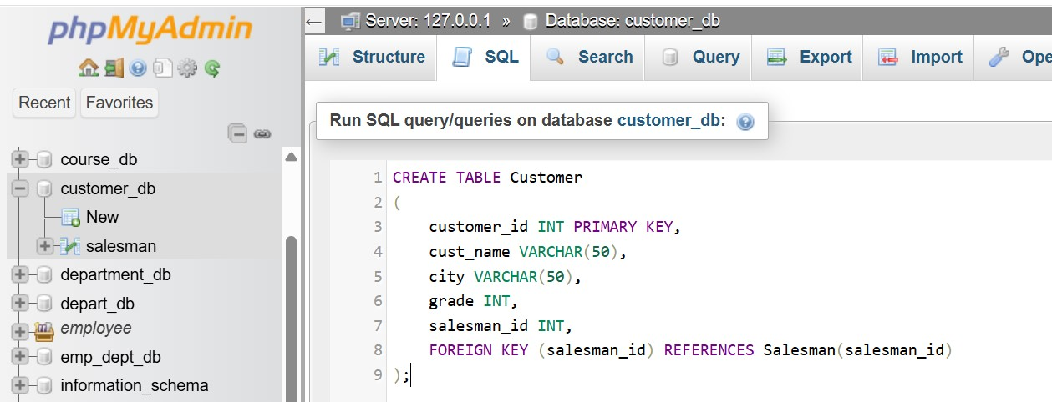

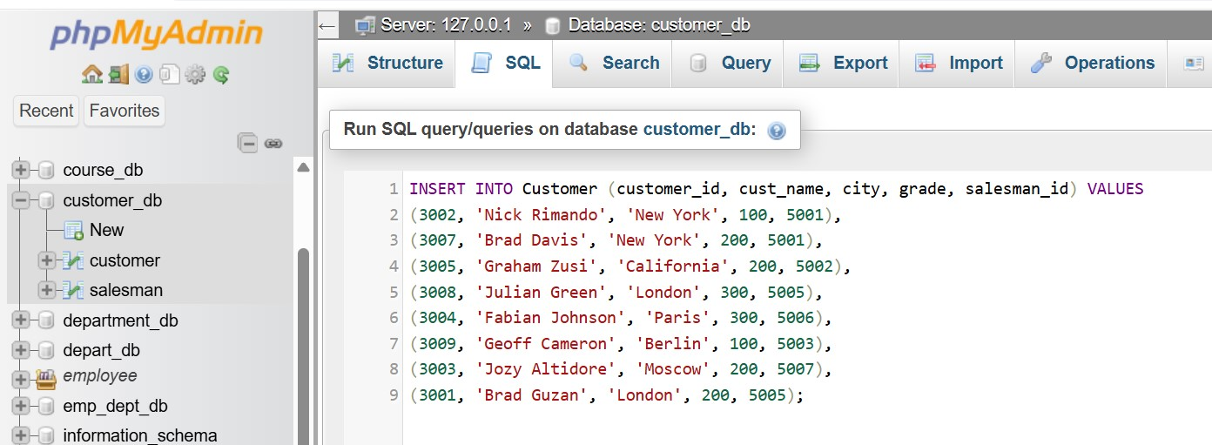

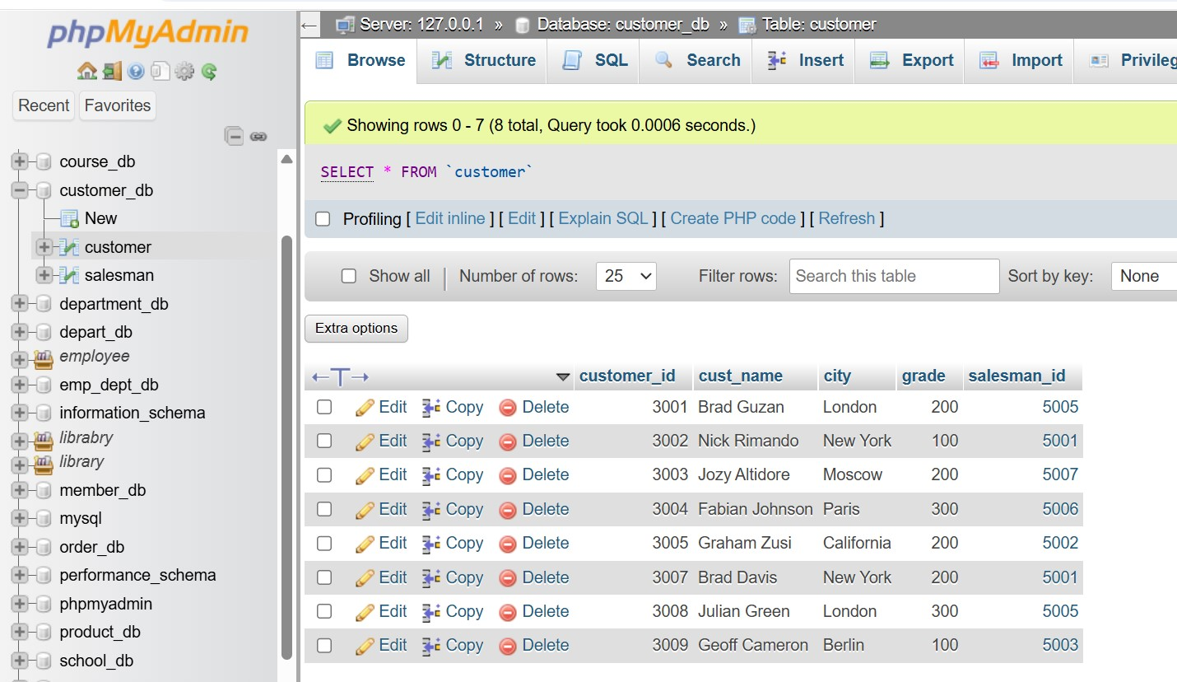

In Salesman table attributes will be salesman id, name, city and commission

Eg:

Table:salesman

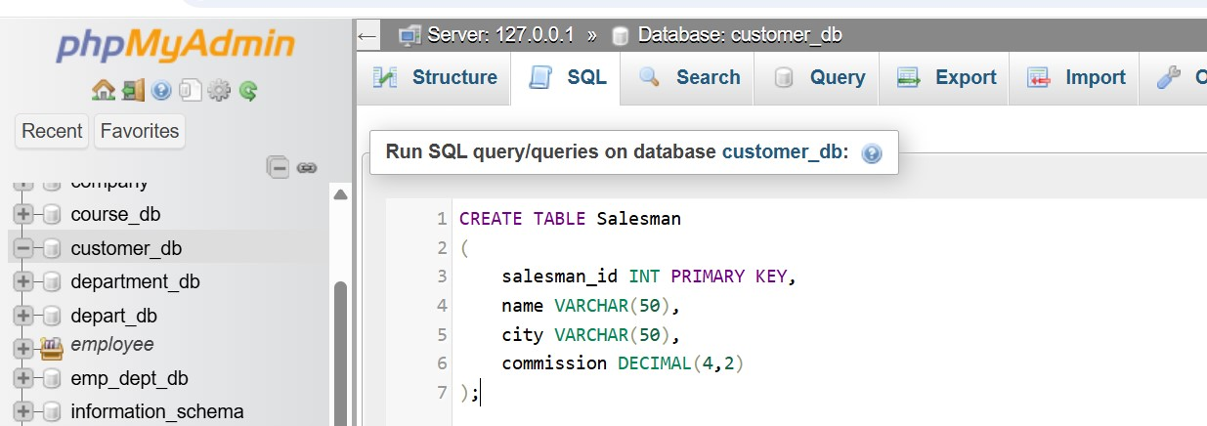

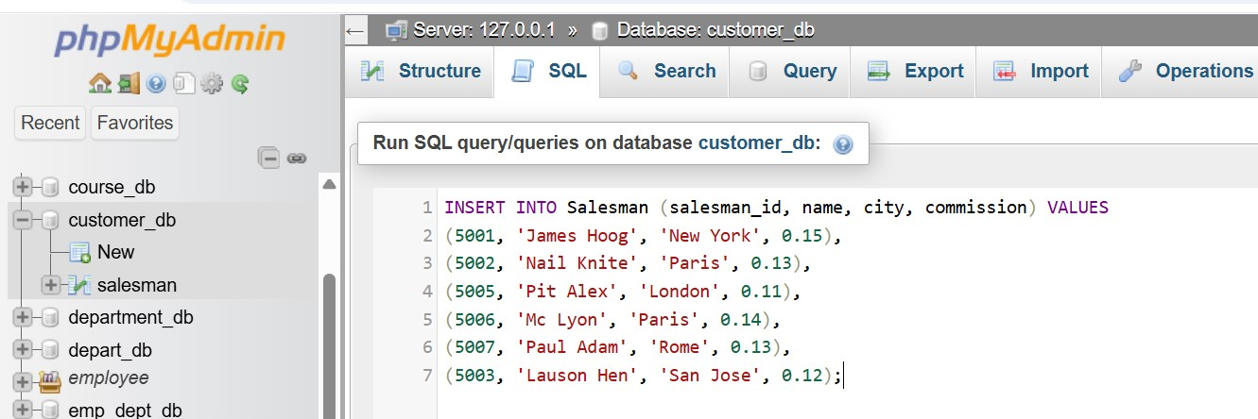

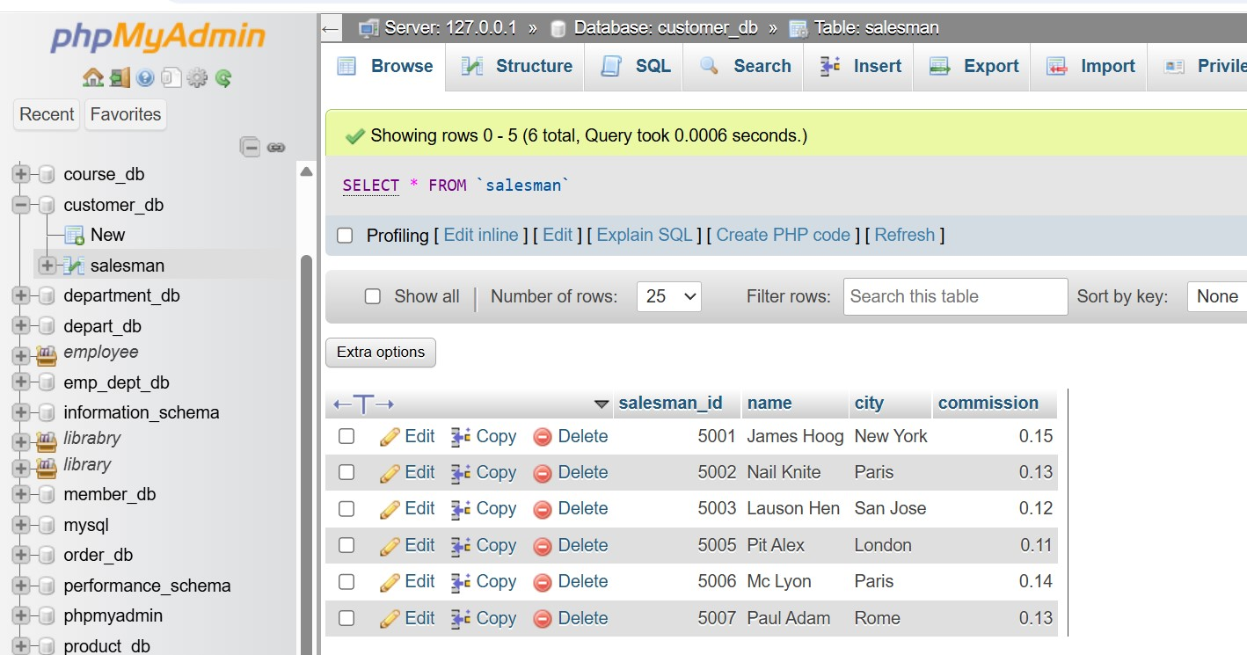

From the above given tables write a SQL query to find the salesperson(s) and the customer(s) represented here. Return the Customer Name, City, Salesman, commission.

