**Quantitative Management Modeling**

**Assignment No. 2**

Question 1.

Solution:

Decision Variables:

Let Xi = Full time consultants

i= 1,2,3 [number of shifts]

8 am 12 pm 4 pm 8 pm 12 am

X1

X2

X3

Let Yj= Part time consultants

j= 1,2,3,4 [number of shifts]

8 am 12 pm 4 pm. 8 pm 12 am

Y1

Y2

Y3

Y4

The full-time consultants work for eight consecutive hours and are paid $14 per hour.

Therefore, total pay per shift is 14*8= 112

The part time consultants work for four hours and are paid $12 per hour.

Therefore, total pay per shift is 12*4=48

**Part a)**

Objective function:

Minimize Z= 112 (X1+X2+X3) + 48 (Y1+Y2+Y3+Y4)

Constraints:

Number of consultants required to be on duty

X1 + Y1 >= 4

X1 + X2 + Y2 >= 8

X2 + X3 + Y3 >= 10

X3 + Y4 >= 6

At least one full-time consultants must be on duty for every part-time consultant on duty

Xi >= Yj

Mathematical Formulation:

s.t.

X1 + Y1 >= 4

X1 + X2 + Y2 >= 8

X2 + X3 + Y3 >= 10

X3 + Y4 >= 6

Xi >= Yj and

Xi, Yj >= 0

**Part b)**

Objective function:

Full time consultants are entitled to a one-hour lunch break after three-hour or four-hour during their eight-hour shift.

Minimize Z= [14*8 (X1+X2+X3) - 14*1(X1+X2+X3)] + 12*4 (Y1+Y2+Y3+Y4)

Minimize Z = [112(X1+X2+X3) - 14(X1+X2+X3)] + 48(Y1+Y2+Y3+Y4)

Constraints:

Number of consultants required to be on duty

X1 + Y1 >= 4

X1 + X2 + Y2 >= 8

X2 + X3 + Y3 >= 10

X3 + Y4 >= 6

At least one full-time consultants must be on duty for every part-time consultant on duty

Xi >= Yj

Mathematical Formulation:

s.t.

s.t.

X1 + Y1 >= 4

X1 + X2 + Y2 >= 8

X2 + X3 + Y3 >= 10

X3 + Y4 >= 6

Xi >= Yj and

Xi, Yj >= 0

Question 2.

Solution:

Objective Function:

Maximize Z = 32X + 24Y ------Equation (1)

Mathematical Formulation:

3X + 2Y <= 5000 ----- Equation (2)

(3/4)X + (2/3)Y <= 1400 ----- Equation (3)

X<=1000 ----- (4)

Y<=1200 & ----- (5)

X, Y >= 0

Graphical Representation:

Steps for plotting the graph:

**From Equation (2)**

3X + 2Y <= 5000

Put X=0

2Y = 5000

Hence, Y = 2500

Co-ordinates = (0,2500)

Put Y=0

3X = 5000

Hence, X = 1666.66

Co-ordinates = (1666.66,0)

**From equation (3)**

(3/4)X + (2/3)Y <= 1400

Put X=0

(2/3)Y = 1400

Hence, Y = 2100

Co-ordinates = (0,2100)

Put Y=0

(3/4)X = 1400

Hence, X = 1866.66

Co-ordinates = (1866.66,0)

**From Equation (1)**

Z = 32X + 24Y

Assume,

Z = 55,500

32X + 24Y = 55,500

Put X=0

24Y=55,500

Hence, Y=2312.5

Co-ordinates = (0,2312.5)

Put Y=0

32X=55,500

Hence, X=1734.37

Co-ordinates = (1734.37,0)

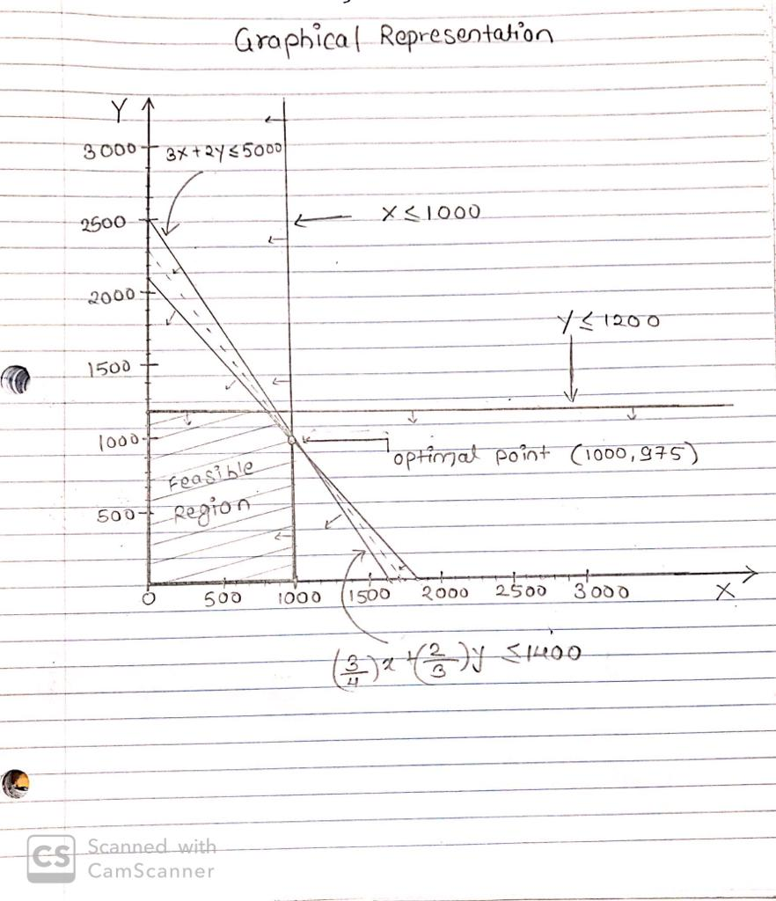

The objective function line touches the line (3/4)X + (2/3)Y <= 1400 and X <= 1000

Therefore,

(3/4)X + (2/3)Y <= 1400

X <= 1000

Hence, Y = 975

Therefore, the objective function line touches the feasible region at point **(1000, 975)**

The optimal solution for maximize the profit is at point (1000, 975) at a total profit of $55,500.

Question 3.

Solution:

1. Decision Variables:

Xij= Number of units of size j products produced at each plant i

i= 1, 2, 3 [Branch Plants of Weigelt Corporation]

j= a, b, c [Large, Medium, & Small size products respectively]

1. Objective Function:

Maximize Z= 420[X1a + X2b + X3c] + 360[X1a + X2b + X3C] + 300[X1a + X2b + X3c]

1. Constraints:

X1a + X1b + X1c <= 750 ---(1)

X2a + X2b + X2c <=900. ---(2)

X3a + X3b + X3c <=450 [for capacity] ---(3)

20X1a + 15X1b + 12X1c <= 13000

20X2a + 15X2b + 12X2c <= 12000

20X3a + 15X3b + 12X2c <= 5000 [for storage]

To avoid layoffs plant has decided to use same percentage of their excess capacity to produce new product. Therefore, the ratio of the plant capacity should be same.

900(X1a + X1b + X1c) - 750(X2a + X2b + X2c) = 0 --- (1) & (2)

450(X1a + X1b + X1c) - 750(X3a + X3b + X3c) = 0 --- (1) & (3)

450(X2a + X2b + X2c) - 900(X3a + X3b + X3c) = 0 --- (2) & (3)

1. Mathematical Formulation:

s.t.

X1a + X1b + X1c <= 750

X2a + X2b + X2c <=900.

X3a + X3b + X3c <=450

20X1a + 15X1b + 12X1c <= 13000

20X2a + 15X2b + 12X2c <= 12000

20X3a + 15X3b + 12X2c <= 5000

900(X1a + X1b + X1c) - 750(X2a + X2b + X2c) = 0

450(X1a + X1b + X1c) - 750(X3a + X3b + X3c) = 0

450(X2a + X2b + X2c) - 900(X3a + X3b + X3c) = 0

And, Xij > = 0