**Assignment No. 4**

Question 1

Solution:

**Decision Variables:**

Let,

A1 = cost of plant A for the Warehouse 1

A2 = cost of plant A for the Warehouse 2

A3 = cost of plant A for the Warehouse 3

B1 = cost of plant B for the Warehouse 1

B2 = cost of plant B for the Warehouse 2

B3 = cost of plant B for the Warehouse 3

A4 & B4 = Dummy Variables

**Objective Function:**

Min Z = (600 + 22) XA1 + (600 + 14) XA2 + (600 + 30) XA3 +(625+16) XB1 + (625 + 20) XB2 + (625 + 24) XB3 + 0 XA4 + 0 XB4

Min Z = 622 XA1 + 614 XA2 + 630 XA3 + 641 XB1 + 645 XB2 + 649 XB3 + 0 XA4 + 0 XB4

**Constraints:**

Monthly Production Capacity:

XA1 + XA2 + XA3 +XA4 = 100

XB1 + XB2 + XB3 +XB4 = 120

Monthly Demand:

XA1 + XB1 = 80

XA2 + XB2 = 60

XA3 + XB3 = 70

XA4 + XB4 = 10 …… (Dummy Variables)

**Mathematical Formulation:**

XA1 + XA2 + XA3 +XA4 = 100

XB1 + XB2 + XB3 +XB4 = 120

XA1 + XB1 = 80

XA2 + XB2 = 60

XA3 + XB3 = 70

XA4 + XB4 = 10 …… (Dummy Variables)

XA1, XA2, XA3, XA4, XB1, XB2, XB3, XB4, XA4, XB4 >= 0

**Network Diagram:**

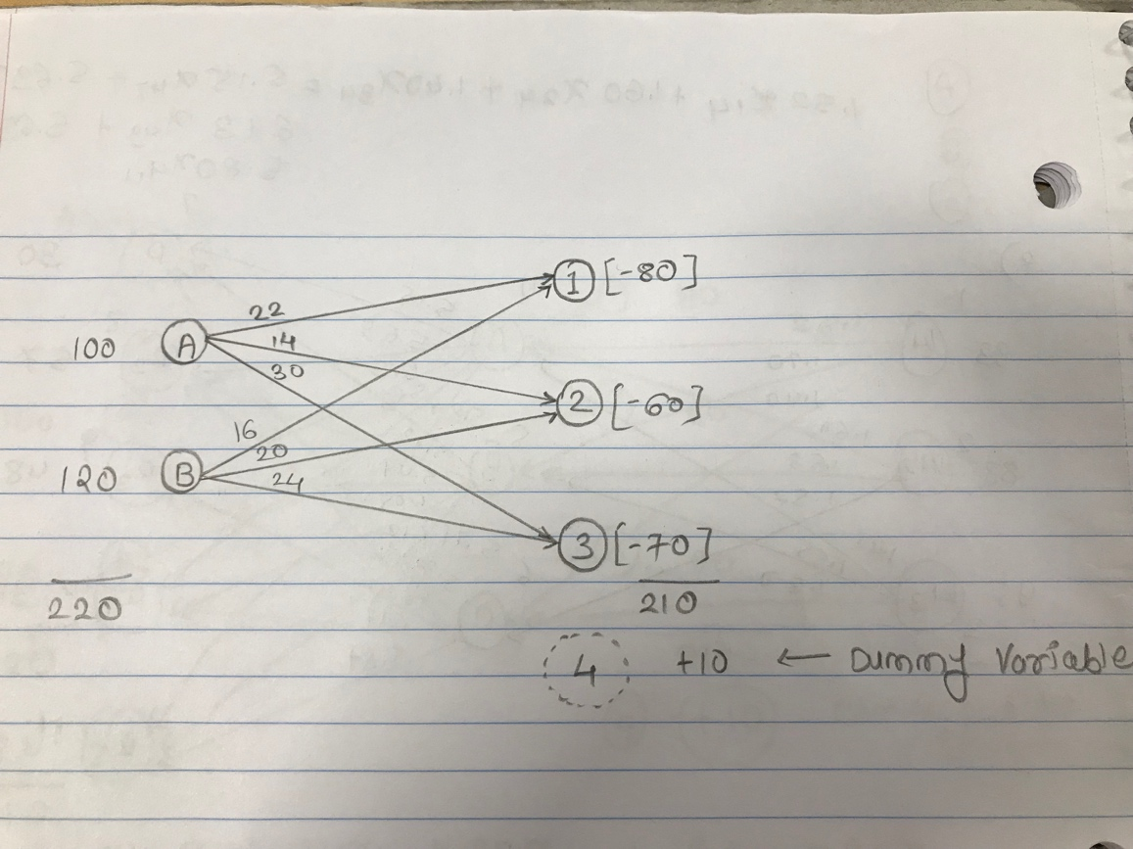

Question 2

Solution:

**Decision Variables:**

Let,

X14 = The daily cost requires form Well 1 to Pump A

X15 = The daily cost requires form Well 1 to Pump B

X16= The daily cost requires form Well 1 to Pump C

X24 = The daily cost requires form Well 2 to Pump A

X25 = The daily cost requires form Well 2 to Pump B

X26= The daily cost requires form Well 2 to Pump C

X34 = The daily cost requires form Well 3 to Pump A

X35 = The daily cost requires form Well 3 to Pump B

X36= The daily cost requires form Well 3 to Pump C

X47= The daily cost requires form Pump A to Refineries 1

X48= The daily cost requires form Pump A to Refineries 2

X49= The daily cost requires form Pump A to Refineries 3

X410= The daily cost requires form Pump A to Refineries 4

X411= The daily cost requires form Pump A to Refineries 5

X57= The daily cost requires form Pump B to Refineries 1

X58= The daily cost requires form Pump B to Refineries 2

X59= The daily cost requires form Pump B to Refineries 3

X510= The daily cost requires form Pump B to Refineries 4

X511= The daily cost requires form Pump B to Refineries 5

X67= The daily cost requires form Pump C to Refineries 1

X68= The daily cost requires form Pump C to Refineries 2

X69= The daily cost requires form Pump C to Refineries 3

X610= The daily cost requires form Pump C to Refineries 4

X611= The daily cost requires form Pump C to Refineries 5

X412, X512, X612 = Dummy Variables

**Objective Function:**

Min Z = 1.52 X14 + 1.60 X15 + 1.40 X16 + 1.70 X24 + 1.63 X25 + 1.55 X26 + 1.45 X34 + 1.57 X35 + 1.30 X36 + 5.15 X47 + 5.12 X57 + 5.32 X67 + 5.69 X48 + 5.47 X58 + 6.16 X68 + 6.13 X49 + 6.05 X59 + 6.25 X69 + 5.63 X410 + 6.12 X510 + 6.17 X610 + 5.80 X411 + 5.71 X511 + 5.87 X611

**Constraints:**

Supply Constraints

X14 + X15 + X16 = 93

X24 + X25 + X26 = 88

X34 + X35 + X36 = 95

Demand Constraints:

X47 + X57 + X67 = 30

X48 + X58 + X68 = 57

X49 + X59 + X69 = 48

X410 + X510 + X610 = 91

X411 + X511 + X611 = 48

X412 + X512 + X612 = 2 …… (Dummy Variables)

Constraints from Pump to Refinery:

X14 + X24 + X34 = X47 + X48 + X49 + X410 + X411

X15 + X25 + X35 = X57 + X58 + X59 + X510 + X511

X16 + X26 + X36 = X67 + X68 + X59 + X610 + X611

**Mathematical Formulation:**

X14 + X24 + X34 = 93

X15 + X25 + X35 = 88

X16 + X26 + X36 = 95

X47 + X57 + X67 = 30

X48 + X58 + X68 = 57

X49 + X59 + X69 = 48

X410 + X510 + X610 = 91

X411 + X511 + X611 = 48

X412 + X512 + X612 = 2 …… (Dummy Variables)

1.52X14 + 1.70X24 + 1.45X34 = 5.15X47 + 5.69X48 + 6.13X49 +5.63X410 + 5.80X411

1.60X15 + 1.63X25 + 1.57X35 = 5.12X57 + 5.47X58 + 6.05X59 +6.12X510 + 5.71X511

1.40X16 + 1.55X26 + 1.30X36 = 5.32X67 + 6.16X68 + 6.25X59 +6.17X610 + 5.87X611

X14, X24, X34, X15, X25, X35, X16, X26, X36, X47, X57, X67, X48, X58, X68, X49, X59, X69, X410, X510, X610, X411, X511, X611, X412, X512, X612 >= 0

Q2 Part 1) Solution:

Using IpSolve the optimal solution is 1966.68.

Well 3 Has used to the capacity in the optimal schedule.

Part 2) Solution:

**Network Diagram:**

