Section 2

Created an AWS instance with following details

Logged into instance via putty

Updated the Ubuntu's package manager using below command
apt-get update

Installed development libraries along with source code compilers. Using below command

apt-get install build-essential libpcre3 libpcre3-dev zlib1g zlib1g-dev libssl-dev libgd-dev libxml2 libxml2-dev uuid-dev

Run the following command to download the source code.

wget http://nginx.org/download/nginx-1.23.1.tar.gz

Extract the tar file using the below command
tar -zxf nginx-1.23.1.tar.gz

Change directory to the extracted folder

cd nginx-1.23.1

Now we have to use the configure flag for configuring NGINX by using this command.

./configure --prefix=/var/www/html --sbin-path=/usr/sbin/nginx --conf-path=/etc/nginx/nginx.conf --http-log-path=/var/log/nginx/access.log --error-log-path=/var/log/nginx/error.log --lock-path=/var/lock/nginx.lock --pid-path=/var/run/nginx.pid

In the above command, we configured our custom path for the NGINX configuration file, access, and Error Log path and others paths

After custom configuration complete we can now compile NGINX source code by using this command :

make

install the compiled source code by using this command.

make install

Start NGINX by using this command
Nginx

Now we have successfully installed NGINX. To verify this, check the NGINX version by using this command.
nginx -V

Now we will check if the Welcome to nginx will load to confirm the installation was successful

We can add a custom init script for restarting the nginx service as below

Now the installation of nginx is complete and we can move on to configure the load balancing using nginx

We need to create a folder conf.d under the location /etc/nginx
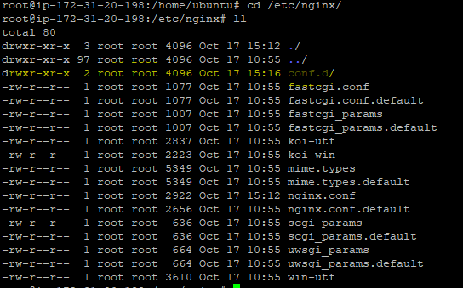

Import the conf.d folder we created in nginx.conf as below
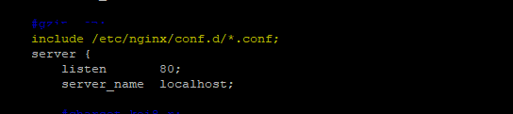

Next step is to create upstream in the conf file (example.conf) under folder conf.d with following content
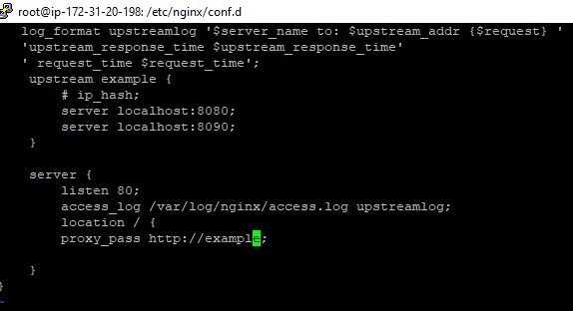

Once this is done check for any syntax error using the below command

Restart nginx service using below commands

Update the hosts file in you base window machine in the below location
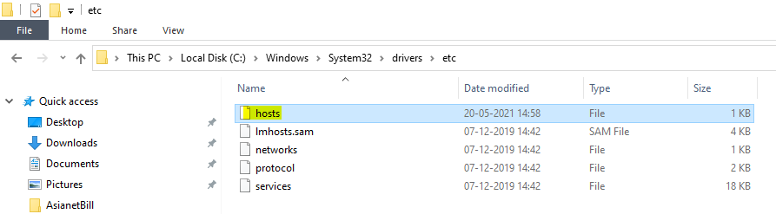

Update the hosts file as below, inoder to resolve the domain name to the specific IP address, once done save the file

Now go to the browser and type example.com and refresh 3-4 time
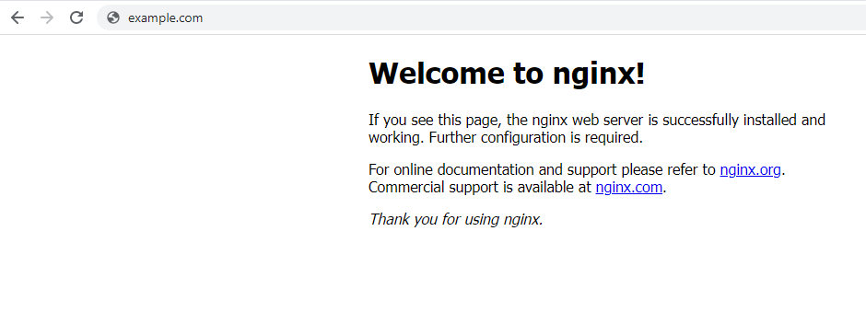

In the access.log of nginx we can see that the request hits ports 8080 and 8090 in a round robin mechanism, because by default the upstream directive uses round robin mechanism for load balancing
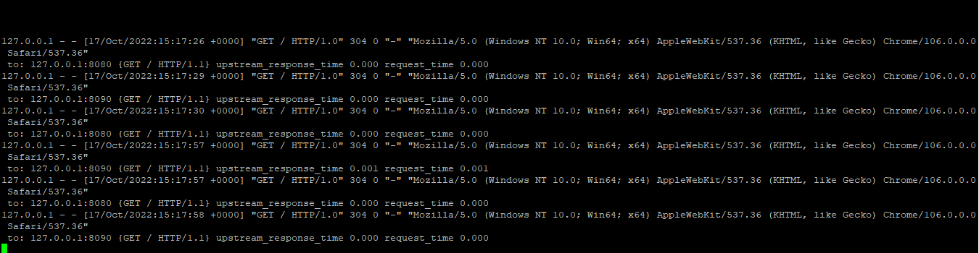

Section 3

