The **logic used in a Donation Management System** involves several core modules working together to ensure smooth handling of donors, donations, campaigns, and reports. Below is a breakdown of the **key logic and workflows** typically used in such software:

---

## 🧠 **Core Logic Used in Donation Management System**

### 1. **User Authentication & Roles**

* **Logic**:

* Verify login credentials (admin, donor, volunteer).

* Role-based access control (only admins can create campaigns, for example).

* **Technologies**: JWT tokens / Session-based login / OAuth

---

### 2. **Donor Management**

* **Logic**:

* Register donor with personal details.

* Retrieve, update, or delete donor information.

* Track donation history per donor.

---

### 3. **Donation Processing**

* **Logic**:

* Accept donation input (amount, donor, payment method, campaign).

* Validate fields (e.g., amount must be numeric and > 0).

* Store donation data with timestamp and transaction ID.

* Trigger confirmation email or receipt generation.

* **Payment Integration**: (if online)

* Integrate with payment gateways (Stripe, PayPal, Razorpay, etc.)

* Logic to handle success/failure callbacks.

---

### 4. **Campaign Management**

* **Logic**:

* Admin can create/update/delete donation campaigns.

* Link donations to specific campaigns.

* Display progress:

`progress = (sum of campaign donations / campaign goal) * 100`

* Option to show/hide completed campaigns.

---

### 5. **Receipt & Acknowledgment**

* **Logic**:

* Auto-generate donation receipt with donor info, amount, date.

* Send via email or downloadable PDF.

* Assign unique receipt numbers.

---

### 6. **Reports and Analytics**

* **Logic**:

* Generate reports based on:

* Date range

* Campaign

* Donor

* Payment method

* Example queries:

* Total donations this month

* Top 5 donors

* Campaign with highest funds raised

* **Graphs and Charts**: Visualize trends using charting libraries.

---

### 7. **Data Validation & Security**

* **Logic**:

* Sanitize user inputs (prevent XSS, SQL injection).

* Encrypt sensitive donor data.

* Secure endpoints with authentication middleware.

---

### 8. **Notification System (Optional)**

* **Logic**:

* Trigger email/SMS when:

* A donation is received.

* A campaign goal is reached.

* A donor receives a receipt or thank-you message.

---

## ⚙️ Example Pseudo-Logic for Donation Flow

```pseudo

IF user submits donation form:

VALIDATE form data

IF valid:

PROCESS payment (if online)

IF payment successful:

STORE donation in database

UPDATE campaign total

SEND receipt to donor

ELSE:

SHOW payment failed message

ELSE:

SHOW validation error

```

---

Here’s a breakdown of the **logic** for a **Donation Management System** structured into **pseudocode, flowcharts**, and **UML**. Let’s dive into each one!

**1. Pseudocode for Donation Processing**

This pseudocode represents the logic of accepting donations, validating them, processing the payment, and storing data.

FUNCTION processDonation(donor, amount, campaignID):

// Validate Donation Amount

IF amount <= 0:

RETURN "Invalid amount"

// Validate Donor Information

IF donor is invalid:

RETURN "Invalid donor details"

// Process Payment (e.g., via Stripe/PayPal)

paymentStatus = processPayment(donor, amount)

// Check if Payment was Successful

IF paymentStatus == "Success":

// Store Donation

donationID = saveDonationToDatabase(donor, amount, campaignID)

// Update Campaign Goal Progress

updateCampaignProgress(campaignID, amount)

// Send Donation Receipt to Donor

sendReceipt(donor, donationID, amount)

RETURN "Donation successful. Receipt sent."

ELSE:

RETURN "Payment failed. Please try again."

END FUNCTION

**2. Flowchart for Donation Workflow**

Here’s a **flowchart** for the donation process:

↓

[Receive Donation Details]

↓

[Validate Donation Amount]

↓

Is Amount >

0?

/ \

No Yes

↓ ↓

[Return Invalid Amount] [Process

Payment]

↓

Is Payment Successful?

/ \

No Yes

↓ ↓

[Return Failure] [Save Donation to DB]

↓

[Update Campaign Progress]

↓

[Send Receipt to Donor]

↓

[Return Success]

[Return Success]

**3. UML Class Diagram**

This UML diagram shows the relationships between classes in a Donation Management System:

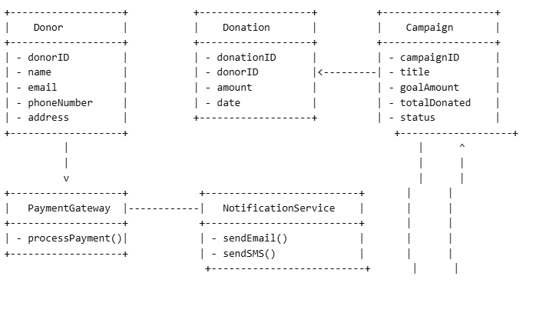**Class Descriptions:**

* **Donor**: Stores donor information like name, email, etc.
* **Donation**: Tracks individual donation details like amount, date, and linked donorID.
* **Campaign**: Represents a donation campaign with a goal amount, total donations, and current status.
* **PaymentGateway**: Interfaces with external payment providers to process donations.
* **NotificationService**: Sends email/SMS notifications to the donor.

**4. Entity-Relationship Diagram (ERD)**

This ERD shows how entities are related in the system:

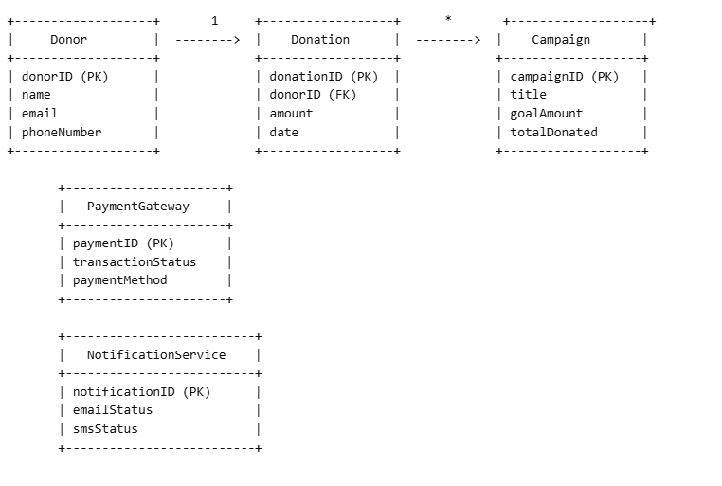

**Key:**

* **Donor**: Contains the personal information of the donor.
* **Donation**: Contains details about each donation, including which donor made it and the amount.
* **Campaign**: Stores campaign information, linking donations to a specific goal.
* **PaymentGateway**: Interfaces with external payment providers.
* **NotificationService**: Sends out confirmation or receipts via email/SMS.

**5. UML Use Case Diagram**

This use case diagram shows the interaction between users (admin, donor) and the system:

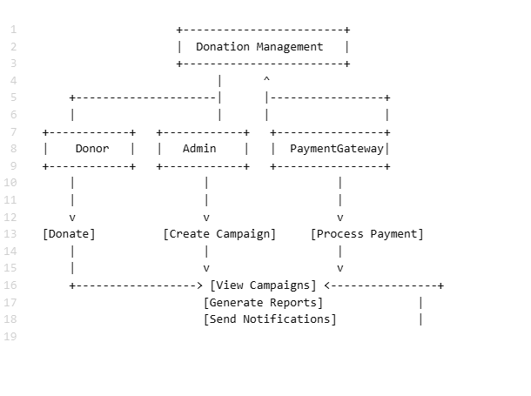

**Use Cases:**

* **Donor**: Can donate, view campaigns, and receive receipts.
* **Admin**: Can create campaigns, view donation reports, and send notifications.
* **Payment Gateway**: Handles payment processing.

**Conclusion**

These diagrams and pseudocode demonstrate the core structure and logic of a **Donation Management System**, helping you visualize the flow from donation processing to payment and receipt handling.

Let me know if you'd like to refine these diagrams or if you're building a system on a specific technology stack, so I can tailor the approach further!