**Course No:** CSE-244 **Course Title:** Algorithm Analysis and Design (Sessional)

***Final Project Proposal on***

***Nearest Restaurant Table Booking Application Using Dijkstra’s Algorithm***

**Team Leader**

Sharmin Ara (1604044)

**Team member**

Tabassum Akter Nusrat(1604063)

**Course Teacher**

Md. Sabir Hossain

Lecturer

Department of Computer Science and Engineering

Chittagong University of Engineering and Technology (CUET).

**Date of Submission:** 19-01-2019**Level: 2 Term:** II **Section:** A **Group:** A2

**01.ABSTRACT:**

In this project we’ve implemented an idea to remove the inconvenience faced by the people of a city or a visitor that is a new comer in the city for finding a good restaurants near their residence or their current location. Generally on different occasion people loves to celebrate in nearby restaurants. But sometimes people get it clumsy in the popular restaurants because they don’t know the availability of table in that restaurants, so they have to return from that restaurant or they have to wait for long time for vacancy of table. This worked as a motivation for us. We designed a system for the user to remove their inconvenience and this system helps them to find out the availability of the nearest restaurants and request a table booking.

**02 .INTRODUCTION:**

This is a web-based application for a user with different features which will help the customer in many ways. By this, the customer or user will be able to know the location of their desired nearest area and it will allow them to reserve a table of nearest location. This will also help the user to change their decision while they decide to cancel the booking of any table and apply for booking a new table of another restaurant. They can remove their reservation on the go.

The user can also give feedback about the restaurant they’ve gone by star marks. And those restaurants with the highest number of star marks will be considered as the most favorite restaurants in the city. The user will be able to see the popular menu of the restaurants, offers and discounts and reviews about the restaurants.

As like the user the restaurants will also make their profile using their Gmail address which will be informative enough for the user containing various information like location, menu, deals discounts availability of the table right that moment, number of booked tables, featured photos of the restaurants etc.

General way to solve this problem is using the co-ordinate system. The system provides a technique of accessing the user’s location by their longitude and latitude. By using the co-ordinate system it will be useful to find out the shortest distance of different location from the restaurants. And after sorting those distance the user will get the nearest, second nearest, third nearest restaurant . So the user will find the suitable one for them according to the current location.

In this situation we’ve implemented the dijktra’s algorithm to find out the shortest distance from the user location. This is the algorithm to find out the distance from single source. In this way firstly we’ve to find out the distance of adjacent nodes distance and then finding out the way by other edges , if the way by other edges distance is shorter we’ll relax the distance of the previous edge nodes. The relaxation process is : ( d[u]+w(u,v)<d[v])=d[u]+w(u,v)

**0.2.1 Objectives of our project**:

01.To provide a facility for a user to book a table in a restaurant.

02.To provide list of restaurants in a sorted way and their menu and deals between customer and admin.

03.To provide a dashboard for restaurants to upload activities i.e. pictures.

04.To allow the user to rate and review the restaurants.

**03.RELATED WORK:**

We read some research papers which are related to our restaurant table booking project. Now the research paper which is summarized is given below:

Paper[1]The used R-cube system of a data structure which is related to the overall system meta-structure using a select variable, group variable, info variable. They generate a hybrid dialogue system for a restaurant which will be convenient for both the customers and restaurant authority. This generated dialogue will not always fit with the customers if their demand changes.

Paper[2]They tried to show the data flow process by using a product lifecycle management system. They tried to sum up the total management of information and data with the ER diagram. The solving process wasn’t described here efficiently.

Paper[3] They utilized near control correspondence sensors, nearness sensors, a microcontroller, and distributed computing. A device structure designed by them that shows the interconnection among quite a number of gadget components. The machine graph used to show the relation of quite a number of elements of the systems. This is not so useful for an it-based society.

Paper[4]They used a different module to solve the problem such as a server module, AP module Handle, Handle Module. Their key contributions were designing hardware and software structure for the wireless system of restaurant reservation. They didn’t mention any solution for systematical error occurs.

Paper[5]To beautify and satisfy the trip of a client they have predicted time the usage of talent algorithm for managing table for a client. Their key contribution used to be to reduce the inconvenience of the customer and increasing managing efficiency. They didn’t give any solution if any emergency solution occurs due to network interruption.

Paper[6] This examination work purposes to plan and actualize a faraway dinners requesting framework. Dijkstra's calculation utilizes the covetous methodology to clear up the most brief issue. The key contributions of this paper are food ordering system, table reservation system, and rating system.

Paper[7]There are three modules in this system and they are as follows: android application for the patron,web-based application for restaurant manager and application for admin to control all the activities. The key contributions of this project are digitized menu, table selection, and mathematical model.

Paper[8] The mission comprises of in an Android utility that can be utilized by employes in an eatery to adapt to the clients, their requests and can help them effortlessly find free tables or place orders. Easy to use interface, Fast access, less mistake are the key commitments. The paper features a few impediments of the PDA-based nourishment requesting framework.

Paper[9]A technique to market restaurant reservation is putting in interface software program well matched with the central distribution processor at a plurality of far-off restaurants. The consumer interface includes a seating chart display. And also consumer pays a reservation fee to an operator of the system. The limitations of this project are it's only for marketing reservations during nonpeak periods by offering promotions.

Paper[10]The user will log in their account either as a customer or restaurant authority. They will view all the restaurants of the city, popular restaurants, and the restaurants that are nearby their area.

Utilizing another calculation like minimum spanning tree algorithm can likewise explain the task diffrently.

**04.0.1 PRELIMINARIES:**

**Dijkstra's Algorithm:**

Dijkstra's calculation is a calculation finding the most minimal ways from a source to some different sources. Here in this calculation, the most brief separation is tallied between two hubs beginning and the consummation hub. On the off chance that there are various hubs, the separation between them is determined by Dijkstra's calculation and after that arranged the separation as per their most limited way.

**4.0.2 Pseudocode:**

1.[n]<-0

2.For every vertex y in chart

3.distance[y]<-infinity

4.EndFor loop

5.n<-empty set

6.P<-Vertex

7.While P!=empty set

8.x<-minimumDistance(P,distance)

9.Source<-Source U {x}

10.For every vertex y an element of neighbours[x]

11.If(distance[x]+D(x,y)<distance[y])

12.distance[y]<-distance[x]+D(x,y)

13.EndIf statement

14.EndFor loop

15.EndWhile loop

16.Return distance

**0.5 Contribution/Outcomes:**

01.Using this application the user will be able to save their time and it will lessen their physical effort as they will be able to preorder for booking a table.

02.It will suggest them the nearest restaurant and by checking status they will be able to know the availability of a table in the chosen restaurant.

03. This syatem will help both the admin and user to manage an online restaurant table booking system .

**6.PROPOSED METHODOLOGY/OVERVIEW OF PROPOSED ALGORITHM:**

**6.1 CONTEXT DIAGRAM**

A context diagram is only a figure which demonstrates how the relationship of the program functions with external elements.

Here the relationship between the entities is given. The input information is taken into the main system and then received it into the processing system and again returns to the main system. After analyzing the process finally the output is displayed.

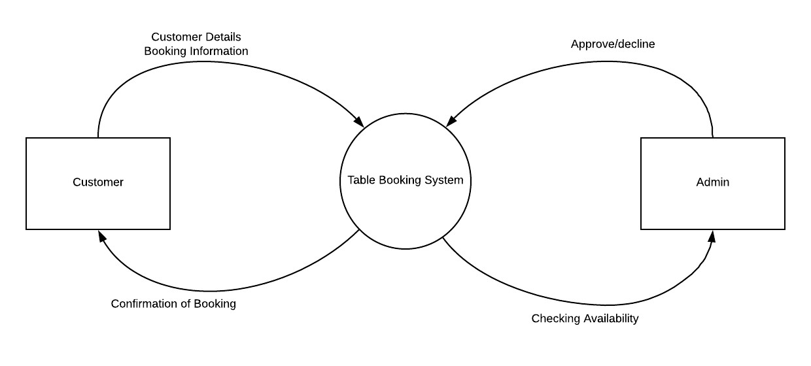

**Fig1: Context Diagram**

**6.2PROPOSED SYSTEM ARCHITECTURE**

To present the flow function of a program or a system through a diagram is called flowchart.

In this flowchart we’ve shown the total procedure of the project and implemented the functions related to the program by various sketch. This diagram will receive information, take decision about the availability of the user’s choice and enter the next step based on the decision on information processing.

After completion of some work it will update database and after executing all step the program will terminate which is shown by the termination sign.

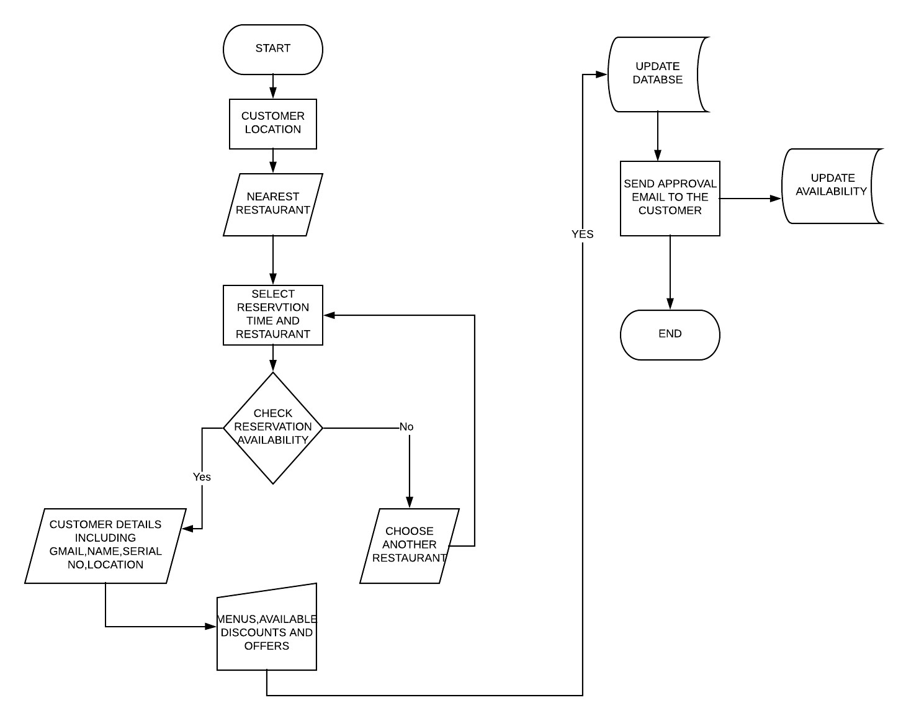

# Fig2:Proposed Methodology

**7. Implementation Details**:

**7.1 Working procedure:**

For finding out the nearest restaurant for a certain area firstly we’ve included the restaurant database and connected it . The database includes the restaurant’s name, it’s location according to co-ordinate system. In our application we’ve provided the system for user log-in and admin-login. Where an user will login with their details. The user also have to login with the information of their co-ordinate. By calculating the distance from those co-ordinate the user will get the distance or edge. After that it will use Dijktra’s algorithm to find out the nearest restaurant from the user location. Then using sorting Algorithm we’ll show the first nearest, second nearest, third nearest restaurant from the user location , so that he can choose one close to his location.

**7.2  Step by step output:**

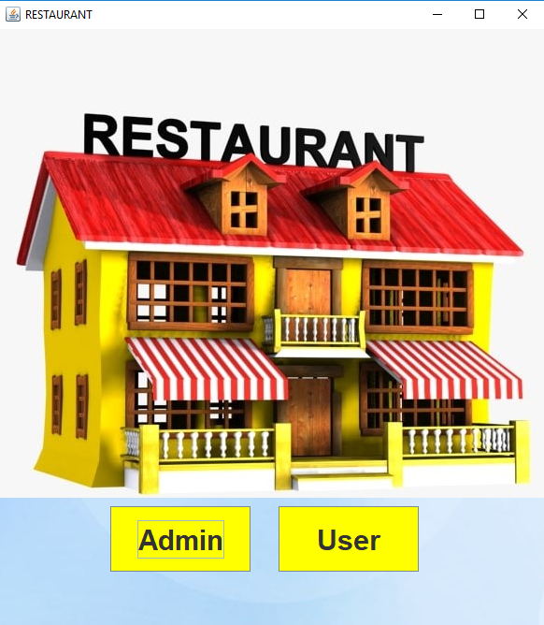

This is the first page of the application where the people will decide weather he’ll login as an admin or an user.The page was designed by JFrame, Jpanel and other functions of swing.

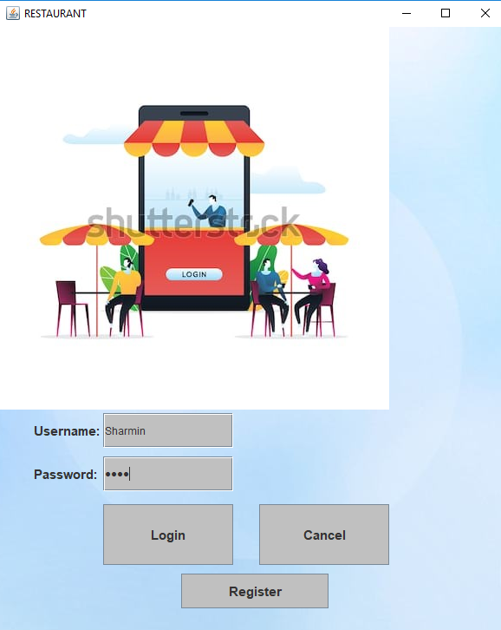

In this section the user will login providing their password and username so that the admin panel can provide them an user id.

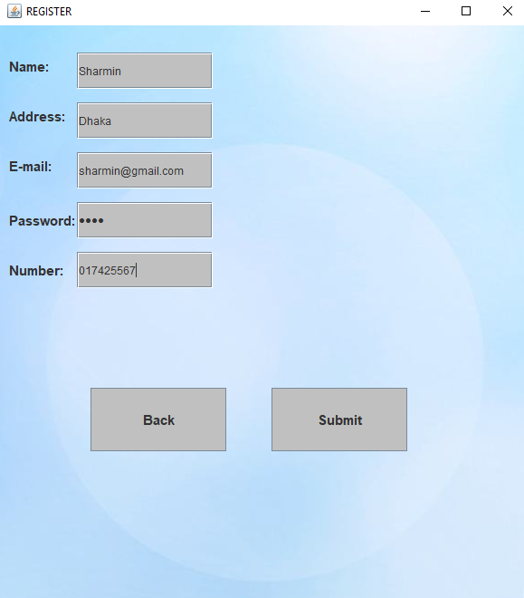

This page provides the details of an user including his gmail address, location and phone number so that he can easily get information about the availability details.

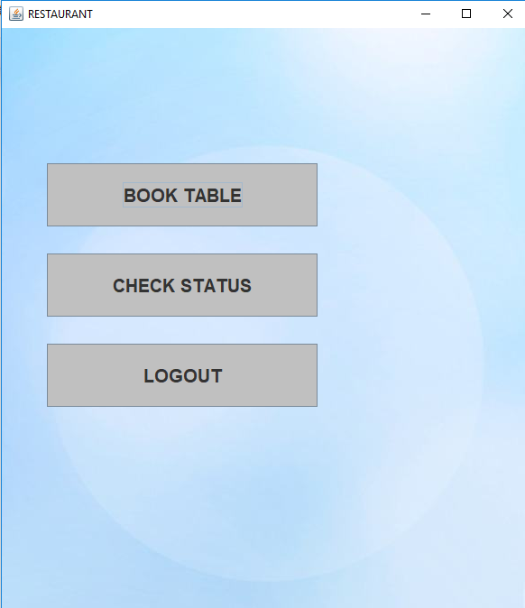

This page provides different option for the user, weather he wants to book a table, check status and log-out if they want.

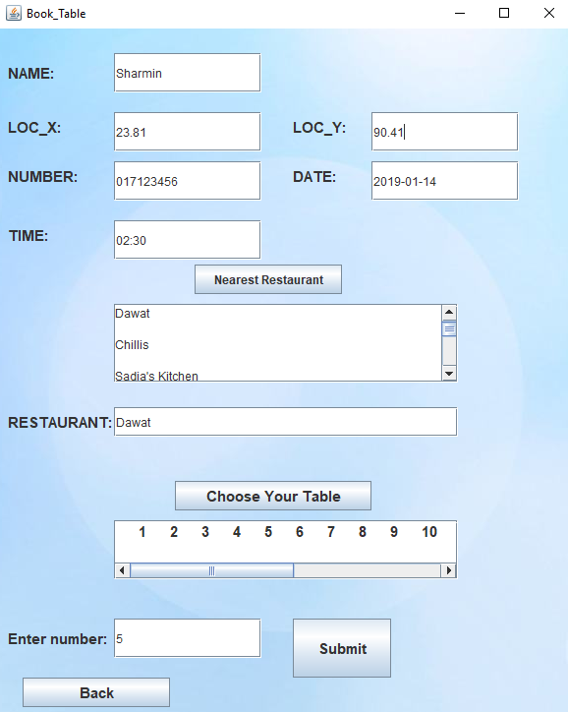

This page originated from the previous page . In this section if an user wants to book a table he have to input his co-ordinate according to his location. This co-ordinate will be used to count the distance from different restaurant and suggest nearest to the user.

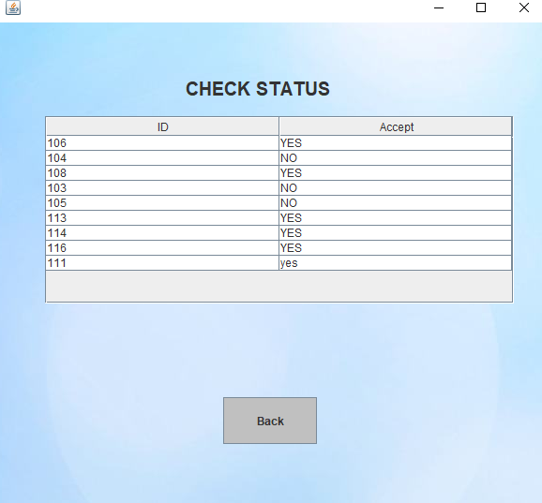

In this section the user will check weather his application was accepted or not from the admin panel for reservation of a table.

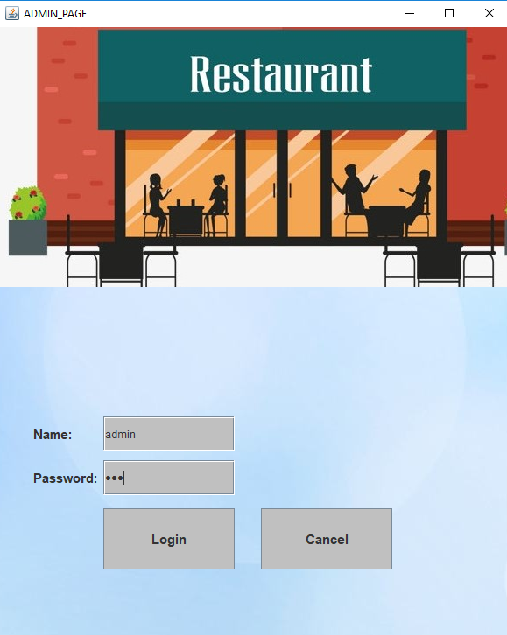

This is the section where the admin will login providing their password.

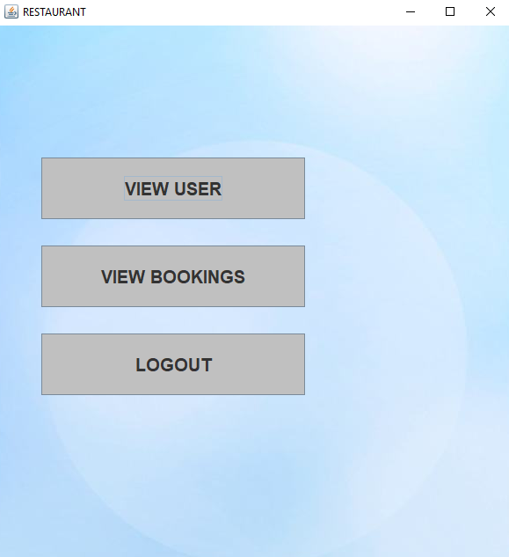

In this section the admin will check the request from the user for booking a table, he’ll see the previous booking.

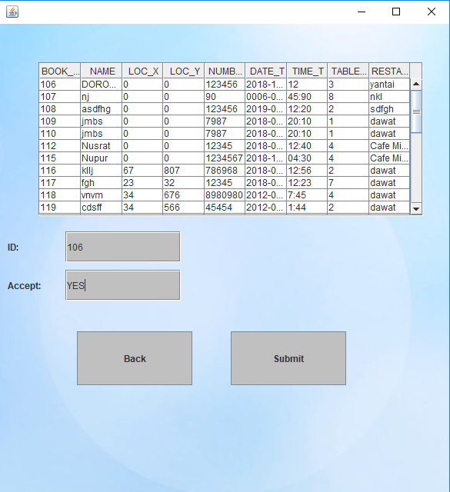

In this section the admin will accept the user’s request or will remove the request based on the vacancy of table on that fixed time.

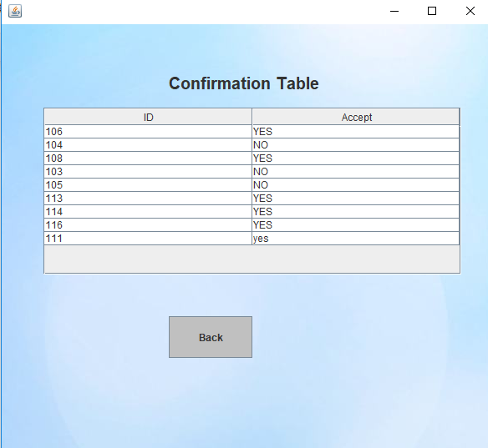

In this section the user will see weather their request was accepted for booking a table or the admin panel didn’t confirmed their request.

**8.Experimental Result and analysis:**

**8.0.1EXPERIMENTAL RESULT:**

Here we are showing participant’s details on Survey Questions using Likert chart:

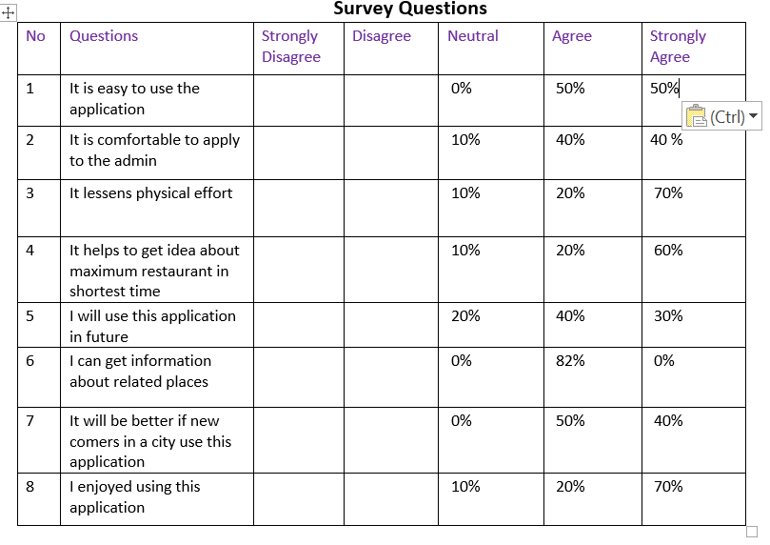

**8.02 USER SURVEY AND ANALYSIS:**

This survey analysis is based on the question we’ve created for the user to have an overall idea about how friendly was our syatem for reservation of an online restaurant table booking application. After ploting the graph based on the opinion percentage of their agree, disagree,neutral , strongly disagree,strongly agree we’ve found that about 40% people were strongly agreed with the question and 40.25% were agree and about 7.50% people were neutral.

**9.CONCLUSION:** The outcome of this experiment was quite satisfactory according to the user details or survey details. By this system a new comer can get overall idea about the nearest restaurant of a certain area and they can save their time and physical effort by checking avaiability of table of different restaurant. After getting an overall survey resullt we can assure that we’ve implemented an user friendly system.

**10 .** **FUTURE RECOMMENDATION:**

We’ve implemented this syatem for a small area as an experiment. In future we’ll try to provide it for larger area and then the syatem will be more useful as we’ll implement this system susch a way so that it will input only location from the user instead of the co-ordinate of their location.

**Reference**

1. S. Kim and R. E.Banchs, “Restaurant Recommendation and Reservation.”
2. K. J. Chen, Y. J. Lo, A. J. C. Trappey, and C. V. Trappey, “Re-engineer restaurant set-meal design process: A combination of modular product design and system engineering evaluation approach,” in *2010 International Conference on System Science and Engineering, ICSSE 2010*, 2010, pp. 587– 592.
3. H. Saeed, A. Shouman, M. Elfar, M. Shabka, S. Majumdar, and C. HorngLung, “Near-field communication sensors and cloud-based smart restaurant management system,” in *2016 IEEE 3rd World Forum on Internet of Things, WF-IoT 2016*, 2017.
4. Z. Yu and W. Zhu, “The research and realization of wireless ordering system based on embedded technology,” in *ICCASM 2010 - 2010 International Conference on Computer Application and System Modeling, Proceedings*, 2010.
5. F. Rarh, D. Pojee, S. Zulphekari, and V. Shah, “Restaurant table reservation using time-series prediction,” in *Proceedings of the 2nd International Conference on Communication and Electronics Systems, ICES 2017*, 2018.
6. V. B. Dhore, S. Thakar, P. Kulkarni, and R. Thorat, “Digital Table Booking and Food Ordering System Using Android Application,” *Int. J. Emerg. Eng. Res. Technol.*, vol. 2, no. 7, pp. 76–81, 2014.
7. P. Bhingre, T. Boddu, A. Chandak, D. Devkar, and S. Prasad Patil, “Digital Dining System using Android,” *Int. J. Eng. Res. Gen. Sci.*, vol. 3, no. 2.
8. James W.rose, “Restaurant reservation system.”
9. C. Mitchell j.Francis, Beverly Hilla, “Discounted restaurant Reservation Distribution system.”
10. P. M. Virendrakumar Rai, Sagar Shinde, Bhushan Mhatre, “Restaurant Management system.”