ASSIGNMENT: 5

Capture 1:

Capture: 2

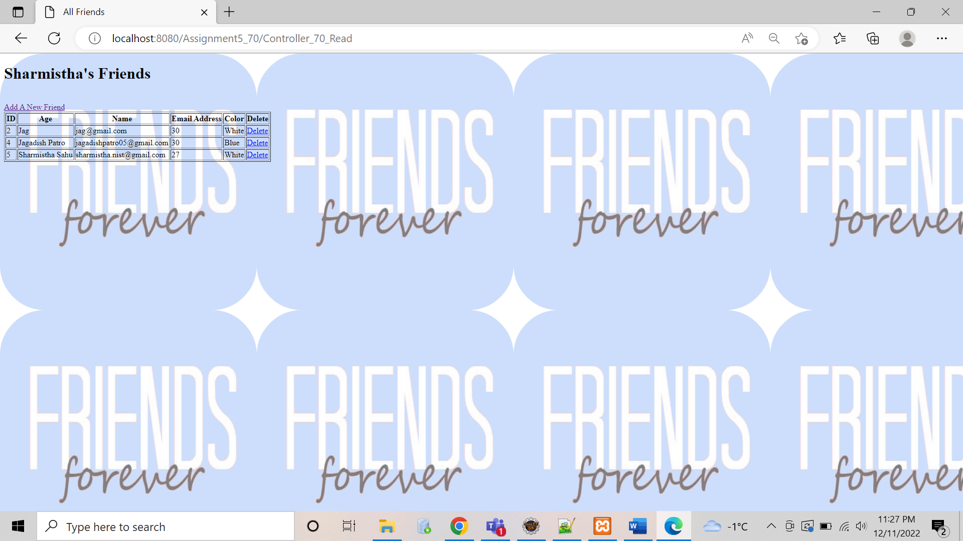

Capture: 3

Capture:4

