***DATA CLEANING***

1. **CREATING A DATA MODEL**

To create a data model we have to match the corresponding records in the schematic diagram. Power BI by default matches the columns with the similar titles. We have to create a relationship between “Geo” in Locations and “Geography” in sales column.

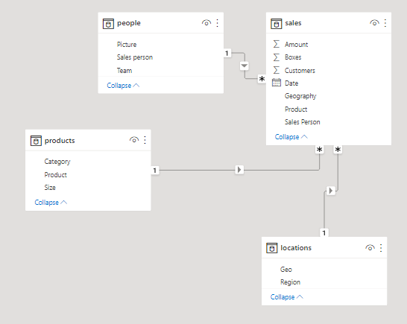

1. **IDENTIFYING THE ANAMOLIES IN THE DATA SET:**
2. To identify the discrepancy in the data set I have created a bar chart with “Geography” as the Axis and “Revenue” as the values to identify the geographically divided revenue collection.

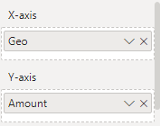

**RESULT:**

There are 14099498 values in the column chart (sales table) that doesn’t have data related to the geography.

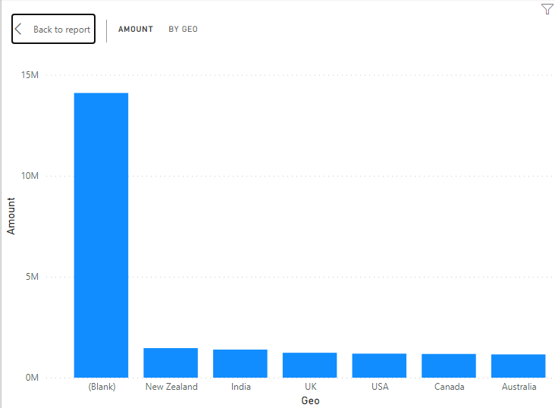

**SOLVING THE BLANK PROBLEM:**

To solve the problem, we have to transform the data. Power query editor will appear. To remove the extra spaces right click on the Geography column Transform->Trim. This will delete all the extra spaces in front of the values.

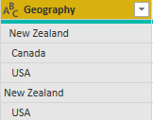 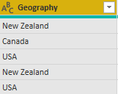

**RESULT:**

The extra spaces before the value are removed by the trim function.

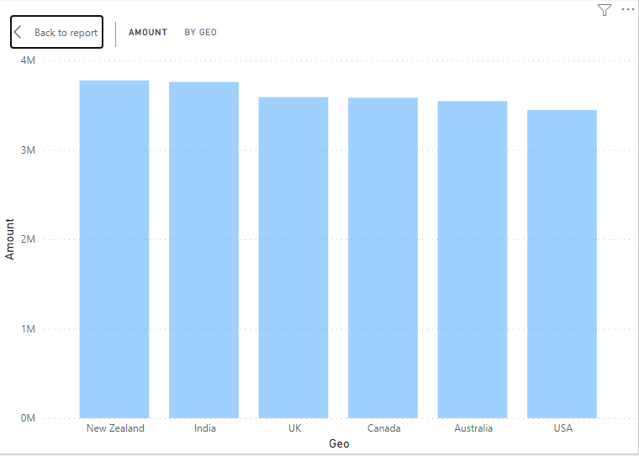

1. The amount/team column chart has the blank space problem.

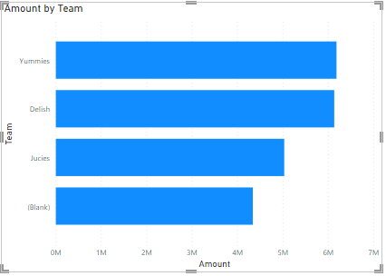

The below table contains the list of sales persons who are not assigned a team.

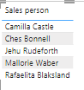

**SOLVING THE BLANK PROBLEM:**

To solve the problem, we have to transform the data. Power query editor will appear. To remove the null values right click on the teams column Replace values-> null values replace by “Special team”.



**RESULT:**

NULL values are now replaced by “Special Team”

