1. ***DATASET:***

***LINK:*** https://github.com/codebasics/DataAnalysisProjects/blob/master/1_SalesInsights/db_dump.sql

1. ***CUSTOMERS (16.0KiB)***

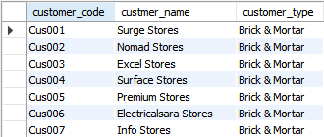

1. ***DATE (80.0KiB)***

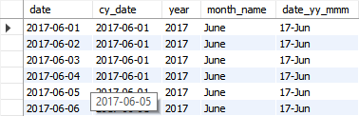

1. ***MARKET (16.0KiB)***

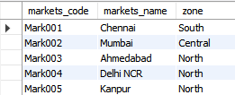

1. ***PRODUCT (16.0KiB)***

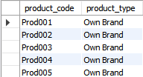

1. ***TRANSACTIONS (11.0MiB)***

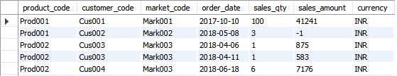

1. ***DATA ANALYSIS USING SQL***
2. **To calculate the total sales report by month**

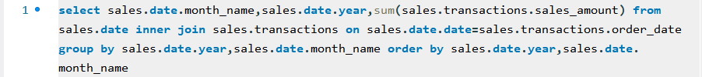

RESULT:

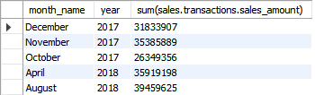

1. **Prioritizing markets by total revenue (Top 5)**

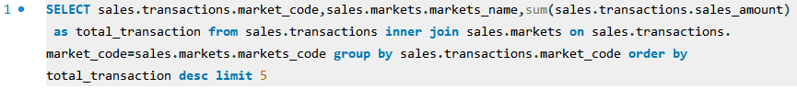

RESULT:

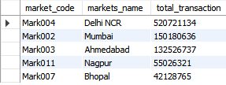

1. **Prioritizing customers by total items purchased (Top 3)**

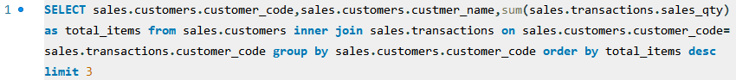

RESULT:

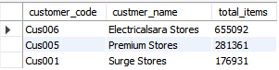

1. **Prioritizing market zones by the maximum number of sales**



RESULT:

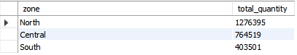

1. **Total revenue for the month December year wise**



RESULT:

