***DATA CLEANING***

1. The data correspond to a company operating in India. In the market table there are values of Paris, New York in market_name. So it is necessary to remove it

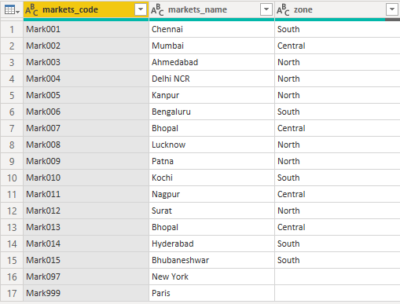

**RESULT:**

= Table.SelectRows(sales_markets, each ([zone] <> ""))

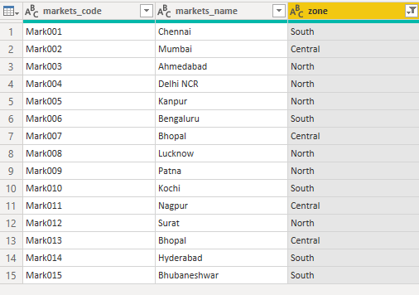

1. In the transactions table there are negative values in the sales_amount column. So it is necessary to remove it

select * from sales.transactions where sales.transactions.sales_amount<=0

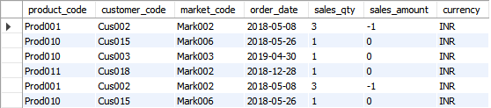

**RESULT:**

= Table.SelectRows(sales_transactions, each ([sales_amount] <> -1 and [sales_amount] <> 0))

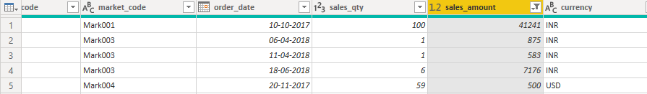

1. Converting currency from USD to INR

select * from sales.transactions where sales.transactions.currency="USD"



**RESULT:**

= Table.AddColumn(#"Filtered Rows", "norm_currency", each if [currency] = "USD" then [sales_amount]*75 else [sales_amount]

