# ONLINE PETALS YARD

*A Project report submitted from*

## Rajiv Gandhi University of Knowledge Technologies SRIKAKULAM

**In Partial fulfillment of the requirements for the Award of the degree of**

# BACHELOR OF TECHNOLOGY IN COMPUTER SCIENCE AND ENGINEERING

**(Full Stack Web Development Course)**

**Submitted by**

**4th year B. Tech 2nd semester**

**Dayam Sharmila (S170669)**

**Oleti Sravani (S170600)**

**Challapalli Sathya Vedam (S170249)**

**Saladi RamaDevi (S170102)**

**Under the Esteemed Guidance of**

**Miss. RadhaUma**



Rajiv Gandhi University of Knowledge Technologies - SKLM

**CERTIFICATE**

This is to certify that the thesis work titled **“ONLINE PETALS YARD an online website”** was successfully completed by Dayam Sharmila (S170669), Oleti Sravani (S170600), Challapalli Sathya Vedam (S170249), Saladi RamaDevi (S170102). In the partial fulfillment of the requirements a project in Computer Science and Engineering (Full Stack Web Development Course) of **Rajiv Gandhi University of Knowledge Technologies** under my guidance and output of the work carried out is satisfactory.

**Miss. RadhaUma**

**Project Guide**

# DECLARATION

I declared that this thesis work titled **“ONLINE PETALS YARD”** an online website is carried out by me during the year 2021-22 in partial fulfillment of the requirements for the summer internship in **Computer Science and Engineering (Full Stack Web Development Course).**

I further declare that this dissertation has not been submitted elsewhere for any Degree. The matter embodied in this dissertation report has not been submitted elsewhere for any other degree. Furthermore, the technical details furnished in various chapters of this thesis are purely relevant to the above project and there is no deviation from the theoretical point of view for design, development and implementation.

**Dayam Sharmila (S170669)**

**Oleti Sravani (S170600)**

**Ch. Sathya Vedam (S170249)**

**Saladi RamaDevi (S170102)**

# ACKNOWLEDGEMENT

I would like to articulate my profound gratitude and indebtedness to my project guide**Miss. RadhaUma**, Assistant Professor who has always been a constant motivation and guiding factor throughout the project time. It has been a great pleasure for me to get an opportunity to work under his guidance and complete the thesis work successfully.

I wish to extend my sincere thanks to **Asst.Prof.Sri.Roopa Madam,M.Tech,**Head of the Computer Science and Engineering Department, for her Constant encouragement throughout the Course.

I am also grateful to other members of the department without their Support my work would have been carried out so successfully.

I thank one and all who have rendered help to me directly or indirectly in the completion of my thesis work.

## Project Associate

**Dayam Sharmila (S170669)**

**Oleti Sravani (S170600)**

**Ch. Sathya Vedam (S170249)**

**Saladi RamaDevi (S170102)**

# ABSTRACT

Nowadays use of the internet has increased a lot across the world. Many people shifted to online shopping for many comfortable reasons like accessible time, affordable prices, easy shipping and to avoid crowded market’s. Many nature lovers are fond of different varieties of flowers, plants which sometimes may not available at their nearer locations. So we are considering of developing an online shopping website for flowers. "Online Petals Yard" is an online flower selling website, which enables the users to come across different varieties of flower pots along with their prices and discounts. They can order the flower pots they want. It is having the best features like the roadmap of the flower shop for better identification and understanding of the location. And having a special feature to collect the name, mobile number and file chosen option to choose the flower pot image for making and delivering the customized flower pots, by these features it is overcoming the existing system. This site provides the reviews of different customers which help customer make purchasing decisions. It is also having the contact details of owner to contact for any help. The main objective of this website is to make different varieties of flower pots available online to customers which saves their time, money, and to reduce the efforts.

**INDEX**

**CH.NO CONTENTS PG.NO**

1. **INTRODUCTION 1**
   1. Introduction 8
   2. Problem of the Statement 9
   3. Objectives 9
   4. Goals 9
   5. Scope 9
   6. Applications 10
   7. Limitations 10
2. **LITERATURE SURVEY 11**
   1. Collecting Information 11
   2. Study 11
   3. Benefits 11
   4. Summary 11
3. **SYSTEM ANALYSIS 12**
   1. Existing System 12
   2. Disadvantages 12
   3. Proposed System 12
   4. Advantages 12
   5. System Requirements 13
4. SYSTEM DESIGN 14

Design of the System 14

* + 1. Class Diagram 14
    2. Use Case Diagram 15
    3. Sequence Diagram 16
    4. Data Flow Diagram 18

1. SYSTEMIMPLEMENTATION 20
   1. Online Petals Yard Website 20
   2. Online Petals Yard 21
2. SOURCECODE 23
   1. Login Code 23
   2. Dashboard Code 25
   3. Products Code 27
3. SYSTEM TESTING 36

Testing Introduction 36

Types Of Testing 36

Levels Of Testing 38

1. CONCLUSION 40
2. **FUTURE ENHANCEMENT APPENDIX**

**REFERENCES**

* 1. **Introduction**

# INTRODUCTION

**Chapter-1**

Online shopping become a trend in nowadays, which is attracting people very much for it’s own benefits . Online shopping can reduce the stress of standing in crowded market lines. It saves time, and can deliver products in affordable prices. Many people love nature and immerge in the feel of nature like heaven. They are fond of different varieties of flowers, plants and beautiful natural locations. But some types of flowers, plants may not be available to them in their reachable locations.

So we are considering of developing an online website for selling flowers in online .It allows users to order the flower pots they are fond of .It allows users to order the flower pots they want. It saves time and providing the flower pots with discounts . And it is having the review option to make purchasing decisions. The roadmap having in this site helps to identify the location easily .It is also allowing users to order the customized the flower pots if they want to by sending the image of the flower pot and message note to explain the features they want clearly. So finally this is the best website for online shopping of flowers which is very much user friendly.

## Statement of the problem

Buying and growing the flower pots is very natural .But sometimes it’s difficult for working people to visit the shops manually and some are unaware of the locations. It takes a lot of time and efforts. So “ONLINE PETALS YARD” is an online website for ordering the different varieties of flower pots. We can also order the customized flower pots through this site, which the best feature overcoming the existing system. It provides the flower pots in an affordable prices, with reviews helping the in making the purchasing decisions.

## Objective

1. To implement an online website for ordering the flower pots online with an affordable prices.
2. To also allow users to order the customized flower pots in online.
3. To deliver the flowers pots very fresh without any damage.
4. To make easier for people to identify the location by roadmap.

## Goals

* + 1. To be heard and understood
    2. Action as soon as possible
    3. responsiveness
    4. User friendly
    5. Simple fast
    6. Low cost and effective

## Scope

1. We are focusing on a system that allow people to order the flower pots in much easier manner .
2. It is actually now developed to work in the village of Dwarapudi in offline.
3. It can be used and implemented in any locations to provide services to the people.

## Applications:

**What users can do in ONLINE PETALS YARD:**

## Order Flower Pots Online:

We can order the flower pots online in an affordable prices , in our flexible time.

## Customized Flower Pots :

We can also order the customized flower pots in online.

## Roadmap:

The roadmap helps in identifying the location easily. Helps users to track and understand the routes easily.

## Limitations:

* + 1. User cannot return the customized flower pots.
    2. Delivery charges must be fixed without any reduction.

# Chapter 2

**LITERATURE SURVEY**

## Collect Information

Firstly we collected information regarding the different varieties of flowers in the entire world. And their locations, brought them into our stores in different locations. And finally made an online website compatible for ordering and delivering of the flower pots in online.

## Study

**Complaint Handling Management System key features:**

Ordering the flower pots online by considering the discounts Allow to order the customized flower pots

Helps users to identify the location easily by roadmap.

## Benefits

Order flower pots online

Know the location easily by roadmap Able to order the customized flower pots.

## Summary

In our system we made an online website for ordering of the flower pots online .It is having the special feature to order the customized flower pots.

## Existing system

# ANALYSIS

**Chapter -3**

* + - Generally people go to market to buy the flower pots manually
    - Users need to order from the available flower pots only by using the existing system.
    - They cannot order their customized flower pots.

## Disadvantages

* + - Users cannot order the customized flower pots.
* They completely unaware of the location of manufacturing.
* Sometimes return options are not available for some flower pots

## Proposed System

* + - Users can create account, login and order their most liked flower pots.
    - In our proposed system , we let the users order the flower pots from the available ones.
    - If they want customized flower pots, we can order by sharing the details of flower pots.
    - We can easily know the physical location of the manufacturing of the flower pots.

## Advantages

* + - Users can order the customized flower pots like they want by contacting the sellers.
    - We can identify the location easily by using the roadmap
    - No need to visit the market . Saves time and money.

## System Requirements Software Requirements:

* + - HTML
    - CSS
    - Javascript
    - PHP
    - MySql

## Hardware Requirements:

* + - RAM: 4GB
    - Hard disk: 500 GB

# CHAPTER-4

**SYSTEM TESTING**

## DESIGN OF THE SYSTEM

Unified Modelling Language (UML) was created in 1995 by using merging diagramming conventions used by three application development methodologies: OMT by James Rumbaugh , Objector y by Invar Jacobson and the Brooch procedure by using Grady Brooch. Previous to this time, these three amigos, together with a few dozen other practitioners had promoted competing methodologies for systematic program development, each and every with its possess system of diagramming conventions. The methodologies adopted a sort of cookbook sort of pushing a application task via a succession of life cycle stages, culminating with a delivered and documented software. One purpose of UML was once to slash the proliferation of diagramming techniques by way of standardizing on a original modelling language, as a result facilitating verbal exchange between builders. It performed that goal in 1997 when the (international) Object administration team (OMG) adopted it as a commonplace. Some critics don’t forget that UML is a bloated diagramming language written by means of a committee. That said, I do not forget it to be the nice manner to be had today for documenting object-oriented program progress. It has been and is fitting more and more utilized in industry and academia. Rational Rose is a pc Aided program Engineering (CASE) software developed by way of the Rational organization underneath the course of Brooch, Jacobson and Rumbaugh to support application progress using UML. Rational Rose is always complex due to its mission of wholly supporting UML. Furthermore, Rational Rose has countless language extensions to Ada, C++, VB, Java, J2EE, and many others. Rational Rose supports ahead and reverse engineering to and from these langue ages. However, Rational Rose does now not aid some usual design tactics as knowledge drift diagrams and CRC cards, due to the fact that these will not be a part of UML. Considering that Rational Rose has so many capabilities it is a daunting task to master it. Happily, loads can be executed making use of only a small subset of these capabilities. These notes are designed to introduce beginner builders into making productive use of the sort of subset.

## Class diagram:

Class diagram in the Unified Modelling Language (UML), is a kind of static structure diagram hat describes the constitution of a process through showing the system's classes, their attributes, and the relationships between the class. The motive of a class diagram is to depict the classes within a model. In an object- oriented software, classes have attributes (member variables), operations (member capabilities) and relation**.**

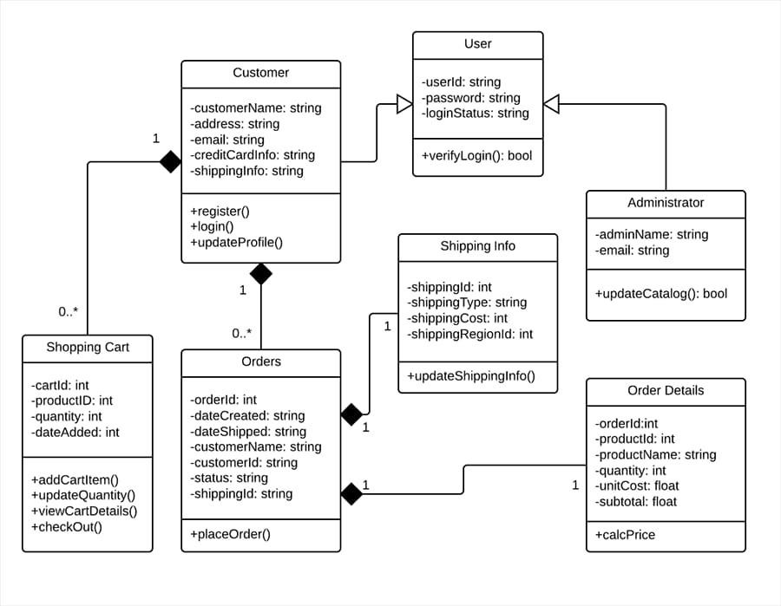

## Use Case Diagram:

It is a visually representation what happens when actor interacts with system. A use case diagram captures the functional aspects of a system.

The system is shown as a rectangle with name of the system inside ,the actor are shown as stick figures, the use case are shown as solid bordered ovals labeled with

name of the use case and relationships are lines or arrows between actor and use cases. Symbols used in Use case are as follows-

Relationship

Actors

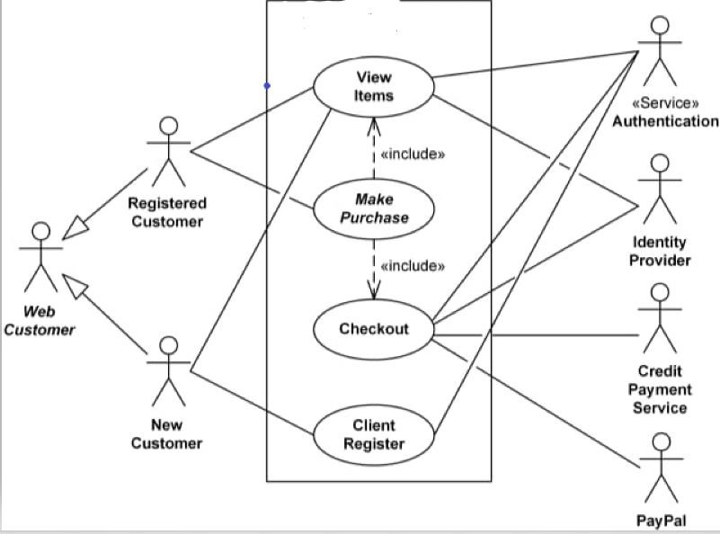

## SEQUENCE DIAGRAM

A sequence diagram in Unified Modelling Language (UML) is one variety of interaction diagram that suggests how methods operate with one other and in what order. It is a construct of a Message Sequence Chart. Sequence diagrams are quite

often referred to as event-hint diagrams, event situations, and timing diagrams. A sequence diagram suggests, as parallel vertical traces (lifelines), special systems or objects that are residing at the same time, and, as horizontal arrows, the messages exchanged between them, within the order the place they occur.

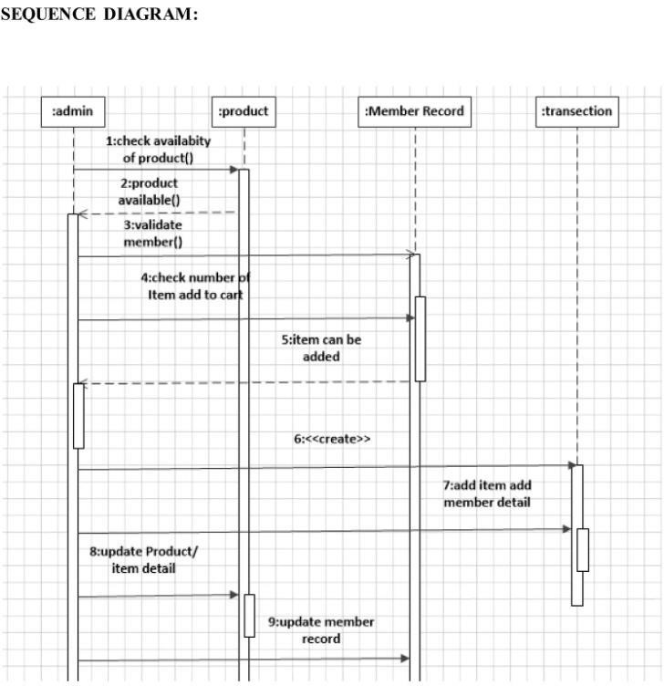

## DFD Diagram:

A data flow diagram or bubble chart (DFD) is a graphical representation of the "flow" of data .through an information system, modeling its process aspects. Often they are a preliminary step used to create an overview of the system which can later be elaborated. DFDs can also be used for the visualization of data processing (structured design).

A DFD shows what kinds of information will be input to and output from the system, where the data will come from and go to, and where the data will be stored. It does not show information about the timing of processes, or information about whether processes will operate in sequence or in parallel (which is shown on a flowchart).

The primitive symbols used for constructing DFD’s are:

Symbols used in DFD

A circle represents a process.

A rectangle represents external entity

A square defines a source or destination of the system data.

An arrow identifies dataflow.

Double line with one end closed indicates data store

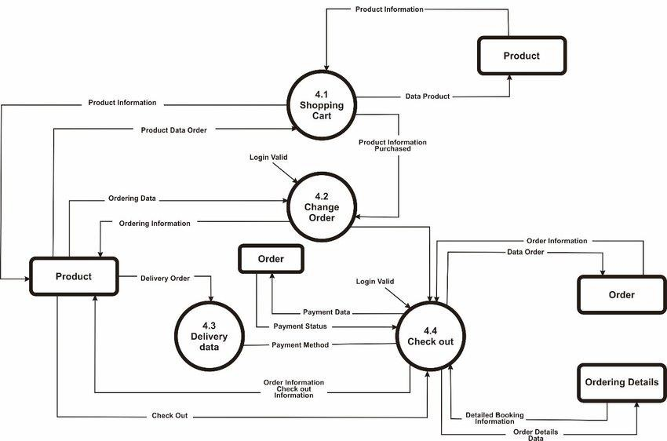

# CHAPTER-5

**SYSTEM IMPLEMENTATION**

## 5.1 ONLINE PETALS YARD Web Site

It is done by using HTML,CSS. we use the necessary components to implement this. With these we built pages like login, shopping, ordering interface page.

## Output of Login Page

* + 1. Sign Up Page

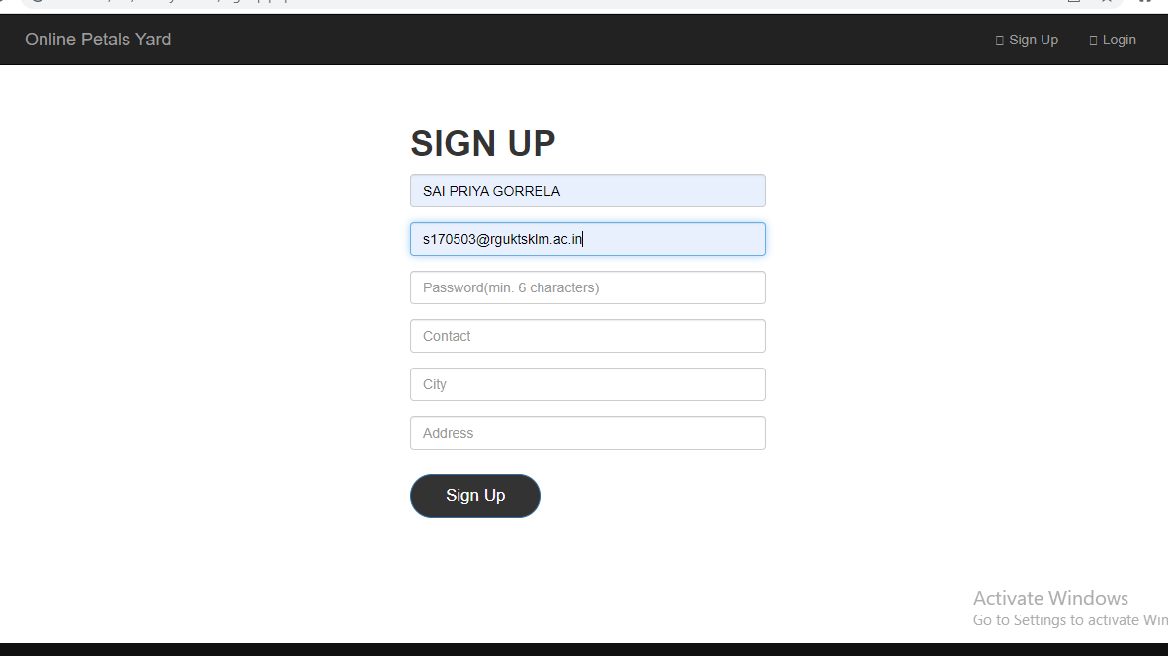

* + 1. Dashboard Section

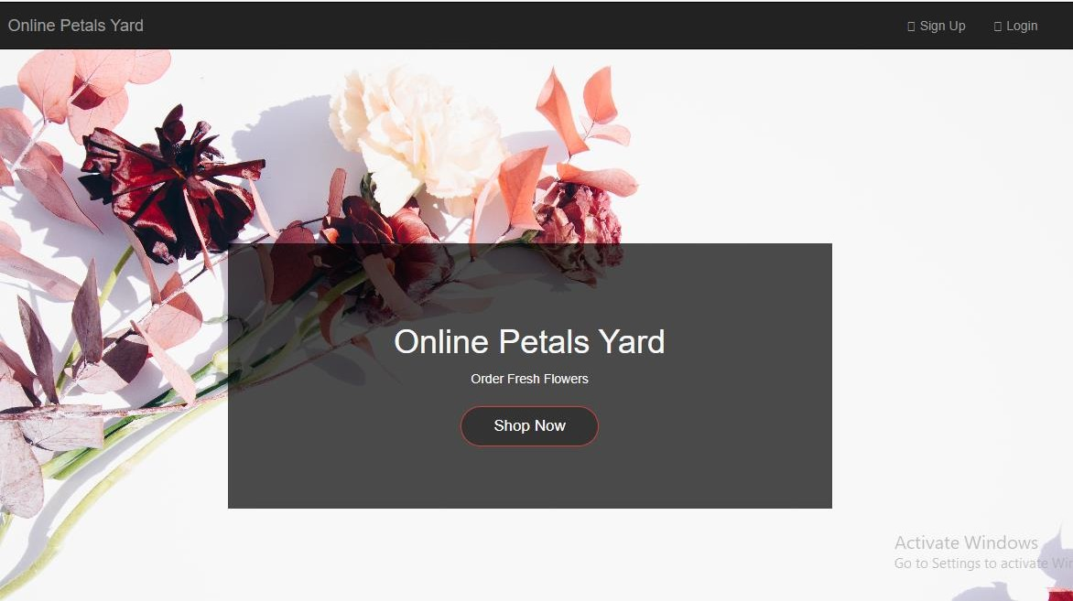

* + 1. Products Section

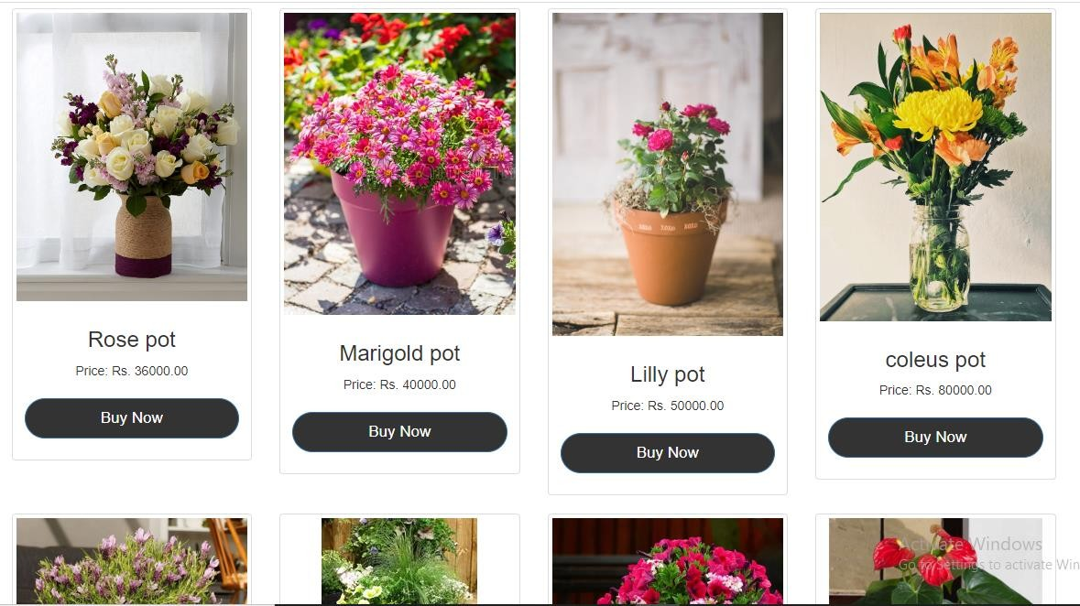

* + 1. Contact Us Section

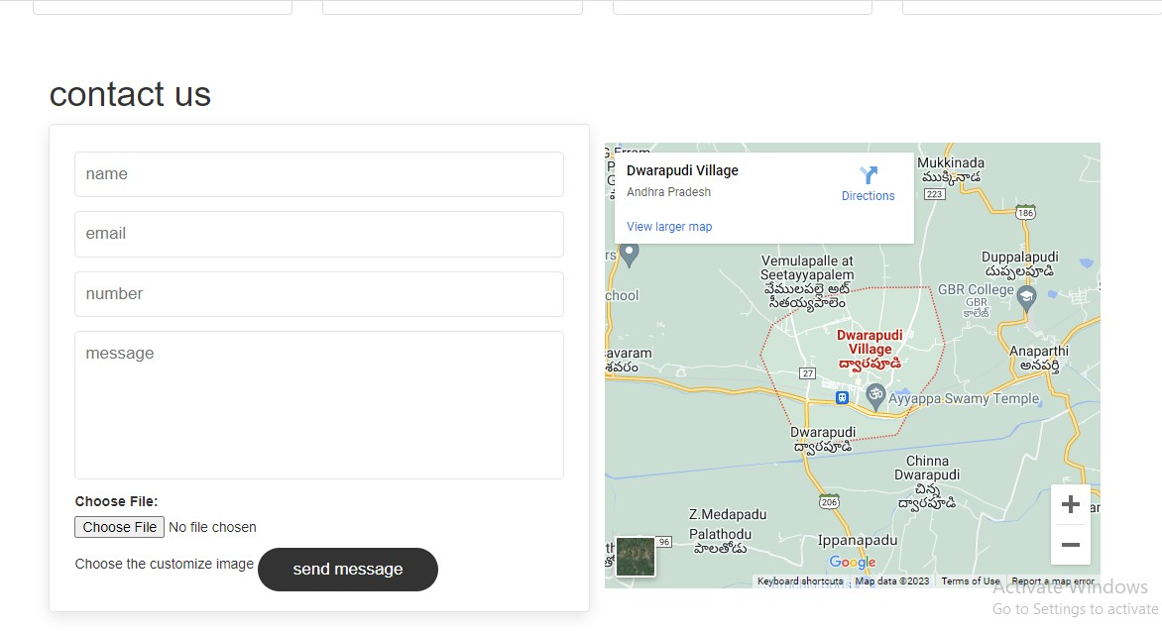

## Login Code

<?php

require 'connection.php'; session_start();

?>

<!DOCTYPE html>

<html>

<head>

# SOURCE CODE

**CHAPTER-6**

<link rel="shortcut icon" href="img/lifestyleStore.png" />

<title>Lifestyle Store</title>

<meta charset="UTF-8">

<meta name="viewport" content="width=device-width, initial-scale=1.0">

<!-- latest compiled and minified CSS -->

<link rel="stylesheet" href="bootstrap/css/bootstrap.min.css" type="text/css">

<!-- jquery library -->

<script type="text/javascript" src="bootstrap/js/jquery- 3.2.1.min.js"></script>

<!-- Latest compiled and minified javascript -->

<script type="text/javascript" src="bootstrap/js/bootstrap.min.js"></script>

<!-- External CSS -->

<link rel="stylesheet" href="css/style.css" type="text/css">

</head>

<body>

<div>

<?php

require 'header.php';

?>

<br><br><br>

<div class="container">

<div class="row">

<div class="col-xs-6 col-xs-offset-3">

<div class="panel panel-primary">

<div class="panel-heading">

<h3>LOGIN</h3>

</div>

<div class="panel-body">

<p>Login to make a purchase.</p>

<form method="post" action="login_submit.php">

<div class="form-group">

<input type="email" class="form-control" name="email" placeholder="Email" pattern="[a-z0-9._%+-]+@[a-z0-9.-]+\.[a- z]{2,3}$">

</div>

<div class="form-group">

<input type="password" class="form-control" name="password" placeholder="Password(min. 6 characters)" pattern=".{6,}">

</div>

<div class="form-group">

<input type="submit" value="Login" class="btn btn-

primary">

</div>

</form>

</div>

<div class="panel-footer">Don't have an account yet? <a href="signup.php">Register</a></div>

</div>

</div>

</div>

</div>

<br><br><br><br><br>

<footer class="footer">

<div class="container">

<center>

</center>

</div>

</footer>

</div>

</body>

</html>

## Dashboard Code

<?php session_start();

?>

<!DOCTYPE html>

<html>

<head>

<link rel="shortcut icon" href="img/lifestyleStore.png" />

<title>Online Petals Yard</title>

<meta charset="UTF-8">

<meta name="viewport" content="width=device-width, initial-scale=1.0">

<link rel="stylesheet" href="bootstrap/css/bootstrap.min.css" type="text/css">

<script type="text/javascript" src="bootstrap/js/jquery- 3.2.1.min.js"></script>

<script type="text/javascript" src="bootstrap/js/bootstrap.min.js"></script>

<link rel="stylesheet" href="css/style.css" type="text/css">

</head>

<body>

<div>

<?php

require 'header.php';

?>

<div id="bannerImage">

<div class="container">

<center>

<div id="bannerContent">

<h1>Online Petals Yard</h1>

<p>Order Fresh Flowers</p>

<a href="products.php" class="btn btn-danger">Shop Now</a>

</div>

</center>

</div>

</div>

<div class="container">

<div class="row">

<div class="col-xs-4">

<div class="thumbnail">

<a href="products.php">

<img src="images/icon-1.png" alt="Camera">

</a>

<center>

<div class="caption">

<p id="autoResize"></p>

<p>Freee shipping</p>

</div>

</center>

</div>

</div>

<div class="col-xs-4">

<div class="thumbnail">

<a href="products.php">

<img src="images/icon-2.png" alt="Watch">

</a>

<center>

<div class="caption">

</div>

</body>

</html>

## Products Code:

<?php

session_start();

require 'check_if_added.php';

?>

<!DOCTYPE html>

<html>

<head>

<link rel="shortcut icon" href="img/lifestyleStore.png" />

<title>Online Petals Yard</title>

<meta charset="UTF-8">

<meta name="viewport" content="width=device-width, initial-scale=1.0">

<!-- latest compiled and minified CSS -->

<link rel="stylesheet" href="bootstrap/css/bootstrap.min.css" type="text/css">

<!-- jquery library -->

<script type="text/javascript" src="bootstrap/js/jquery- 3.2.1.min.js"></script>

<!-- Latest compiled and minified javascript -->

<script type="text/javascript" src="bootstrap/js/bootstrap.min.js"></script>

<!-- External CSS -->

<link rel="stylesheet" href="css/style.css" type="text/css">

</head>

<body>

<div>

You can order in the flexible hours.We can assure you that you will recieve the very fresh flower pots without any damage.</p>

<a href="#" class="btn">learn more</a>

</div>

</div>

</section>

<div class="container">

<div class="row">

<div class="col-md-3 col-sm-6">

<div class="thumbnail">

<a href="cart.php">

<img src="images/img-1.jpg" alt="">

</a>

<center>

<div class="caption">

<h3>Rose pot</h3>

<p>Price: Rs. 36000.00</p>

<?php if(!isset($_SESSION['email'])){ ?>

<p><a href="login.php" role="button" class="btn btn- primary btn-block">Buy Now</a></p>

<?php

}

else{

if(check_if_added_to_cart(1)){

<p>Price: Rs. 80000.00</p>

<div class="thumbnail">

<a href="cart.php">

<img src="images/img-7.jpg" alt="">

</a>

<center>

<div class="caption">

<h3>Pink pot</h3>

<p>Price: Rs. 8000.00</p>

<?php if(!isset($_SESSION['email'])){ ?>

<p><a href="login.php" role="button" class="btn btn- primary btn-block">Buy Now</a></p>

<?php

}

else{

if(check_if_added_to_cart(7)){

echo '<a href="#" class=btn btn-block btn-success

disabled>Added to cart</a>';

}else{

?>

<a href="cart_add.php?id=7" class="btn btn- block btn-primary " name="add" value="add" class="btn btn-block btr- primary">Add to cart</a>

<?php

}

}

?>

</div>

if(check_if_added_to_cart(11)){

echo '<a href="#" class=btn btn-block btn-success

disabled>Added to cart</a>';

}else{

?>

<a href="cart_add.php?id=11" class="btn btn- block btn-primary " name="add" value="add" class="btn btn-block btr- primary">Add to cart</a>

<?php

}

}

?>

</div>

</center>

</div>

</div>

<div class="col-md-3 col-sm-6">

<div class="thumbnail">

<a href="cart.php">

<img src="images/img-17.jpeg">

</a>

<center>

<div class="caption">

<h3>Chrys pot</h3>

<p>Price: Rs. 1200.00</p>

<?php if(!isset($_SESSION['email'])){ ?>

<p><a href="login.php" role="button" class="btn btn- primary btn-block">Buy Now</a></p>

<?php

<form action="">

<input type="text" placeholder="name" class="box">

<input type="email" placeholder="email" class="box">

<input type="number" placeholder="number" class="box">

<textarea name="" class="box" placeholder="message" id="" cols="30" rows="10"></textarea>

<label for="myfile">Choose File:</label>

<input type="file" id="myfile"name="myfile">Choose the customize

image

<input type="submit" value="send message" class="btn">

</form>

<div class="image">

<iframe src="https://[www.google.com/maps/embed?pb=!1m18!1m12!1m3!1d30534.76](http://www.google.com/maps/embed?pb=!1m18!1m12!1m3!1d30534.76) 9179191397!2d81.90565087523433!3d16.932879754542594!2m3!1f0!2f0!3f0!

3m2!1i1024!2i768!4f13.1!3m3!1m2!1s0x3a379764feac498d%3A0xc5afc27483

17a187!2sDwarapudi%20Village%2C%20Andhra%20Pradesh!5e0!3m2!1sen!2 sin!4v1674540824382!5m2!1sen!2sin" width="500" height="450" style="border:0;" allowfullscreen="" loading="lazy" referrerpolicy="no- referrer-when-downgrade"></iframe>

</div>

</div>

</section>

<br>

</body>

</html>

## :Review and Contact section Code:

<section class="review" id="review">

<h1 class="heading"> customer's <span>review</span> </h1>

<div class="box-container">

<div class="box">

<div class="stars">

<i class="fas fa-star"></i>

<i class="fas fa-star"></i>

<i class="fas fa-star"></i>

<i class="fas fa-star"></i>

<i class="fas fa-star"></i>

</div>

<p>This is such a great platform to get the most beautiful flower pots through online.

The flowers I have recieved are very fresh.They delivered them in very less time.

It saves my time.

I got my flower pots in affordable prices only.The website is very user friendly.</p>

<div class="user">

<img src="images/pic-1.png" alt="">

<div class="user-info">

<h3>Latha Mahesh</h3>

<span>happy customer</span>

</div>

</div>

<span class="fas fa-quote-right"></span>

</div>

<div class="box">

<div class="stars">

<i class="fas fa-star"></i>

<i class="fas fa-star"></i>

<i class="fas fa-star"></i>

<i class="fas fa-star"></i>

<i class="fas fa-star"></i>

</div>

<p>I have ordered some customized flower pots .The service was very nice.I have recieved my flower pots as it is I have said them to made.That is the happiest thing.My friend also ordered and recieved the beautiful flower pots.She loves them very much.</p>

<div class="user">

<img src="images/pic-2.jpeg" alt="">

<div class="user-info">

<h3>Sneha Roi</h3>

<span>happy customer</span>

</div>

</div>

<span class="fas fa-quote-right"></span>

</div>

<div class="box">

<div class="stars">

<i class="fas fa-star"></i>

<i class="fas fa-star"></i>

<h1 class="heading"> <span> contact </span> us </h1>

<div class="row">

<form action="">

<input type="text" placeholder="name" class="box">

<input type="email" placeholder="email" class="box">

<input type="number" placeholder="number" class="box">

<textarea name="" class="box" placeholder="message" id="" cols="30" rows="10"></textarea>

<input type="submit" value="send message" class="btn">

</form>

<div class="image">

<iframe src="https://[www.google.com/maps/embed?pb=!1m18!1m12!1m3!1d30534.76](http://www.google.com/maps/embed?pb=!1m18!1m12!1m3!1d30534.76) 9179191397!2d81.90565087523433!3d16.932879754542594!2m3!1f0!2f0!3f0!

3m2!1i1024!2i768!4f13.1!3m3!1m2!1s0x3a379764feac498d%3A0xc5afc27483

17a187!2sDwarapudi%20Village%2C%20Andhra%20Pradesh!5e0!3m2!1sen!2 sin!4v1674540824382!5m2!1sen!2sin" width="500" height="450" style="border:0;" allowfullscreen="" loading="lazy" referrerpolicy="no- referrer-when-downgrade"></iframe>

</div>

</div>

</section>

# CHAPTER 7

**SYSTEM TESTING**

## INTRODUCTION

The cause of testing is to detect mistakes. Making an attempt out is the technique of looking for to realize each viable fault or weakness in a piece product. It presents a method to determine the performance of add-ons, sub-assemblies, assemblies and/or a completed product. It is the method ofexercising program with the intent of constructing certain that the application procedure meets its necessities and client expectations and does no longer fail in an unacceptable process. There are rather plenty of forms of scan. Each experiment sort addresses a special trying out requirement.

## TYPES OF TESTS:

Unit testing:

Unit checking out involves the design of scan circumstances that validate that the Internal application good judgment is functioning safely, and that program inputs produce legitimate outputs. All decision branches and interior code float must be validated. It's the checking out of character application items of the application . It is achieved after the completion of an person unit earlier than integration. It is a structural checking out, that relies on competencies of its construction and is invasive. Unit exams participate in common exams at component level and scan a distinct business approach, utility, and/or process configuration. Unit assessments be certain that every specified course of a industry method performs appropriately to the documented requisites and involves clearly outlined inputs and anticipated results.

Integration testing:

Integration Testing are designed to scan built-in program accessories to determine within the occasion that they evidently run as one software. Trying out is occasion driven and is more concerned with the fundamental final result of screens or fields. Integration assessments reveal that despite the fact that the accessories had been for my part pleasure, as proven through effectively unit checking out, the combo of accessories is correct and regular. Integration checking out is chiefly aimed at exposing the issues that come up from the performance of different components.

Functional testing:

Functional Testing checks provide systematic demonstrations that capabilities established are to be had as particular by means of the business and technical

specifications, method documentation, and consumer manuals. Functional testing is working on below mentioned data:

Legitimate input : identified lessons of legitimate input ought to be accredited. Invalid enter : recognized lessons of unacceptable effort must be rejected.

Capabilities : recognized features ought to be exercised.

Output : recognized courses of software outputs have got to be exercised. Systems/Procedures : performance of the system here was invoked

Individual and team work of useful checks is fascinated by specifications, key capabilities, or special scan instances. Moreover, systematic insurance plan

concerning establish business method flows; data fields, predefined processes, and successive strategies have to be regarded for trying out. Before useful trying out is whole, extra checks are recognized and the strong price of present checks be strongminded.

System testing:

Scheme difficult ensure so as to the whole included agenda process meets principles. It exams a pattern to make sure identified and predictable outcome. An illustration of procedure testing is the configuration oriented approach integration scan. System testing is based on approach descriptions and flows, emphasizing pre-driven system links and integration aspects.

White Box Testing:

This testing is a trying out wherein where the application tester has competencies of the interior workings, constitution and software language, or at least its cause. It's rationale. It's used to test areas that can't be reached from a black box stage.

Black Box Testing:

This is testing the software with none advantage of the inside workings, establishment or words of the unit life form veteran. Black field checks, Additional aspects of the software beyond features and functionality.

## LEVELS OF TESTING

Unit testing strategy

Unit checking out is most commonly performed as a part of a mixed code and unit experiment part of the software lifecycle, though it be not exceptional for coding and unit checking out to be performed as two targeted phases.

Test strategy and approach:

Field testing out can be carried out manually and sensible assessments shall be written in element.

Test objectives

Each field must be work correctly.

Each page must be activated through the specified link.

Features to be tested Verify that the entries are of the correct format No duplicate entries should be allowed

Integration testing strategy

Software integration testing is the incremental integration checking out of two

otherwise further included software gears on top of a solo stage to fabricate failure induced with the aid of interface defects. The project of the mixing scan is to check that components or program applications,

e.g. Components in a program approach or œ one step up œ software purposes at the company degree œ interact without error.

Test Results:

All of the scan circumstances recounted above passed efficiently. No defects encountered.

Acceptance Testing

User Acceptance testing trying out is a crucial section of any mission and requires enormous participation by the tip user. It additionally ensures that the procedure meets the functional specifications.

Test Results: The entire test cases recounted above passed effectually. No defects Encountered

## CONCLUSION

This project “ONLINE PETALS YARD, an online” was successfully executed by me to check the end results and it is found that our proposed system provides efficient and effective result when compared to existing system. Our System provides the facilities like ordering of flower pots on online etc,. It can be accessed through smart phones as well as web site to get an opportunity and saves time, money as well. The system allows the users like nature lovers and all people to make orders online and also let them receive the flower pots freshly with return options also.

## Future Enhancement

With a goal to provide ordering of flower pots online with affordable prices irrespective of devices, a convenient Website is also developed with using the basics of web development.

To fulfil the above requirement, using Html , CSS an online Website can be designed. It is designed primarily for providing a simple interface and the ability to interactively evaluated. The major design goal was to keep the system small and simple, while providing an almost effective online ordering system for flower pots.

Based on our website development concept, it can be further extended to product based online shopping websites like clothes, groceries, food etc. to manage and improve seller- customer relationship

# APPENDIX REFERENCES

Submitted by CHIT KWUNG SEE WET98014, Faculty of Computer Science and Information Technology, University of Malaya 200012001

[Online Flowers and Gifts Shop](http://studentsrepo.um.edu.my/8768/1/Online_flowers_and_gifts_shop.pdf)

Rishikesh R Prajapati,DEPARTMENT OF COMPUTER SCIENCE , NAGINDAS KHANDWALA COLLEGE

[FLORIST ONLINE FLOWER SHOP](https://nkc.ac.in/uploaded_files/1.3.4_STDNTPRJ_CS_P_10.pdf)