1. **FIX THE ERROR**

<html lang="en">  
 <head>  
 <title>Document  
 <body>  
 guvi  
 </title>  
 </head>  
 <div>  
 Lorem ipsum dolor sit amet consectetur adipisicing elit.  
 <div>  
 <div>  
 Guvi Geek Network  
 </div>  
 </body>  
 </html>

*From <*[*https://github.com/rvsp/HTML-CSS/blob/master/Mini-tasks/001-HTML.md*](https://github.com/rvsp/HTML-CSS/blob/master/Mini-tasks/001-HTML.md)*>*

ANSWER

<!DOCTYPE html>

<html lang="en">

<head>

<title>Document</title>

</head>

<body>

<div>

guvi

</div>

<div>

Lorem ipsum dolor sit amet consectetur adipisicing elit.

<div>

<div>

Guvi Geek Network

</div>

</div>

</div>

1. **Fix the Error**

<html lang="en">  
 <head>  
 <title>Document  
 <body>  
 guvi  
 </head>  
 <div>  
 Lorem ipsum dolor sit amet consectetur adipisicing elit.  
 <div>  
 <div>  
 Guvi Geek Network  
 </div>  
 </body>  
 </html>

*From <*[*https://github.com/rvsp/HTML-CSS/blob/master/Mini-tasks/001-HTML.md*](https://github.com/rvsp/HTML-CSS/blob/master/Mini-tasks/001-HTML.md)*>*

Answer:

<html lang="en">  
 <head>  
 <title>Document</title>  
 </head>

<body>

<div>Guvi</div>

<div> Lorem ipsum dolor sit amet consectetur adipisicing elit.</div>

<div>Guvi Geek Network</div>

</body>  
 </html>

**3.Create a Contact Form:**

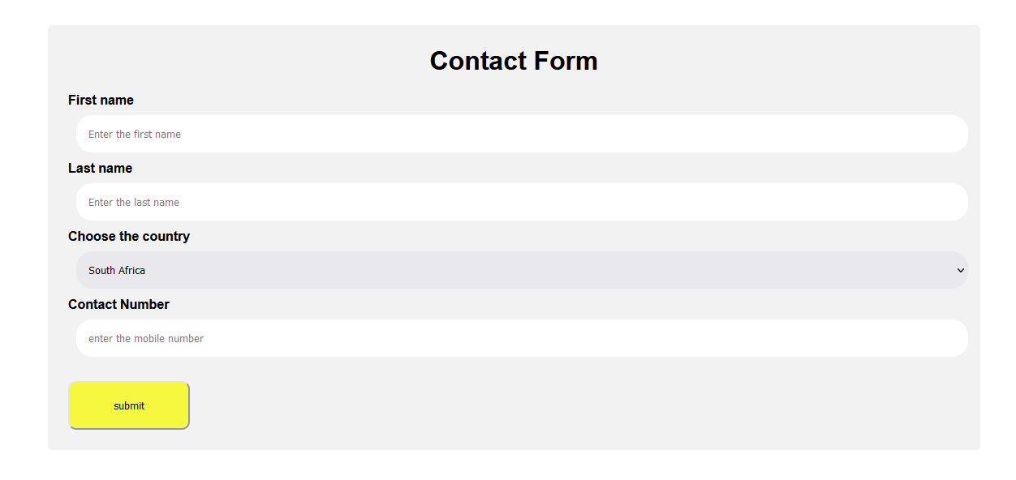

 HTML CODE:

<!DOCTYPE html>

<html lang="en">

<head>

    <meta charset="UTF-8">

    <meta name="viewport" content="width=device-width, initial-scale=1.0">

    <title>Contact Form</title>

    <link rel="stylesheet" href="style.css">

</head>

<body>

    <div class="form">

        <h1>Contact Form</h1>

        <div class="firstname">

            First name

            <input type="text" id="one" placeholder="Enter the first name">

        </div>

        <div class="lastname">

            <label>Last name</label>

            <input type="text" id="two" placeholder="Enter the last name">

        </div>

        <label for="county">Choose the country</label>

        <select class="country">

            <option value="Australia">Australia</option>

            <option value="India">India</option>

            <option value="England">England</option>

            <option value="South Africa">South Africa</option>

        </select>

        <div class="contact-number">

            Contact Number

            <input type="text" id="three" placeholder="enter the mobile number">

        </div>

        <div class="btn">

            <button type="submit" id="sumbit">submit</button>

        </div>

    </div>

</body>

</html>

CSS-CODE:

*

{

    margin:0px;

    padding:0px;

}

h1

{

    text-align: center;

    color:black;

    margin-bottom: 20px;

}

.form

{

    border-radius: 5px;

    background-color: #f2f2f2;

    padding: 25px;

    margin: 100px;

    font-family: sans-serif;

    font-weight: bolder;

}

input,select

{

    box-sizing: border-box;

    border-radius: 20px;

    border-color: none;

    border:none;

    padding: 15px;

    width: 100%;

    margin: 10px;

}

button

{

    margin-top: 20px;

    width: 150px;

    padding: 20px;

    border-radius: 10px;

    background-color: rgb(245, 248, 63);

    cursor: pointer;

}

button:hover

{

    background-color:greenyellow;

}

**4.**

**HTML elements to display the following in a HTML page.**

From <[*https://github.com/rvsp/HTML-CSS/blob/master/Mini-tasks/001-HTML.md*](https://github.com/rvsp/HTML-CSS/blob/master/Mini-tasks/001-HTML.md)>

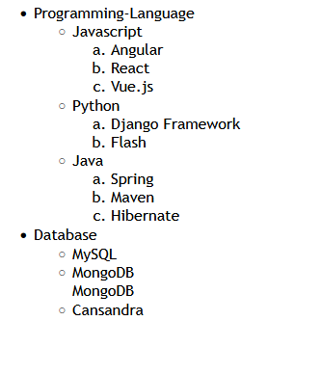

HTML CODE:

<!DOCTYPE html>

<html lang="en">

<head>

    <meta charset="UTF-8">

    <meta name="viewport" content="width=device-width, initial-scale=1.0">

    <title>Demo HTML </title>

</head>

<body>

    <div class="container" style="font-family: 'Trebuchet MS', 'Lucida Sans Unicode', 'Lucida Grande', 'Lucida Sans', Arial, sans-serif">

        <ul id="pl-db">

            <li id="programming-language">Programming-Language

                <ul id="languages">

                    <li id="javascript">Javascript

                        <ol id="js-frameworks" type="a">

                            <li>Angular</li>

                            <li>React</li>

                            <li>Vue.js</li>

                        </ol>

                    </li>

                    <li id="Python">Python

                        <ol id="python-frameworks" type="a">

                            <li>Django Framework</li>

                            <li>Flash</li>

                        </ol>

                    </li>

                    <li id="java">Java

                        <ol id="java-frameworks" type="a">

                            <li>Spring</li>

                            <li>Maven</li>

                            <li>Hibernate</li>

                </ul>

            </li>

            <li id="Database">Database

                <ul id="database">

                    <li>MySQL</li>

                    <li>MongoDB</li>MongoDB

                    <li>Cansandra</li>

                </ul>

            </li>

        </ul>

    </div>

</body>

</html>

**5.Create an element that helps you to open the https://google.com in separate new tab.**

HTML CODE:

<a href="https://www.google.com/webhp?hl=en&sa=X&ved=0ahUKEwjoneL2gKGFAxX3xDgGHS9_BYUQPAgJ">Google</a>

//Anchor tag is used to link to any website provided we have give the URL.

OUTPUT



**6.RADIO BUTTON**

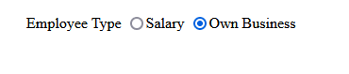

HTML CODE:

<div class="form">

       <label for="employee Type">Employee Type</label>

       <input type="radio" name="employeetype" id="salaryid" value="1">Salary

       <input type="radio" name="employeetype" id="ownbusinessid" value="2">Own Business

      </div>

**/8. Use the table tag to design given image**

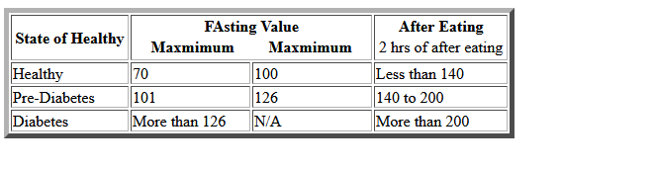

<html lang="en">

<head>

<meta charset="UTF-8">

<meta http-equiv="X-UA-Compatible" content="IE=edge">

<meta name="viewport" content="width=device-width, initial-scale=1.0">

<style>

td, th{

min-width: 115px;

}

</style>

<title>Tables</title>

</head>

<body>

<table border="5" bordercolor="green">

<tr>

<th>State of Health</th>

<th colspan="2">Fasting Value

<table>

<tr>

<th colspan="1">Minimum</th>

<th colspan="1">Maximum</th>

</tr>

</table>

</th>

<th colspan="1">After eating

<table>

<tr>

<td>2 hours after eating</td>

</tr>

</table>

</th>

</tr>

<tr>

<td>Healthy</td>

<td>70</td>

<td>100</td>

<td>Less than 140</td>

</tr>

<tr>

<td>Pre-Diabetes</td>

<td>101</td>

<td>126</td>

<td>140 to 200</td>

</tr>

<tr>

<td>Diabetes</td>

<td>More than 126</td>

<td>N/A</td>

<td>More than 200</td>

</tr>

</table>

</body>

</html>

**//9. Write HTML input tags snippet to show default values for all Form elements.**

Output:

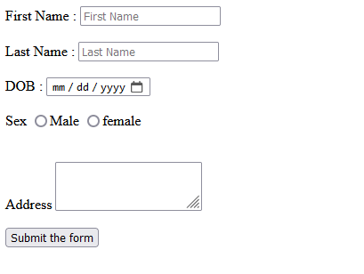

<body>

<form action="https:\\google.com" method="GET">

<label for="first_name">First Name : </label>

<input type="text" placeholder="First Name" value="first"/>

<br>

<label for="last_name">Last Name : </label>

<input type="text" placeholder="Last Name" value="last"/>

<br>

<label for="DOB">DOB : </label>

<input type="date" placeholder="Date of birth" value="01/01/2999"/>

<br>

<label for="Address">Address : </label>

<textarea cols="30" rows="5" name="address_details" placeholder="Enter your full address here"></textarea>

<button name="submit">Submit the form</button>

<br>

<div>

<label for="employee_type">Employee Type :</label>

<input type="radio" name="sal">Salaried</input>

<input type="radio" name="self">Self employed</input>

</div>

</form>

</body>

**//10. In your, HTML page add the below line and Highlight it without using any CSS.**

"HTML & CSS is awesome"

Output: 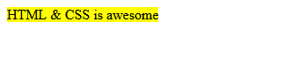

HTML:Code

<div>

<mark>HTML & CSS is awesome</mark> </div>

**11. Create an HTML page, which should contain all types of input elements.**

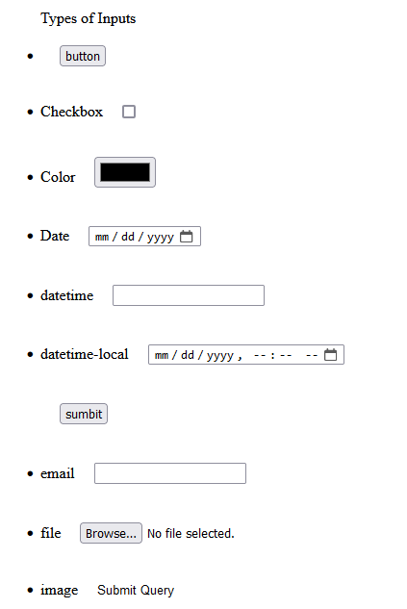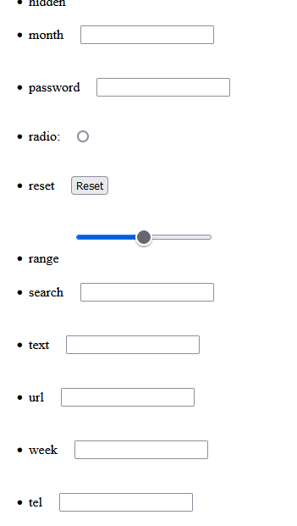

HTML CODE:

|  |
| --- |
| <div> |
|  | <ul>Types of Inputs |
|  | <li><input type="button" value="button"/></li> |
|  | <li>Checkbox<input type="checkbox" value=""/></li> |
|  | <li>Color<input type="color"/></li> |
|  | <li>Date<input type="date"/></li> |
|  | <li>datetime<input type="datetime"/></li> |
|  | <li>datetime-local<input type="datetime-local"/></li> |
|  | <li>email<input type="email"/></li> |
|  | <li>file<input type="file"/></li> |
|  | <li>image<input type="image"/></li> |
|  | <li>hidden<input type="hidden"/></li> |
|  | <li>month<input type="month"/></li> |
|  | <li>password<input type="password"/></li> |
|  | <li>radio:<input type="radio"/></li> |
|  | <li>reset<input type="reset"/></li> |
|  | <li>range<input type="range"/></li> |
|  | <li>search<input type="search"/></li> |
|  | <li>text<input type="text"/></li> |
|  | <li>url<input type="url"/></li> |
|  | <li>week<input type="week"/></li> |
|  | <li>tel<input type="tel"/></li> |
|  | </ul> |
|  | </div> |