Meetly: Software Requirements Specification
Assignment 1: SRS, class diagram and project setup. Social media platform for sharing class routines, finding free friends, and hanging out.
Field | Details
Course | [course code and title]
Group / Section | [group number] / [section]
Team members | [Name, ID]; [Name, ID]; [Name, ID]
Faculty | [faculty name]
Version / date | 1.0 / 19 October 2026

1. Introduction

1.1 Purpose
This document specifies the requirements of Meetly, a social media web platform for university students and faculty. It is meant for the project team and the course faculty, and it is the basis for design, implementation and testing.

1.2 Scope
At BRAC University, students follow an open-credit system, so friends in the same or different departments have different schedules and rarely know when they are free together. Meetly lets members share their weekly routines. The platform finds free time, shows which friends are free in the user's own free slots, and lets a user poke a friend with a hangout proposal that the friend can accept, reject, or reject with a suggestion. Faculty members also share routines, so students can see which faculty members are available in their free time and in which room. Members can also chat, share posts and instants, and share location with trusted friends for emergencies.
Out of scope: login and logout are not considered a feature in this project and are assumed to be provided by a separate authentication module. Payments, video calls and integration with the official university portal are also out of scope for this version.

1.3 Definitions
Term | Meaning
Routine | A user's weekly schedule for one semester.
Free slot | A time range between routine entries when the user has nothing scheduled.
Poke | A hangout proposal sent to a friend, with motive, time slot and place.
Instant | A photo or short post that disappears after 24 hours.
Trusted friend | A friend who has agreed to receive the user's SOS alerts.
SOS alert | An emergency alert with the user's live location sent to trusted friends.
Ghost mode | A setting that hides the user's location and free-time status.
SRS | Software Requirements Specification.

1.4 References
- IEEE Std 830-1998, Recommended Practice for Software Requirements Specifications.
- Course assignment brief for Assignment 1.

2. Overall description

2.1 Product perspective
Meetly is a new, standalone web application with a React frontend, a Node.js (NestJS) backend and a PostgreSQL database. Real-time features (chat, pokes, SOS) use WebSockets. It does not depend on any existing university system.

2.2 User classes
User | Description | Main needs
Student | University student with a changing open-credit schedule. | Share routine, find free friends, poke, chat, post, use SOS.
Faculty | Teacher with classes and office hours. | Share routine and office hours with room number; answer consultation requests.
Admin | Platform moderator. | Review reports, suspend users, verify faculty.

2.3 Operating environment
- Modern web browsers on desktop and mobile (Chrome, Edge, Firefox, Safari).
- Server: Node.js LTS, PostgreSQL (Neon or Supabase), cloud hosting for the API and the frontend.

2.4 Constraints
- Student project: 12-week timeline and a small team with no fixed roles.
- Location is shared only with the user's consent and only at the level the user chooses.
- Free hosting tiers limit storage and traffic.

2.5 Assumptions and dependencies
- Users are BRAC University students and faculty with university email addresses.
- Users enter or import their own routines; the university does not supply them.
- Authentication (login and logout) is available from another module and is not specified here.
- Users allow browser location access for check-ins and SOS.

3. Features and functional requirements
Priority: Must = needed for the first working version, Should = important and planned, Could = if time allows. Login and logout are excluded as required by the assignment.

3.1 Routine management
ID | Requirement | Priority
FR-1.1 | The user can create a weekly routine for a semester by adding entries with title, course code, section, day, start time, end time, room and type (class, lab, office hours, club, other). | Must
FR-1.2 | The user can edit and delete routine entries. | Must
FR-1.3 | The system warns the user when a new entry overlaps an existing entry. | Must
FR-1.4 | The user can keep separate routines for different semesters; old routines are archived (open-credit students change their schedule every semester). | Should
FR-1.5 | The user can import a routine from a CSV file and review it before saving. | Should
FR-1.6 | The user can add one-off events and mark a class as cancelled or rescheduled for a single day. | Should
FR-1.7 | The user chooses who can see the routine (all friends, selected friends, only me) and whether they see class details or only busy/free blocks. | Must

3.2 Free time and availability
ID | Requirement | Priority
FR-2.1 | The system calculates the user's free slots from the gaps between routine entries inside configurable campus hours (for example 8:00 to 20:00). | Must
FR-2.2 | For each of the user's free slots, the system lists the friends who are also free at that time ("who is free with me"). | Must
FR-2.3 | The system shows "free now" and "free later today" status for each friend. | Must
FR-2.4 | The user can find common free slots for two or more selected friends. | Should
FR-2.5 | The user can filter the list of free friends by department, course or friend group. | Should
FR-2.6 | Free-time results respect each friend's visibility settings and ghost mode. | Must

3.3 Friends
ID | Requirement | Priority
FR-3.1 | The user can search for other users by name, student ID or department and send a friend request. | Must
FR-3.2 | The receiver can accept or decline a request; the sender can cancel it; either side can unfriend. | Must
FR-3.3 | The user can view the friend list and a quick profile of each friend. | Must
FR-3.4 | The system suggests people who share a course, section or department. | Could

3.4 Poke (hangout proposals)
ID | Requirement | Priority
FR-4.1 | The user can poke a friend who is free by choosing a motive (hangout, lunch, study, project work, other), an optional note, a proposed time slot inside the friend's free time, and a place. | Must
FR-4.2 | The receiver is notified and can accept the poke; both users are notified and a chat opens for them. | Must
FR-4.3 | The receiver can reject the poke, optionally with a short reason. | Must
FR-4.4 | The receiver can reject the poke and suggest an alternative time slot or place; the sender can accept or decline the suggestion. | Must
FR-4.5 | The sender can cancel a pending poke; a pending poke expires automatically when its time slot has passed. | Should
FR-4.6 | The user can see poke history with status (pending, accepted, rejected, countered, expired, cancelled). | Should
FR-4.7 | The user can poke several friends at once and collect their answers in one thread. | Should
FR-4.8 | The user can mute pokes from a friend or turn on do-not-disturb. | Should

3.5 Faculty availability
ID | Requirement | Priority
FR-5.1 | A faculty member can create a routine in the same way as a student and mark office hours with a room number. | Must
FR-5.2 | A student can see which faculty members are available during the student's own free slots, together with the room number. | Must
FR-5.3 | A student can search faculty by name, initial or department and view their weekly availability. | Must
FR-5.4 | A faculty member chooses what is visible (office hours and room only, or full routine). | Should
FR-5.5 | A student can send a consultation request for a faculty free slot; the faculty member can accept, reject or suggest another time. | Should

3.6 Chat
ID | Requirement | Priority
FR-6.1 | Friends can chat one to one in real time; a chat is created automatically when a poke is accepted. | Must
FR-6.2 | Users can send text, emoji and images in a chat. | Must
FR-6.3 | Users can create group chats (for example a hangout group or project group). | Should
FR-6.4 | The system shows read receipts and a typing indicator. | Could
FR-6.5 | Users can delete their own messages and leave a chat. | Must

3.7 Posts, instants and profiles
ID | Requirement | Priority
FR-7.1 | The user can create a post with text and up to a limited number of images. | Must
FR-7.2 | The user can share an "instant" (a photo or short post) that disappears after 24 hours. | Should
FR-7.3 | The home feed shows friends' posts and instants in time order with pagination. | Must
FR-7.4 | Users can like and comment on posts; the post owner can delete comments on their post. | Must
FR-7.5 | The user can edit and delete their own posts. | Must
FR-7.6 | The user can choose the audience of each post (all friends, selected friends, only me). | Should
FR-7.7 | Each user has a profile page with name, department, avatar, bio and their posts; the user can edit the profile. | Must

3.8 Notifications
ID | Requirement | Priority
FR-8.1 | The system sends in-app notifications for friend requests, pokes and replies, messages, likes, comments and SOS alerts. | Must
FR-8.2 | The system can send push or email notifications for important events. | Should
FR-8.3 | The user can choose which notifications to receive. | Could

3.9 Location sharing and emergency SOS
ID | Requirement | Priority
FR-9.1 | The user can share a campus location (building or room) as an opt-in check-in that expires after a chosen time. | Must
FR-9.2 | The user chooses who sees the location (all friends, selected friends, trusted friends only). | Must
FR-9.3 | The user can add trusted friends who must accept the role; the user can remove them any time. | Must
FR-9.4 | The user can trigger an SOS alert with one tap; the system sends the alert and the user's current location to all trusted friends and keeps updating it until the user marks themselves safe. | Must
FR-9.5 | Trusted friends can acknowledge the alert ("on my way") and call the user from the alert screen; the alert records who has seen it. | Must
FR-9.6 | The SOS screen shows campus security and national emergency numbers. | Should
FR-9.7 | The user can start a safety timer; if the user does not confirm safety in time, the system alerts trusted friends automatically. | Should

3.10 Privacy and safety
ID | Requirement | Priority
FR-10.1 | The user can turn on ghost mode to hide location and free-time status from everyone. | Must
FR-10.2 | The user can block and mute other users; a blocked user cannot see the user's routine, posts, location or send pokes and messages. | Must
FR-10.3 | The user can report a user, post, comment or message with a category (harassment, spam, inappropriate, other) and an optional note. | Must
FR-10.4 | The system removes EXIF and location metadata from every uploaded image. | Must

3.11 Admin
ID | Requirement | Priority
FR-11.1 | An admin can review reports and warn, suspend or restore accounts. | Must
FR-11.2 | An admin can verify faculty accounts before faculty features are enabled. | Must
FR-11.3 | An admin can manage the community guidelines and the list of poke motives. | Could
FR-11.4 | An admin can view basic usage statistics (active users, pokes sent and accepted). | Could

3.12 Main use cases
Actor | Use cases
Student | Manage routine, view free friends, send friend request, send poke, answer poke (accept, reject, counter-suggest), view faculty availability, chat, create post or instant, share location, trigger SOS.
Faculty | Manage routine and office hours, answer consultation request, chat, post.
Trusted friend | Accept trusted role, receive SOS alert, acknowledge alert, view live location.
Admin | Review report, suspend or restore user, verify faculty.

4. Non-functional requirements
ID | Category | Requirement
NFR-1 | Performance | Free-slot and "who is free" results for a user with up to 200 friends are returned in about 2 seconds; the feed loads in about 1 second per page.
NFR-2 | Real-time delivery | Chat messages and pokes appear within about 2 seconds; an SOS alert reaches online trusted friends within about 5 seconds.
NFR-3 | Security | Passwords are hashed, traffic uses HTTPS, every API call checks permissions on the server, and inputs are validated.
NFR-4 | Privacy | Routine, location and free-time data are visible only to people the user allows; location expires automatically; ghost mode overrides all sharing.
NFR-5 | Usability | Responsive design for phones and desktops; the main flow (see free friends, send poke) takes no more than three taps or clicks.
NFR-6 | Reliability | The system keeps data consistent when two users answer or cancel a poke at the same time; daily database backups.
NFR-7 | Scalability | The design supports thousands of students without changing the architecture; slow queries are indexed or cached.
NFR-8 | Maintainability | MVC structure, consistent coding style, short pull requests with review, and unit tests for free-slot logic.
NFR-9 | Compatibility | Works on the latest two versions of major browsers.
NFR-10 | Accessibility | Readable colour contrast and text size, labels for form fields and buttons.

5. External interface requirements
- User interface: responsive web pages: home (who is free), routine grid, friends, pokes, chat, feed, profile, faculty directory, SOS, settings and admin pages.
- Software interfaces: REST API (JSON) between frontend and backend; WebSocket channel for real time; PostgreSQL; image storage service (Cloudinary or S3); browser Geolocation API.
- Hardware interfaces: device camera or gallery for images, GPS or network location for check-ins and SOS.
- Communication: HTTPS for all traffic; WebSocket over TLS.

6. Class diagram
The class diagram is split into three parts so that it stays readable. The abstract class User appears in each part. Notation: hollow triangle = inheritance, filled diamond = composition (part cannot exist without the whole), plain line = association with multiplicity, dashed arrow = dependency.

6.1 Users, routines, free time, pokes and location
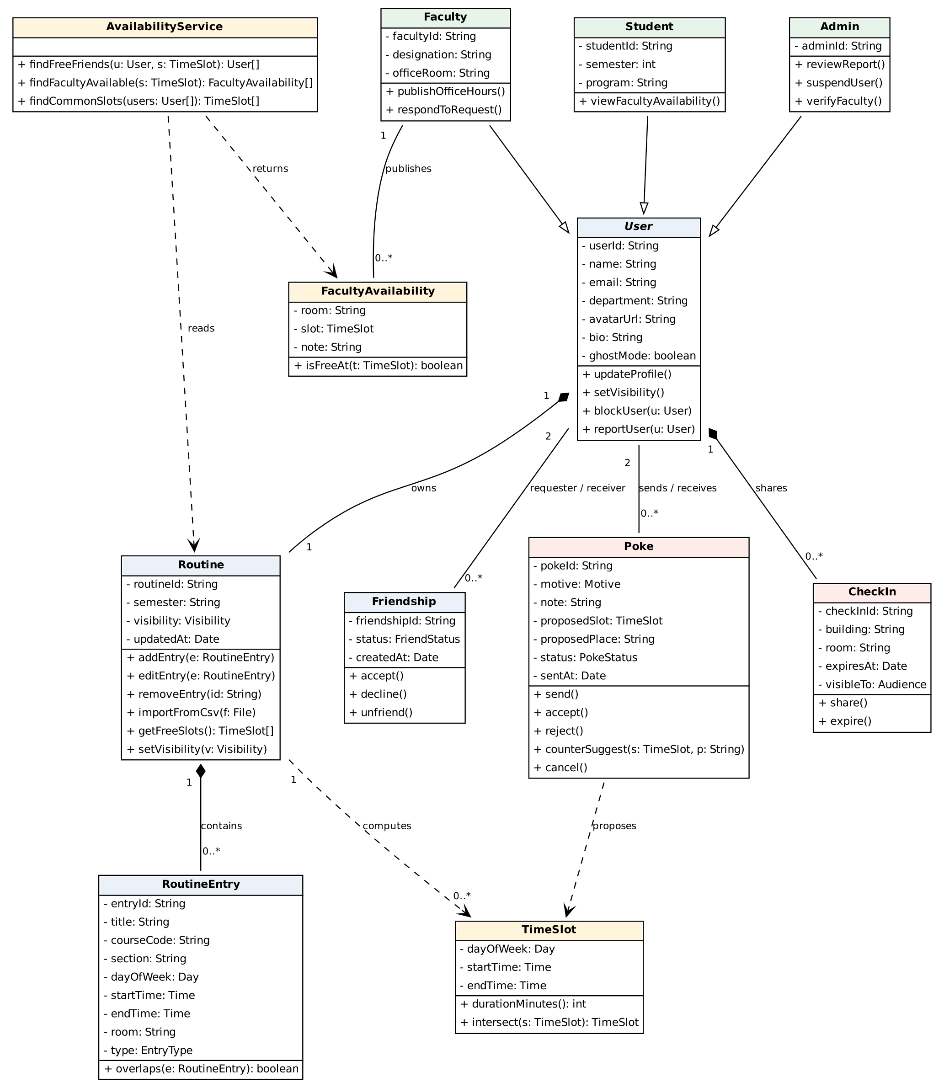
Figure 1: Core classes (users, routine, availability, friendship, poke, check-in)

6.2 Chat, posts and notifications
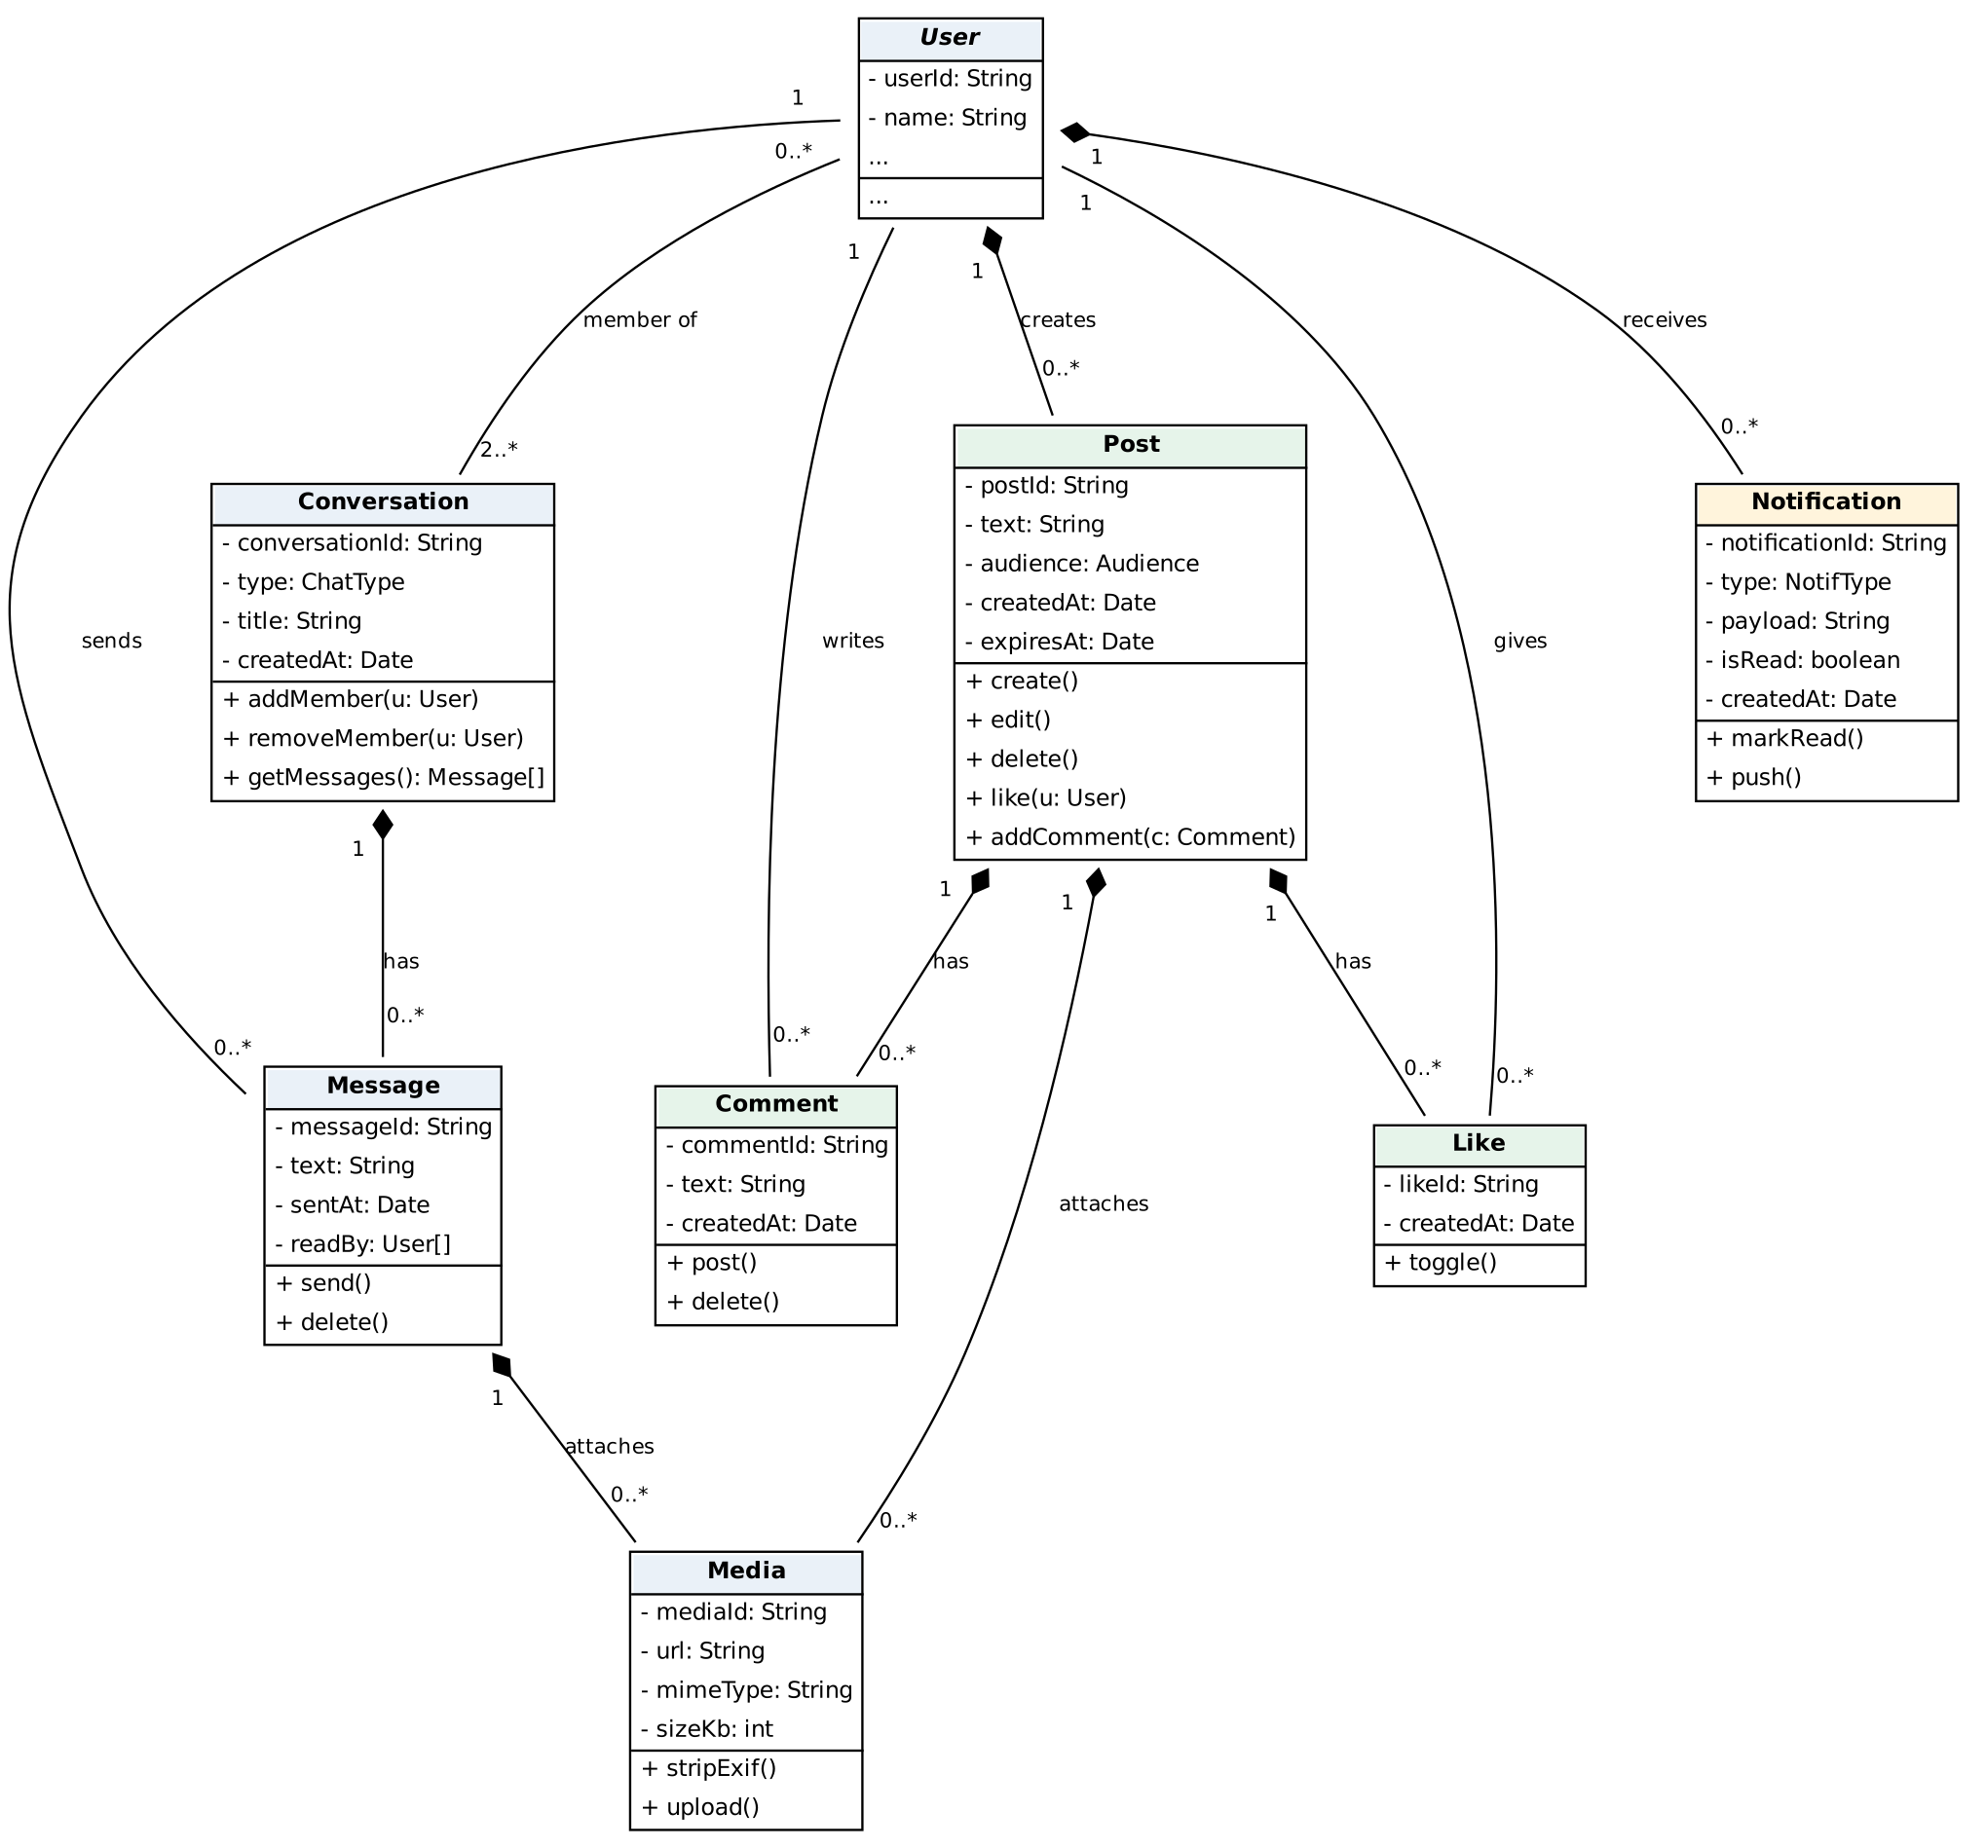
Figure 2: Social classes (conversation, message, post, comment, like, media, notification)

6.3 Safety and moderation
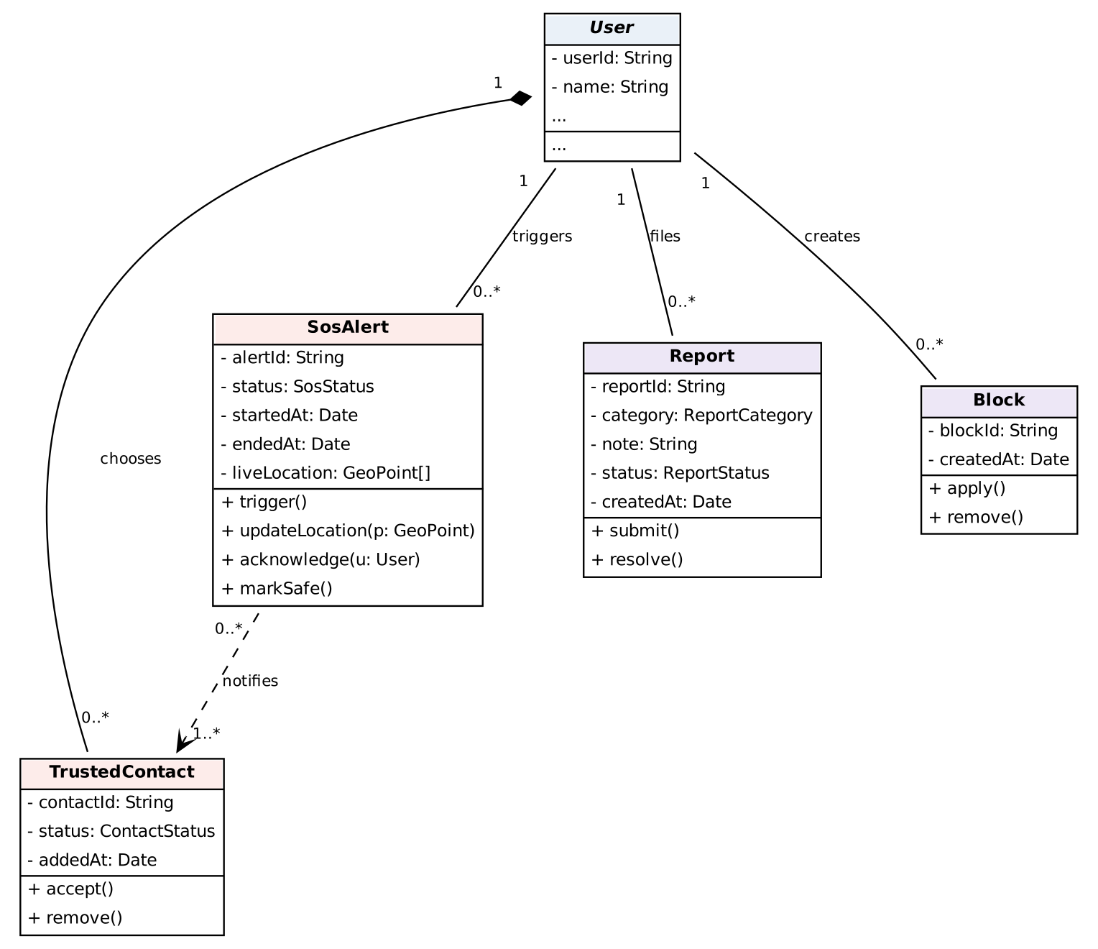
Figure 3: Safety classes (trusted contact, SOS alert, report, block)

6.4 Class descriptions
Class | Responsibility
User (abstract) | Base account: profile data, privacy settings, blocking and reporting. Parent of Student, Faculty and Admin.
Student | A student user; has student ID, semester and program; can view faculty availability.
Faculty | A faculty user; has designation and office room; publishes office hours and answers consultation requests.
Admin | Moderator; reviews reports, suspends users and verifies faculty.
Routine | A user's weekly schedule for one semester, with a visibility setting; can compute free slots.
RoutineEntry | One class, lab, office hour or event in a routine (day, start, end, room, type).
TimeSlot | A day and time range; used for free slots and for the slot proposed in a poke.
AvailabilityService | Matches routines: finds free friends, common slots and available faculty for a time slot.
FacultyAvailability | A faculty free slot with its room, shown to students.
Friendship | A friend request and its status between two users.
Poke | A hangout proposal with motive, slot and place; can be accepted, rejected or countered.
CheckIn | An opt-in, expiring campus location shared with a chosen audience.
Conversation / Message | A one-to-one or group chat and the messages in it.
Post / Comment / Like | Social content: posts and instants with their comments and likes.
Media | An uploaded image; EXIF data is stripped on upload.
Notification | An alert for a user about an event (poke, message, SOS, and so on).
TrustedContact | A friend chosen to receive the user's emergency alerts.
SosAlert | An emergency alert with live location updates and acknowledgements.
Report / Block | Moderation records: a report about a user or content, and a block between two users.

7. Project setup tasks
These are the preparation tasks required in the assignment. Team member names and exact dates should be filled in by the group.

7.1 Framework setup
- Backend: create a NestJS project (Node.js, TypeScript) with TypeORM for PostgreSQL, class-validator for input checks and Socket.IO gateways for real time.
- Frontend: create a React and TypeScript project with Vite, React Router and a UI library (Tailwind or MUI).
- Structure (MVC): Models = TypeORM entities, Controllers = NestJS controllers, Views = React pages and components; services hold business logic.
- Repository: one GitHub repository with two folders (backend, frontend) or two repositories; protect the main branch; use feature branches and pull requests.
- Hello-world check: a health-check endpoint on the backend and a page on the frontend that calls it, deployed once to confirm the setup works.

7.2 Environment configuration
Item | Setup
Tools | Node.js LTS, npm, Git, VS Code (ESLint and Prettier), Postman or Thunder Client, pgAdmin or DBeaver.
Database | PostgreSQL (local Docker or a free Neon or Supabase database); one database for development and one for testing; seed script with demo routines.
Environment variables | .env file per project (never committed) and an .env.example listing: PORT, DATABASE_URL, JWT_SECRET, CLIENT_URL, CLOUDINARY keys.
Local run | Backend on port 3000, frontend on port 5173; CORS allows only the frontend URL.
Image storage | Cloudinary (or S3) account; EXIF stripping before upload.
CI and hosting | GitHub Actions to run lint and tests on pull requests; API on Render or Railway, frontend on Vercel.
Code style | TypeScript strict mode, shared ESLint and Prettier rules, commit messages like feat: or fix:.

7.3 Self-learning plan
Topic | What to learn | Weeks
TypeScript and Node.js basics | Types, async/await, modules, npm. | 1
React | Components, hooks, routing, forms, state, calling APIs. | 1-2
NestJS | Modules, controllers, services, DTOs, guards, WebSocket gateways. | 1-2
PostgreSQL and TypeORM | Tables, relations, indexes, SQL joins and time-range queries for free-slot matching. | 1-2
Git and GitHub workflow | Branches, pull requests, code review, resolving conflicts. | 1
UML and SRS writing | Class diagrams, requirement statements, use cases. | 1
Security basics | Password hashing, JWT, input validation, image metadata removal. | 1
Method: use the official documentation and short tutorials, build a tiny practice feature for each topic, and present what was learned to the team in the Friday demo.

7.4 Workload distribution
Template for a team of three; adjust the names and the number of rows to match your team. Each member owns features end to end (database, API and UI) and also does one shared task.
Area | Member 1 | Member 2 | Member 3
Assignment 1 documents | SRS sections 1-3 | SRS sections 4-5 and class diagram | Project setup (section 7) and review
Framework and environment | Backend setup | Frontend setup | Repository, CI and deployment
Features (first build) | Routine, free time, faculty availability | Friends, pokes, notifications | Chat, posts, location and SOS
Templates | Backend module template | Page and component templates | Document and PR templates
Testing and review | Test free-slot logic | Test poke flow | Test chat and SOS

7.5 Template creation
- Page templates (wireframes): home (who is free), routine grid, friend free-time view, poke dialog and poke list, chat, feed, profile, faculty directory, SOS screen, settings.
- Reusable components: navigation bar, routine grid, free-slot card, friend card, poke card, chat bubble, post card, notification item, SOS button.
- Design basics: colour palette, fonts, spacing, button and form styles defined once and reused; created as wireframes in Figma (or on paper).
- Code templates: backend module (schema, controller, service, DTO) and frontend page template, so every feature starts with the same layout.
- Document templates: SRS outline, GitHub issue template, pull request template and weekly meeting notes.

7.6 Other setup tasks
- Create a GitHub Projects board with one card per requirement ID.
- Agree on the database schema and API conventions together in the first week; write the API list in Swagger (OpenAPI).
- Prepare a seed script with sample students, faculty and routines to test free-time matching.
- Plan testing: unit tests for free-slot and overlap logic, API tests for the poke flow, manual checks for privacy rules.
- Keep a short risk list (see below) and review it every week.
Risk | Mitigation
Free-slot matching is slow with many friends | Index routine entries by day and time; cache results; limit the search window.
Users do not enter routines | Make entry fast (grid, CSV import); show value early with sample data.
Location misuse or privacy worries | Opt-in, expiry, building-level only, ghost mode, clear privacy page.
Team members learn at different speeds | Pair on first features; weekly demos; shared code templates.
Scope too large for 12 weeks | Build all Must requirements first; drop Could items.

8. Suggested additions and improvements
These ideas are not part of the required features. They are grouped by whether they mainly help the app work better (Performance) or help more people find and keep using it (Reach). Effort is a rough guess for a small student team.
Idea | Why it helps | Type | Effort
Progressive Web App (installable, works on phones) | Most students use phones between classes; installing from the browser avoids app-store delay and improves daily use. | Reach | Low
Verified BRAC University email signup | Keeps the network campus-only, builds trust and reduces fake accounts. | Reach | Low
Automatic friend discovery from shared courses and sections | New students find classmates with no typing; speeds up network growth. | Reach | Medium
"Free together now" quick view on the home screen | The main value in one tap: who is free right now and where. | Performance | Low
Smart meeting suggestion (best time and place for a group) | Removes back-and-forth; makes group plans easy. | Performance | Medium
Calendar export (.ics) and Google Calendar sync | Fits the app into the tools students already use. | Reach | Low
Campus map with food, study and hangout places | Gives pokes a place to point to; helpful for new students. | Reach | Medium
Class-cancelled and room-change alerts | Faculty announce changes; free-time results update immediately. | Performance | Medium
Exam-week and study-group mode | Match students with the same course for study sessions in free slots. | Reach | Medium
Events and club pages | Clubs post events that appear on members' routines; strong growth channel. | Reach | High
Invite links and QR codes at campus | Easy sharing in classes and clubs; helps word-of-mouth growth. | Reach | Low
Bangla and English interface, dark mode | Wider comfort and accessibility. | Reach | Low
Hangout streaks and badges | Light gamification that keeps people returning. | Reach | Low
Cached free-slot results and database indexes (Redis optional) | Free-time matching is the heaviest query; caching keeps it fast as users grow. | Performance | Medium
Pagination, image compression and lazy loading | Faster pages on slow campus Wi-Fi and mobile data. | Performance | Low
Routine import from a screenshot (OCR) with manual review | Removes the biggest barrier: typing the routine in. | Reach | High
Carpool, lost and found, and campus marketplace sections | Extra daily reasons to open the app; keep for later. | Reach | High
Privacy dashboard ("who can see what") | Builds trust, which matters because the app shares schedules and location. | Performance | Low

Suggested short list: installable web app (PWA), verified university email signup, automatic friend discovery from shared courses, the "free together now" home view, calendar export, caching of free-slot results, and invite links. These give the largest gain for the least work.

