ASG_Airline Use Case Submission
Submitted By,
Sharon Dany (2548044)
Msc Data Science
Christ (Deemed to be University)

1.Dataset Structure
The source Excel workbook contains four related tables: flights, bookings, passengers and payments. The tables are connected using flight_id, passenger_id and booking_id.

Table | Initial Rows | Columns | Key | Main Contents
Flights | 1,020 | 7 | flight_id | Airline, source, destination, departure time, arrival time, duration
Bookings | 1,000 | 9 | booking_id | Passenger, flight, booking date, status, seat and contact details
Passengers | 1,039 | 9 | passenger_id | Passenger name, age, gender, email, phone, Aadhaar and DOB
Payments | 1,000 | 4 | payment_id / booking_id | Booking, amount and payment method

Table Relationships:
passengers.passenger_id → bookings.passenger_id
bookings.flight_id → flights.flight_id
bookings.booking_id → payments.booking_id

2.Architecture Diagram

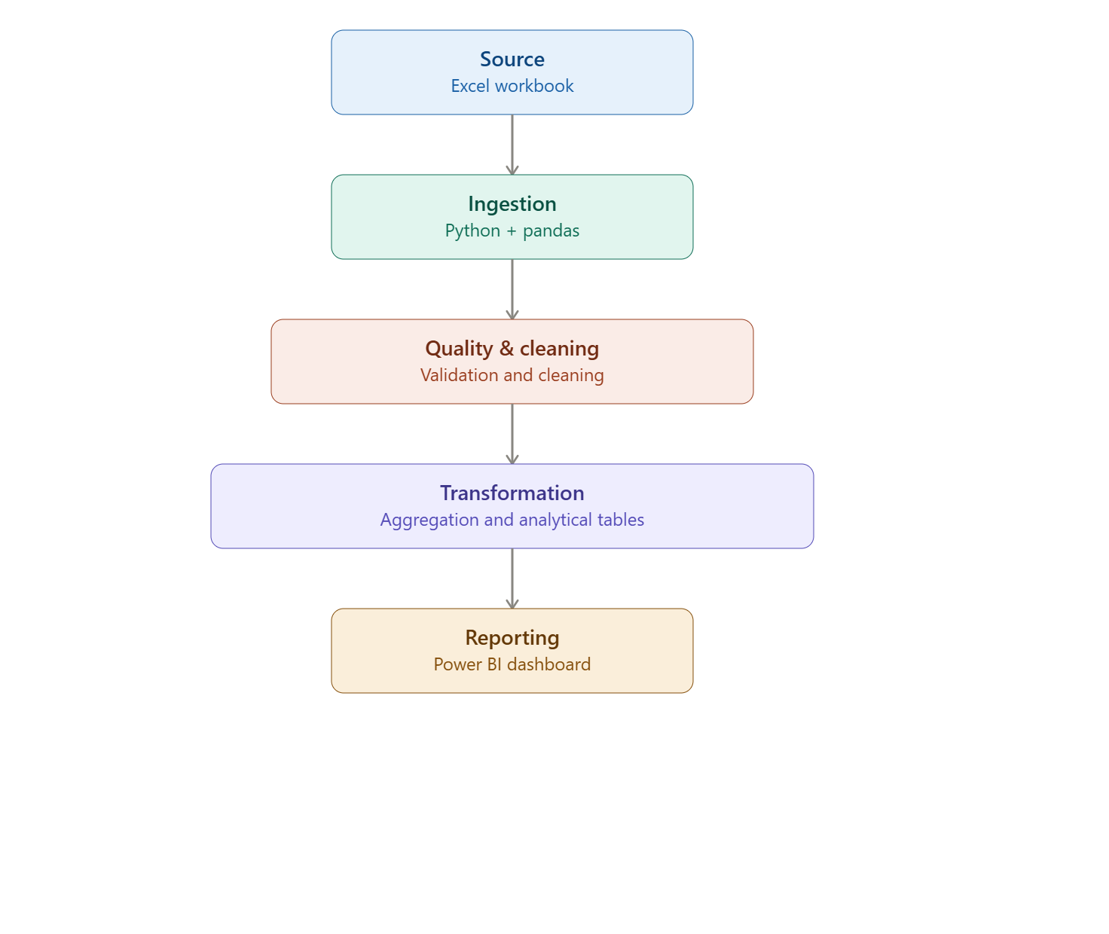
Flow: Excel Workbook → Python/Pandas Ingestion → Data Profiling → Cleaning and Validation → Transformation and Aggregation → Analytical Tables → Power BI.

3. Data Flow Diagram
Stage | Input | Processing | Output
1. Source | Excel workbook | Read four sheets | Loaded DataFrames
2. Profiling | Loaded DataFrames | Check shape, types, missing values and duplicates | Quality findings
3. Cleaning | Raw DataFrames | Fix invalid values, duplicates and inconsistencies | Cleaned data
4. Transformation | Cleaned data | Create derived fields and categories | Analytical features
5. Aggregation | Bookings and payments | Aggregate payments and summaries | Analytical tables
6. Reporting | Analytical tables | Power BI modelling and visualization | Interactive dashboard

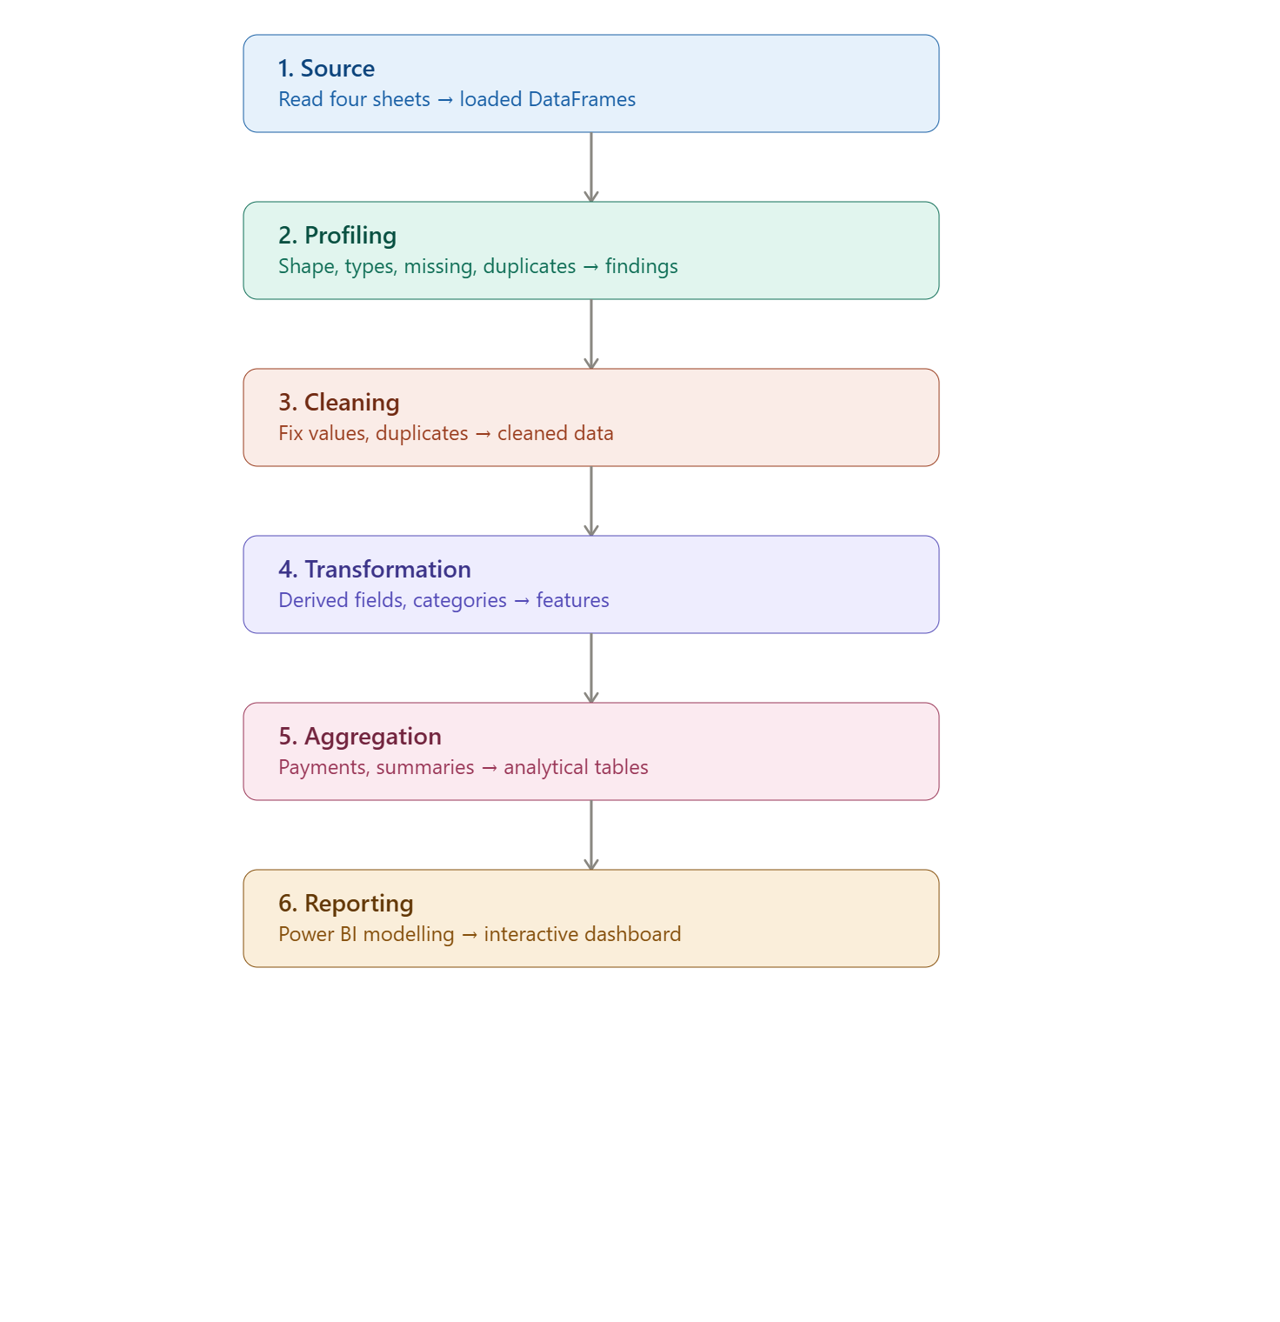

4. Data Model
fact_bookings is the central booking-level table. Supporting tables provide flight, passenger and payment context.
Table | Final Rows | Key | Role
fact_bookings | 1,000 | booking_id | Central booking-level analytical table
dim_flights | 1,003 | flight_id | Flight and route information
dim_passengers | 1,000 | passenger_id | One-row-per-passenger analytical lookup
dim_payments | 637 | booking_id | Payment totals summarized by booking
Payment records were aggregated by booking_id before merging so that multiple payment records did not multiply booking rows.

5. Data Cleaning Logic and Strategy
5.1 Flights
- 15 exact duplicate flight rows were removed.
- Missing and UNKNOWN airline values were standardized using flight ID prefixes: 6F = IndiGo, AI = Air India, SJ = SpiceJet and UK = Vistara.
- One invalid timestamp was identified for SJ192 and corrected using its recorded five-hour duration.
- The conflicting 6F250 records were flagged as ambiguous rather than resolved by guessing.
- The two ambiguous 6F250 records were excluded from the flight table used for booking joins, while the bookings were retained.
5.2 Payments
- 48 payment amounts were missing and 30 were marked INVALID.
- Payment amounts were safely converted to numeric values; invalid values became missing.
- A payment_missing flag was created.
- Multiple payment records for the same booking were grouped and summed before integration.
- Missing payment amounts were retained as missing rather than treated as zero.

5.3 Bookings
- 45 booking statuses were missing and 30 were INVALID.
- INVALID statuses were converted to missing values.
- A status_missing flag was created.
- Booking IDs were checked for uniqueness and duplicate booking rows were not found.
- Passenger, flight and payment relationships were validated.

5.4 Passengers
- The passenger table contained 1,039 rows and 1,000 unique passenger IDs.
- Repeated passenger IDs were investigated because some records contained conflicting details.
- 10 missing last names were corrected where the name could be reliably separated.
- A one-row-per-passenger analytical lookup was created for reporting.
- Sensitive fields were excluded from the public analytical layer.

5.5 Text and Date Standardization
- Text fields were stripped of unnecessary spaces.
- Departure time, arrival time, booking date and date of birth were standardized as datetime fields.

6. Transformation Steps and Logic

Derived Field | Transformation Logic
route | source + destination
airline_route | airline + route
duration_minutes | hours × 60 + minutes + seconds / 60
duration_category | Short ≤120; Medium 121–240; Long >240 minutes
departure_date / arrival_date | Date extracted from timestamps
departure_period | Night, Morning, Afternoon or Evening based on departure hour
booking_month | Year-month extracted from booking_date
booking_year | Year extracted from booking_date
days_before_flight | Departure date minus booking date
booking_lead_category | Last Minute 0–7; Short Term 8–30; Medium Term 31–90; Long Term >90 days
booking_group | CONFIRMED/PENDING = Active; CANCELLED = Cancelled
payment_missing | True when there is no valid payment amount
status_missing | True when booking status is missing

7. Duration Calculation

- The source duration column was stored as time objects. It was converted into numeric minutes using the hour, minute and second components.
- For example, 02:54 becomes 174 minutes. Timestamp differences between arrival and departure were also compared with recorded duration to identify inconsistent records.
- Small differences of a few tenths of a second were treated as rounding-level differences because the timestamps contained milliseconds.

8. Overnight Flight Handling

- A flight is considered overnight when arrival_date is later than departure_date. Complete departure and arrival datetime values were retained, so overnight flights do not require manually adding 24 hours.
- The final analytical flight table contains 124 overnight flights. The invalid SJ192 timestamp was handled separately because its arrival date was earlier than its departure date in a way inconsistent with the recorded duration.

9.PII Protection and Handling

The source dataset contains personally identifiable information (PII), particularly in the passengers and bookings tables. The following fields were identified as sensitive:
- Passenger names
- Email addresses
- Phone numbers
- Aadhaar ID
- Passport number
- Emergency contact name
- Emergency contact phone number
- Date of birth
PII was handled using the following approach:
- PII Identification: Sensitive columns were identified during the initial data inspection.
- Masking: Masked versions were created for sensitive values where required for inspection or reporting:
  - Aadhaar ID :only the last four digits retained.
  - Phone number only the last four digits retained.
  - Email :local part masked while retaining the email domain.
  - Passport number :masked.
  - Emergency contact phone :masked.

- Data Minimization: Only the fields required for analytical reporting were used in the analytical model. Sensitive contact and identity fields were not required for KPI calculations.
- Source Protection: The original Excel workbook containing PII was kept locally and was excluded from the GitHub repository using .gitignore.
- Analytical Use: Passenger-level analysis uses non-sensitive attributes such as passenger ID, age and gender wherever possible, rather than exposing identity or contact information.

10. Assumptions Made

- The supplied Excel workbook is treated as the source of truth.
- The SJ192 arrival timestamp is corrected using its recorded five-hour duration.
- The two conflicting 6F250 records are treated as ambiguous; the pipeline does not guess the correct record.
- Multiple payment records for one booking are summed to create a booking-level amount.
- Missing payment amounts remain missing and are not interpreted as zero.
- CONFIRMED and PENDING are grouped as Active for analytical reporting.
- A one-row-per-passenger lookup is used for reporting when repeated passenger IDs occur.
- No delay KPI is calculated because the dataset does not contain scheduled and actual flight times or a dedicated delay field.

11. Final Analytical Outputs

- fact_bookings.csv — booking-level analytical data.
- dim_flights.csv — cleaned and standardized flight data.
- dim_passengers.csv — one-row-per-passenger reporting lookup.
- dim_payments.csv — payment totals summarized by booking.
- These analytical outputs are used as the source for the Power BI report. The original workbook contains PII and is retained locally rather than uploaded to the public GitHub repository.

12 PowerBI Dashboard

