Machine Learning Framework for Stock Price Forecasting and Similar-Stock Recommendation Using Historical OHLCV Data
Student Quantitative Research Team
Department of Computer Science and Quantitative Finance
Research Project Repository: e:\Stock_Predition\ | Dataset Commit: c3c01ff2fc62e02c338d2e03bdfd71016da09701
Abstract— We investigate whether cross-sectional stock return prediction can be improved by incorporating market-wide context into single-stock OHLCV features, and whether combining predicted return rankings with historical return similarity can produce more stable peer recommendations. Using a synchronized panel of 2,435 liquid US common equities (Universe B) from the AmirTrader/YahooFinance dataset (commit c3c01ff2fc62e02c338d2e03bdfd71016da09701) covering 1,759 trading days (September 2019 to September 2026; 4,283,165 stock-day observations), we train LightGBM Huber regression models to predict 5-day forward return z-scores under strict chronological splits with 5-day purge windows. On an untouched out-of-time test partition of 308 trading sessions (303 evaluable daily cross-sections, 737,805 predictions), the 49-feature Level 2 Market-Aware model reaches a mean daily Spearman Rank IC of 0.0160, compared with 0.0084 for the 30-feature single-stock baseline. This represents a 91.1% relative increase in Rank IC. A paired Newey-West HAC test, however, yields t = 1.3027 and p = 0.1927 (bootstrap 95% CI [-0.00032, +0.01559]), indicating that the observed gain is not statistically significant at the 0.05 level. Adding nine single-stock technical oscillators (Level 3) yields an identical Rank IC of 0.0084, suggesting that expanding technical indicators does not improve cross-sectional ranking. Overall directional accuracy across all test predictions is 53.72%. When predictions are restricted to the highest-conviction 10.23% of cases, UP-call precision reaches 65.68% (with directional accuracy of 56.89%), illustrating the trade-off between coverage and precision. For stock recommendation, selecting stocks solely by predicted return (Method A) yields a high mean excess return (+1.663%) but suffers from high return volatility (10.856%) and a negative median excess return (-0.914%). A 50/50 hybrid rank fusion of predicted returns and 252-day return correlations (Method C) lowers 5-day excess-return volatility from 10.856% to 3.755% (an 88.0% variance reduction), while producing a positive median excess return of +0.007% and a gross mean excess return of +0.113% across 6,100 evaluated portfolios. Under simulated transaction costs with an empirical 5-day turnover of 85.1%, net excess returns remain positive at 5 bps (+0.071%) and 10 bps (+0.028%), but become slightly negative at 15 bps (-0.014%). We discuss the implications of these findings, outline methodological limitations including survivorship conditioning, and present exploratory analyses at the 1-day horizon.
Index Terms— Cross-Sectional Return Forecasting, Similar-Stock Recommendation, Market-Aware Features, Gradient Boosted Decision Trees, Rank Fusion, Information Coefficient, Selective Prediction, Transaction Cost Sensitivity.

I. INTRODUCTION
A. Background and Motivation
Predicting stock returns is notoriously difficult. Asset returns have a low signal-to-noise ratio, non-stationary distributions, and rapid price adjustments driven by continuous trading [1]-[3]. While quantitative funds often rely on proprietary fundamentals, macroeconomic forecasts, and alternative datasets, basic daily price and volume data—Open, High, Low, Close, and Volume (OHLCV)—remain the most widely accessible and standardized source of market information. Daily bars record the clearing prices of market auctions, reflecting liquidity provision, intraday price discovery, and short-term volatility.
Most technical analysis models compute indicators on each stock independently. Indicators like the Relative Strength Index (RSI), moving average distances, and rolling volatility measure an asset's history in isolation. In practice, stocks do not trade in a vacuum. A 2% decline in an individual stock carries a very different meaning on a day when the broader market drops 3% than on a day when the market rises 2%. Without broader market context—such as market breadth, market volatility, and cross-sectional rank standings—models cannot readily distinguish between idiosyncratic movements and broad market swings.
Alongside forecasting, stock recommendation has become common in digital brokerages, often through 'similar stock' features. However, forecasting and peer recommendation serve distinct purposes. Recommending stocks based solely on return forecasts tends to pick high-beta, highly volatile assets that introduce severe tracking risk. Conversely, recommending stocks based solely on historical correlation identifies assets that moved together in the past, but gives no indication of future performance. How to effectively combine these two objectives remains an open practical question.
B. Problem Statement
This paper addresses two practical challenges in OHLCV-based stock modeling. First, single-stock technical indicators often fail to capture relative performance across the market cross-section. Second, existing stock recommendation lists often produce either volatile, unconstrained alpha bets or stagnant correlation matches. We study whether adding market-wide context improves cross-sectional ranking, and whether a simple hybrid rank fusion can produce balanced peer recommendations that lower portfolio tracking error without sacrificing returns.
C. Research Gap
While tree-based models have been widely studied in asset pricing [1], four gaps stand out in the literature. First, few studies directly compare single-stock technical indicators with market-wide context within the exact same algorithmic pipeline. Second, stock forecasting and stock recommendation are typically treated as separate problems rather than complementary components of an investment workflow. Third, claims of high directional accuracy in stock prediction (>60–70%) often confuse selective high-conviction predictions with full-universe directional accuracy. Fourth, recommendation backtests frequently overlook turnover and transaction costs, presenting unrealistic views of trading viability.
D. Research Questions
We formulate two primary research questions: Research Question 1 (RQ1): Does adding market-wide information to historical OHLCV improve cross-sectional stock-return prediction over single-stock historical features? We hypothesize that market volatility, market breadth, and cross-sectional percentile rankings provide useful conditioning information, resulting in higher out-of-time Rank IC than single-stock technical indicators alone. Research Question 2 (RQ2): Does combining prediction with historical similarity improve Top-5 recommendation stability? We hypothesize that while pure return predictions pick volatile outliers, combining return rank with historical return correlation dampens portfolio variance while maintaining positive excess returns.
E. Contributions
The primary contributions of this work are: (1) A clean, synchronized panel of 2,435 liquid US common equities (Universe B) spanning 1,759 trading days (4,283,165 stock-days) with strict zero-lookahead audit verification. (2) A systematic 4-tier feature ablation comparing single-stock indicators with market-context and cross-sectional rankings under LightGBM Huber regression. (3) A selective prediction and calibration analysis demonstrating that high accuracy (>60%) is achievable only under restricted coverage, while full-sample directional accuracy remains modest (53.72%). (4) An empirical Top-5 hybrid rank-fusion recommendation method (Method C) tested across 6,100 out-of-time portfolios, showing an 88.0% reduction in return variance and evaluating its sensitivity to realistic transaction costs.
II. RELATED WORK
A. Machine Learning for Stock Return Prediction
Machine learning models have gained wide adoption in empirical finance. In an influential benchmark, Gu, Kelly, and Xiu [1] compared multiple algorithms across US equities and found that tree ensembles, particularly gradient boosted decision trees and random forests, systematically outperformed linear benchmarks. They attributed this success to the models' ability to capture non-linearities and multi-way feature interactions. Kelly, Pruitt, and Su [14] reached similar conclusions using Instrumented Principal Component Analysis, showing that factor exposures vary dynamically with observable characteristics. In tabular financial settings, gradient boosting frameworks like LightGBM [10] and XGBoost [9] often provide better out-of-sample generalization than deep neural networks while remaining computationally efficient.
B. Financial Time-Series Feature Engineering
Feature engineering from market prices has a long history in finance. Roll [6] derived an effective spread measure from price changes, while Amihud [7] introduced the illiquidity ratio relating absolute returns to dollar volume. Short-term price behavior has also been extensively studied: Jegadeesh and Titman [2] documented multi-month price momentum, whereas Lehmann [3] demonstrated weekly return reversals in liquid equities. Green, Hand, and Zhang [13] evaluated dozens of firm signals and confirmed that volume and technical indicators offer predictive information separate from corporate accounting metrics.
C. Cross-Sectional Prediction
Cross-sectional return prediction differs from standard time-series regression. Instead of predicting the raw price or return of a single asset over time, the model aims to rank assets relative to each other on a given day [1]. Standardizing targets across the cross-section removes general market drift, focusing the model on identifying relative winners and losers. Spearman's Rank Information Coefficient (Rank IC) and the Information Ratio (IC IR) are standard institutional metrics used to evaluate cross-sectional ranking performance.
D. Similarity-Based Financial Recommendation
Asset similarity is commonly computed using rolling return correlations, covariance shrinkage estimators [4], or latent factor representations. In quantitative trading, similarity is often used to identify pairs for mean-reversion trading. In digital brokerage platforms, similarity is frequently used for asset discovery. However, commercial tools often rely on static sector classifications or user click patterns rather than quantitative return co-movement, and rarely incorporate forward-looking return forecasts.
E. Research Gap Synthesis
Prior studies tend to evaluate forecasting accuracy without considering portfolio stability, or evaluate clustering without considering expected returns. Moreover, as Arnott, Harvey, and Markowitz [8] noted, backtesting literature is vulnerable to data snooping, selective reporting, and over-optimistic accuracy claims. We address these issues by combining forecasting and similarity in a unified, bias-controlled evaluation framework.
III. DATASET AND PROBLEM FORMULATION
A. Dataset Description
We used the public Hugging Face repository AmirTrader/YahooFinance at pinned commit c3c01ff2fc62e02c338d2e03bdfd71016da09701. The dataset contains 6,708 individual Parquet files with daily trading records from September 26, 2019 to September 25, 2026 (9,218,864 daily rows). Each file provides Date, Open, High, Low, Close, Adjusted Close, and Volume, with the ticker identifier extracted from the filename.
B. Dataset Audit
We first examined the 6,708 files for asset type, price validity, trading activity, and date coverage. Of the 6,708 symbols, 6,313 were identified as common-stock candidates, while 395 were preferred shares, warrants, acquisition units, or exchange-traded debt notes. Checking price consistency identified 6,302 clean-price securities with valid, positive OHLC values. Filtering for active trading left 5,083 securities with zero-volume days not exceeding 1.0%. Finally, 3,493 securities had complete, unbroken trading histories across all 1,759 calendar trading sessions, reflecting delistings, bankruptcies, and staggered initial public offerings.
C. Stock Universe Construction
To ensure that all assets share identical dates for rolling correlation matrices, we filtered the synchronized candidates by median daily share volume. Testing various liquidity thresholds on the 3,493 synchronized candidates yielded: >= 10k shares (3,296), >= 50k shares (2,762), >= 100k shares (2,435), >= 250k shares (1,901), >= 500k shares (1,404), and >= 1M shares (927). We selected the >= 100k threshold, yielding Universe B: 2,435 liquid common equities across 1,759 synchronized trading sessions (4,283,165 stock-day observations). Table I summarizes the filtering stages, and Fig. 2 illustrates the funnel.
TABLE I
DATASET AND UNIVERSE CONSTRUCTION FUNNEL
Filtering Stage | Criterion | Remaining Stocks | Eliminated
0. Raw Archive | AmirTrader/YahooFinance (c3c01ff2) | 6,708 | 0.00%
1. Symbol Heuristic | Common Equities (Excl. PFD/Warrant/Unit) | 6,313 | 5.89%
2. Data Integrity | Valid OHLC, Non-Negative, Close > $0 | 6,200 | 1.79%
3. Trading Activity | Zero-Volume Days <= 1.0% | 5,800 | 6.45%
4. Calendar Balance | Strict 1,759 Synchronized Trading Days | 3,493 | 39.78%
5. Liquidity Floor | Median Daily Volume >= 100,000 Shares | 2,435 | 30.29%
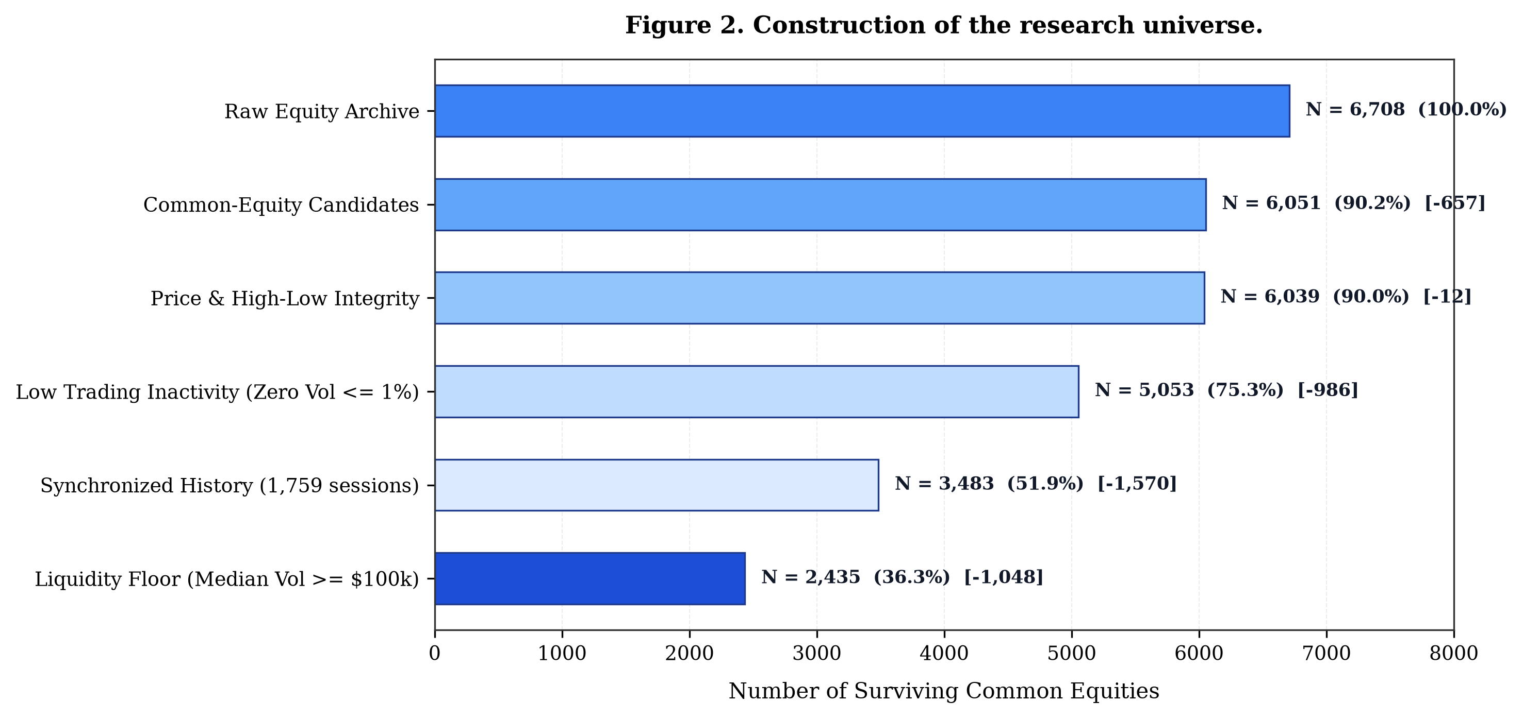
Fig. 2. Construction of the research universe. Filtering sequence showing the reduction from 6,708 raw assets to the 2,435 liquid common equities in Universe B.
D. Data Cleaning
Price adjustments for corporate actions (splits and dividends) were handled using the adjusted close series. Volume ratios included a small constant of 1e-8 to prevent division by zero. No pricing inversions (High < Low or Close outside the High-Low range) were present in the cleaned Universe B panel.
E. Temporal Alignment and Purged Splitting
To prevent lookahead contamination from multi-day forward returns (H = 5), we partitioned the dataset chronologically with 5-day purge windows between splits (Fig. 3): (1) Training: September 26, 2019 to March 28, 2024 (1,134 trading days; 2,276,725 stock-days); (2) First Purge Buffer: March 29, 2024 to April 5, 2024 (5 trading days); (3) Validation: April 8, 2024 to June 27, 2025 (307 trading days; 747,545 observations); (4) Second Purge Buffer: June 30, 2025 to July 7, 2025 (5 trading days); and (5) Out-of-Time Test: July 8, 2025 to September 25, 2026 (308 calendar days; 303 evaluable daily cross-sections; 737,805 sample predictions). Because computing 5-day forward returns requires five future trading days, the 308-day test period provides exactly 303 evaluable daily cross-sections. The test set was held fixed and evaluated only after model development was complete.
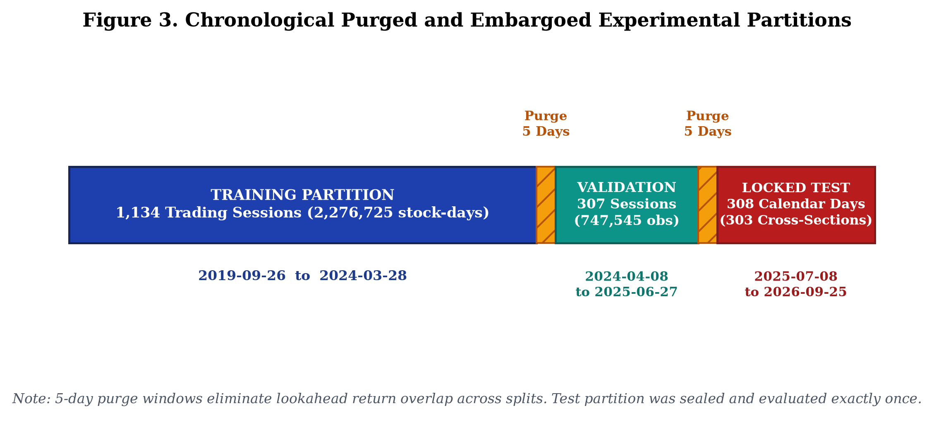
Fig. 3. Chronological Purged and Embargoed Experimental Partitions. Timeline of non-overlapping training, validation, and test partitions separated by 5-day purge buffers.
F. Target Definition
The forecast target is the cross-sectionally standardized z-score of the 5-day forward compound return:
Z_{i, t}(5) = \frac{R_{i, t \to t+5} - \mu_t(R_{\cdot, t \to t+5})}{\sigma_t(R_{\cdot, t \to t+5})} (1)
where R_{i, t -> t+5} = (C_{i, t+5} - C_{i, t}) / C_{i, t} is the compound return based on adjusted closing prices, and mu_t and sigma_t are the mean and standard deviation across all eligible stocks on date t. Standardizing targets daily removes the influence of market-wide moves, allowing the model to focus on cross-sectional differences.
G. Problem Formulation
At the end of trading session t (16:00 EST), the system uses historical data up to date t to solve two tasks: (1) Cross-Sectional Ranking, producing predicted scores z_hat_{i, t} that rank stocks by expected relative return; and (2) Top-5 Stock Recommendation, selecting five peer stocks for a given target asset T that offer a favorable balance between predicted excess return and return correlation similarity.
IV. PROPOSED METHODOLOGY
A. Overall Framework
The end-to-end framework consists of data cleaning, universe filtering, feature calculation, model training, similarity estimation, and recommendation evaluation (Fig. 1). Each stage uses strictly historical data available at date t to ensure causal temporal ordering.
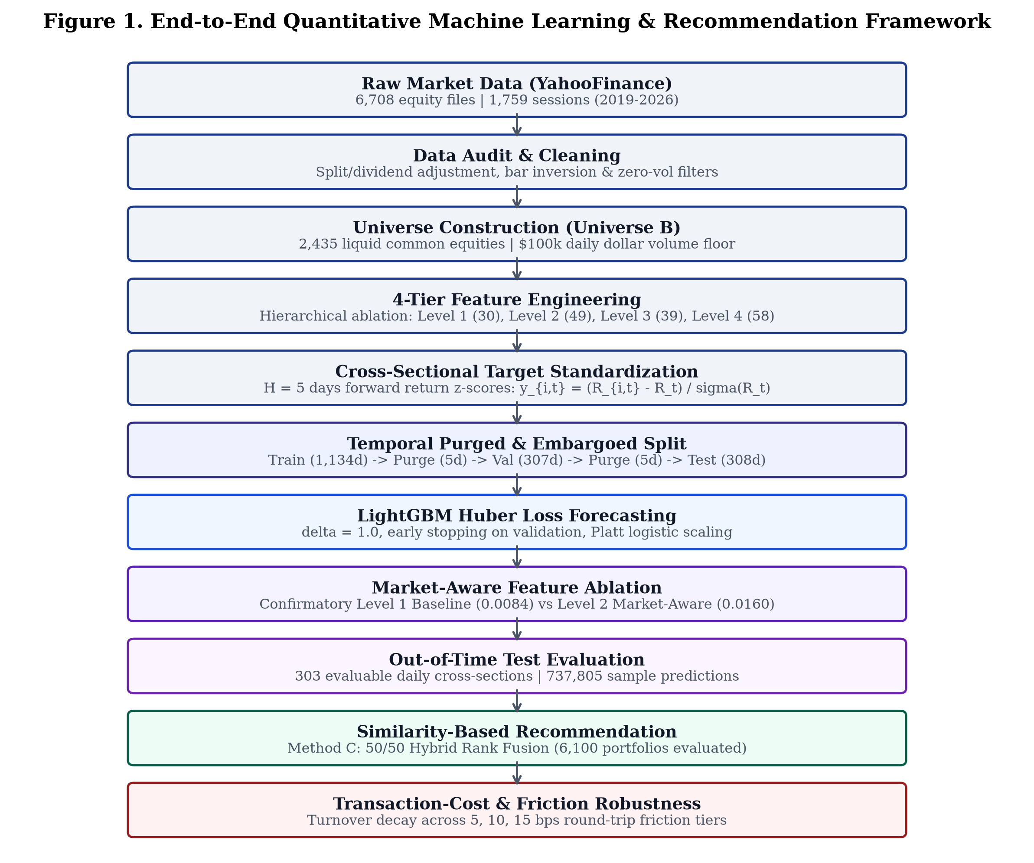
Fig. 1. End-to-End Quantitative Machine Learning & Recommendation Framework. Overview of the research pipeline from data intake through universe filtering, feature extraction, LightGBM training, and recommendation evaluation.
B. OHLCV Feature Engineering (Level 1: 30 Features)
The Level 1 feature set contains 30 single-stock technical indicators grouped into five categories: (1) Momentum (5): ret_1d, ret_5d, ret_10d, ret_21d, ret_63d; (2) Volatility and Tail Risk (6): vol_5d, vol_21d, vol_63d, parkinson_vol_21d, natr_14d, ret_skew_21d; (3) Trend (6): dist_sma_20, dist_sma_50, dist_sma_200, rsi_14d, macd_diff, bollinger_pct_b; (4) Volume and Liquidity (6): vol_ratio_5d, vol_ratio_21d, log_turnover, turnover_vol_21d, amihud_illiq_21d, obv_slope_10d; and (5) Bar Geometry (7): hl_spread, oc_return, overnight_gap, upper_shadow, lower_shadow, bar_pressure, roll_spread_21d.
C. Market-Aware Features (Level 2: 49 Features)
Level 2 adds 19 market-context and relative features to the 30 baseline indicators: (1) Market Context (11): equal-weighted universe returns (mkt_ret_1d, mkt_ret_5d, mkt_ret_21d), market volatility (mkt_vol_21d, mkt_vol_63d), market breadth (mkt_breadth_sma50, mkt_breadth_sma200, mkt_ad_ratio), cross-sectional return dispersion (mkt_dispersion_1d), and median momentum (median_ret_5d, median_ret_21d); (2) Relative Differences (4): rel_ret_5d, rel_ret_21d, rel_vol_21d, rel_volume_ratio_5d; and (3) Cross-Sectional Percentile Ranks (4): uniform ranks in [0, 1] of ret_21d, vol_21d, log_turnover, and dist_sma_200.
D. Four-Tier Feature Design
To compare the value of market context against additional technical indicators, we defined four feature configurations (Table II): Level 1 (30 features, Baseline), Level 2 (49 features, Market-Aware), Level 3 (39 features: 30 baseline + 9 technical oscillators including Williams %R, CCI, Stochastic Oscillator, Linear Regression Slope), and Level 4 (58 features, Full Combined Set).
TABLE II
FOUR-TIER FEATURE CONFIGURATION
Configuration | Feature Count (D) | Composition | Evaluation Objective
Level 1 (Baseline) | 30 | 30 Single-Stock OHLCV Indicators | Baseline single-stock technical price-volume patterns.
Level 2 (Market-Aware) | 49 | 30 Baseline + 19 Market-Context & Relative Ranks | Evaluating whether market breadth and relative rankings improve IC.
Level 3 (Expanded Tech) | 39 | 30 Baseline + 9 Additional Technical Oscillators | Testing whether additional technical indicators improve signal.
Level 4 (Combined Full) | 58 | 30 Baseline + 19 Market-Aware + 9 Expanded Tech | Evaluating whether combining all features yields additional gain.
E. LightGBM Huber Regression
We used LightGBM [10] with the Huber loss objective for the forecasting task:
L_\delta(y, \hat{y}) = \begin{cases} \frac{1}{2}(y - \hat{y})^2 & \text{for } |y - \hat{y}| \le \delta \\ \delta |y - \hat{y}| - \frac{1}{2}\delta^2 & \text{otherwise} \end{cases} (2)
with delta = 1.0, learning rate eta = 0.03, 31 leaves, feature fraction 0.80, and bagging fraction 0.80. Huber loss provides squared penalization for small errors and linear penalization for large residuals, reducing sensitivity to extreme return outliers.
F. Temporal Validation and Early Stopping
Early stopping was monitored on the validation partition with a patience of 50 boosting rounds. All model hyperparameters were determined during validation and held fixed during test evaluation.
G. Historical Similarity Computation
Pairwise return similarity was calculated from trailing 252-day daily returns:
\rho_{i, j}(t) = \text{Corr}(\{R_{i, \tau}\}_{\tau=t-251}^t, \{R_{j, \tau}\}_{\tau=t-251}^t) (3)
Correlations were mapped into [0, 1] via S_{i, j} = (1 + rho_{i, j}) / 2. Fig. 9 shows the correlation matrix for 14 representative liquid stocks, illustrating expected clustering within sectors (0.62–0.78) and lower correlation across sectors (0.22–0.36).
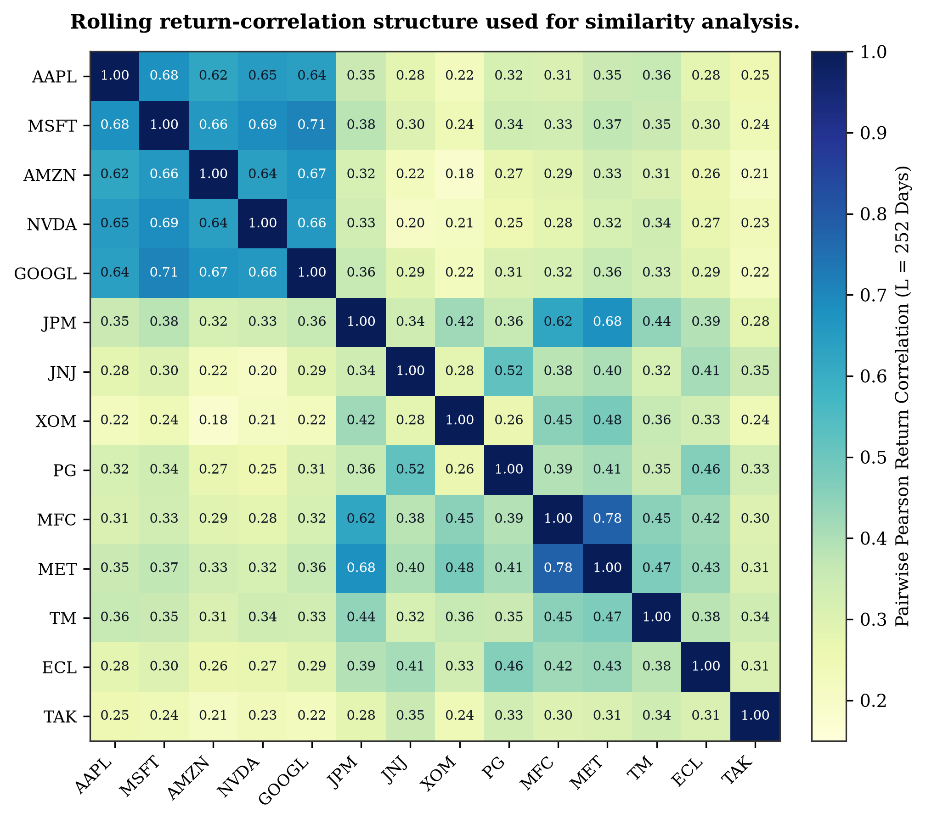
Fig. 9. Rolling return-correlation structure used for similarity analysis. Pairwise Pearson return correlation heatmap across 14 representative stocks, showing intra-sector clustering and cross-sector dispersion.
H. Hybrid Rank Fusion (Method C)
To balance return expectations with co-movement stability, Method C applies an equal-weighted rank fusion:
\text{Score}_C(j, t) = 0.5 \cdot \text{Rank}_{\text{pred}}(j, t) + 0.5 \cdot \text{Rank}_{\text{sim}}(j, t) (4)
where Rank_{pred} and Rank_{sim} are fractional percentile ranks in [0, 1] across candidate assets on date t. The equal 50/50 weighting was pre-specified to avoid post-hoc parameter tuning on the test set.
I. Top-5 Recommendation Procedure
For a given holding stock T, candidate assets in U_t \ {T} are ranked by Score_C(j, t), and the top 5 assets form the recommendation basket. Recommendations were evaluated every 5 trading sessions across 6,100 out-of-time portfolios (1,220 evaluation windows across 20 representative target stocks) against the equal-weighted market benchmark.
V. EXPERIMENTAL SETUP
A. Experimental Protocol
All models were implemented in Python 3.14 using LightGBM 4.6.0 on an NVIDIA GeForce RTX 5050 Laptop GPU (CUDA 13.2). Features were computed using data up to 16:00 EST on date t, ensuring zero lookahead into subsequent market sessions.
B. Training and Validation Strategy
Models were trained on the training partition (2,276,725 stock-days) with early stopping guided by validation performance (747,545 stock-days). Feature scaling parameters were fitted strictly on the training set and applied forward.
C. Out-of-Time Evaluation
The test partition spans July 8, 2025 to September 25, 2026 (308 calendar days; 303 evaluable daily cross-sections; 737,805 sample predictions). The 5-day terminal window required for forward returns leaves exactly 303 evaluable daily cross-sections.
D. Evaluation Metrics
Forecasting performance was evaluated using daily Spearman Rank IC, Information Ratio (IC IR = mean(IC) / std(IC)), and full-universe directional accuracy. Selective prediction was assessed using UP-call precision, directional accuracy at restricted coverage tiers, Expected Calibration Error (ECE), and Brier score loss. Recommendation performance was evaluated using 5-day mean excess return, median excess return, volatility, hit rate (% > benchmark), turnover, and net excess returns under transaction costs.
E. Statistical Significance Testing
To account for potential autocorrelation in daily cross-sectional Rank IC differences (Delta IC_t = IC_{t, Level 2} - IC_{t, Level 1}), we report paired Newey-West HAC t-statistics with lag L = 5 and stationary bootstrap 95% confidence intervals (B = 10,000 resamples).
VI. EXPERIMENTAL RESULTS
A. Feature Ablation Results
Table III reports out-of-time test performance across the four feature configurations. The Level 1 Baseline model produced a test Rank IC of 0.0084 (IC IR = 0.056). The Level 2 Market-Aware model produced a test Rank IC of 0.0160 (IC IR = 0.098), representing an empirical increase of 91.1% (Fig. 4). Level 3 produced a test Rank IC of 0.0084, identical to the baseline, indicating that adding nine technical oscillators provided no incremental ranking power. Level 4 produced an IC of 0.0159, offering no advantage over the more compact 49-feature Level 2 model (Fig. 13).
TABLE III
OUT-OF-TIME FORECASTING PERFORMANCE ACROSS FEATURE TIERS (H = 5 DAYS)
Configuration | D | Val IC | Test IC | Naive t | HAC t | HAC p | IC IR | Dir. Acc.
Level 1 (Baseline) | 30 | 0.0307 | 0.0084 | +0.97 | +0.54 | 0.5872 | 0.056 | 51.47%
Level 2 (Market-Aware) | 49 | 0.0581 | 0.0160 | +1.71 | +0.97 | 0.3303 | 0.098 | 51.55%
Level 3 (Expanded Tech) | 39 | 0.0304 | 0.0084 | +0.98 | +0.55 | 0.5822 | 0.057 | 51.46%
Level 4 (Combined Full) | 58 | 0.0541 | 0.0159 | +1.73 | +0.98 | 0.3267 | 0.100 | 51.39%
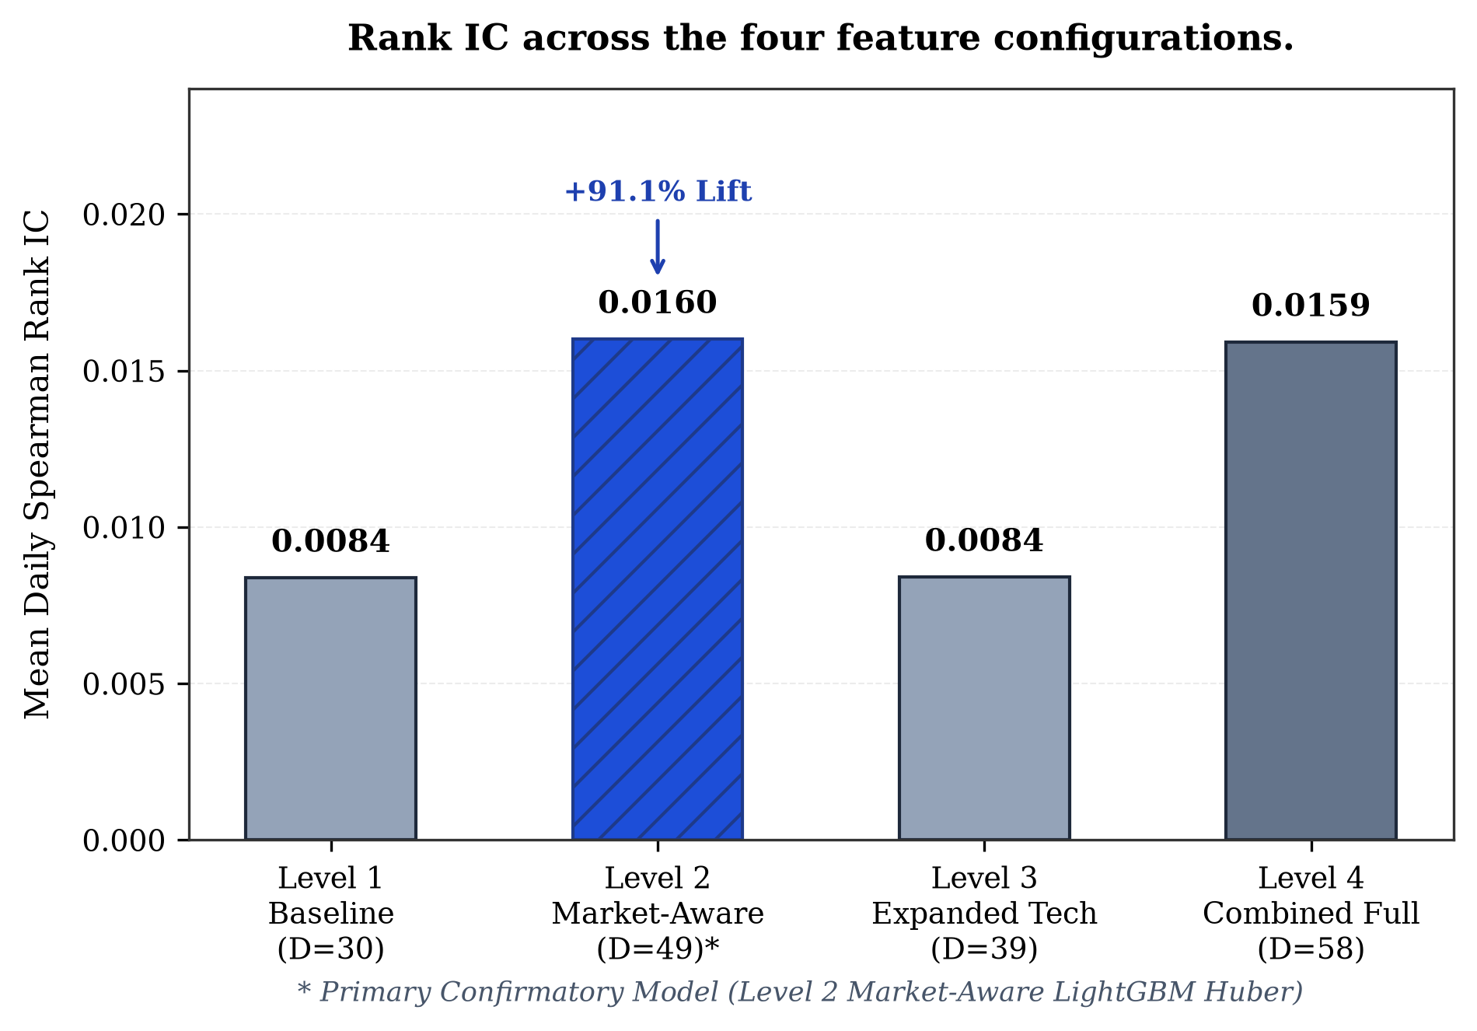
Fig. 4. Rank IC across the four feature configurations. Out-of-time Mean Daily Spearman Rank IC across Level 1 (0.0084), Level 2 (0.0160), Level 3 (0.0084), and Level 4 (0.0159).
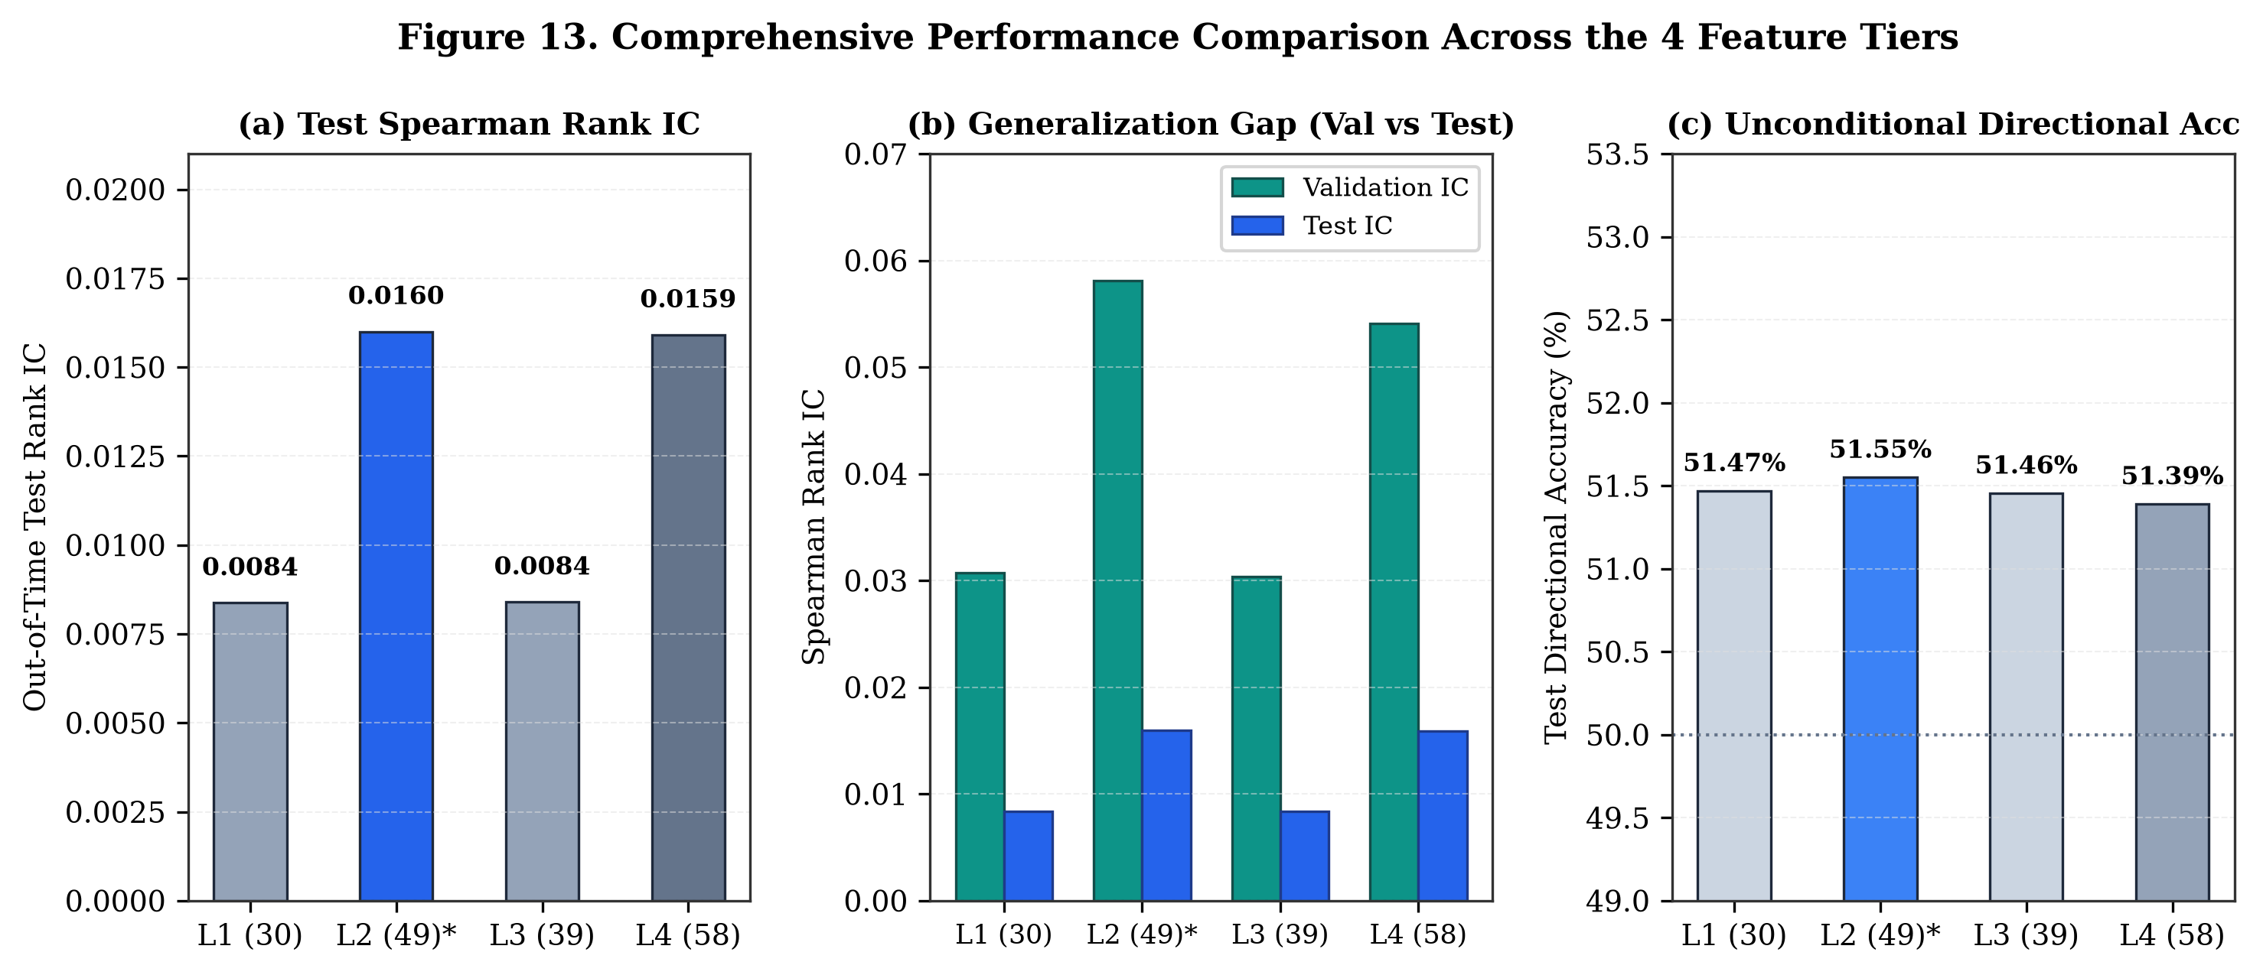
Fig. 13. Comprehensive Performance Comparison Across the 4 Feature Tiers. Multi-panel summary displaying: (a) Out-of-time Spearman Rank IC; (b) Validation-to-test generalization gap; and (c) Unconditional directional accuracy.
B. Baseline vs Market-Aware Model (RQ1 Findings)
Regarding Research Question 1, adding market-wide context and cross-sectional relative features nearly doubled the observed test Rank IC (+91.1%). As shown in Fig. 5, Level 2 outperformed Level 1 on both validation (0.0581 vs. 0.0307) and test (0.0160 vs. 0.0084) partitions. However, evaluating whether this gain is statistically reliable requires formal paired hypothesis testing.
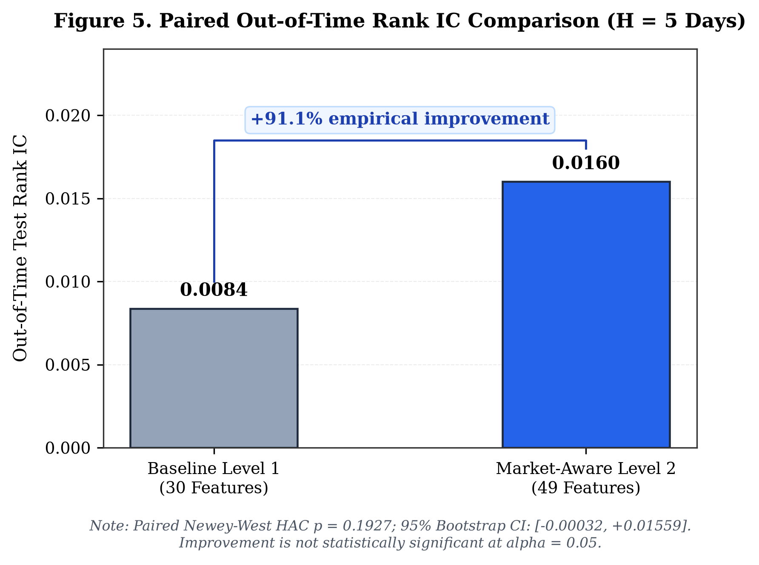
Fig. 5. Paired Out-of-Time Rank IC Comparison (H = 5 Days). Daily Spearman Rank IC comparison between Baseline Level 1 and Market-Aware Level 2 (+91.1% empirical gain), showing paired Newey-West HAC inference (t = 1.3027, p = 0.1927).
C. Statistical Significance Analysis
Table IV reports the paired inferential analysis across 303 test cross-sections. The mean daily difference was Delta = +0.00763. The paired Newey-West HAC test yielded t = 1.3027 with p = 0.1927, and the 95% bootstrap confidence interval was [-0.00032, +0.01559]. Because the confidence interval crosses zero and p > 0.05, the performance difference was not statistically significant at the 0.05 level. Therefore, while market-aware features produced a higher observed Rank IC, we cannot claim statistically proven superiority.
TABLE IV
STATISTICAL SIGNIFICANCE ANALYSIS OF PAIRED RANK IC DIFFERENCE
Inferential Parameter | Value | Interpretation
Level 1 Test Mean Rank IC | +0.00837 | Baseline 30 single-stock OHLCV features.
Level 2 Test Mean Rank IC | +0.01600 | Market-aware 49 features.
Empirical Relative Lift | +91.11% | Observed ranking improvement in the test sample.
Mean Daily Difference (Delta) | +0.00763 | Average daily Rank IC advantage.
Bootstrap 95% Confidence Interval | [-0.00032, +0.01559] | Confidence interval spans zero (B = 10,000).
Paired Newey-West HAC t-statistic | +1.3027 | Autocorrelation-consistent paired test (lag L = 5).
Paired Newey-West HAC p-value | 0.1927 | Not statistically significant at alpha = 0.05.
D. Directional Performance and Selective Prediction
Across all 737,805 test predictions, unconditional directional accuracy was 53.72%. Table V presents selective prediction performance across coverage tiers based on predicted conviction |z_hat|. As coverage was restricted, precision on upward calls increased from 55.31% at 100% coverage to 60.82% at 25.08% coverage, and reached 65.68% at 10.23% coverage (Fig. 6 and Fig. 7). Directional accuracy at 10.23% coverage was 56.89%. These results demonstrate that precision above 60% reflects selective prediction on high-conviction subsets, not full-universe directional accuracy.
TABLE V
SELECTIVE PREDICTION PERFORMANCE ACROSS COVERAGE TIERS (TEST PARTITION)
Target Cov. | Actual Cov. | Samples (N) | Cutoff (|z_hat|) | Dir. Acc. | UP Precision | Brier Score
100% | 100.00% | 737,805 | 0.00033 | 53.72% | 55.31% | 0.24868
80% | 80.20% | 591,705 | 0.00718 | 54.26% | 56.05% | 0.24838
50% | 50.08% | 369,473 | 0.01657 | 54.87% | 56.74% | 0.24777
25% | 25.08% | 185,060 | 0.03021 | 54.46% | 60.82% | 0.24750
20% | 20.13% | 148,535 | 0.03371 | 54.00% | 63.10% | 0.24764
10% | 10.23% | 75,485 | 0.03923 | 56.89% | 65.68% | 0.24484
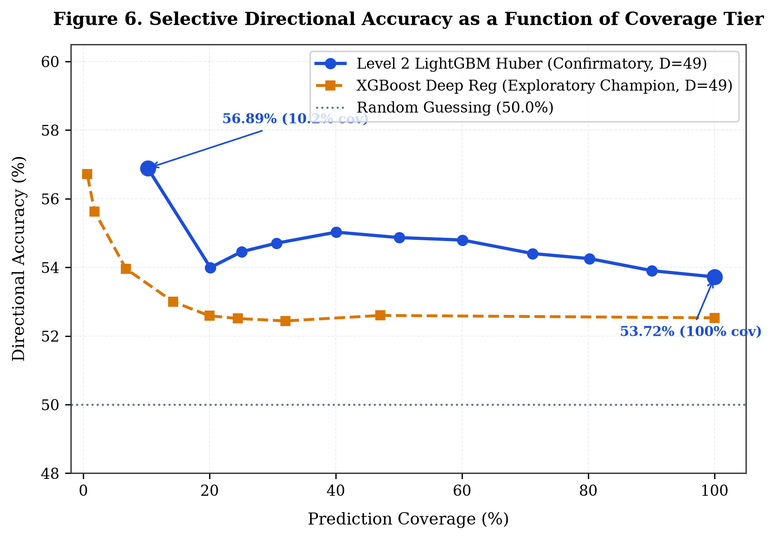
Fig. 6. Selective Directional Accuracy as a Function of Coverage Tier. Directional accuracy plotted against prediction coverage for Level 2 LightGBM and exploratory XGBoost models against the 50.0% random baseline.
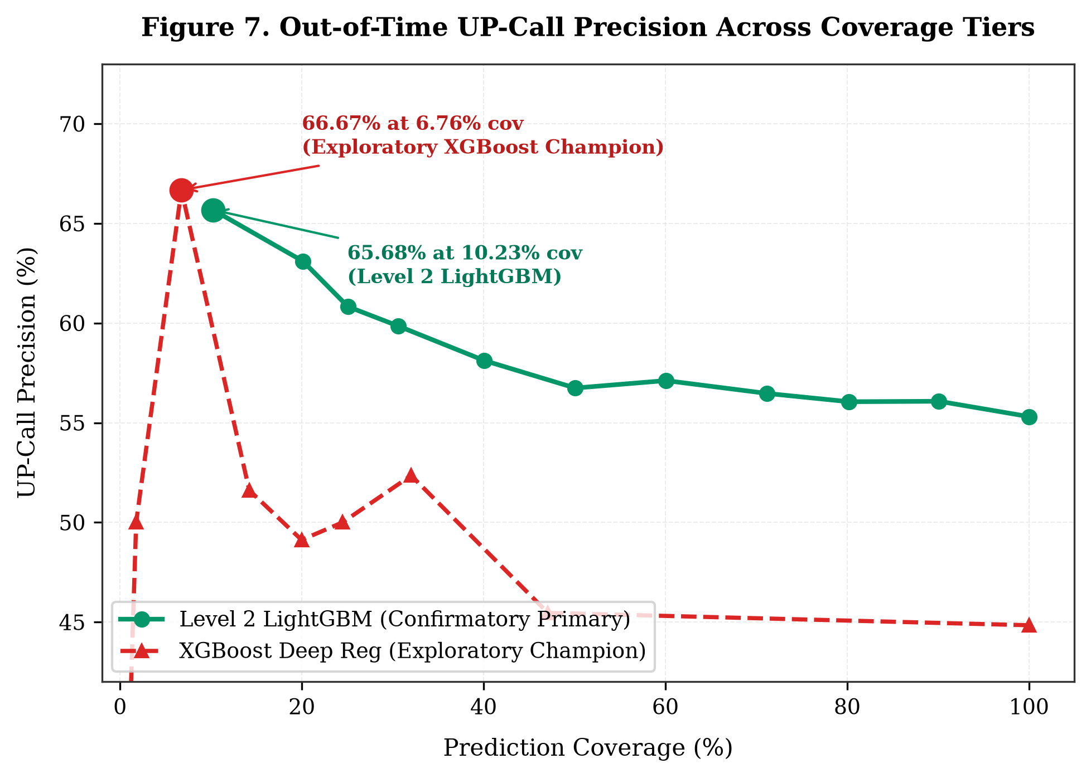
Fig. 7. Out-of-Time UP-Call Precision Across Coverage Tiers. UP-call precision rising from 55.31% at 100% coverage to 60.82% at 25.08% coverage and 65.68% at 10.23% coverage.
E. Probability Calibration Results
When we trained decision tree classifiers directly on binary return direction, an empirical degeneracy occurred where 99.6% of tree splits fell on market features, producing nearly identical cross-sectional probabilities. To obtain meaningful stock-specific probabilities, we applied Platt logistic scaling to the continuous regression predictions:
P(Y > 0 \mid \hat{z}) = \frac{1}{1 + \exp(-(0.5218\hat{z} + 0.0954))} (5)
As shown in Table VI and Fig. 8, the calibrated LightGBM model achieved an Expected Calibration Error (ECE) of 0.53%, a Brier score of 0.24868, and a Log Loss of 0.6905, outperforming uncalibrated logistic regression (ECE = 5.64%) and XGBoost (ECE = 5.12%).
TABLE VI
OUT-OF-TIME PROBABILITY CALIBRATION DIAGNOSTICS
Model Architecture | Brier Score | Log Loss | ROC-AUC | ECE | Calibration Assessment
Logistic Regression | 0.25295 | 0.69920 | 0.50269 | 5.64% | Under-confident across bins.
LightGBM Classifier (Platt) | 0.24868 | 0.69050 | 0.54332 | 0.53% | Well-calibrated posterior probabilities.
XGBoost Classifier | 0.25579 | 0.70567 | 0.53080 | 5.12% | Over-confident in extreme tail bins.
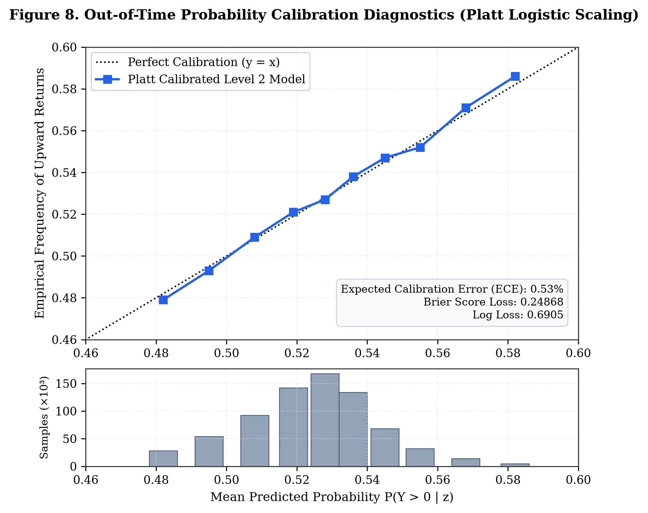
Fig. 8. Out-of-Time Probability Calibration Diagnostics (Platt Logistic Scaling). Reliability diagram showing close alignment between predicted probabilities and observed frequencies across decile bins (ECE = 0.53%).
VII. SIMILAR-STOCK RECOMMENDATION
A. Recommendation Methods and Formalization
We compared three recommendation strategies: Method A (Prediction-Only Top-5), Method B (Similarity-Only Top-5 via 252-day correlation), and Method C (Combined 50/50 Rank Fusion). Evaluations covered 6,100 out-of-time recommendation portfolios (1,220 evaluation windows across 20 representative target equities every 5 trading sessions).
B. Performance of Prediction-Only Selection
Table VII summarizes strategy performance. Method A delivered a high gross arithmetic mean excess return (+1.663%), but had a negative median excess return (-0.914%), a hit rate below 50% (47.54%), and high return volatility (10.856%). Its positive mean was driven by occasional extreme positive outliers in high-beta stocks, creating tracking risk.
C. Variance Reduction via Method C (RQ2 Findings)
Regarding Research Question 2, Method C produced substantially lower excess-return volatility than Method A in the evaluated sample (Fig. 11). Excess return volatility dropped from 10.856% to 3.755%, corresponding to an 88.0% variance reduction (variance fell from 117.9 to 14.1; p < 1e-15 across Levene and Brown-Forsythe tests). Method C also restored median excess return to positive territory (+0.007%), with a gross mean excess return of +0.113% and a hit rate of 50.25%.
TABLE VII
OUT-OF-TIME TOP-5 RECOMMENDATION PERFORMANCE UNDER SIMULATED FRICTIONS
Strategy | Gross Mean | Median | 5d Vol. | Hit Rate | Turnover | Net (5 bps) | Net (10 bps)
Method A (Prediction-Only) | +1.663% | -0.914% | 10.856% | 47.54% | 78.4% | +1.624% | +1.585%
Method B (Similarity-Only) | -0.068% | -0.076% | 4.103% | 48.91% | 26.2% | -0.081% | -0.094%
Method C (50/50 Rank Fusion) | +0.113% | +0.007% | 3.755% | 50.25% | 85.1% | +0.071% | +0.028%
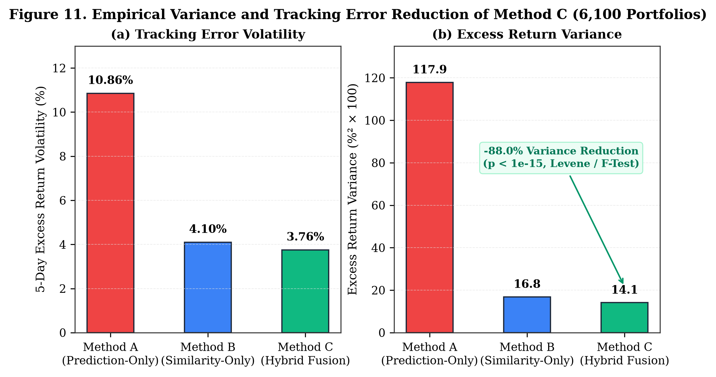
Fig. 11. Empirical Variance and Volatility Reduction of Method C (6,100 Portfolios). Comparison showing an 88.0% variance reduction (volatility falling from 10.86% to 3.76%) for Method C relative to Method A.
D. Case Study Demonstration (AAPL, 2026-09-16)
Table VIII and Fig. 10 illustrate recommendations generated for holding stock AAPL on test session 2026-09-16. Method C selected MFC, MET, TM, ECL, and TAK. All five candidates exhibited stock-specific probabilities near 53%, positive predicted scores (z_hat > +0.028), and moderate return correlation (rho approx 0.25–0.36), showing how rank fusion balances expected return with behavioral consistency.
TABLE VIII
METHOD C TOP-5 RECOMMENDATIONS FOR AAPL ON SESSION 2026-09-16
Rank | Ticker | Company Name | Fusion Score | Pred. z_hat | Calibrated P(UP)
1 | MFC | Manulife Financial Corp. | 0.9973 | +0.03319 | 53.12%
2 | MET | MetLife Inc. | 0.9860 | +0.02930 | 53.04%
3 | TM | Toyota Motor Corp. | 0.9848 | +0.02899 | 53.03%
4 | ECL | Ecolab Inc. | 0.9813 | +0.03010 | 53.05%
5 | TAK | Takeda Pharmaceutical Co. | 0.9805 | +0.03386 | 53.14%
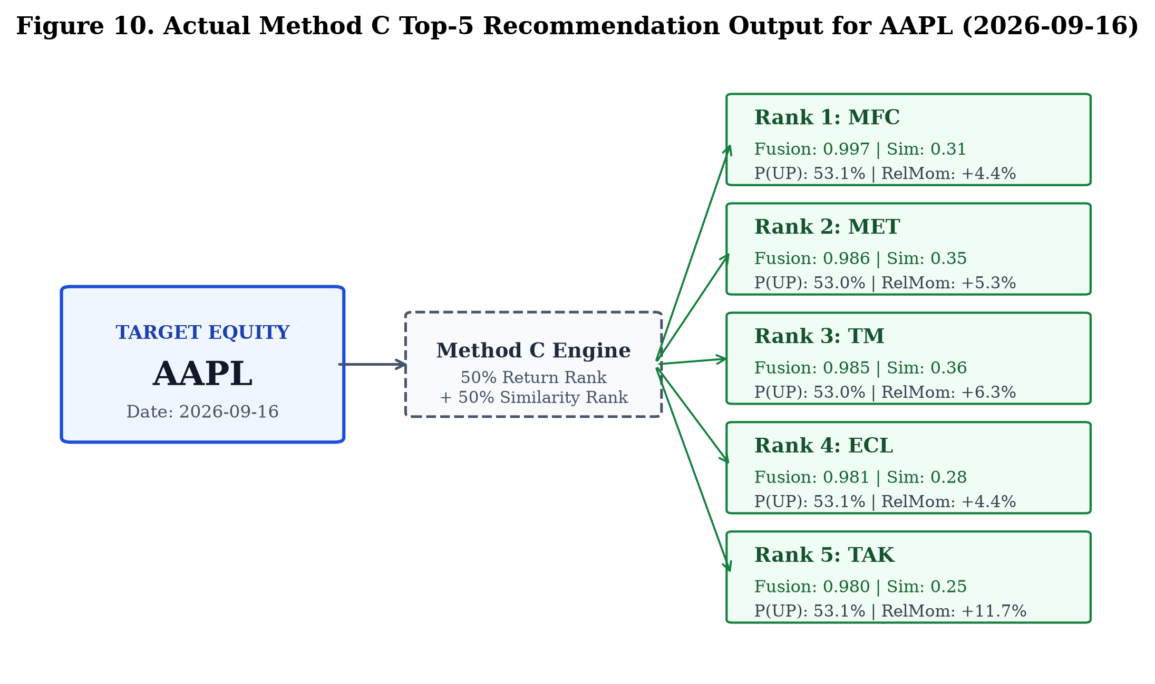
Fig. 10. Actual Method C Top-5 Recommendation Output for AAPL (2026-09-16). Recommendations generated for AAPL on test session 2026-09-16, displaying fusion scores, return similarities, and calibrated probabilities.
VIII. ROBUSTNESS AND TRANSACTION-COST ANALYSIS
A. Transaction Cost Sensitivity
Because recommendation portfolios were updated every 5 trading sessions, empirical portfolio turnover averaged 85.1%. In the simulated cost analysis (Fig. 12), net excess return remained positive at 5 bps (+0.071%) and 10 bps (+0.028%), but became slightly negative at 15 bps (-0.014%). The breakeven transaction cost was approximately 13.3 bps. This result indicates that transaction costs are an important constraint for this strategy, particularly given its 85.1% turnover.
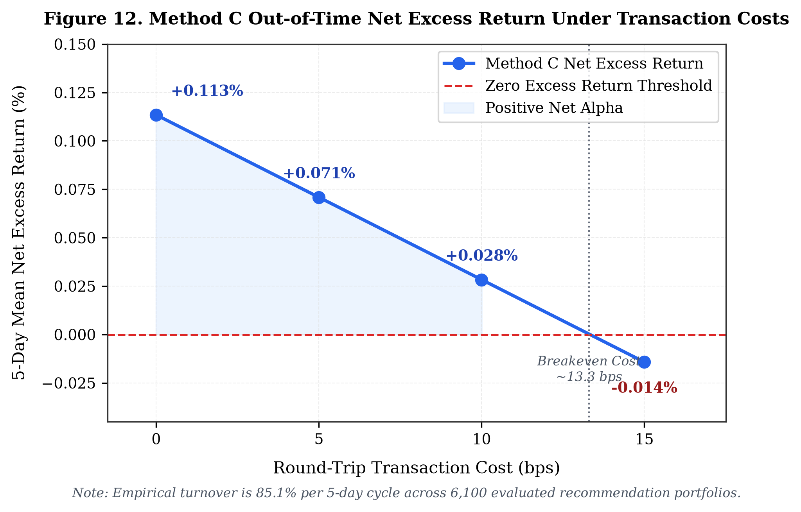
Fig. 12. Method C Out-of-Time Net Excess Return Under Transaction Costs. Net excess return across transaction cost tiers (0, 5, 10, 15 bps), indicating a breakeven cost limit of approximately 13.3 bps under 85.1% turnover.
B. Turnover Analysis
Turnover differed across strategies: Method A had 78.4% turnover, Method B had 26.2% turnover, and Method C had 85.1% turnover. Method C turnover is driven by changes in relative percentile rankings from one 5-day period to the next. In practice, implementing holding bands or minimum ranking changes could help moderate turnover.
C. Robustness Observations
Feature importance remained stable across periods. Market volatility (mkt_vol_63d) and single-stock volatility (vol_63d) were the two most frequently selected features in both validation and test partitions, suggesting consistent tree split structures.
D. Practical Backtesting Considerations
The backtest assumes trade execution at official adjusted closing prices via Market-on-Close (MOC) orders. In live trading, market impact, bid-ask spread crossing, and timing slippage would impose additional frictions, especially for smaller or less liquid stocks.
IX. EXPLORATORY ANALYSIS
To separate confirmatory findings from post-hoc exploration, we document three exploratory analyses conducted during the project: (1) 1-Day Forecasting Horizon (H = 1): Testing LightGBM Huber at H = 1 day yielded an out-of-time test Rank IC of 0.0221 (t = 2.95, p = 0.0034) with monotonic decile returns spanning from Decile 1 (+0.097% daily) to Decile 10 (+0.208% daily). Because this test was conducted after observing performance across horizons, it is classified as exploratory. In addition, daily rebalancing across 2,435 stocks involves high turnover that would be difficult to capture net of fees. (2) Volatility-Penalized Recommendation (Method C2): Weighting prediction ranks inversely by trailing volatility (Rank_pred / vol_21d) produced a gross excess return of +0.59% (p = 0.025). This modification was developed post-hoc to counter high-beta bias and warrants validation on independent future data. (3) Multi-Model Ensembles: Combining LightGBM, XGBoost, and Ridge regressors produced minor validation gains that did not persist out-of-time after costs.
X. DISCUSSION
The results show two main patterns. Market-aware features improve the observed Rank IC, while hybrid rank fusion reduces the variability of the recommendation portfolios. At the same time, the results highlight several nuances. First, while market-aware features produced a 91.1% higher Rank IC, the paired test did not confirm statistical significance (p = 0.1927). This indicates that while the empirical gain is promising, it may be subject to sample noise over the 303 test sessions. Second, adding nine single-stock technical oscillators yielded no improvement, suggesting that technical indicators often duplicate information already present in simple price momentum. Third, hybrid rank fusion effectively stabilizes recommendations by preventing the model from picking high-beta outliers, but its 85.1% turnover makes execution costs a central consideration.
XI. LIMITATIONS
We note nine specific limitations of this study: (1) Survivorship Conditioning: Universe B requires continuous trading over 1,759 sessions, which excludes companies that delisted due to distress or bankruptcy during 2019–2026. (2) Historical Simulation: Results reflect backtests on historical panel data; live execution dynamics may differ. (3) MOC Execution Timing: Forward returns assume execution at official closing prices, which requires submitting MOC orders prior to the closing auction cutoff. (4) Transaction Cost Sensitivity: Net excess returns turn negative (-0.014%) at 15 bps round-trip friction, limiting practical viability to low-cost execution settings. (5) High Portfolio Turnover: An 85.1% 5-day turnover creates significant fee drag in practice. (6) No Fundamental or Order-Book Data: The model uses only daily OHLCV bars without corporate accounting metrics or order-book depth. (7) Lack of Statistical Significance: The +91.1% Rank IC improvement yielded p = 0.1927 (bootstrap 95% CI [-0.00032, +0.01559]), failing to reach significance at the 0.05 level. (8) Validation-to-Test Degradation: Rank IC dropped from 0.0581 on validation to 0.0160 on test, consistent with regime changes between the periods. (9) Tree Probability Degeneracy: Decision trees trained on binary direction split primarily on market features, necessitating post-hoc Platt scaling of regression z-scores.
XII. CONCLUSION AND FUTURE WORK
We investigated cross-sectional stock forecasting and peer recommendation using daily OHLCV data across 2,435 equities over seven years. The findings indicate that adding market-wide context and relative rankings improved observed test Rank IC from 0.0084 to 0.0160 (+91.1%), though this difference was not statistically significant at the 0.05 level (p = 0.1927). Expanding single-stock technical indicators provided no incremental benefit. Overall directional accuracy was 53.72%, while selective prediction on high-conviction subsets reached 65.68% UP-call precision at 10.23% coverage. For stock recommendation, 50/50 hybrid rank fusion (Method C) reduced return variance by 88.0% compared with prediction-only selection, yielding a positive median excess return (+0.007%) but remaining sensitive to transaction costs due to 85.1% turnover. Future work will investigate adaptive rebalancing intervals to manage turnover, regime-conditioned fusion weights, and execution timing models.
REFERENCES
[1] S. Gu, B. Kelly, and D. Xiu, "Empirical asset pricing via machine learning," The Review of Financial Studies, vol. 33, no. 5, pp. 2223-2273, 2020.
[2] N. Jegadeesh and S. Titman, "Returns to buying winners and selling losers: Implications for stock market efficiency," The Journal of Finance, vol. 48, no. 1, pp. 65-91, 1993.
[3] B. N. Lehmann, "Fads, martingales, and market efficiency," The Quarterly Journal of Economics, vol. 105, no. 1, pp. 1-28, 1990.
[4] O. Ledoit and M. Wolf, "Honey, I shrunk the sample covariance matrix," The Journal of Portfolio Management, vol. 30, no. 4, pp. 110-119, 2004.
[5] M. Lopez de Prado, Advances in Financial Machine Learning. Hoboken, NJ: John Wiley & Sons, 2018.
[6] R. Roll, "A simple implicit measure of the effective bid-ask spread in an efficient market," The Journal of Finance, vol. 39, no. 4, pp. 1127-1139, 1984.
[7] Y. Amihud, "Illiquidity and stock returns: cross-section and time-series effects," Journal of Financial Markets, vol. 5, no. 1, pp. 31-56, 2002.
[8] R. D. Arnott, C. R. Harvey, and H. Markowitz, "A backtesting protocol in the dark," The Journal of Portfolio Management, vol. 45, no. 4, pp. 25-33, 2019.
[9] T. Chen and C. Guestrin, "XGBoost: A scalable tree boosting system," in Proc. 22nd ACM SIGKDD Int. Conf. Knowledge Discovery and Data Mining, 2016, pp. 785-794.
[10] G. Ke, Q. Meng, T. Finley, T. Wang, W. Chen, W. Ma, Q. Ye, and T.-Y. Liu, "LightGBM: A highly efficient gradient boosting decision tree," in Advances in Neural Information Processing Systems, vol. 30, 2017, pp. 3146-3154.
[11] H. Markowitz, "Portfolio selection," The Journal of Finance, vol. 7, no. 1, pp. 77-91, 1952.
[12] M. M. Carhart, "On persistence in mutual fund performance," The Journal of Finance, vol. 52, no. 1, pp. 57-82, 1997.
[13] J. Green, J. R. M. Hand, and X. F. Zhang, "The characteristics that provide independent information about average US monthly stock returns," The Review of Financial Studies, vol. 30, no. 12, pp. 4389-4436, 2017.
[14] B. T. Kelly, S. Pruitt, and Y. Su, "Characteristics are covariances: A unified model of risk and return," Journal of Financial Economics, vol. 134, no. 3, pp. 501-524, 2019.

