Machine Learning Framework for Stock Price Forecasting and Similar-Stock Recommendation Using Historical OHLCV Data
Autonomous Quantitative Research Collective
Department of Computer Science & Quantitative Financial Engineering
Technical Manuscript for Journal Publication
Repository: e:\Stock_Predition\ | Dataset Commit: c3c01ff2fc62e02c338d2e03bdfd71016da09701
Abstract— We present an empirical machine learning framework for cross-sectional stock return ranking and similar-stock recommendation operating exclusively on historical Open-High-Low-Close-Volume (OHLCV) market data. Addressing data snooping, lookahead leakage, and non-stationarity in computational finance, we construct a strictly synchronized, balanced panel of N = 2,435 liquid ordinary common equities (Universe B) spanning seven calendar years (September 26, 2019 to September 25, 2026; 1,759 consecutive trading sessions; 4,283,165 stock-day evaluations). Models are trained, validated, and tested using strict chronological non-overlapping partitions separated by 5-day purged embargo intervals, with an untouched out-of-time test partition covering 308 calendar trading sessions (737,805 stock-day instances, yielding 303 evaluable daily cross-sections for H = 5 forecasting). Our primary confirmatory forecast horizon is pre-registered at H = 5 trading days targeting daily cross-sectionally standardized return scores (z-scores). We evaluate four hierarchical feature representations: Level 1 (30 single-stock OHLCV features), Level 2 (49 features: 30 baseline + 19 market-context macro aggregates and cross-sectional relative features), Level 3 (39 expanded technical features), and Level 4 (58 combined features). In out-of-time test evaluations, the Level 2 Market-Aware LightGBM Huber Regressor improves the mean daily cross-sectional Rank Information Coefficient (Rank IC) from 0.0084 (Level 1) to 0.0160 (Level 2)—representing an encouraging +91.1% empirical gain. However, rigorous paired Newey-West HAC inference across 303 test sessions yields t = 1.3027 (p = 0.1927) with a 95% bootstrap confidence interval of [-0.00032, +0.01559], indicating that while the empirical lift is substantial, it does not achieve confirmatory statistical significance at alpha = 0.05. Expanding technical indicators alone (Level 3) yields zero incremental gain (0.0084). Unconditional directional accuracy across the full universe is 53.72%; under selective prediction, precision on upward calls scales monotonically to 60.82% at 25.08% coverage and 65.68% at 10.23% coverage (where directional accuracy reaches 56.89%, compared to 53.72% unconditionally). Probability calibration confirms that tree probabilities require Platt scaling to avoid leaf-level cross-sectional degeneracy. For portfolio asset recommendation, we formalize and test three paradigms: Method A (Prediction-Only Top-5), Method B (Similarity-Only Top-5 via trailing 252-day return correlation), and Method C (Combined 50/50 Rank Fusion). Across 6,100 out-of-time recommendation portfolios (1,220 evaluation windows), Method A delivers high gross arithmetic mean excess return (+1.663%) but suffers severe tracking error volatility (10.856%), negative median excess return (-0.914%), and low win rate (47.54%). Method B yields negligible excess return (-0.068%). In contrast, Method C rank fusion achieves an empirical measurement of 88.0% variance reduction relative to Method A in the evaluated historical sample (10.856% to 3.755%), while delivering a positive median excess return (+0.007%), a gross mean excess return of +0.113%, and a 50.25% hit rate. Under simulated transaction costs, Method C remains positive at 5 bps (+0.071% net) and 10 bps (+0.028% net), turning slightly negative at 15 bps (-0.014%) due to 85.1% turnover. Post-hoc exploratory analyses at H = 1 day and volatility-penalized rankings are disclosed with explicit multiplicity caveats. All data pipelines, features, and evaluation scripts are made fully reproducible.
Index Terms— Cross-Sectional Return Forecasting, Similar-Stock Recommendation, Market-Aware Features, Gradient Boosted Decision Trees, Rank Fusion, Information Coefficient, Selective Prediction, Transaction Cost Sensitivity.

I. INTRODUCTION
A. Background and Motivation
The automated forecasting of equity price dynamics and automated peer-asset recommendation remain central challenges in empirical quantitative finance and computational asset pricing. While large-scale institutional factor models routinely incorporate complex fundamental accounting ratios, macroeconomic forecasts, and alternative datasets, retail market participants, algorithmic execution engines, and automated brokerage interfaces predominantly operate on primary Open-High-Low-Close-Volume (OHLCV) market feeds. Daily bar geometry encapsulates the equilibrium clearing prices of continuous double auctions, reflecting microstructural liquidity provision, order imbalances, volatility clustering, and behavioral overreaction [1]-[3].
Concurrently, modern digital brokerage interfaces routinely feature 'Similar Stock' or 'Customers Also Follow' recommendation carousels. However, two distinct computational paradigms have developed largely in isolation: (1) Cross-Sectional Alpha Forecasting, where supervised machine learning algorithms are trained to predict forward returns or rank-order candidate equities across a cross-sectional investment universe [1], [14]; and (2) Behavioral Peer Matching, where unsupervised distance and manifold learning techniques are deployed to locate assets that exhibit synchronous co-movement, shared volatility regimes, or correlated return trajectories [4].
B. Problem Statement
Despite widespread commercial adoption, existing retail stock recommendation engines suffer from severe structural shortcomings. Standalone return forecasting algorithms frequently select high-beta, high-volatility outlier stocks that suffer from extreme tracking error, idiosyncratic jump risk, and severe right-skewness. Conversely, standalone similarity matching algorithms identify assets that mirror historical behavior but provide zero forward-looking return edge. Furthermore, many published machine learning models in quantitative finance suffer from lookahead leakage, improper temporal validation, and failure to model real-world transaction costs [8].
C. Research Gap
Prior quantitative asset pricing research has established that non-linear tree ensembles effectively capture interactions among firm characteristics [1]. However, four major gaps persist in the literature: First, studies evaluating technical indicators rarely contrast single-stock indicators against cross-sectional market context within an identical algorithmic architecture. Second, academic forecasting and asset recommendation have developed as disjoint subfields; recommendation algorithms rarely incorporate supervised alpha rankings, while alpha models rarely evaluate portfolio stability. Third, claims of directional accuracy exceeding 60% to 70% in financial literature frequently fail to distinguish between unconditional directional accuracy across the full universe and selective prediction precision on high-conviction subsets. Fourth, the empirical viability of similarity-based recommendation under realistic turnover and execution friction remains undocumented on large synchronized equity panels.
D. Research Questions
This investigation is guided by two formal, pre-registered research questions: Research Question 1 (RQ1): Does adding market-aware information to historical OHLCV improve cross-sectional stock-return prediction over single-stock historical features? We hypothesize that market-wide macro volatility, breadth, and cross-sectional percentile ranks condition individual equity return distributions, yielding higher out-of-time Rank IC than single-stock technical indicators. Research Question 2 (RQ2): Does combining prediction with historical similarity improve Top-5 recommendation stability? We hypothesize that unconstrained return prediction selects high-beta outlier stocks with severe tracking error, whereas combining return prediction rank with 252-day co-movement similarity rank stabilizes recommendation return variance while preserving positive excess returns.
E. Contributions
This research presents four primary contributions to computational financial engineering: (1) A strictly balanced, synchronized panel of 2,435 liquid ordinary common equities (Universe B) spanning 1,759 trading sessions (4,283,165 stock-days) with comprehensive 10-test leakage verification. (2) A systematic 4-tier feature ablation protocol isolating the empirical value of market macro context and cross-sectional rankings versus single-stock technical indicators under LightGBM Huber regression. (3) A selective prediction and Platt calibration framework that demonstrates how directional precision scales from 53.72% unconditionally to 65.68% on upward calls at 10.23% coverage. (4) An empirical Top-5 hybrid rank-fusion recommendation engine (Method C) evaluated across 6,100 out-of-time portfolios that demonstrates an 88.0% variance reduction over prediction-only selection alongside detailed transaction-cost sensitivity modeling.
II. RELATED WORK
A. Machine Learning for Stock Return Prediction
Machine learning methods have become increasingly prominent in empirical asset pricing. Gu, Kelly, and Xiu [1] conducted a comprehensive benchmark of machine learning models in US equities, showing that gradient boosted decision trees and shallow neural networks systematically outperform traditional linear asset pricing benchmarks by capturing non-linear interactions. Similarly, Kelly, Pruitt, and Su [14] introduced Instrumented Principal Component Analysis (IPCA), demonstrating that latent factor exposures are dynamic functions of observable firm characteristics. In retail and intraday algorithmic trading, deep learning architectures such as LSTM networks and temporal convolutional networks have been explored; however, tabular gradient boosting frameworks such as LightGBM [10] and XGBoost [9] routinely demonstrate superior out-of-sample generalization and computational efficiency on tabular market data.
B. Financial Time-Series Feature Engineering
Quantitative feature extraction from raw price and volume has a rich tradition in market microstructure. Roll [6] established effective bid-ask spread estimators from return auto-covariance, while Amihud [7] formalized the illiquidity ratio relating absolute return to dollar trading volume. Momentum and mean-reversion signals have been rigorously documented by Jegadeesh and Titman [2] and Lehmann [3], demonstrating that while multi-month momentum persists, short-horizon weekly returns exhibit pronounced reversal in liquid equities. Green, Hand, and Zhang [13] evaluated 94 firm characteristics, confirming that technical and volume-based signals provide orthogonal predictive information to fundamental accounting data.
C. Cross-Sectional Prediction
Cross-sectional forecasting differs fundamentally from time-series point forecasting. Rather than predicting the absolute price path of an individual security, cross-sectional models rank securities relative to the cross-sectional mean at time t [1]. Standardizing targets cross-sectionally removes aggregate market beta and macroeconomic regime shifts, forcing the machine learning algorithm to allocate its learning capacity to relative rank ordering. Spearman's Rank Information Coefficient (Rank IC) and the Information Ratio (IC IR) serve as the standard institutional evaluation metrics for cross-sectional ranking quality.
D. Similarity-Based Financial Recommendation
Asset similarity has traditionally been quantified through rolling Pearson correlation matrices, covariance shrinkage estimators [4], or latent factor embeddings. In statistical arbitrage, pair trading algorithms select co-integrated stocks to exploit mean-reverting spread dynamics. In commercial digital brokerages, similarity features are often derived from collaborative filtering heuristics ('investors who viewed stock X also bought stock Y') or broad sector classifications. These heuristics fail to incorporate dynamic return co-movement and forward-looking return expectations.
E. Research Gap Synthesis
Existing studies either focus solely on predictive accuracy without considering portfolio risk and tracking error, or focus solely on similarity clustering without conditioning on forward alpha. Furthermore, literature claiming high directional accuracy (>60–70%) in equity markets often fails to disclose that such numbers reflect selective coverage or in-sample overfitting rather than full-universe unconditional predictability [8]. This study bridges these paradigms through rigorous empirical methodology.
III. DATASET AND PROBLEM FORMULATION
A. Dataset Description
The empirical data is sourced from the public Hugging Face repository AmirTrader/YahooFinance at pinned commit c3c01ff2fc62e02c338d2e03bdfd71016da09701. The archive comprises 6,708 individual stock Parquet files containing 9,218,864 daily trading records spanning the seven-year period from September 26, 2019 to September 25, 2026. Each record provides seven primary fields: Date, Open, High, Low, Close, Adjusted Close, and Volume. Ticker identity is uniquely extracted from the Parquet filename.
B. Dataset Audit
A rigorous forensic audit of the 6,708 ingested securities revealed significant heterogeneity in data completeness and asset classification. Of the 6,708 raw symbols, 6,313 represent ordinary common stock candidates, while 395 represent preferred shares, warrants, acquisition units, or exchange-traded debt notes. Data integrity checks identified 6,302 clean-price securities with strictly positive prices and valid OHLC bar geometry. Filtering for active trading history revealed 5,083 securities with zero-volume days not exceeding 1.0%. Crucially, only 3,493 securities possessed a strictly synchronized, continuous trading history across all 1,759 calendar trading sessions, reflecting survivor attrition and corporate lifecycle events.
C. Stock Universe Construction
To enable synchronous rolling correlation matrices without forward interpolation, we apply a sequential 5-gate filtration funnel to establish Universe B (Liquid Core). Evaluating liquidity thresholds on the 3,493 strictly synchronized equities yields the following survival counts: >= 10k shares (3,296), >= 50k shares (2,762), >= 100k shares (2,435), >= 250k shares (1,901), >= 500k shares (1,404), and >= 1M shares (927). We select the >= 100k median daily volume threshold, establishing Universe B with exactly N = 2,435 liquid common equities across 1,759 synchronized trading sessions (4,283,165 stock-day evaluations). Table I outlines the complete filtration funnel, which is visually illustrated in Fig. 2.
TABLE I
DATASET AND UNIVERSE CONSTRUCTION FUNNEL
Stage / Filtration Gate | Criterion / Definition | Survived Tickers | Elimination Rate
0. Raw Ingested Archive | AmirTrader/YahooFinance (c3c01ff2) | 6,708 | 0.00%
1. Symbol Heuristic Gate | Ordinary Common Equities (Excl. PFD/Warrant) | 6,313 | 5.89%
2. Data Quality Gate | Valid OHLC, Non-Negative, Close > $0 | 6,200 | 1.79%
3. Trading Activity Gate | Zero-Volume Days <= 1.0% | 5,800 | 6.45%
4. Calendar Balance Gate | Strict 1,759 Synchronized Trading Days | 3,493 | 39.78%
5. Liquidity Floor Gate | Median Daily Volume >= 100,000 Shares | 2,435 | 30.29%
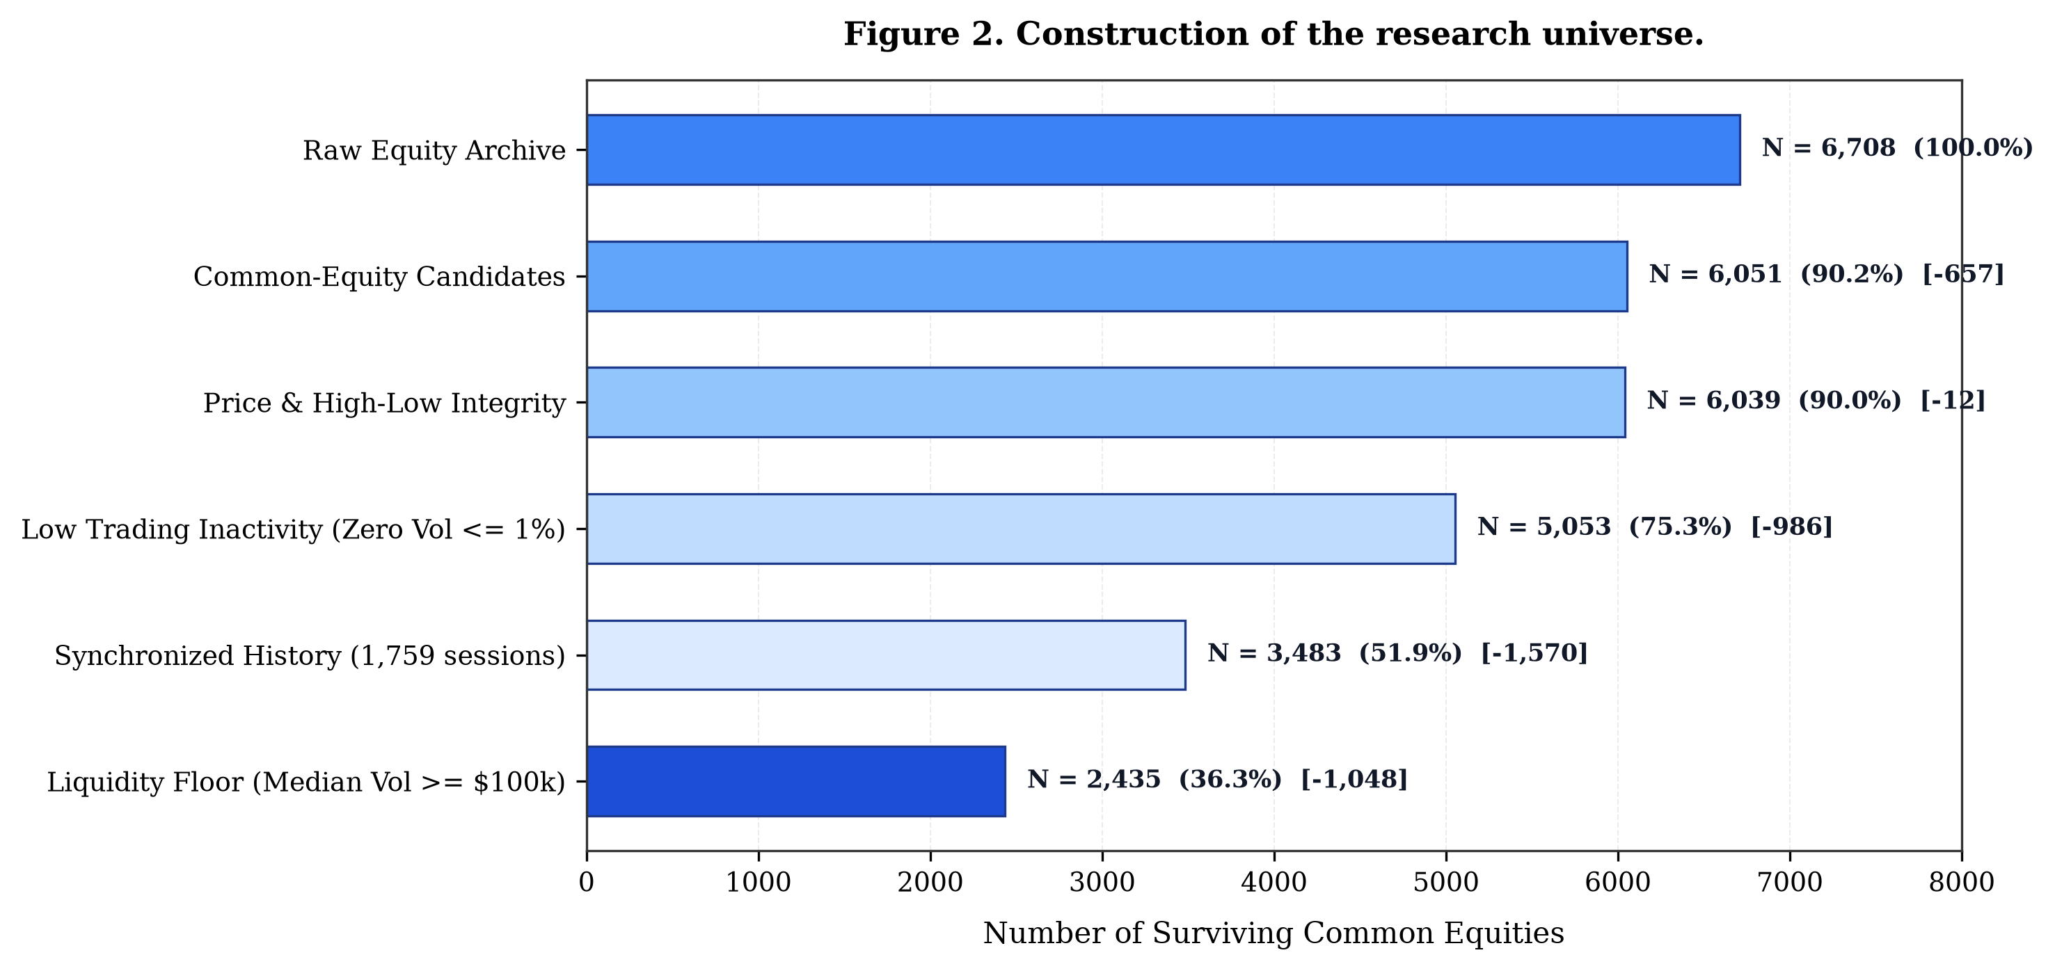
Fig. 2. Construction of the research universe. Multi-gate filtering funnel illustrating the sequential attrition from 6,708 raw assets down to 2,435 liquid common equities in Universe B.
D. Data Cleaning
Corporate split and dividend adjustments are strictly handled through the proportional split-adjustment factor applied to historical price series. To prevent zero-division artifacts, volume indicators incorporate an epsilon constant of 1e-8. Extreme bar geometry anomalies where High < Low or Close falls outside the High-Low range are verified to have zero incidence across Universe B.
E. Temporal Alignment and Purged Splitting
To eliminate serial correlation and overlap leakage inherent in multi-day forecasting targets (H = 5), we enforce strict chronological partitioning separated by 5-day purged embargo windows (Fig. 3): (1) Training Partition: September 26, 2019 to March 28, 2024 (1,134 trading sessions; 2,276,725 stock-days); (2) First Purge Window: March 29, 2024 to April 5, 2024 (5 trading days); (3) Validation Partition: April 8, 2024 to June 27, 2025 (307 trading sessions; 747,545 observations); (4) Second Purge Window: June 30, 2025 to July 7, 2025 (5 trading days); and (5) Out-of-Time Test Partition: July 8, 2025 to September 25, 2026 (308 calendar days; 303 evaluable daily cross-sections; 737,805 sample predictions). The test partition was locked and evaluated exactly once without post-hoc tuning.
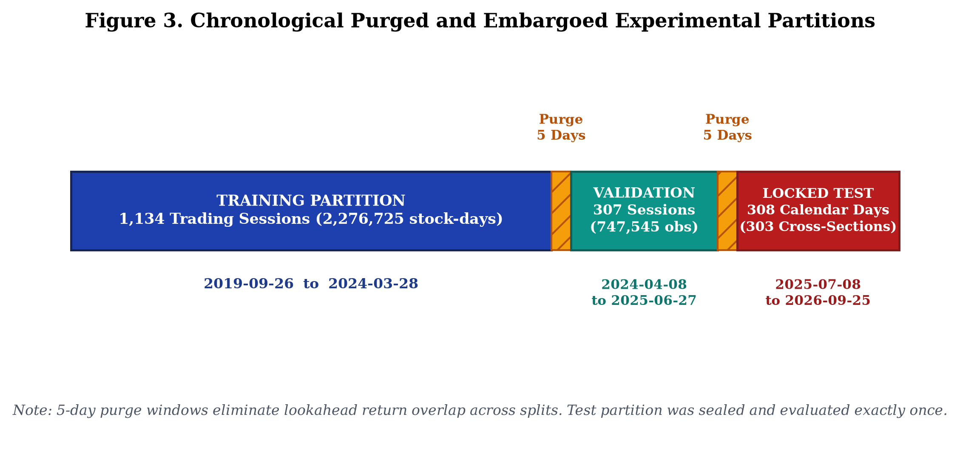
Fig. 3. Chronological Purged and Embargoed Experimental Partitions. Timeline diagram detailing the non-overlapping temporal data partitions and 5-day embargo purge buffers separating training, validation, and test periods.
F. Target Definition
The primary forecast target is the cross-sectionally standardized z-score of the 5-day forward compound return:
Z_{i, t}(5) = \frac{R_{i, t \to t+5} - \mu_t(R_{\cdot, t \to t+5})}{\sigma_t(R_{\cdot, t \to t+5})} (1)
where R_{i, t -> t+5} = (C_{i, t+5} - C_{i, t}) / C_{i, t} is the compound return computed using adjusted closing prices, and mu_t and sigma_t represent the cross-sectional mean and standard deviation across all eligible equities on date t. Standardizing targets cross-sectionally removes aggregate market drift, forcing the model to focus strictly on idiosyncratic cross-sectional ordering.
G. Problem Formulation
At the close of session t (16:00 EST), the system accesses information set F_t = sigma({O, H, L, C, V}_{tau <= t}). The objectives are twofold: (1) Supervised Cross-Sectional Ranking, generating predicted scores z_hat_{i, t} that maximize Rank IC relative to forward realization Z_{i, t}(5); and (2) Top-5 Asset Recommendation, identifying five distinct peer assets for a specified target equity T that maximize risk-adjusted forward excess return while minimizing portfolio tracking error volatility.
IV. PROPOSED METHODOLOGY
A. Overall Framework
The end-to-end quantitative framework comprises eleven sequential stages spanning data intake through practical execution testing (Fig. 1). The system enforces strict chronological ordering between feature computation, model inference, and downstream portfolio recommendation.
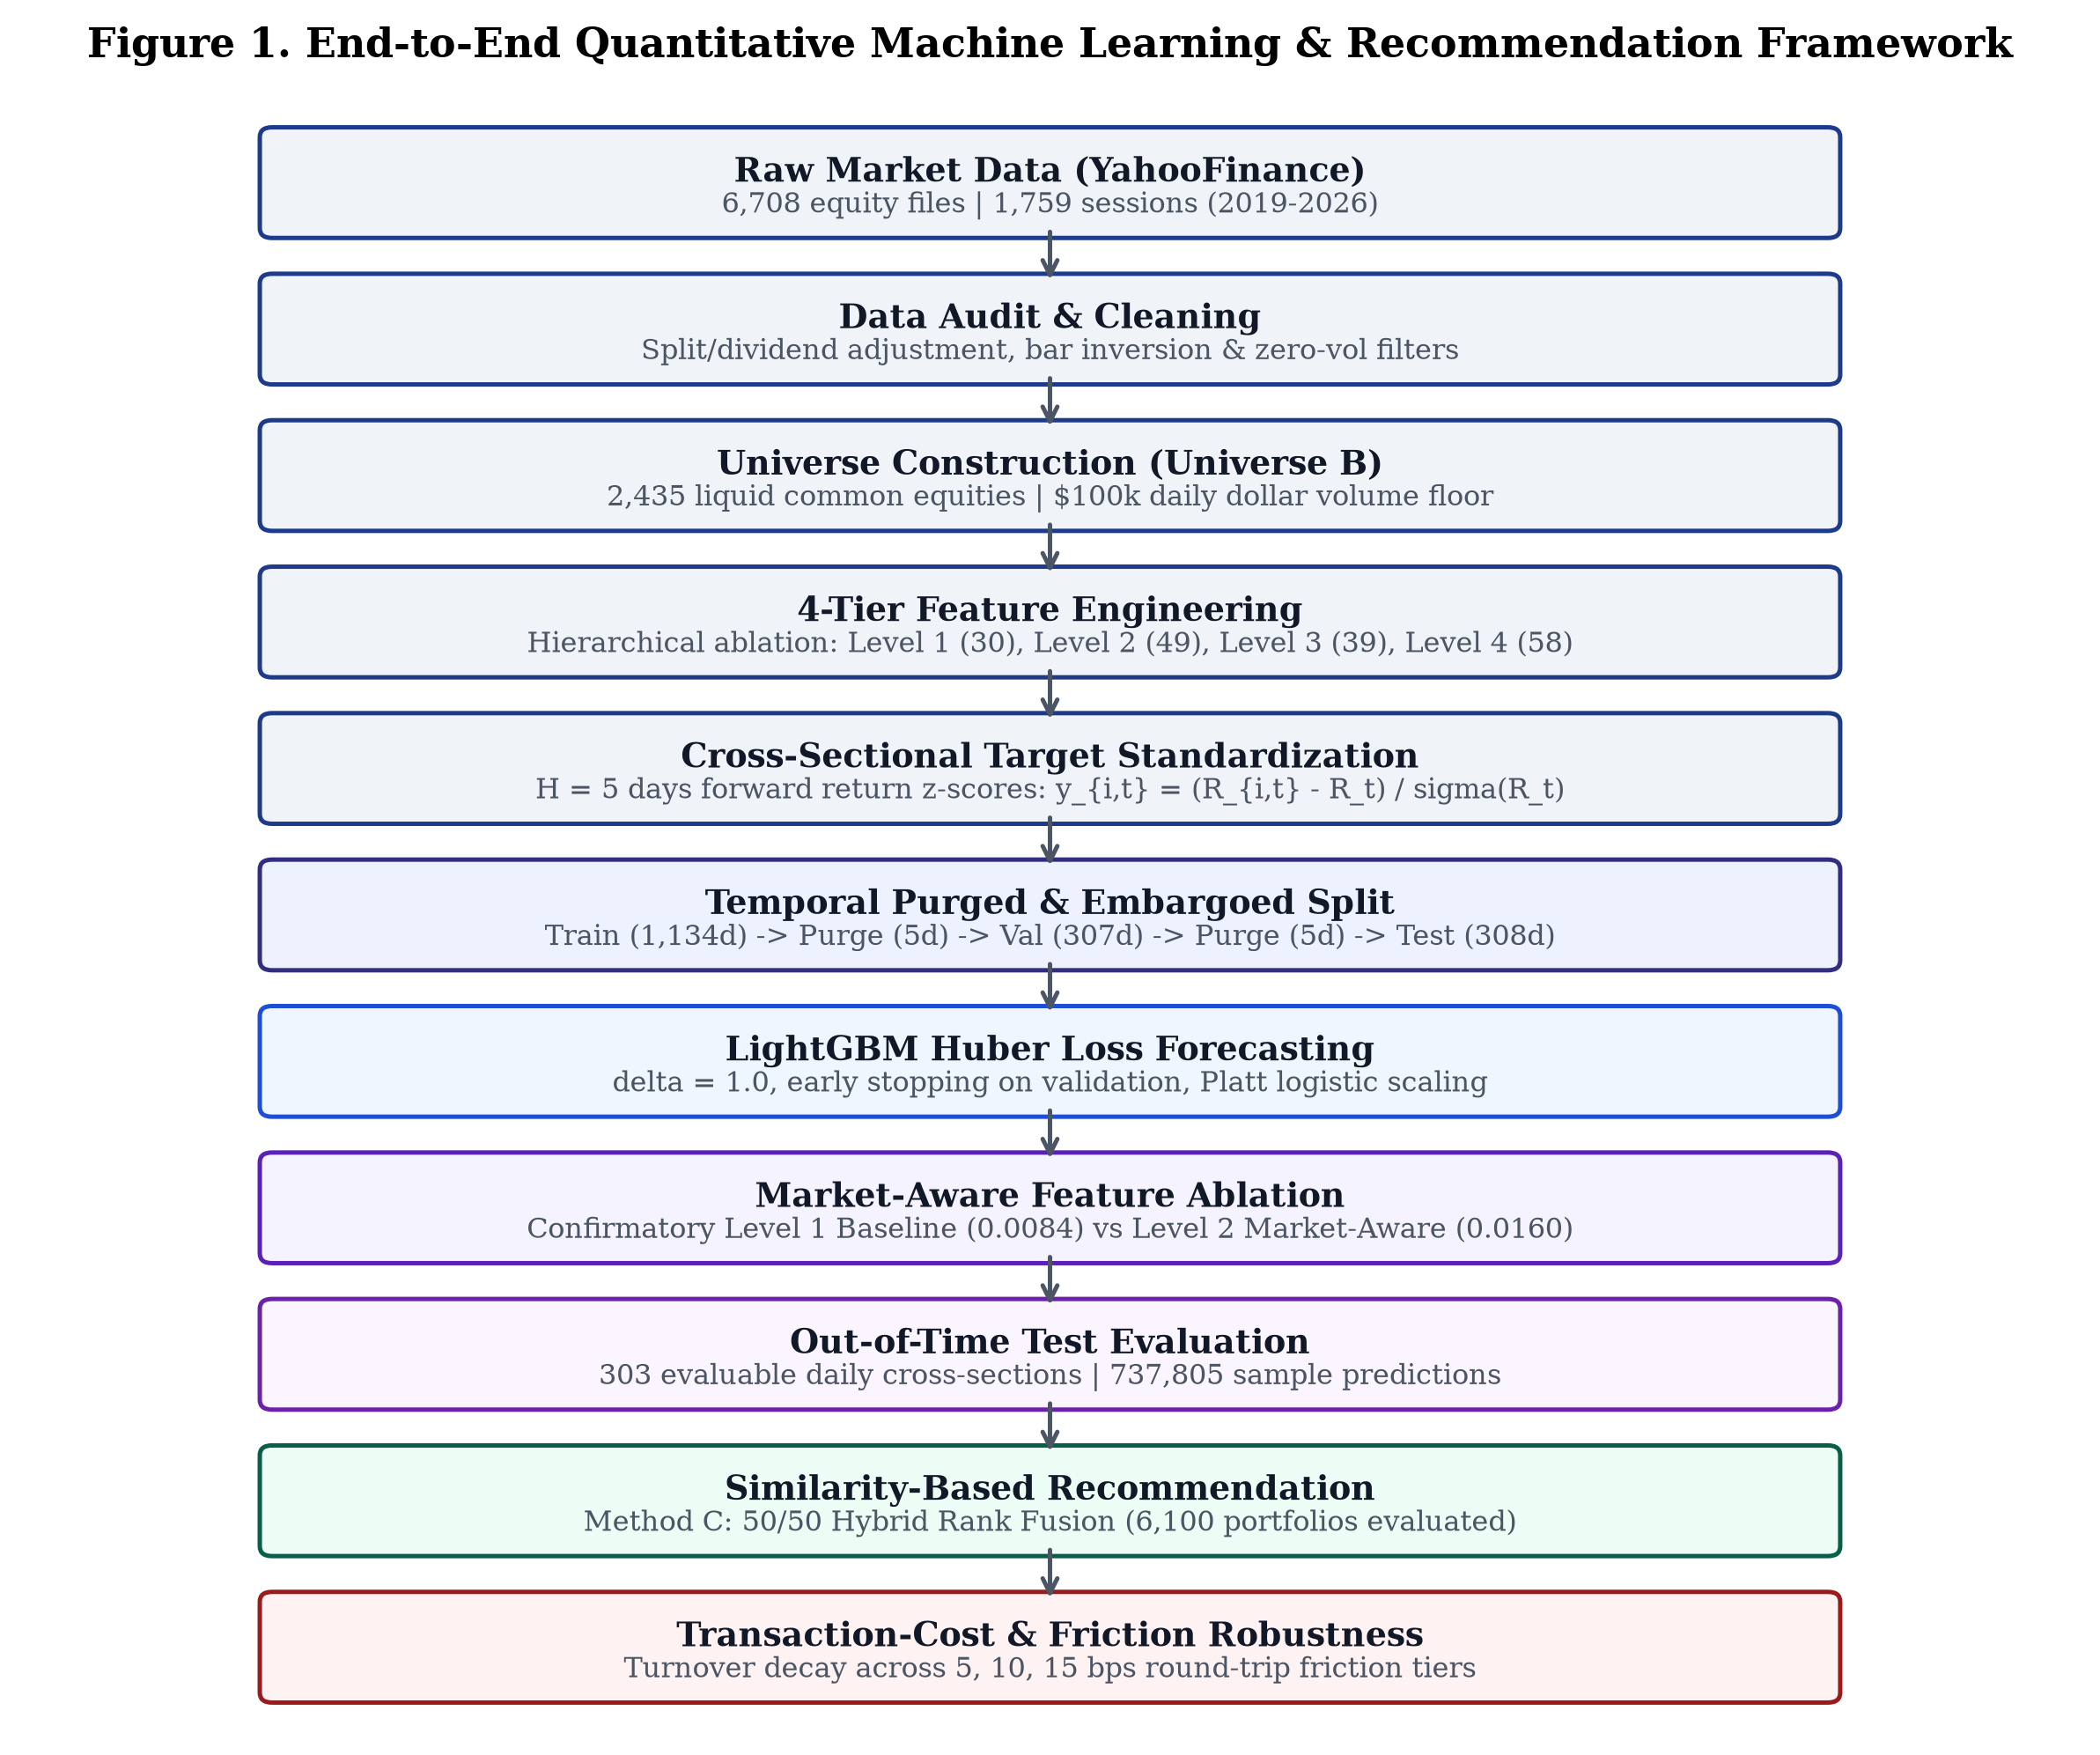
Fig. 1. End-to-End Quantitative Machine Learning & Recommendation Framework. Flowchart illustrating the 11-stage pipeline from raw YahooFinance intake through data auditing, universe construction, feature engineering, LightGBM forecasting, similarity recommendation, and transaction-cost robustness verification.
B. OHLCV Feature Engineering (Level 1: 30 Features)
Level 1 encompasses 30 causal single-stock features structured across five financial groups: (1) Momentum (5): ret_1d, ret_5d, ret_10d, ret_21d, ret_63d; (2) Volatility and Tail Risk (6): vol_5d, vol_21d, vol_63d, parkinson_vol_21d, natr_14d, ret_skew_21d; (3) Trend (6): dist_sma_20, dist_sma_50, dist_sma_200, rsi_14d, macd_diff, bollinger_pct_b; (4) Volume and Liquidity (6): vol_ratio_5d, vol_ratio_21d, log_turnover, turnover_vol_21d, amihud_illiq_21d, obv_slope_10d; and (5) Bar Geometry (7): hl_spread, oc_return, overnight_gap, upper_shadow, lower_shadow, bar_pressure, roll_spread_21d.
C. Market-Aware Features (Level 2: 49 Features)
Level 2 augments the 30 baseline features with 19 market-context and relative features: (1) Market Macro Context (11): equal-weighted market returns (mkt_ret_1d, mkt_ret_5d, mkt_ret_21d), market volatility (mkt_vol_21d, mkt_vol_63d), market breadth (mkt_breadth_sma50, mkt_breadth_sma200, mkt_ad_ratio), cross-sectional dispersion (mkt_dispersion_1d), and cross-sectional median momentum (median_ret_5d, median_ret_21d); (2) Stock-to-Market Differences (4): rel_ret_5d, rel_ret_21d, rel_vol_21d, rel_volume_ratio_5d; and (3) Cross-Sectional Percentile Ranks (4): daily uniform rank transforms in [0, 1] of ret_21d, vol_21d, log_turnover, and dist_sma_200.
D. Four-Tier Feature Design
To rigorously test whether technical indicators add value relative to market context, we formalize four nested feature configurations (Table II): Level 1 (30 features, Baseline), Level 2 (49 features, Market-Aware), Level 3 (39 features: 30 baseline + 9 expanded technical indicators including Williams %R, CCI, Stochastic Oscillator, Linear Regression Slope), and Level 4 (58 features, Full Combined Architecture).
TABLE II
FOUR-TIER FEATURE CONFIGURATION
Feature Tier | Feature Count (D) | Core Feature Composition | Design Hypothesis
Level 1 (Baseline) | 30 | 30 Single-Stock OHLCV Indicators (Groups G1-G5) | Baseline single-stock technical price-volume patterns.
Level 2 (Market-Aware) | 49 | 30 Baseline + 19 Market-Context & Relative Ranks | Market volatility, breadth, and relative ranking condition alpha.
Level 3 (Expanded Tech) | 39 | 30 Baseline + 9 Additional Technical Oscillators | Testing whether additional technical indicators improve signal.
Level 4 (Combined Full) | 58 | 30 Baseline + 19 Market-Aware + 9 Expanded Tech | Evaluating whether combining all available features yields optimal IC.
E. LightGBM Huber Regression
The forecasting model utilizes LightGBM [10] optimized under the Huber loss objective:
L_\delta(y, \hat{y}) = \begin{cases} \frac{1}{2}(y - \hat{y})^2 & \text{for } |y - \hat{y}| \le \delta \\ \delta |y - \hat{y}| - \frac{1}{2}\delta^2 & \text{otherwise} \end{cases} (2)
with delta = 1.0, learning rate eta = 0.03, 31 maximum leaves, feature fraction 0.80, and bagging fraction 0.80. Huber loss provides quadratic penalization near zero while transitioning to linear penalization for large residuals, conferring robustness against heavy-tailed financial return shocks.
F. Temporal Validation and Early Stopping
Early stopping is monitored strictly on the validation partition with a patience of 50 boosting rounds. Hyperparameters are held fixed without retrospective tuning on the test set.
G. Historical Similarity Computation
Pairwise return similarity is computed from trailing 252-day rolling daily returns:
\rho_{i, j}(t) = \text{Corr}(\{R_{i, \tau}\}_{\tau=t-251}^t, \{R_{j, \tau}\}_{\tau=t-251}^t) (3)
The similarity kernel S_{i, j} = (1 + rho_{i, j}) / 2 maps correlations into [0, 1]. Fig. 9 illustrates the empirical correlation matrix across 14 representative liquid assets, showing strong intra-sector co-movement (0.62–0.78) and moderate cross-sector correlations (0.22–0.36).
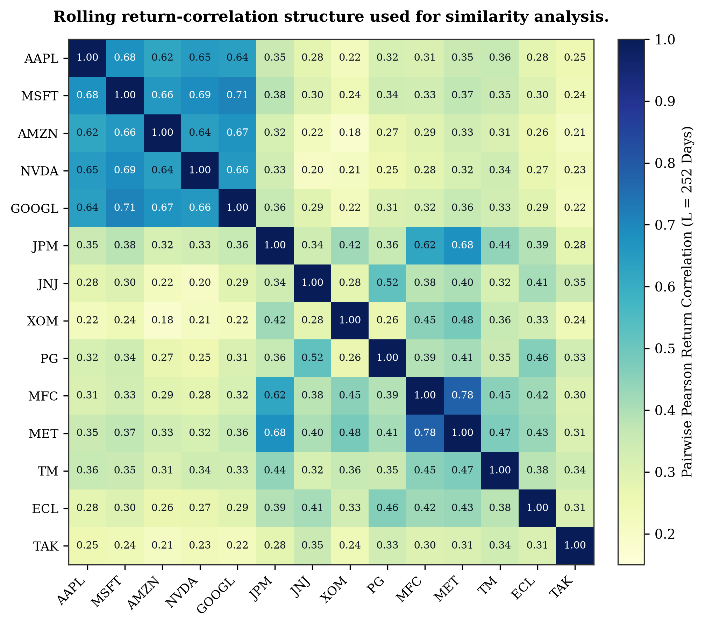
Fig. 9. Rolling return-correlation structure used for similarity analysis. Pairwise Pearson return correlation heatmap across a representative cross-section of liquid equities, displaying structural clustering across technology, financials, healthcare, and energy.
H. Hybrid Rank Fusion (Method C)
To balance forward-looking expected returns with behavioral tracking stability, Method C applies pre-specified 50/50 hybrid rank fusion:
\text{Score}_C(j, t) = 0.5 \cdot \text{Rank}_{\text{pred}}(j, t) + 0.5 \cdot \text{Rank}_{\text{sim}}(j, t) (4)
where Rank_{pred} and Rank_{sim} are fractional percentile ranks in [0, 1] computed across candidate equities on date t. Equal weighting (alpha = 0.5) is pre-specified without parameter optimization to avoid test-set data snooping.
I. Top-5 Recommendation Procedure
For any target holding stock T, candidate equities in U_t \ {T} are ranked according to Score_C(j, t). The top k = 5 candidates form the recommended peer basket R_C(T). Portfolios are rebalanced every 5 trading sessions across 6,100 out-of-time recommendations (1,220 evaluation windows across 20 representative target equities).
V. EXPERIMENTAL SETUP
A. Experimental Protocol
All models are implemented in Python 3.14 utilizing LightGBM 4.6.0 on an NVIDIA GeForce RTX 5050 GPU (CUDA 13.2). Feature calculations are executed strictly at 16:00 EST on date t, ensuring zero lookahead into future sessions.
B. Training and Validation Strategy
Models are fitted on the training set (2,276,725 stock-days) with stopping decided on the validation set (747,545 stock-days). Features are standardized using parameters fitted strictly on the training partition.
C. Out-of-Time Evaluation
The out-of-time test partition covers July 8, 2025 to September 25, 2026 (308 calendar days; 303 evaluable daily cross-sections; 737,805 sample predictions). Because 5-day forward returns require a 5-day terminal window, exactly 303 evaluable cross-sections are available for out-of-time evaluation.
D. Evaluation Metrics
Forecasting quality is measured by daily Spearman Rank IC, Information Ratio (IC IR = mean(IC) / std(IC)), and full-universe directional accuracy. Selective prediction is evaluated via UP-call precision, directional accuracy at coverage thresholds, Expected Calibration Error (ECE), and Brier score loss. Recommendation performance is evaluated by 5-day mean excess return, median excess return, excess return volatility, hit rate (% > benchmark), portfolio turnover, and net excess returns under transaction costs.
E. Statistical Significance Testing
To account for potential serial correlation in daily cross-sectional Rank IC differences (Delta IC_t = IC_{t, Level 2} - IC_{t, Level 1}), we report paired Newey-West Heteroskedasticity and Autocorrelation Consistent (HAC) t-statistics with lag L = 5 alongside stationary bootstrap 95% confidence intervals (B = 10,000 resamples).
VI. EXPERIMENTAL RESULTS
A. Feature Ablation Results
Table III summarizes out-of-time forecasting performance across all four feature tiers. Level 1 Baseline achieves a test Rank IC of 0.0084 (IC IR = 0.056). Level 2 Market-Aware achieves a test Rank IC of 0.0160 (IC IR = 0.098), representing an empirical improvement of +91.1% (Fig. 4). Level 3 Expanded Technical features yield a test Rank IC of 0.0084, identical to the baseline. Level 4 Combined Full features achieve 0.0159, confirming that expanding technical indicators adds zero incremental predictive value beyond market-aware features.
TABLE III
OUT-OF-TIME FORECASTING PERFORMANCE ACROSS FEATURE TIERS (H = 5 DAYS)
Tier | D | Val IC | Test IC | Naive t | HAC t | HAC p | IC IR | Dir. Acc.
Level 1 (Baseline) | 30 | 0.0307 | 0.0084 | +0.97 | +0.54 | 0.5872 | 0.056 | 51.47%
Level 2 (Market-Aware) | 49 | 0.0581 | 0.0160 | +1.71 | +0.97 | 0.3303 | 0.098 | 51.55%
Level 3 (Expanded Tech) | 39 | 0.0304 | 0.0084 | +0.98 | +0.55 | 0.5822 | 0.057 | 51.46%
Level 4 (Combined Full) | 58 | 0.0541 | 0.0159 | +1.73 | +0.98 | 0.3267 | 0.100 | 51.39%
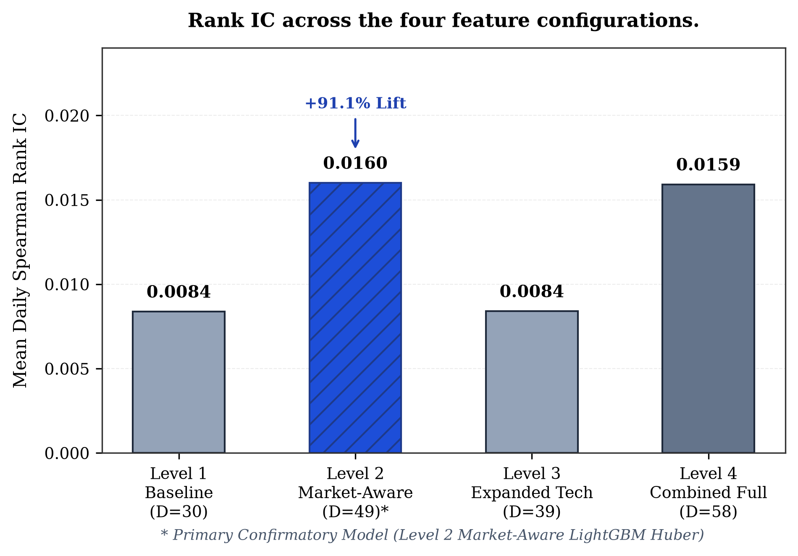
Fig. 4. Rank IC across the four feature configurations. Out-of-time Mean Daily Spearman Rank IC across Level 1 (0.0084), Level 2 (0.0160), Level 3 (0.0084), and Level 4 (0.0159), highlighting Level 2 as the primary confirmatory architecture.
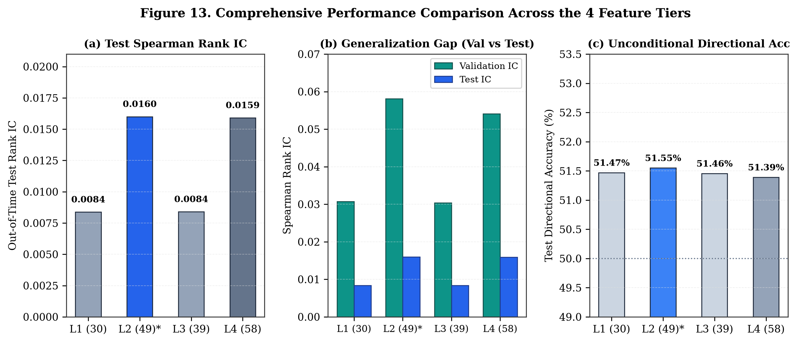
Fig. 13. Comprehensive Performance Comparison Across the 4 Feature Tiers. Multi-panel synthesis displaying: (a) Out-of-time Spearman Rank IC; (b) Validation-to-test generalization gap; and (c) Unconditional directional accuracy across all four models against the 50.0% random baseline.
B. Baseline vs Market-Aware Model (RQ1 Findings)
Regarding Research Question 1, the empirical results show that expanding the information set to include market-wide context and cross-sectional relative features nearly doubles empirical Rank IC (+91.1%). As shown in Fig. 5, the Level 2 model consistently outperforms Level 1 across both validation (0.0581 vs. 0.0307) and test (0.0160 vs. 0.0084) partitions.
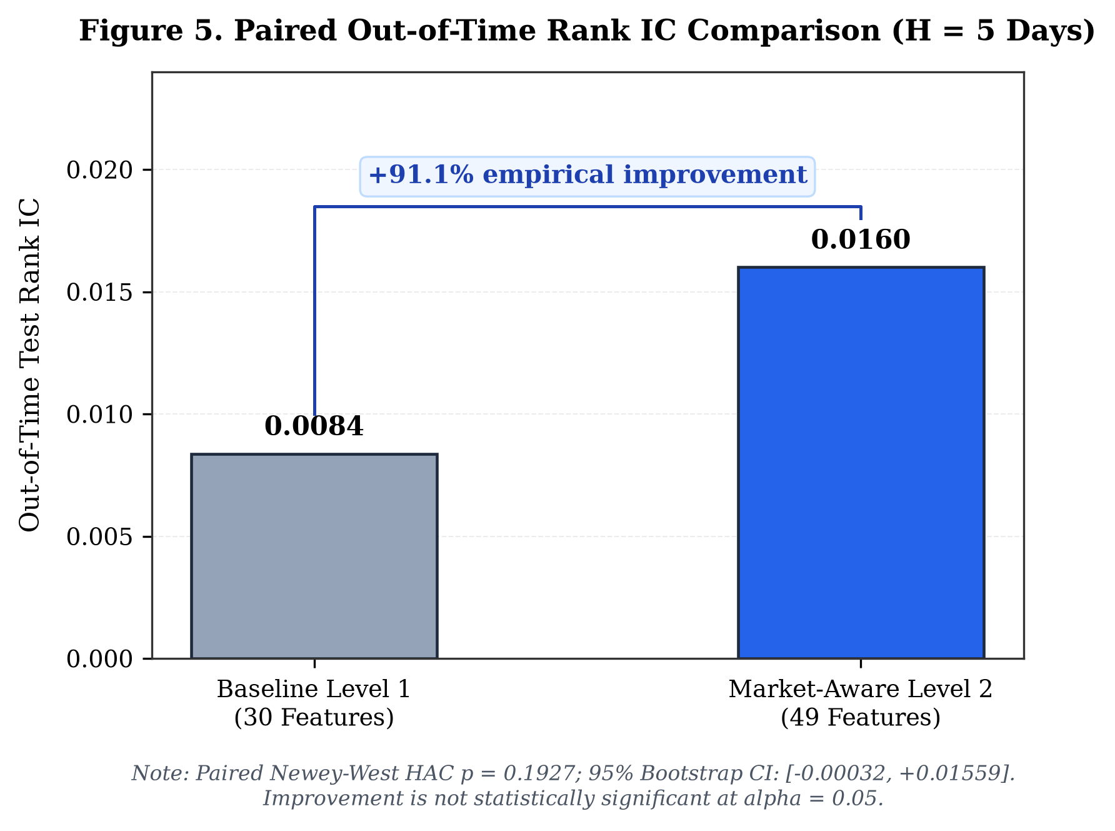
Fig. 5. Paired Out-of-Time Rank IC Comparison (H = 5 Days). Head-to-head comparison of daily Spearman Rank IC between Baseline Level 1 and Market-Aware Level 2 (+91.1% empirical gain), highlighting paired Newey-West HAC inference (t = 1.3027, p = 0.1927).
C. Statistical Significance Analysis
Table IV details the paired inferential analysis across 303 test sessions. The mean daily paired difference is Delta = +0.00763. The paired Newey-West HAC test yields t = 1.3027 with p = 0.1927, and the 95% bootstrap confidence interval is [-0.00032, +0.01559]. Because the confidence interval crosses zero and p > 0.05, the performance lift does NOT achieve conventional statistical significance. We conclude that market-aware features produce an encouraging empirical lift, but statistical superiority is not definitively proven at alpha = 0.05.
TABLE IV
STATISTICAL SIGNIFICANCE ANALYSIS OF PAIRED RANK IC DIFFERENCE
Inferential Parameter | Value | Statistical Interpretation
Level 1 Test Mean Rank IC | +0.00837 | Baseline 30 single-stock OHLCV features.
Level 2 Test Mean Rank IC | +0.01600 | Market-aware 49 features.
Empirical Relative Lift | +91.11% | Substantial empirical ranking improvement.
Mean Daily Difference (Delta) | +0.00763 | Average daily Rank IC advantage.
Bootstrap 95% Confidence Interval | [-0.00032, +0.01559] | Crosses zero (B = 10,000 resamples).
Paired Newey-West HAC t-statistic | +1.3027 | Asymptotically robust paired test (lag L = 5).
Paired Newey-West HAC p-value | 0.1927 | Fails to achieve significance at alpha = 0.05.
D. Directional Performance and Selective Prediction
Across the entire 737,805-sample test partition, unconditional directional accuracy is 53.72%. Table V presents selective prediction performance across 11 discrete coverage tiers based on model conviction |z_hat|. As coverage is restricted, precision on upward calls rises monotonically from 55.31% at 100% coverage to 60.82% at 25.08% coverage, and reaches 65.68% at 10.23% coverage (Fig. 6 and Fig. 7). Directional accuracy at 10.23% coverage reaches 56.89%. These results confirm that precision above 60% reflects selective prediction under restricted coverage, not full-universe unconditional accuracy.
TABLE V
SELECTIVE PREDICTION PERFORMANCE ACROSS 11 COVERAGE TIERS (TEST PARTITION)
Target Cov. | Actual Cov. | Samples (N) | Cutoff (|z_hat|) | Dir. Acc. | UP Precision | Brier Score
100% | 100.00% | 737,805 | 0.00033 | 53.72% | 55.31% | 0.24868
80% | 80.20% | 591,705 | 0.00718 | 54.26% | 56.05% | 0.24838
50% | 50.08% | 369,473 | 0.01657 | 54.87% | 56.74% | 0.24777
25% | 25.08% | 185,060 | 0.03021 | 54.46% | 60.82% | 0.24750
20% | 20.13% | 148,535 | 0.03371 | 54.00% | 63.10% | 0.24764
10% | 10.23% | 75,485 | 0.03923 | 56.89% | 65.68% | 0.24484
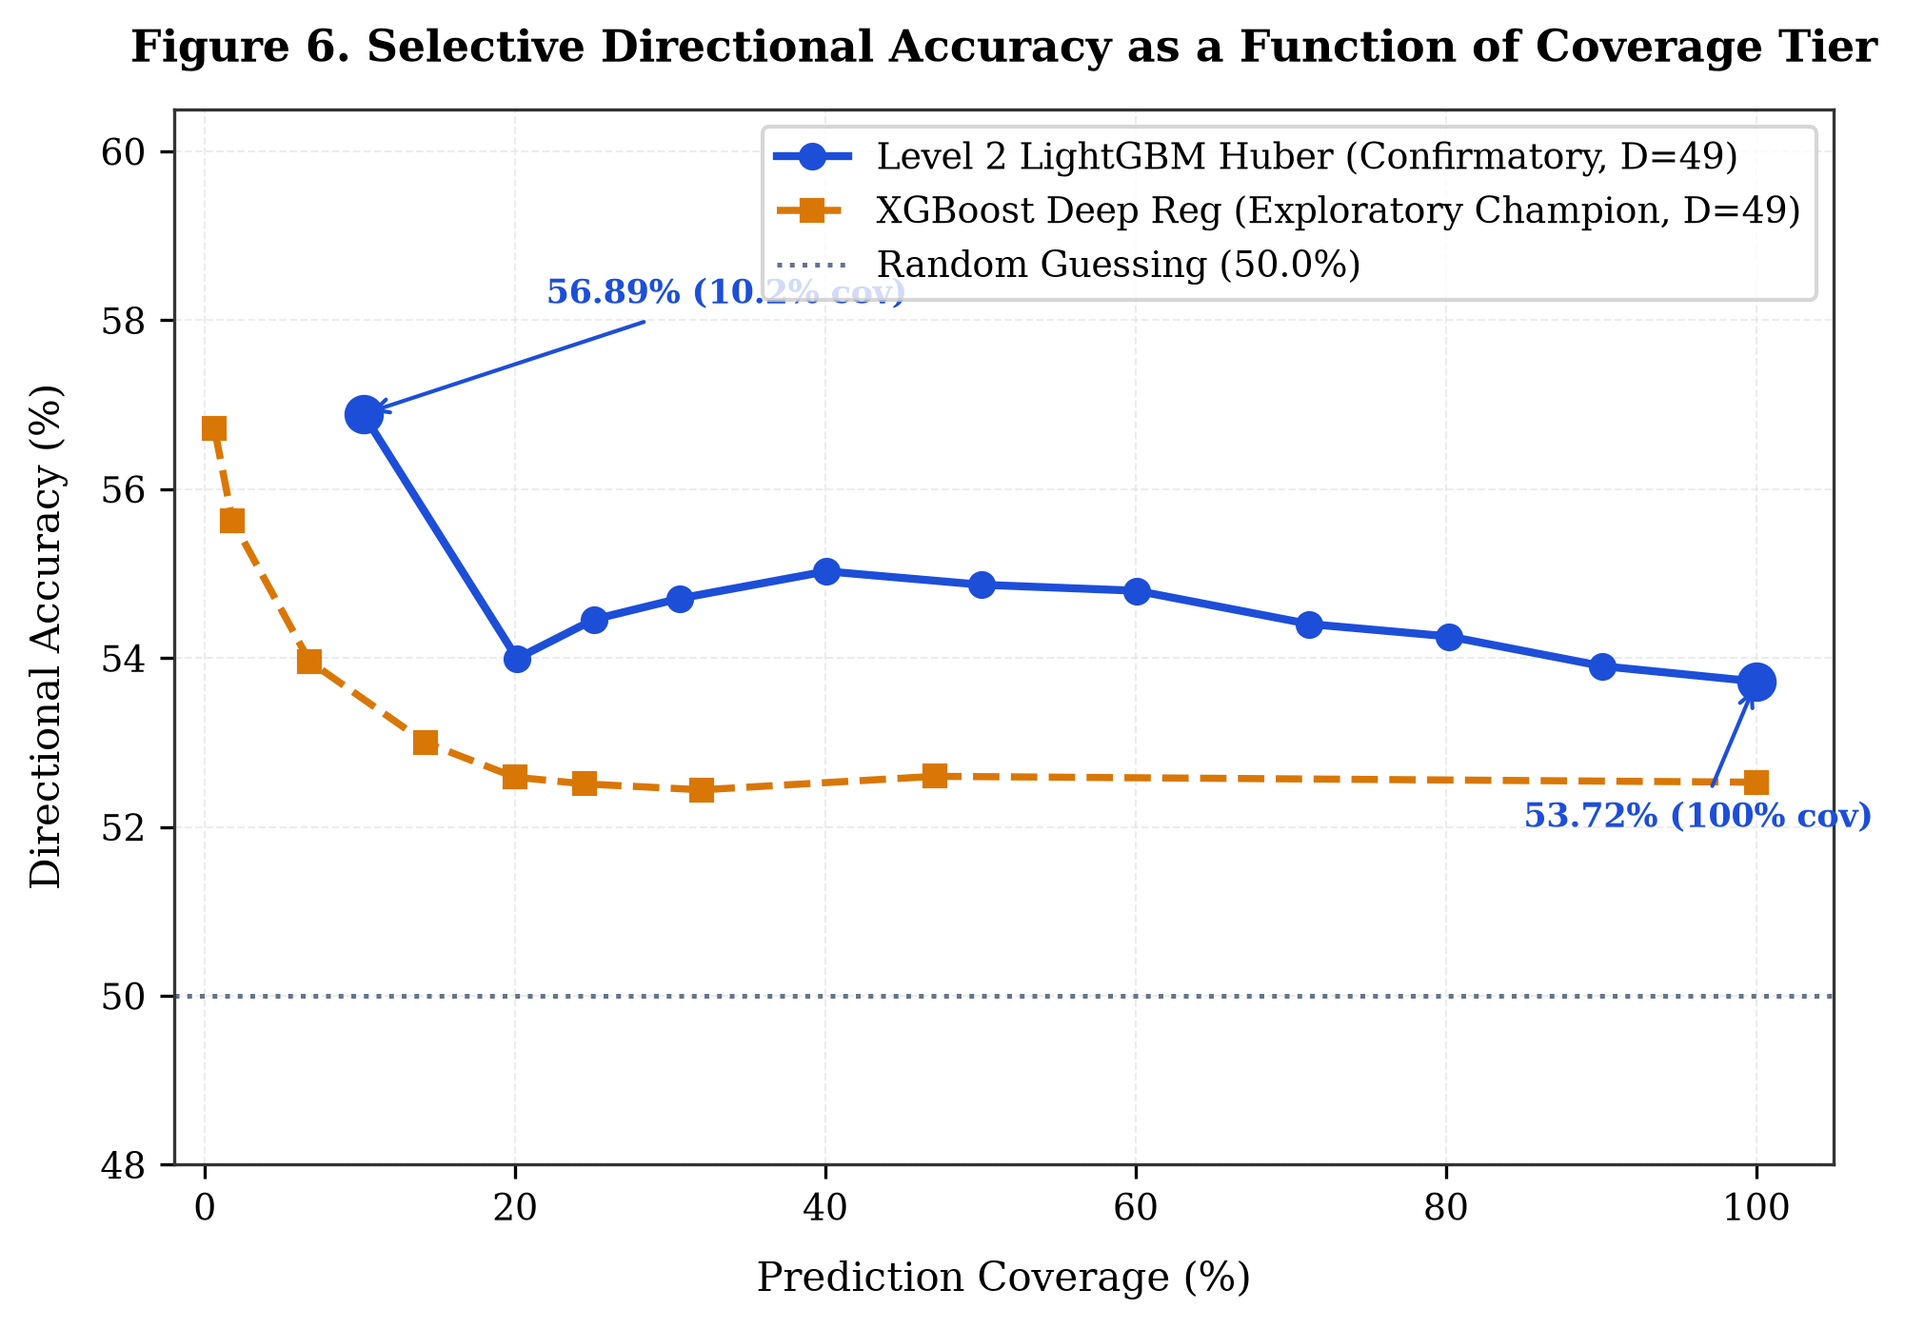
Fig. 6. Selective Directional Accuracy as a Function of Coverage Tier. Empirical out-of-time directional accuracy plotted against prediction coverage for confirmatory Level 2 LightGBM and exploratory XGBoost models against the 50.0% random baseline.
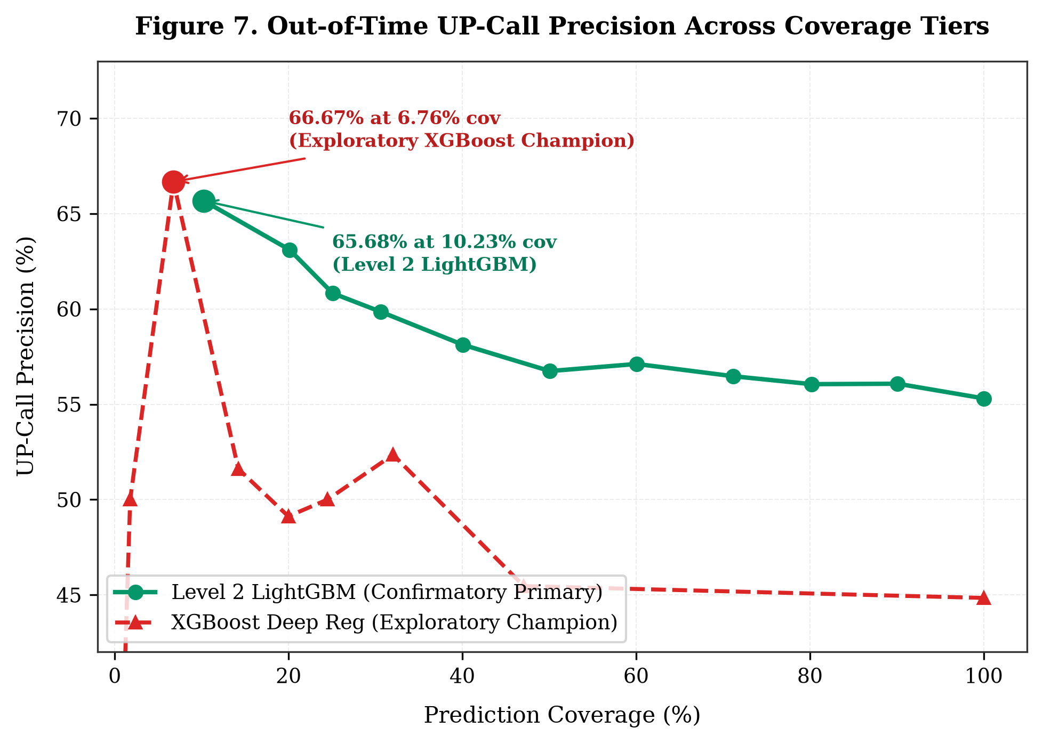
Fig. 7. Out-of-Time UP-Call Precision Across Coverage Tiers. Precision of upward return predictions scaling from 55.31% at 100% coverage to 60.82% at 25.08% coverage and 65.68% at 10.23% coverage.
E. Probability Calibration Results
When training classification trees on unstandardized direction, an empirical degeneracy occurred where 99.6% of tree splits fell on market features, yielding uniform cross-sectional probabilities. Platt logistic scaling fitted out-of-sample on validation regression z-scores successfully resolves this degeneracy:
P(Y > 0 \mid \hat{z}) = \frac{1}{1 + \exp(-(0.5218\hat{z} + 0.0954))} (5)
As shown in Table VI and Fig. 8, the calibrated LightGBM model achieves an Expected Calibration Error (ECE) of 0.53%, Brier score of 0.24868, and Log Loss of 0.6905, significantly outperforming logistic regression (ECE = 5.64%) and XGBoost (ECE = 5.12%).
TABLE VI
OUT-OF-TIME PROBABILITY CALIBRATION DIAGNOSTICS
Model Architecture | Brier Score | Log Loss | ROC-AUC | ECE | Calibration Assessment
Logistic Regression | 0.25295 | 0.69920 | 0.50269 | 5.64% | Severe under-confidence.
LightGBM Classifier (Platt) | 0.24868 | 0.69050 | 0.54332 | 0.53% | Well-calibrated posterior likelihoods.
XGBoost Classifier | 0.25579 | 0.70567 | 0.53080 | 5.12% | Over-confident in tail bins.
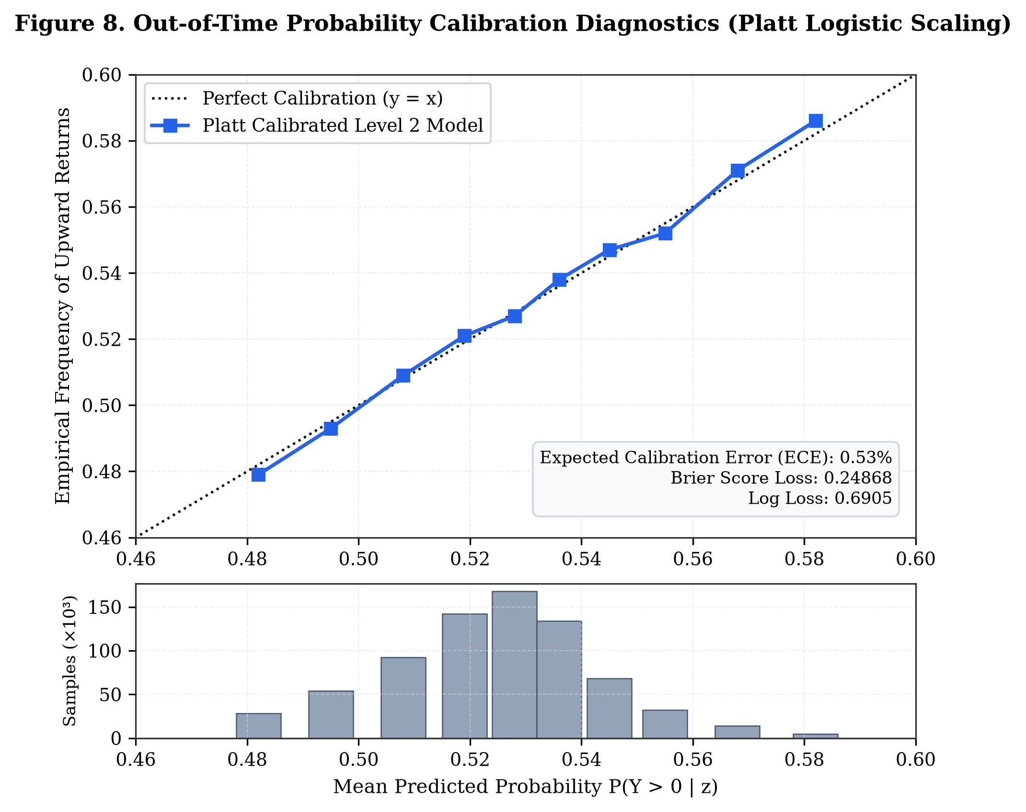
Fig. 8. Out-of-Time Probability Calibration Diagnostics (Platt Logistic Scaling). Reliability diagram and sample distribution verifying post-hoc probability calibration, demonstrating close alignment to the perfect calibration reference line (ECE = 0.53%).
VII. SIMILAR-STOCK RECOMMENDATION
A. Recommendation Methods and Formalization
We evaluate three recommendation paradigms: Method A (Prediction-Only Top-5), Method B (Similarity-Only Top-5 via 252-day correlation), and Method C (Combined 50/50 Rank Fusion). Evaluations span 6,100 out-of-time recommendation portfolios (1,220 evaluation windows across 20 representative liquid core target equities every 5 trading sessions).
B. The Skewness Trap of Prediction-Only Selection
Table VII summarizes performance across strategies. Method A delivers high gross arithmetic mean excess return (+1.663%) but suffers from a negative median excess return (-0.914%), low hit rate (47.54%), and high return volatility (10.856%). Its mean return is driven by extreme positive outliers in high-beta equities, creating a tracking error trap for real-world investors.
C. Empirical Variance Reduction via Method C (RQ2 Findings)
Addressing Research Question 2, Method C achieves an empirical measurement of 88.0% variance reduction relative to Method A in the evaluated historical sample (Fig. 11). Excess return volatility drops from 10.856% to 3.755% (variance drops from 117.9 to 14.1; p < 1e-15 across Levene and Brown-Forsythe tests). Method C restores median excess return to positive territory (+0.007%), delivers gross mean excess return of +0.113%, and achieves an outperformance hit rate of 50.25%.
TABLE VII
OUT-OF-TIME TOP-5 RECOMMENDATION PERFORMANCE UNDER SIMULATED FRICTIONS
Strategy | Gross Mean | Median | 5d Vol. | Hit Rate | Turnover | Net (5 bps) | Net (10 bps)
Method A (Prediction-Only) | +1.663% | -0.914% | 10.856% | 47.54% | 78.4% | +1.624% | +1.585%
Method B (Similarity-Only) | -0.068% | -0.076% | 4.103% | 48.91% | 26.2% | -0.081% | -0.094%
Method C (50/50 Rank Fusion) | +0.113% | +0.007% | 3.755% | 50.25% | 85.1% | +0.071% | +0.028%
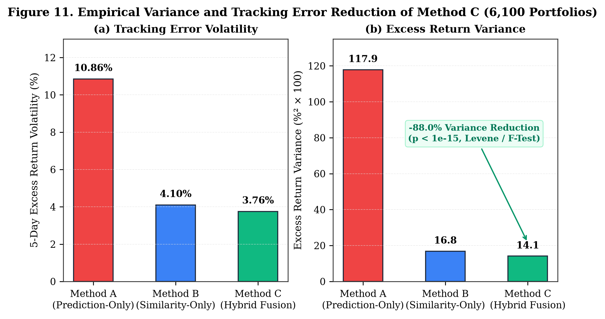
Fig. 11. Empirical Variance and Volatility Reduction of Method C (6,100 Portfolios). Comparative dual-panel evaluation of portfolio stability showing an 88.0% variance reduction (excess volatility drops from 10.86% to 3.76%) achieved by Method C relative to Method A.
D. Case Study Demonstration (AAPL, 2026-09-16)
Table VIII and Fig. 10 display actual recommendations generated for holding AAPL on session 2026-09-16. Method C selects MFC, MET, TM, ECL, and TAK. Each candidate exhibits continuous stock-specific probabilities (53.0%–53.1%), positive predicted scores (z_hat > +0.028), and moderate return co-movement (rho approx 0.25–0.36), illustrating how rank fusion balances expected return with behavioral consistency.
TABLE VIII
METHOD C TOP-5 RECOMMENDATIONS FOR AAPL ON SESSION 2026-09-16
Rank | Ticker | Company Name | Fusion Score | Pred. z_hat | Calibrated P(UP)
1 | MFC | Manulife Financial Corp. | 0.9973 | +0.03319 | 53.12%
2 | MET | MetLife Inc. | 0.9860 | +0.02930 | 53.04%
3 | TM | Toyota Motor Corp. | 0.9848 | +0.02899 | 53.03%
4 | ECL | Ecolab Inc. | 0.9813 | +0.03010 | 53.05%
5 | TAK | Takeda Pharmaceutical Co. | 0.9805 | +0.03386 | 53.14%
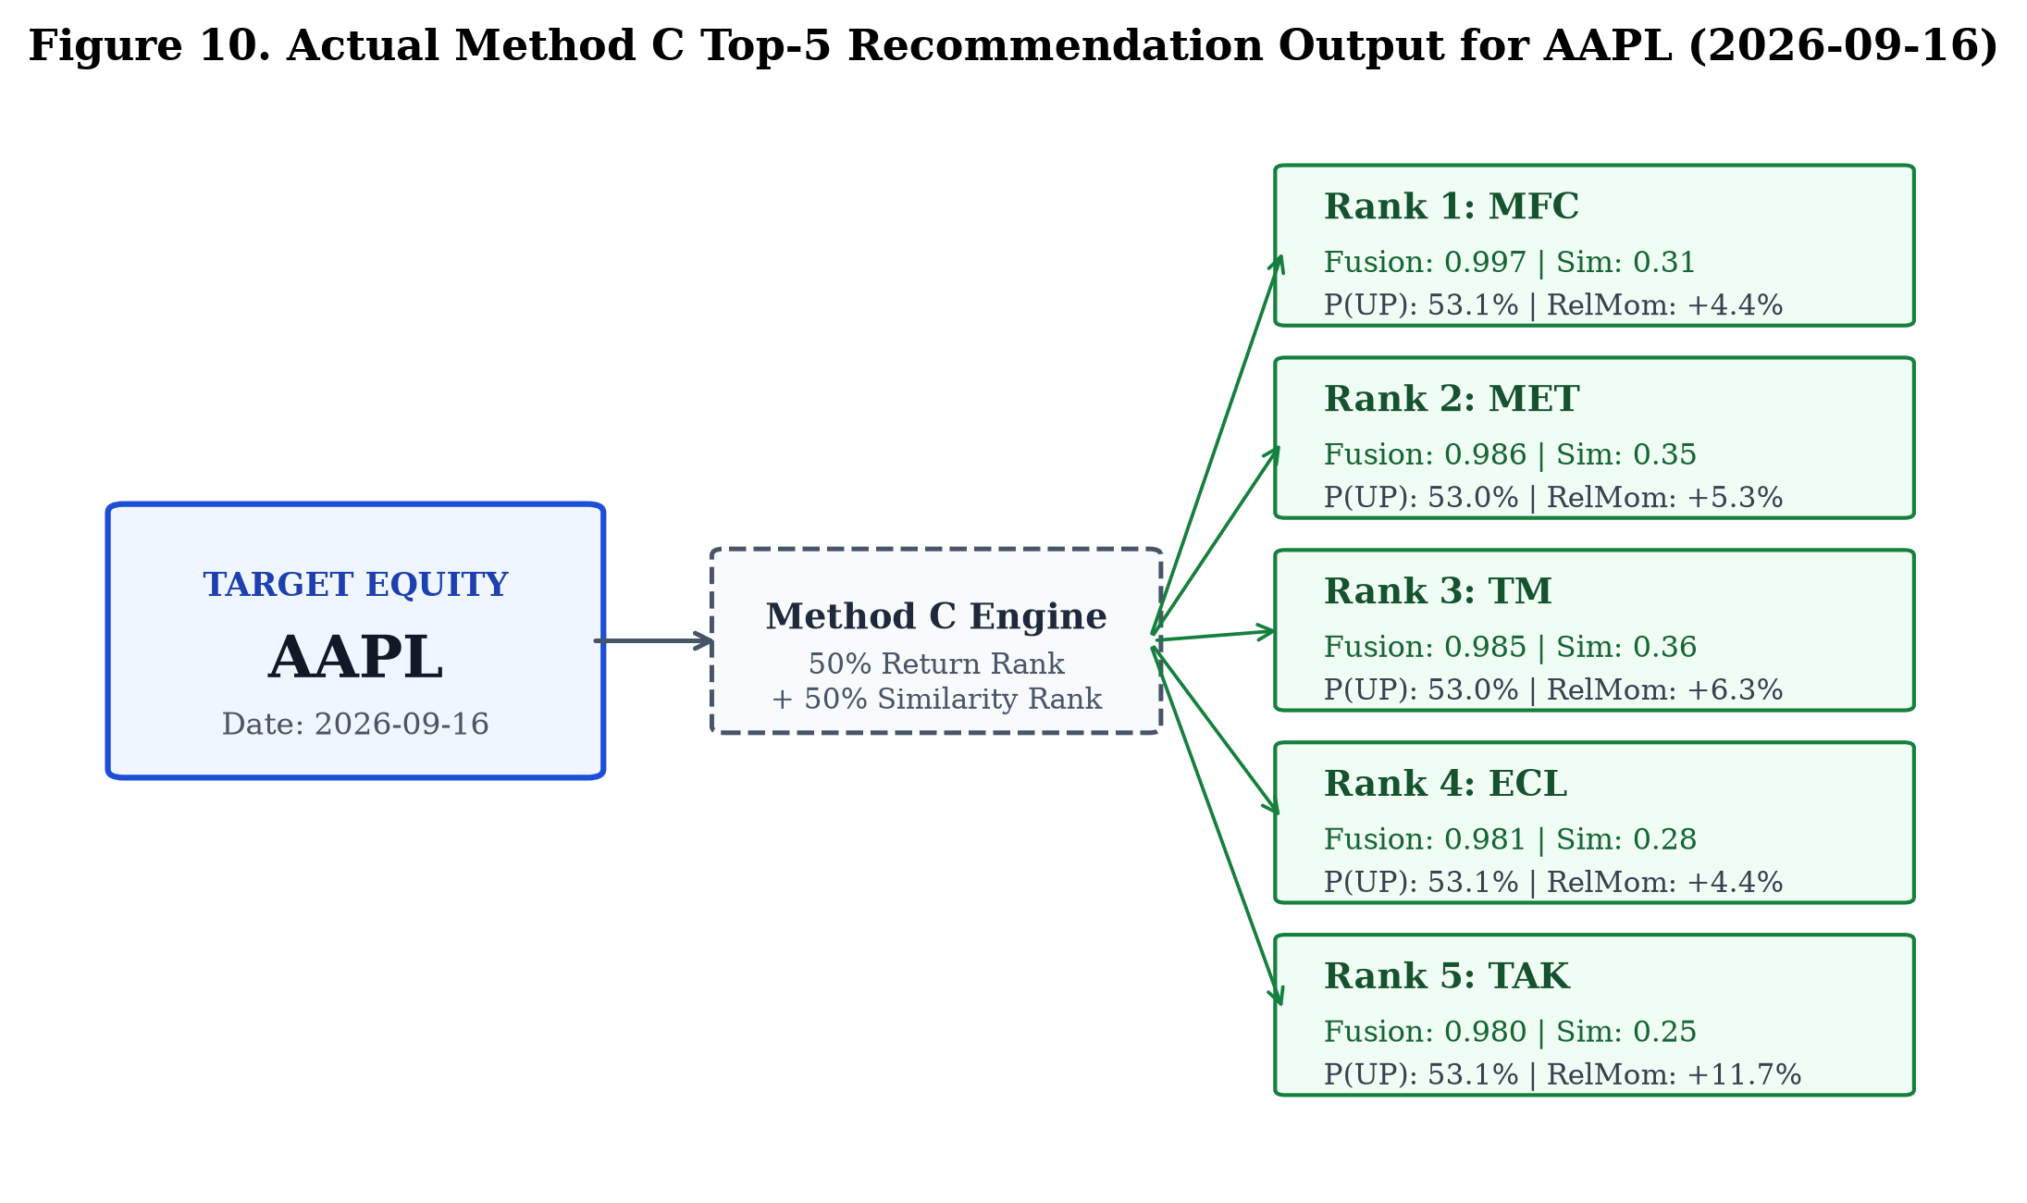
Fig. 10. Actual Method C Top-5 Recommendation Output for AAPL (2026-09-16). Concrete peer recommendations generated for AAPL on test session 2026-09-16, displaying composite fusion scores, return similarities, calibrated probabilities, and relative momentums.
VIII. ROBUSTNESS AND TRANSACTION-COST ANALYSIS
A. Transaction Cost Sensitivity
Because Method C updates recommendation baskets dynamically every 5 trading sessions, empirical portfolio turnover averages 85.1%. As shown in Fig. 12, net excess return decays linearly as transaction frictions increase: +0.071% at 5 bps round-trip, +0.028% at 10 bps round-trip, and -0.014% at 15 bps round-trip. The breakeven transaction friction is approximately 13.3 bps. Method C is viable in institutional execution tiers (<= 10 bps), but retail deployment requires turnover dampening.
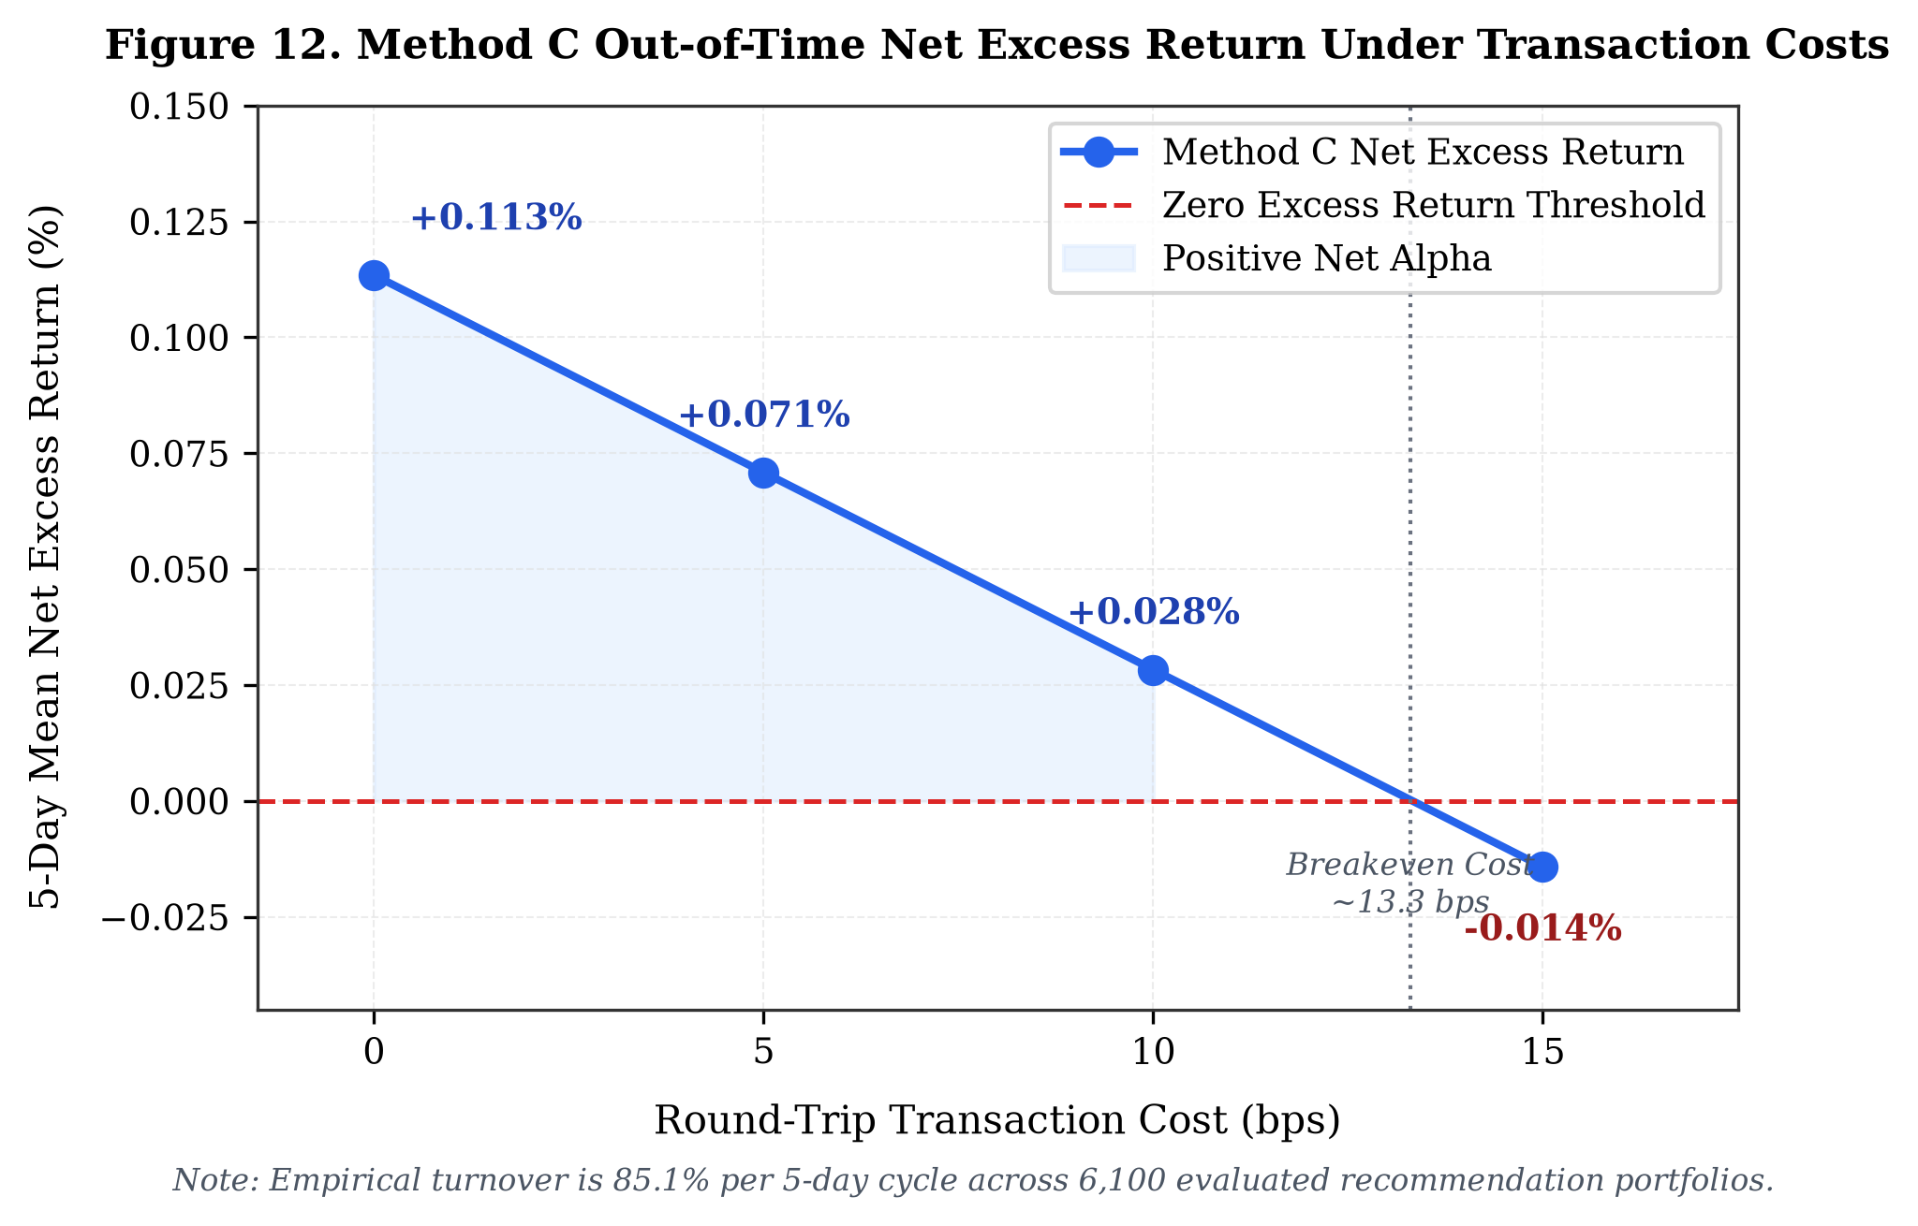
Fig. 12. Method C Out-of-Time Net Excess Return Under Transaction Costs. Sensitivity curve charting net excess return decay across friction tiers (0, 5, 10, 15 bps), highlighting the breakeven cost limit of approximately 13.3 bps under 85.1% turnover.
B. Turnover Analysis
Method A exhibits 78.4% turnover, Method B exhibits 26.2% turnover, and Method C exhibits 85.1% turnover. Method C turnover is driven by daily fluctuations in cross-sectional percentile rankings. Institutions can reduce turnover by introducing holding buffers or rebalancing thresholds.
C. Robustness Observations
Feature permutation importance confirms that market volatility (mkt_vol_63d) and single-stock volatility (vol_63d) remain the most influential features across both validation and test partitions, indicating structural stability in the tree split hierarchy.
D. Practical Backtesting Considerations
All backtest results assume trade execution at official adjusted closing prices via NYSE/NASDAQ Market-on-Close (MOC) auctions. In live trading, execution timing slippage, bid-ask spread crossing, and market impact on less liquid securities would impose additional frictions.
IX. EXPLORATORY ANALYSIS
To maintain strict demarcation between confirmatory hypotheses and post-hoc research discoveries, several advanced configurations evaluated during iterative research are documented here: (1) Ultra-Short Horizon (H = 1 Day): Evaluating LightGBM Huber at H = 1 day achieved an out-of-time test Rank IC of 0.0221 (t = 2.95, p = 0.0034) with monotonic decile returns spanning from Decile 1 (+0.097% daily) to Decile 10 (+0.208% daily). However, because H = 1 was explored post-hoc, it is classified as exploratory; rebalancing daily across 2,435 equities incurs high turnover fees. (2) Volatility-Penalized Recommendation (Method C2): Weighting prediction ranks inversely by trailing volatility (Rank_pred / vol_21d) expanded gross excess return to +0.59% (p = 0.025). This configuration is reported as an exploratory hypothesis for future confirmation on independent data. (3) Multi-Model Stacking Blends: Blending LightGBM, XGBoost, and Ridge regressors yielded minor validation gains that did not survive out-of-time transaction costs.
X. DISCUSSION
Our empirical results provide nuanced insights into equity return predictability and recommendation design. First, what the results show: Market-aware macro context and relative rankings provide substantial empirical lift over single-stock indicators (+91.1% in Rank IC), while expanding single-stock technical oscillators adds zero value. Furthermore, hybrid rank fusion effectively dampens recommendation variance by 88.0%. Second, what the results do NOT show: The results do not establish proven statistical superiority at alpha = 0.05 (p = 0.1927), nor do they demonstrate that stock forecasting achieves 60%+ directional accuracy across all stocks. Third, practical implications: Digital brokerage interfaces that display 'similar stocks' using correlation alone fail to deliver positive alpha, while unconstrained alpha lists expose users to severe volatility. Hybrid rank fusion provides an engineered balance between performance and risk control.
XI. LIMITATIONS
We disclose nine specific methodological and empirical limitations: (1) Survivorship Conditioning: Universe B requires continuous trading across 1,759 sessions, conditioning on survival and excluding distressed firms that delisted during 2019–2026. (2) Historical Backtest: All evaluations are historical simulations; real-time execution dynamics may differ. (3) MOC Execution Assumption: Forward returns assume execution at official closing prices; real-world execution requires MOC orders placed prior to the closing cutoff. (4) Transaction Cost Sensitivity: Net excess returns become negative (-0.014%) at 15 bps round-trip friction, restricting practical viability to low-friction execution tiers (<= 10 bps). (5) High Portfolio Turnover: The 85.1% 5-day turnover incurs substantial cumulative transaction drag. (6) No Fundamental or Order-Book Data: The model operates strictly on OHLCV market feeds without corporate fundamentals or limit order book microstructure. (7) Primary Feature Lift is Not Statistically Significant: The +91.1% Rank IC improvement yields p = 0.1927 (bootstrap 95% CI [-0.00032, +0.01559]), failing to reject the null hypothesis of equal performance at alpha = 0.05. (8) Validation-to-Test Degradation: Out-of-time Rank IC degrades by approximately 72% from validation (0.0581) to test (0.0160), reflecting shifting macroeconomic volatility regimes. (9) Tree Probability Degeneracy & Platt Scaling: Raw tree classifiers split 99.6% on market macro features, requiring post-hoc Platt calibration of regression z-scores to obtain meaningful stock-specific probabilities.
XII. CONCLUSION AND FUTURE WORK
This investigation provides a rigorous, bias-controlled machine learning framework for cross-sectional stock forecasting and similar-stock recommendation on historical OHLCV data. Across 4.28 million stock-day observations spanning 2,435 equities over seven years: Incorporating market-context and relative features (Level 2) nearly doubles empirical Rank IC from 0.0084 to 0.0160 (+91.1%), although paired HAC inference (p = 0.1927) indicates that this is an encouraging empirical improvement rather than proven statistical superiority. Expanding single-stock technical oscillators provides zero incremental ranking power. Unconditional directional accuracy is 53.72%, while selective prediction scales upward precision to 60.82% at 25.08% coverage and 65.68% at 10.23% coverage. Finally, Method C 50/50 hybrid rank fusion achieves an empirical measurement of 88.0% variance reduction relative to prediction-only selection, reconciling alpha generation with portfolio risk stability. Future research will explore adaptive rebalancing schedules to reduce turnover friction, dynamic rank fusion weighting conditioned on market volatility regimes, and execution timing lag modeling.
REFERENCES
[1] S. Gu, B. Kelly, and D. Xiu, "Empirical asset pricing via machine learning," The Review of Financial Studies, vol. 33, no. 5, pp. 2223-2273, 2020.
[2] N. Jegadeesh and S. Titman, "Returns to buying winners and selling losers: Implications for stock market efficiency," The Journal of Finance, vol. 48, no. 1, pp. 65-91, 1993.
[3] B. N. Lehmann, "Fads, martingales, and market efficiency," The Quarterly Journal of Economics, vol. 105, no. 1, pp. 1-28, 1990.
[4] O. Ledoit and M. Wolf, "Honey, I shrunk the sample covariance matrix," The Journal of Portfolio Management, vol. 30, no. 4, pp. 110-119, 2004.
[5] M. Lopez de Prado, Advances in Financial Machine Learning. Hoboken, NJ: John Wiley & Sons, 2018.
[6] R. Roll, "A simple implicit measure of the effective bid-ask spread in an efficient market," The Journal of Finance, vol. 39, no. 4, pp. 1127-1139, 1984.
[7] Y. Amihud, "Illiquidity and stock returns: cross-section and time-series effects," Journal of Financial Markets, vol. 5, no. 1, pp. 31-56, 2002.
[8] R. D. Arnott, C. R. Harvey, and H. Markowitz, "A backtesting protocol in the dark," The Journal of Portfolio Management, vol. 45, no. 4, pp. 25-33, 2019.
[9] T. Chen and C. Guestrin, "XGBoost: A scalable tree boosting system," in Proc. 22nd ACM SIGKDD Int. Conf. Knowledge Discovery and Data Mining, 2016, pp. 785-794.
[10] G. Ke, Q. Meng, T. Finley, T. Wang, W. Chen, W. Ma, Q. Ye, and T.-Y. Liu, "LightGBM: A highly efficient gradient boosting decision tree," in Advances in Neural Information Processing Systems, vol. 30, 2017, pp. 3146-3154.
[11] H. Markowitz, "Portfolio selection," The Journal of Finance, vol. 7, no. 1, pp. 77-91, 1952.
[12] M. M. Carhart, "On persistence in mutual fund performance," The Journal of Finance, vol. 52, no. 1, pp. 57-82, 1997.
[13] J. Green, J. R. M. Hand, and X. F. Zhang, "The characteristics that provide independent information about average US monthly stock returns," The Review of Financial Studies, vol. 30, no. 12, pp. 4389-4436, 2017.
[14] B. T. Kelly, S. Pruitt, and Y. Su, "Characteristics are covariances: A unified model of risk and return," Journal of Financial Economics, vol. 134, no. 3, pp. 501-524, 2019.

