A Deep Learning Image Augmentation Method for Field Agriculture
Machine and Deep learning algorithms performance often dependent on dataset quality sometime this algorithm performance heavily affected because of dataset scarcity or dataset imbalance issue. To overcome from this issue many Augmentation algorithms were introduced which used to generate synthetic text or images data based on available dataset. All existing algorithms were heavily using Rotation, scaling techniques to generate new images which is not accurate to enhance algorithm performance.
To overcome from existing algorithm disadvantages we are proposing Advance GAN algorithm by combining CNN and basic traditional image transformation such as Rotation, flipping etc. CNN is best known for accurate features extraction so basic transformation will give different images and GAN CNN algorithm will generate new image by extracting best features from train model so better quality of image will be generated which help classification algorithm to boost its accuracy.
In propose work we are using Rice Health Crop dataset which contains 3 different class labels or crop diseases and each class contains only 40 images so this dataset is perfect example of dataset scarcity as its having very less number of images.
So by using this dataset we are training CNN algorithm without doing any augmentation and the recording accuracy. In next step we are augmenting dataset by using traditional augmentation technique like rotation and scaling and then recoding accuracy. In final step we are augmenting dataset using propose Advance GAN algorithm and then training CNN on advance augmented data and then recording accuracy. In all 3 experiments like No Augmentation, Traditional Augmentation and Propose Advance Augmentation we found propose GAN got high accuracy.
Each algorithm performance is evaluated in terms of accuracy, precision, recall, Confusion Matrix and FSCORE
Crop dataset can be downloaded from below URL
https://www.kaggle.com/datasets/vbookshelf/rice-leaf-diseases
All the above implementation we did using JUPYTER notebook and below are the code and output screens with blue colour comments
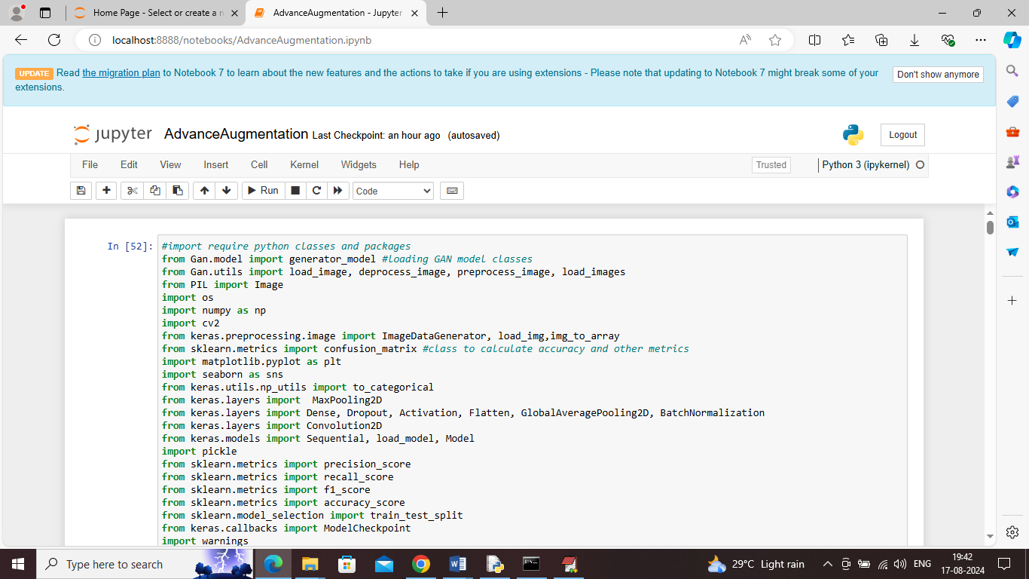
In above screen we are importing advance GAN and other python packages and classes
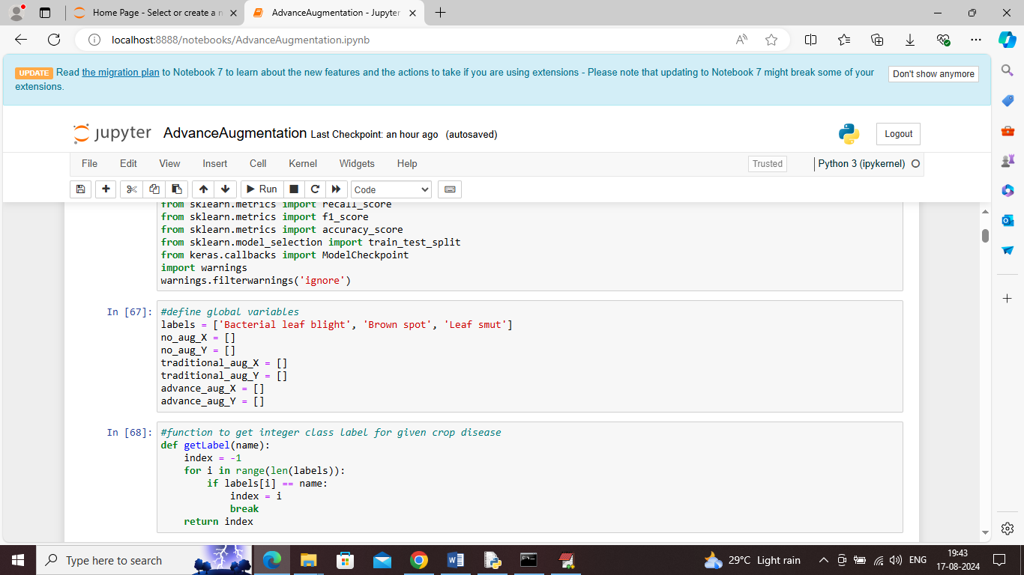
In above screen defining global variables to store images of different types such as No Augmentation, traditional and Propose Advance GAN and then defining function to get class integer value for given image name.
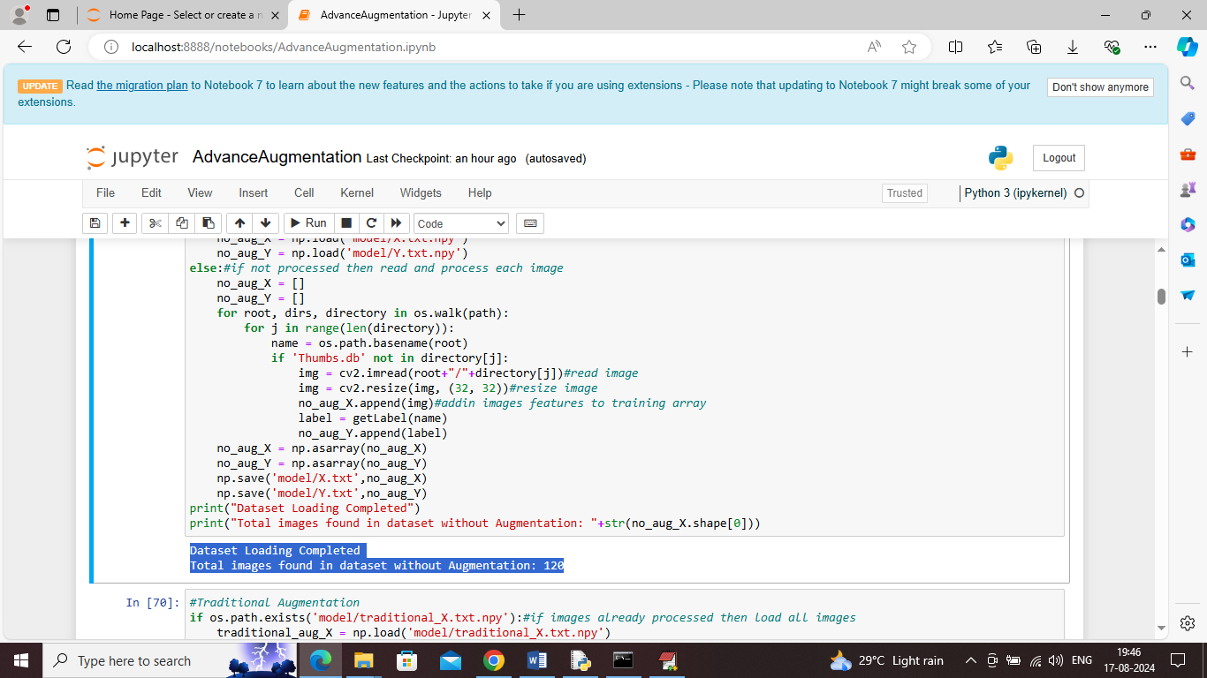
In above screen loading and processing all dataset images without any augmentation and in blue colour output can see Dataset contains 120 images
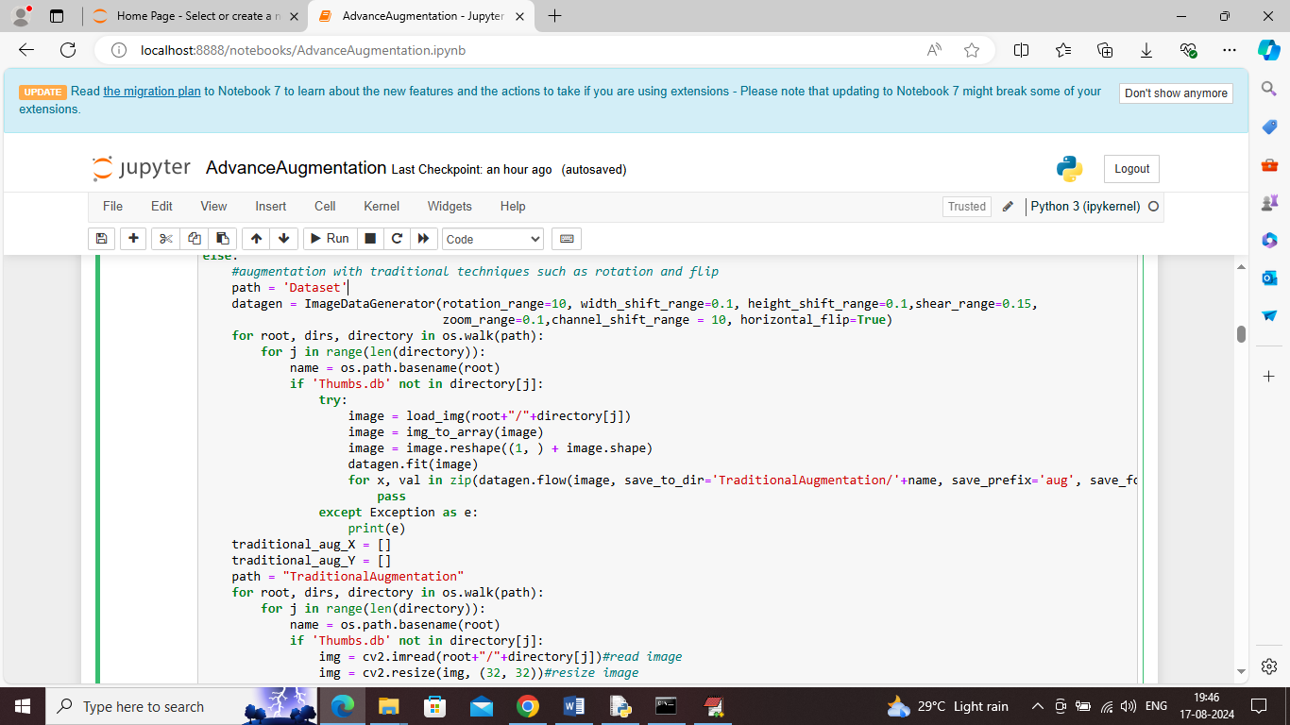
In above screen augmenting dataset using Traditional technique and after executing above block will get below output
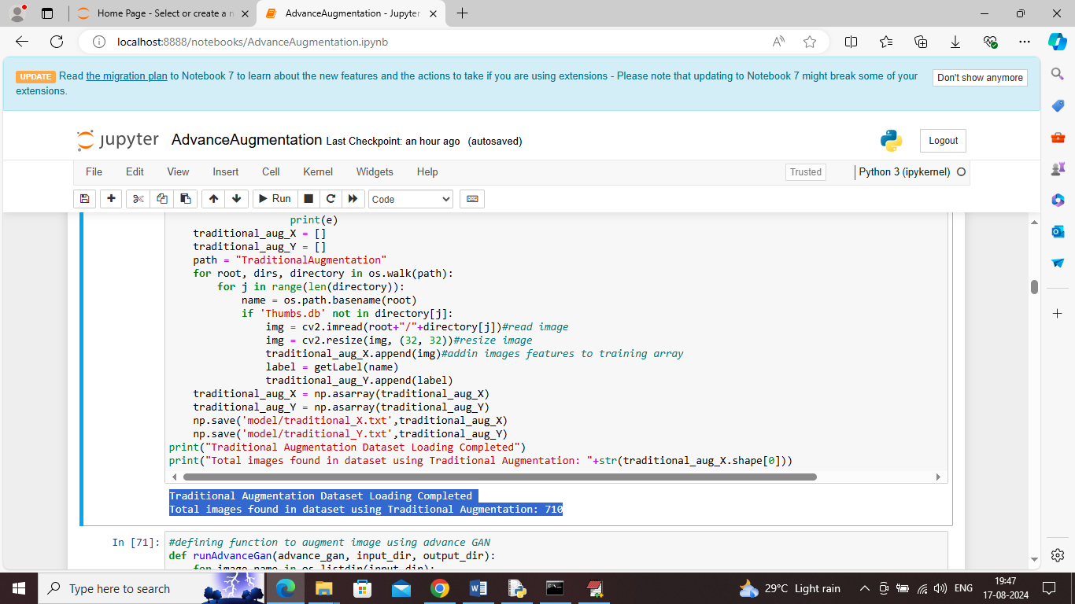
In above screen in blue colour output can see dataset images increased to 710 from 120 after applying traditional augmentation
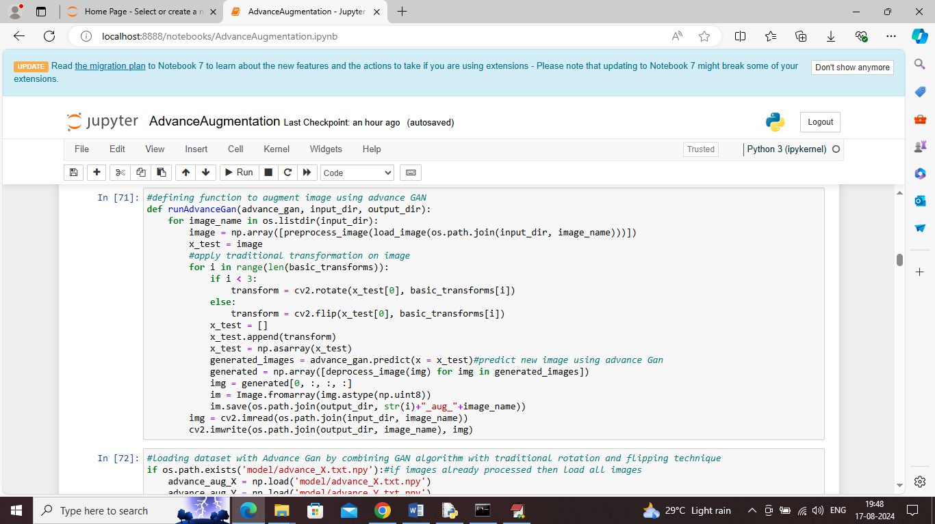
In above screen defining Advance GAN function which is generating new synthetic images by using GAN model and basic traditional transformation
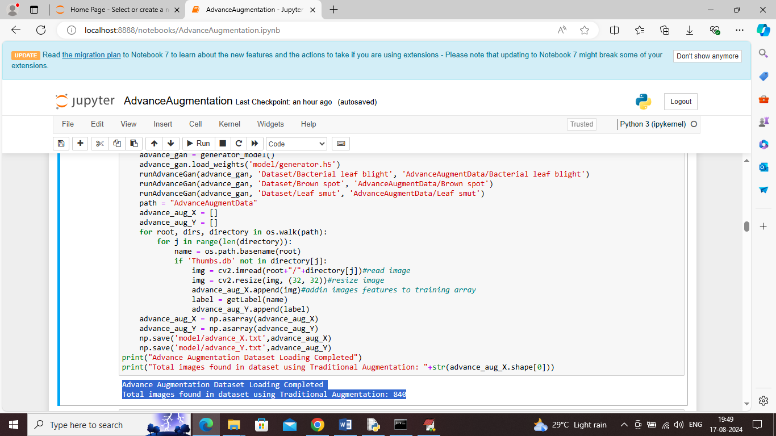
In above screen after applying propose Advance GAN algorithm dataset images increased to 840. Now we generated images without augmentation and with traditional and Propose Advance GAN techniques and now will train all different images with CNN algorithm and record accuracy
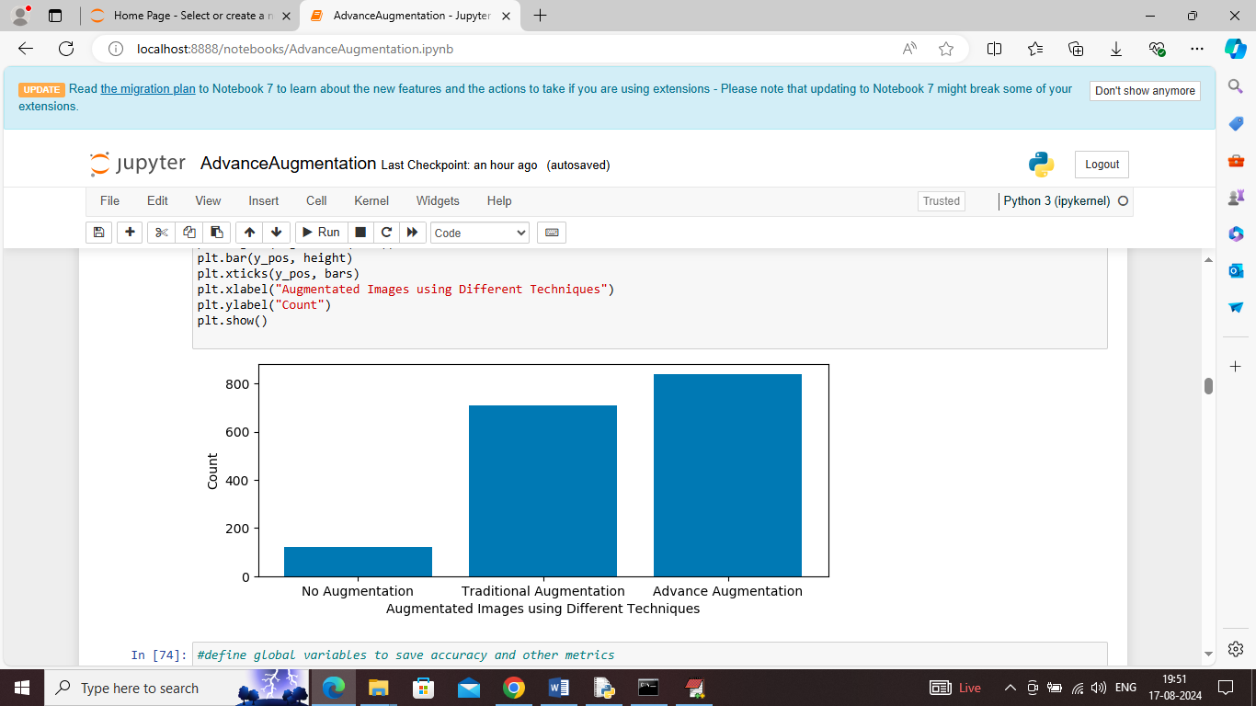
In above graph displaying images size with different augmentation techniques and in above graph x-axis represents augmentation type and y-axis represents Images count.
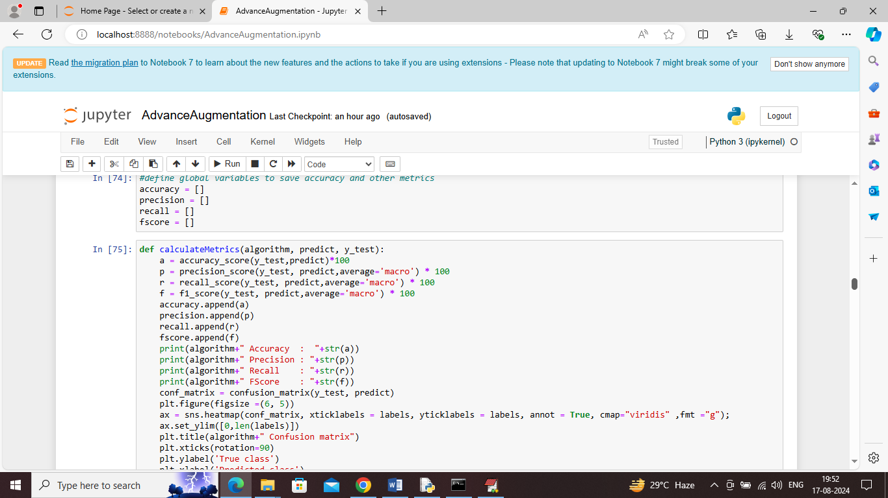
In above screen defining function to calculate accuracy and other metrics
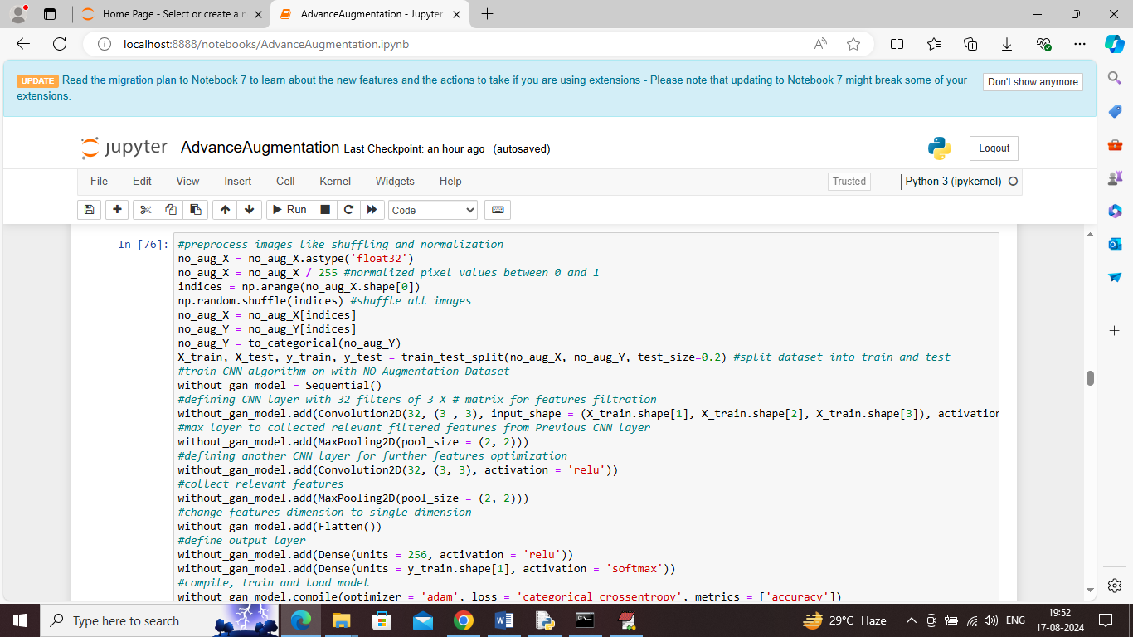
In above screen training CNN algorithm without GAN images and after executing this block will get below prediction output
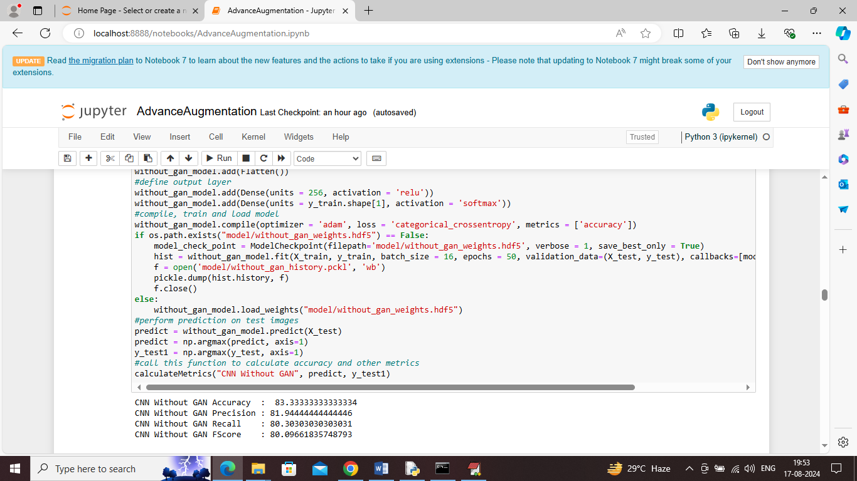
In above screen without Augmentation CNN got 83% accuracy and can see other metrics like precision, recall and FSCORE. In below screen can see confusion matrix graph
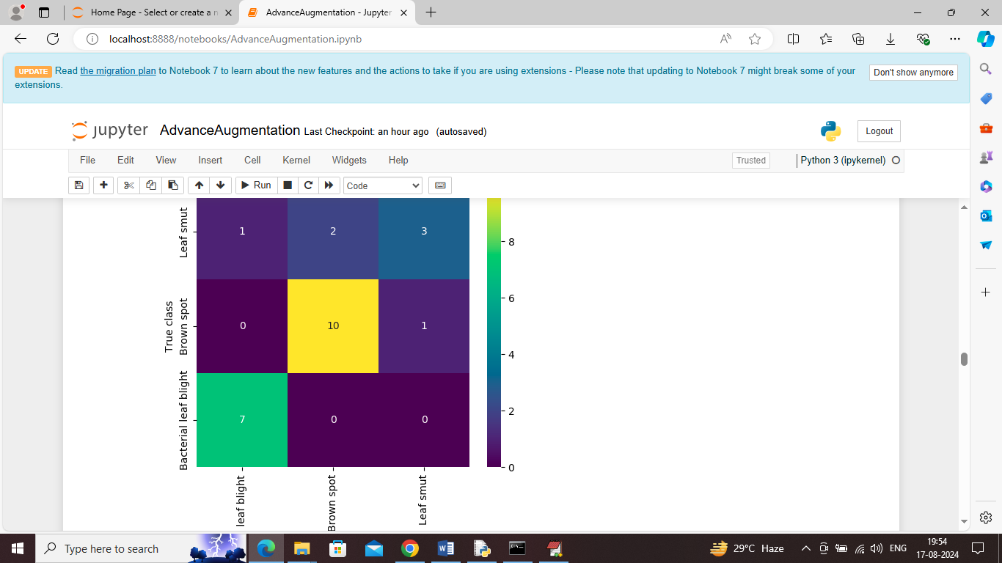
In above graph x-axis represents Predicted Labels and y-axis represents True Labels and then all different colour boxes in diagnol represents correct prediction count and all blue boxes represents incorrect prediction count which are very few
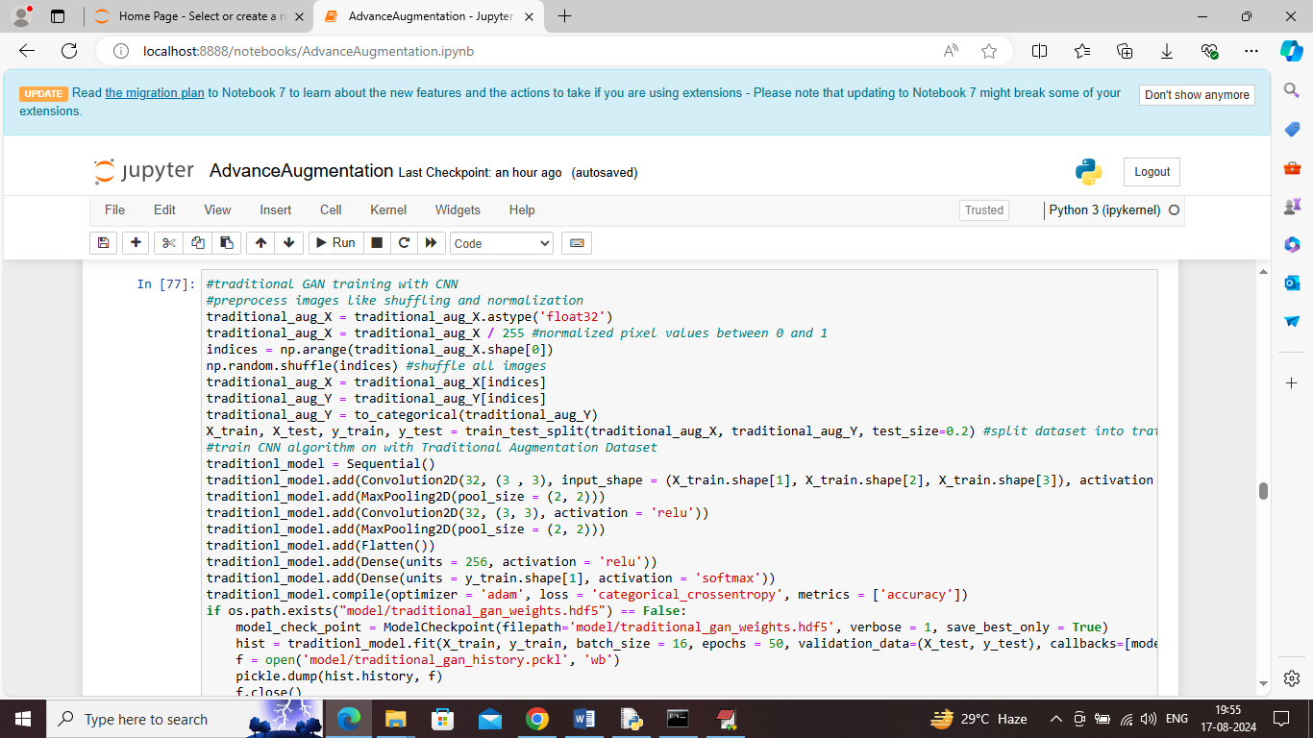
In above screen training CNN algorithm with traditional augmented image features and after executing above block will get below output
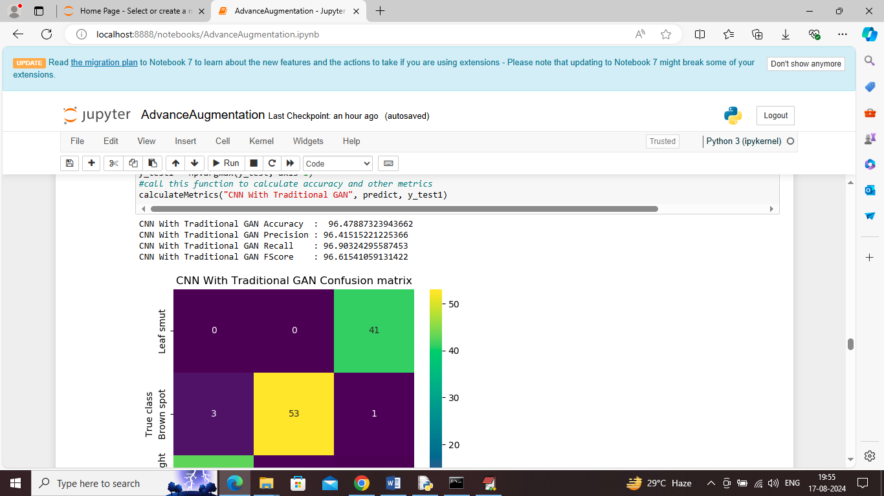
In above screen CNN with traditional GAN augmented images got 96% accuracy and can see other metrics also
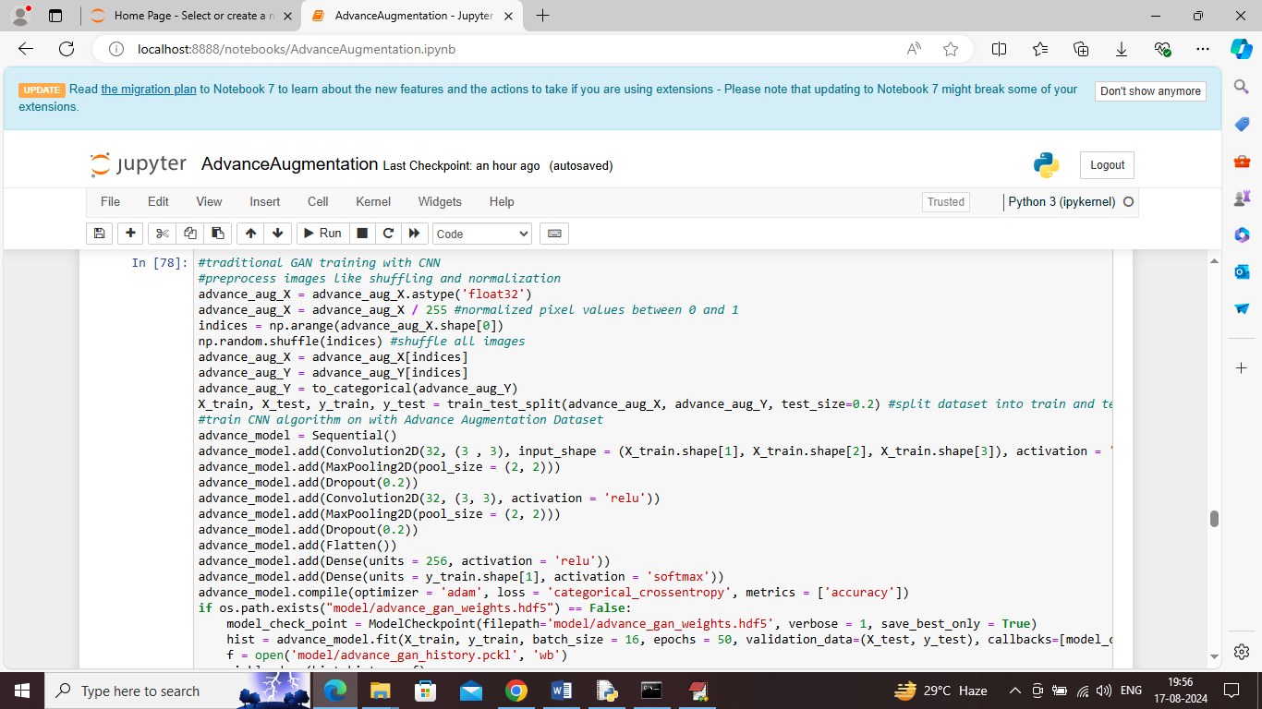
In above screen training CNN with advance GAN augmentation image features and after executing above block will get below output
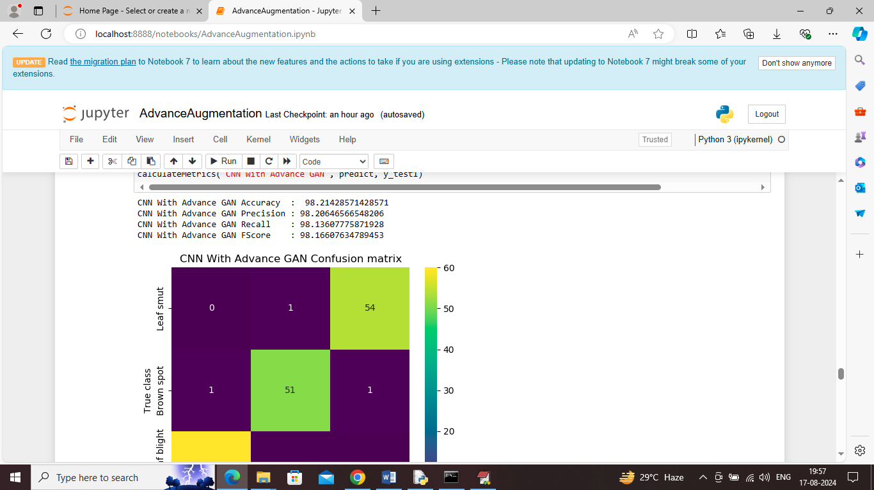
In above screen CNN with propose Advance GAN got 98% accuracy and can see other metrics also
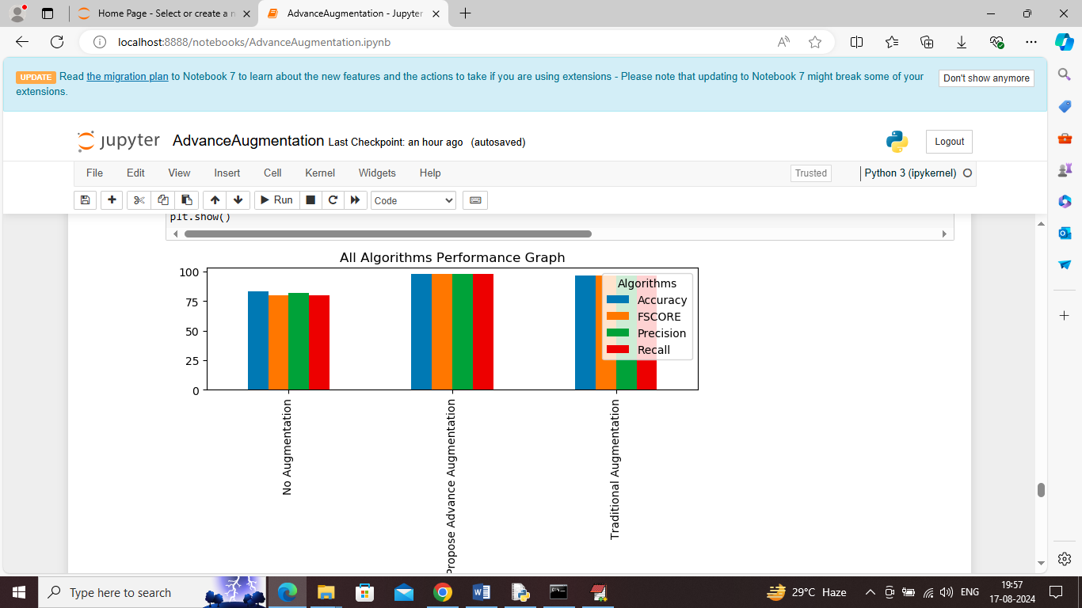
In above screen displaying comparison graph between all algorithms were x-axis represents algorithm names and y-axis represents accuracy and other metrics in different colour bars and in all algorithms propose Advance GAN got high performance
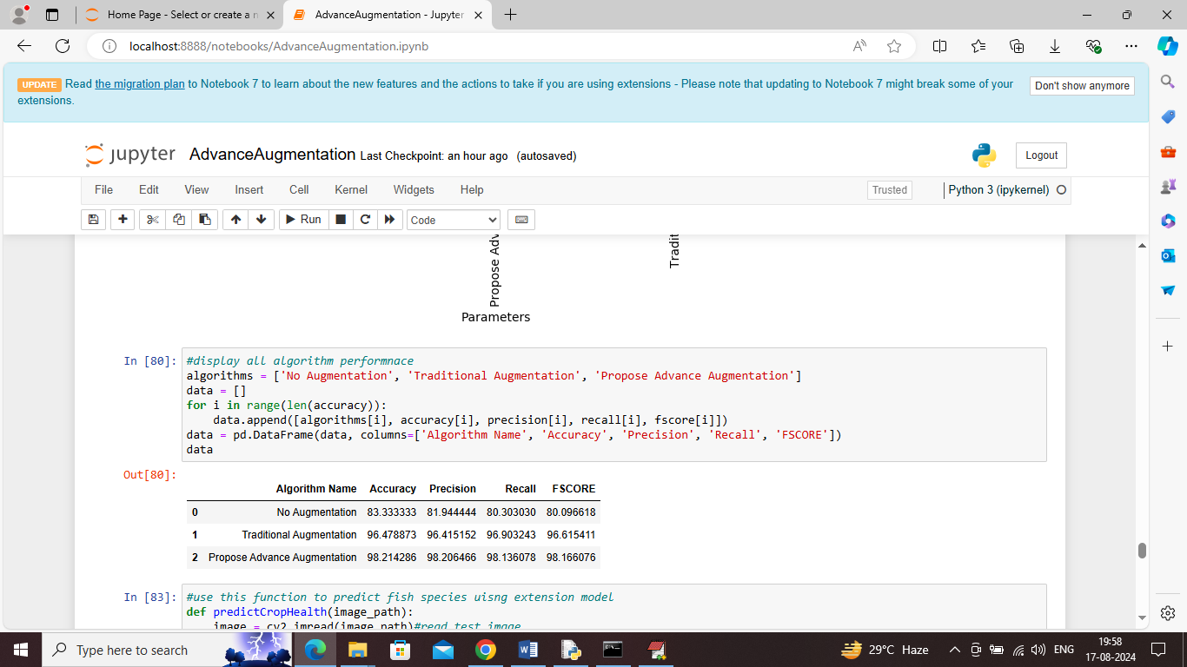
In above screen showing all algorithm performance in tabular format
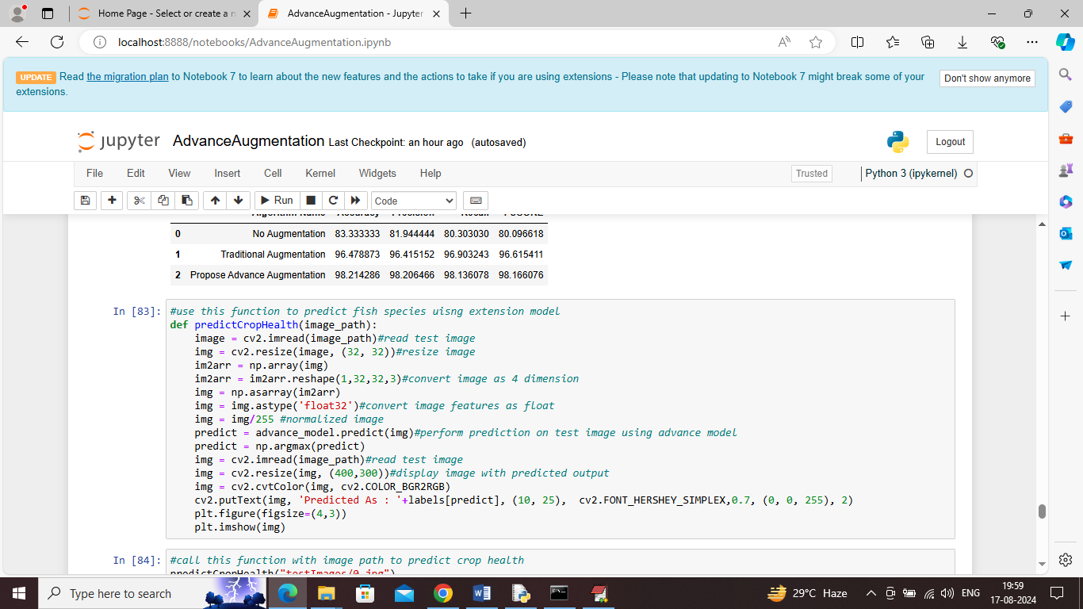
In above screen defining predict function which will take test image path as input and then predict crop health
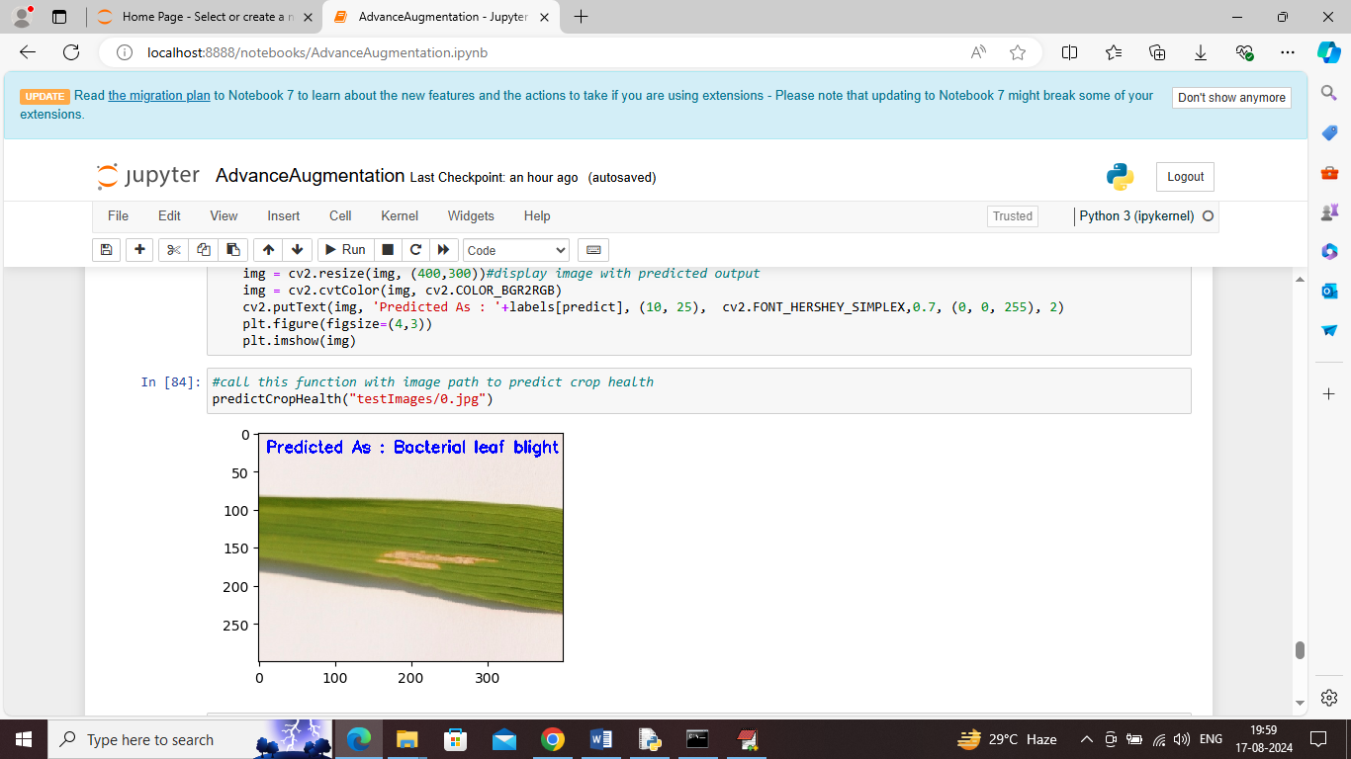
In above screen calling ‘Predict Crop Health’ function with test image path and then given crop predicted as ‘Bacterial leaf blight’ disease
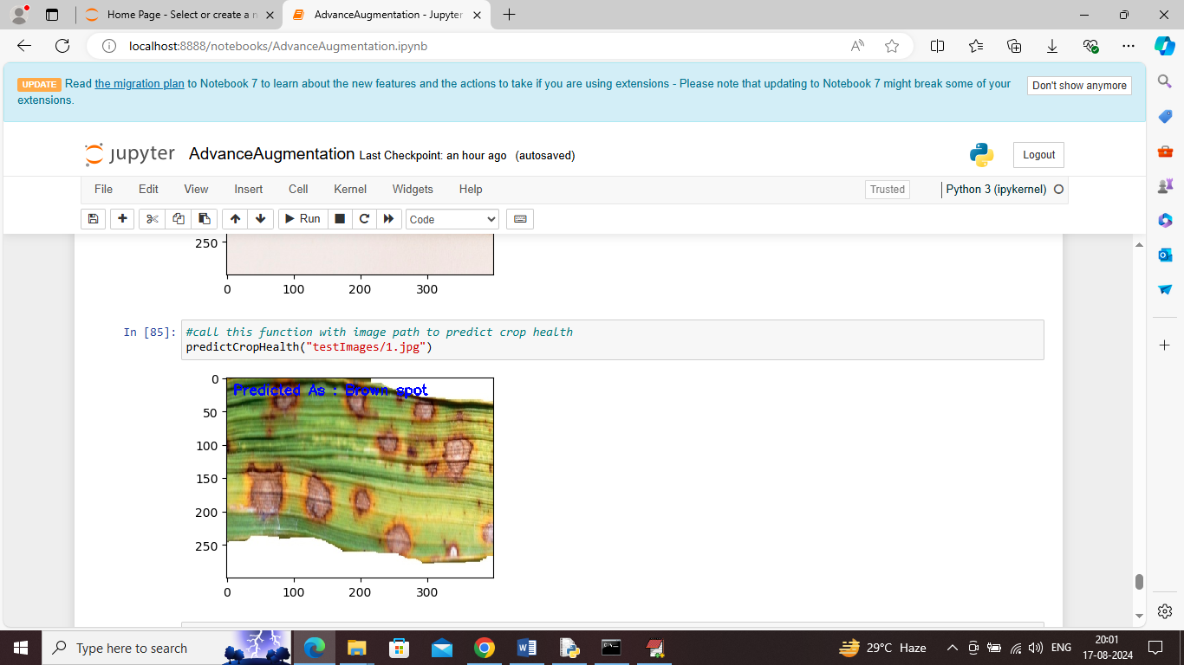
In above screen given crop predicted as ‘Brown Spot’ disease
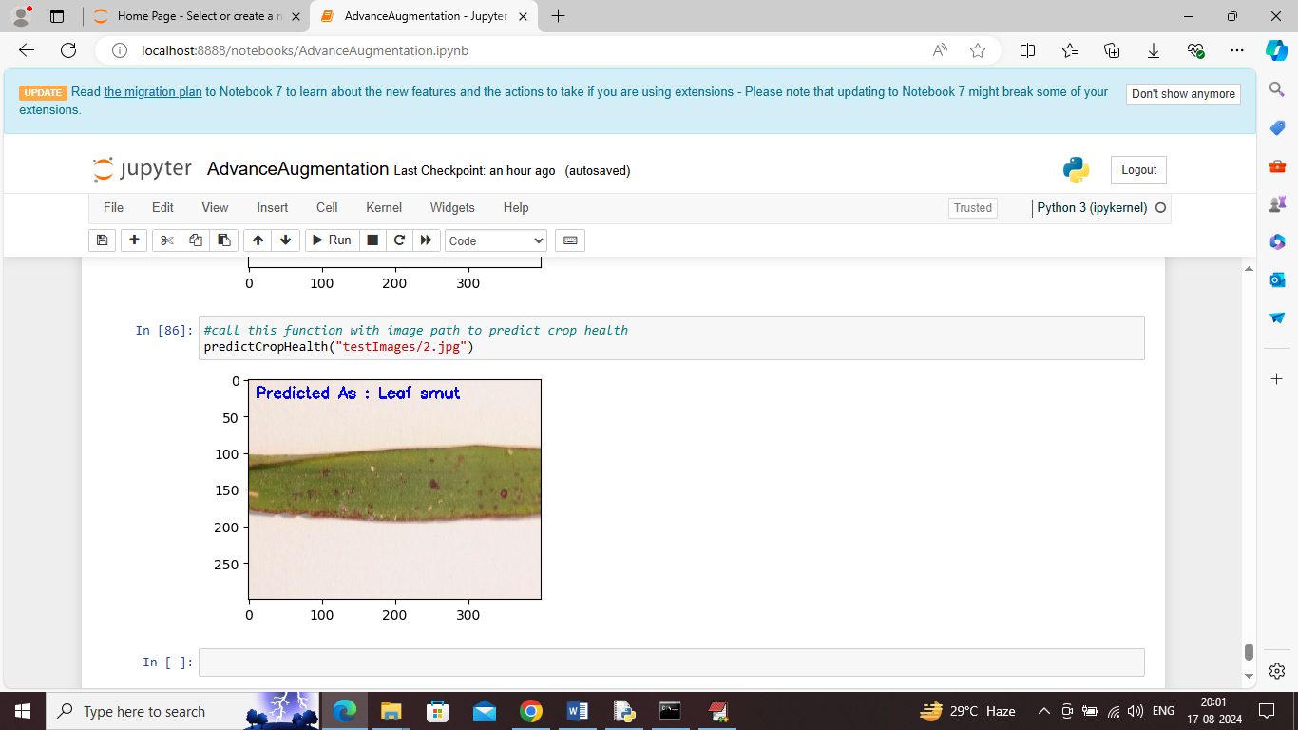
In above screen given crop predicted as ‘Leaf Smut’ disease. Similarly by calling this function with test image path you can perform prediction on different images

