Rainfall Prediction Model Using Machine Learning

*Abstract*—This abstract outlines a machine learning-based approach for rainfall prediction using the existing or historical weather data. Machine learning techniques have shown promising results in predicting rainfall patterns by analyzing various meteorological parameters.

This study proposes the utilization of these algorithms to forecast rainfall based on diverse input features like temperature, humidity, wind speed, atmospheric pressure, and geographical location. Historical weather data sets encompassing these parameters collected from weather stations are utilized for training, validating and evaluating the predictive model. The process involves collecting the data, cleaning and processing it, featuring the selection model, training, validation, evaluating and testing. Evolution matrix such as accuracy, precision, recall are used to access the model’s performance. Additionally, time series analysis and cross validation techniques are applied to enhance the robustness and accuracy of predictions.

The proposed rain prediction model aims to provide accurate and timely forecasts contributing significantly to sectors reliant on weather forecasts and aiding in decision making processes for agriculture water resource management and disaster mitigation strategies.

Keywords—machine learning, rainfall prediction

# Introduction

Rainfall prediction plays a vital role in various sectors including agriculture, water resource management and disasters preparedness. Accurate forecasting of precipitation patterns is essential for effective planning and decision making in these fields. Traditional methods of weather prediction often face challenges due to complexity and variability of atmospheric conditions and as a result, the integration of machine learning algorithms has emerged as a promising approach to improve the accuracy of rainfall prediction.

There are various algorithms of machine learning technique which helps in creating a model which gives us the prediction for expected rainfall in a given region. It includes classification and regression algorithms namely, linear regression, random forest method, and so on. The collected data is divided into two sets namely the training and testing sets. Based on this, the model is evaluated by training and testing to check whether it is giving accurate predictions of rainfall in a particular region as desired or not. The result is further monitored for any area of improvement.

This paper represents an investigation into the development of this model leveraging machine learning algorithms. The primary objective is to create a robust and reliable predictive model that uses historical weather data to forecast rain patterns accurately. Machine learning techniques offer the advantage of handling large volumes of data, identifying intricate relationships among various meteorological parameters, and enabling the creation of predictive models capable of learning from historical trends.

The proposed model makes use of diverse weather related parameters such as temperature humidity, wind speed, atmospheric pressure, geographical location,and potentially other relevant features historical data sets obtained from weather station, satellite imagery, or other sources serve as the foundation for training and validating the model. Thus, the model makes use of these historical data and helps to predict the chances of rainfall in a particular region.

# Problem Statement

Rainfall prediction holds significant importance in various domains such as agriculture, water resource management, and disaster mitigation. However, accurately forecasting rainfall remains a challenging task due to the complex and dynamic nature of atmospheric conditions. Traditional methods of weather prediction often face limitations in capturing the intricate relationships between meteorological variables leading to less precise forecasts.

The problem at hand is to develop an effective rainfall prediction model using machine learning algorithms. The primary challenge lies in creating a predictive model that can leverage historical weather data to accurately forecast rainfall patterns with a high degree of reliability, precision and accuracy.

The key aspects of the problem includes data complexity, feature selection, model selection and performance, overcoming data variability, evaluation and validation. The challenge involves handling and integrating the heterogeneous and voluminous data obtained from diverse sources for effective analysis. Also, identifying relevant features from the raw data and choosing appropriate algorithm capable of learning complex patterns within the data is essential to exhibit high variability and non-linearity.

Addressing these challenges require the exploration and implementation of advanced machine learning techniques, data pre-processing methodologies, feature engineering strategies, and robust model evolution techniques. Therefore, the ultimate goal is to create a rain prediction model that enhances the accuracy and reliability of weather forecasts in real time scenarios thereby aiding decision making processes in sectors reliant on accurate weather predictions.

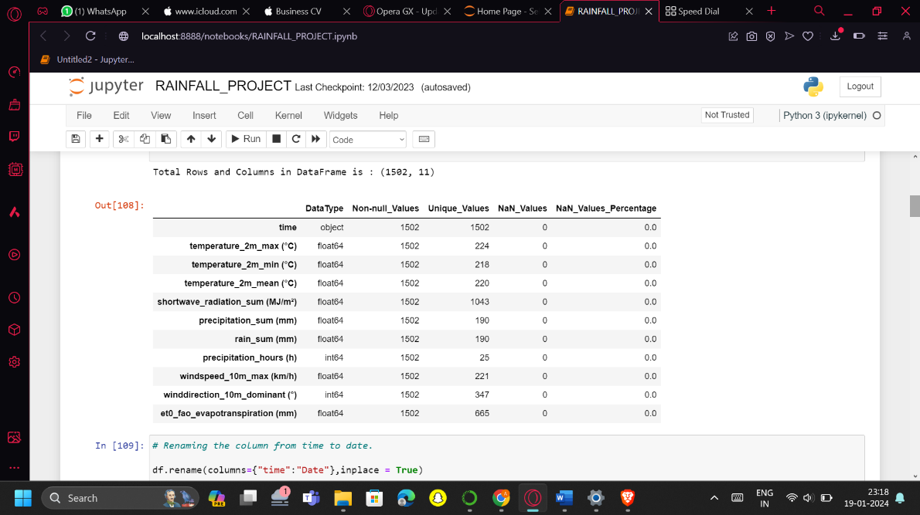

1. Information about the input data.

# Proposed Solution

In this rainfall prediction model using machine learning technique, we have trained the model to check which one is best suitable for the prediction and based on various criteria we can conclude that the best one we can go for is regression model, precisely random forest method as it gives the most accurate prediction of rain based on the analysis of historical data set given.

We start by collecting the historical data such as temperature, humidity, wind speed and direction, precipitation, and so on, of a particular region for a particular period of time. Then we process the data by treating the null values, checking for outliers and removing any duplicate data from the data set. This step prepares the raw and unfiltered data for further use. Then we move on to exploratory data analysis(EDA), which is an approach to analyse and summarize datasets to extract insights. This helps to understand the data better as it makes use of various visualization techniques to sense the patterns and relationship within the data. We further manipulate the data to improve the model training leading to better performance and increase the accuracy of model.

After this, we split the data into training and testing sets. The training set is used for training the model based on the historical data and the testing set is used to test the model for desired outcome. Based on the results, the model is then tested for unseen testing set. After this, we finally use the data in machine learning techniques to create the best suitable model for the required prediction. Although they are all various machine learning algorithms for creating a model for rainfall forecasting. In this, we are using random forest method, which comes under the category of regression algorithm of machine learning technique, since it gives the rainfall prediction of highest accuracy and precision compared to the other algorithms.

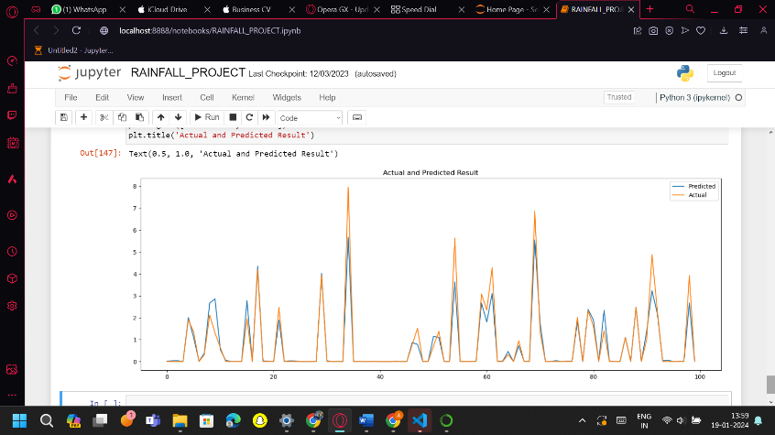

1. The actual and the predicted result graph.

## Mehodology

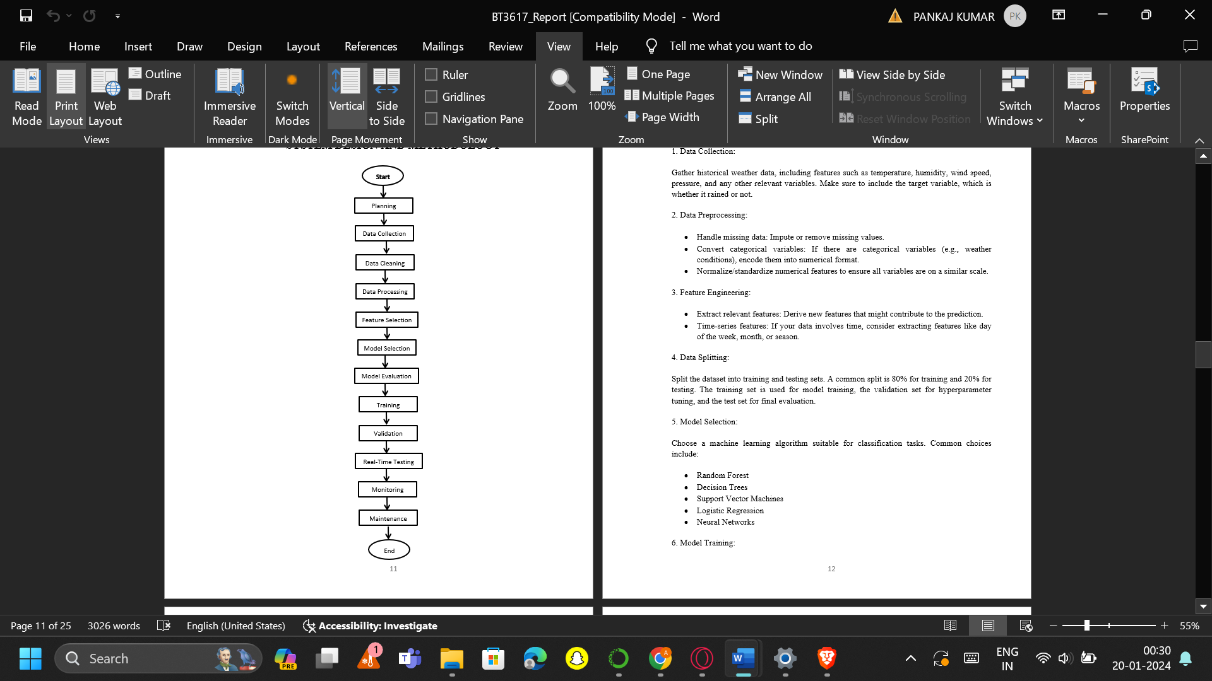

1. System design.

### Developing a rain prediction model using machine learning involves several steps and methodologies:

### Data Collection: Gather historical weather data, including features such as temperature, humidity, wind speed, pressure, and any other relevant variables. Make sure to include the target variable, which is whether it rained or not.

### Data Preprocessing: Handle missing data: Impute or remove missing values. If there are categorical variables (e.g., weather conditions), encode/covert them into numerical format. Normalize/standardize numerical features to ensure all variables are on a similar scale.

### Feature Engineering: Extract relevant features by deriving new features that might contribute to the prediction. If your data involves time (time-series features), consider extracting features like day of the week, month, or season.

### Data Splitting: Split the dataset into training and testing sets. A common split is 80% for training and 20% for testing. The training set is used for model training, the validation set for hyperparameter tuning, and the test set for final evaluation.

### Model Selection: Choose a machine learning algorithm suitable for classification tasks. Common choices include Random Forest, Decision Trees, Support Vector Machines, Logistic Regression, Neural Networks, etc.

### Model Training: Train the selected model using the training dataset, using techniques like cross-validation and grid search to optimize hyperparameters and avoid overfitting.

### Model Evaluation: Evaluate the model's performance using the testing dataset. Common metrics include accuracy, precision, recall, and F1 score.

### Hyperparameter Tuning: Fine-tune the model's hyperparameters to improve performance.

### Deployment: Once satisfied with the model's performance, deploy it to make real-time predictions.

### Model Testing: Finally, assess the selected model's performance on the test set to gauge its real-world predictive capabilities.

### Monitoring and Maintenance: Monitor the model's performance over time in performance, retrain and update it as needed. Consider retraining the model with new data periodically.

## Dependencies

### Numpy: Fundamental package for scientific computing with support for large, multi-dimensional arrays and matrices.

### Pandas: Data manipulation and analysis library, providing data structures like DataFrames for efficient data handling.

### Seaborn: Statistical data visualization library based on Matplotlib, providing a high-level interface for drawing attractive and informative statistical graphics.

### Matplotlib: 2D plotting library for creating static, animated, and interactive visualizations in Python.

### Sklearn: Simple and efficient tools for data mining and data analysis. It includes various machine learning algorithms and utilities.

# Objectives

Some of the primary objectives of this rainfall prediction model include:

### Accurate rainfall forecasting: Developing a predictive model capable of accurately forecasting rainfall patterns based on historical data such as occurrence intensity and special distribution.

### Utilization of diverse meteorological parameters: Incorporating and exploiting various meteorological parameters such as humidity to enhance the accuracy of rainfall predictions.

### Feature selection and engineering: Identifying the most relevant features from raw weather data that significantly impact rain forecasting and employing them to optimize the features set to improve the model’s predictive power.

### Evaluation and validation: Establishing methodologies to access model’s performance and utilizing metrics such as precision to validate the model’s reliability and effectiveness in predicting rainfall.

### Real time forecasting: Aiming for real time or near real time predictions that enable timely decision making and designing model to provide forecasts promptly.

### Model robustness and generalisation: Developing a robust machine learning model capable of handling variations, non-linearity, and complex interactions within whether data to ensure the model’s ability to generalise well to unseen data.

### Improving resilience and preparedness: Contributing to improving resilience against weather related risks and enhancing preparedness for extreme weather events.

### Enhancing existing forecasting systems: Integrating the developed model into existing weather forecasting systems to complement and enhance their capabilities for improving their accuracy.

### Contribution to scientific knowledge: Contributing insights and findings to the scientific community by elucidating the significance of machine learning techniques in rainfall prediction.

## Impact and Contribution

The contribution of a rainfall prediction model is impactful across various domains. Some of them include:

### Improved accuracy in rainfall forecasting: The model’s ability to leverage machine learning algorithm facilitates more accurate predictions of rainfall patterns compared to traditional methods. This heightened accuracy aids in better planning and decision making in sectors heavily reliant on weather forecasts.

### Enhanced resilience in agriculture: Accurate rainfall predictions empower farmers and agricultural practitioners with valuable information for crowd planning, irrigation scheduling, and pest management. This contributes to increased agricultural productivity and minimises crop losses due to adverse weather conditions.

### Efficient water resource management: Reliable rainfall forecast support efficient water resource allocation and management strategies. Reservoir management and drought mitigation plans benefit from timely and accurate predictions ensuring better utilisation of water resources.

### Improved disaster preparedness: Only an accurate forecast of heavy rainfall or extreme weather events aid in disaster preparedness and response. Timely warnings can mitigate risk associated with warding landslides and other weather related disasters.

### Environmental impact assessment: Accurate rainfall prediction facility metal assessment of environmental impacts such as changes in ecosystems and contribute to scientific research for understanding of complex weather patterns. Insights can aid in further research on atmospheric science and weather dynamics.

##### Acknowledgments

We would like to thank everyone who helped us achieve this success. It was a great experience of working on this project of “Rainfall Prediction Model Using Machine Learning”. It would not be possible without the consistent help of all our mentors, guide, friends, family, and facilitators. We are immensely grateful to our university and our department, that is, Department of Computer Science and Engineering, Galgotias University, Greater Noida, and the members of the management including our dean, guide, and reviewer, for providing us this great opportunity where we could put our best knowledge together to give this outcome. A special thank you to all who gave us their precious time and knowledge, which really helped us to think better and produce the best of what we could achieve with this project.

##### References

1. “Nishchala C Barde and Mrunalinee Patole. Classification and forecasting of weather using ann, k-nn and naive bayes algorithms “. In This paper, here some algorithms are used to predict the rainfall. K-NN, ANN, and Naïve bayes algorithms are used to predict the weather.
2. SML Venkata Narasimhamurthy & et al. “Rice Crop Yield Forecasting Using Random Forest Algorithm”. Highest accuracy of 85.89% is obtained by using this method. In this paper gives good accuracy for crop prediction using rainfall prediction model.
3. Dr. Bharat Mishra & et al. “Soybean Productivity Modelling using Decision Tree Algorithms”. Decision tree is being converted to classification rules using IF-THEN- ELSE. In this model tries to give good prediction for crops. Here data mining techniques are used to building the model.
4. K Chowdary, R Girisha, and KC Gouda. “A study of rainfall over India using data mining”. Some datamining techniques are used to predict the output in future.
5. Pinky Saikia Dutta and Hitesh Tahbilder. “Prediction of rainfall using data mining technique over assam “. This paper done based on datamining techniques are using to trained the model for rainfall. and some techniques are used such as statistical techniques , multilinear regression . this model predicts rainfall based on month in assam.
6. Arun Kumar & et al. “Efficient Crop Yield Prediction using rainfall Using Machine Learning Algorithms”. in this paper includes rainfall prediction And the range of productivity will be 7. defined.
7. Kawsar Akhand & et al. “Yield Prediction using rainfall in Bangladesh Using Satellite Remote Sensing Data and Artificial Neural Network”. In this machine learning algorithms are used to test the datasets and also used for predicting the system.
8. P. Priya*1 & et al. “Predicting the Crop Yield Using Machine Learning Algorithm”. in this paper having dataset cleaning, testing are done using machine learning algorithms and Decision tree is used for classification purposes.