* Write SQL query to solve the problem given below

Consider a scenario in which you have to create a table called Nobel_win where you have given the information about the entity who has achieved nobel prize in a particular subject all over the world.

Over here the table Nobel_win will contain attributes like year, subject, winner, country and category

You need to use the sql commands to create the table given and to solve the problem given below.

Eg :

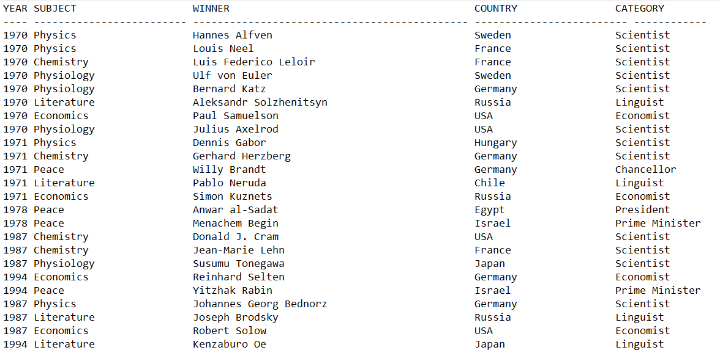

Now make sure to solve the following query :

* Write sql query to find the nobel prize winners of the year 1970. Return year,subject and winner

Ans: SELECT year, subject, winner

FROM nobel_prize

WHERE year = 1970;

* Write sql query to find the nobel prize winners in chemistry between the years 1965 and 1975. Begin and end values are includedReturn year, subject, winner and country

Ans: SELECT year, subject, winner, country

FROM nobel_prize

WHERE subject = 'Chemistry' AND year BETWEEN 1965 AND 1975;

* Write sql query to retrieve the details of the winners whose first name matches with

the string ‘Louis’. Return year,subject,winner,country

Ans: SELECT year, subject, winner, country

FROM nobel_prize

WHERE winner LIKE 'Louis%';

* Write sql query to find Nobel prize winners for the subject that does not begin with

the letter ‘P’. Order the result by year, descending and winner in ascending

* Write sql query to find the details of 1970 Nobel prize winners. Order the result by subject, ascending except for ‘Chemistry’ and ‘Economics’ which will come at the end of the result set. Return year, subject, winner , country and category.

Make sure to make your clean and clear code