Page 1 of 23

GOVERNMENT POLYTECHNIC COLLEGE

KUNNAMKULAM

KIZHOOR(P.O), THRISSUR (DT), KERALA,

PIN-680523

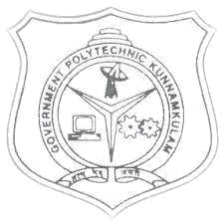

SEMINAR REPORT

2018-2019

DATA LEAKAGE DETECTION

PRESENTED BY

SHARON T S S

REGISTER NO:20133031

Directorate of Technical Education

Government of Kerala

Page 2 of 23

GOVERNMENT POLYTECHNIC COLLEGE

KUNNAMKULAM

KIZHOOR(P.O), THRISSUR (DT), KERALA, PIN-680523

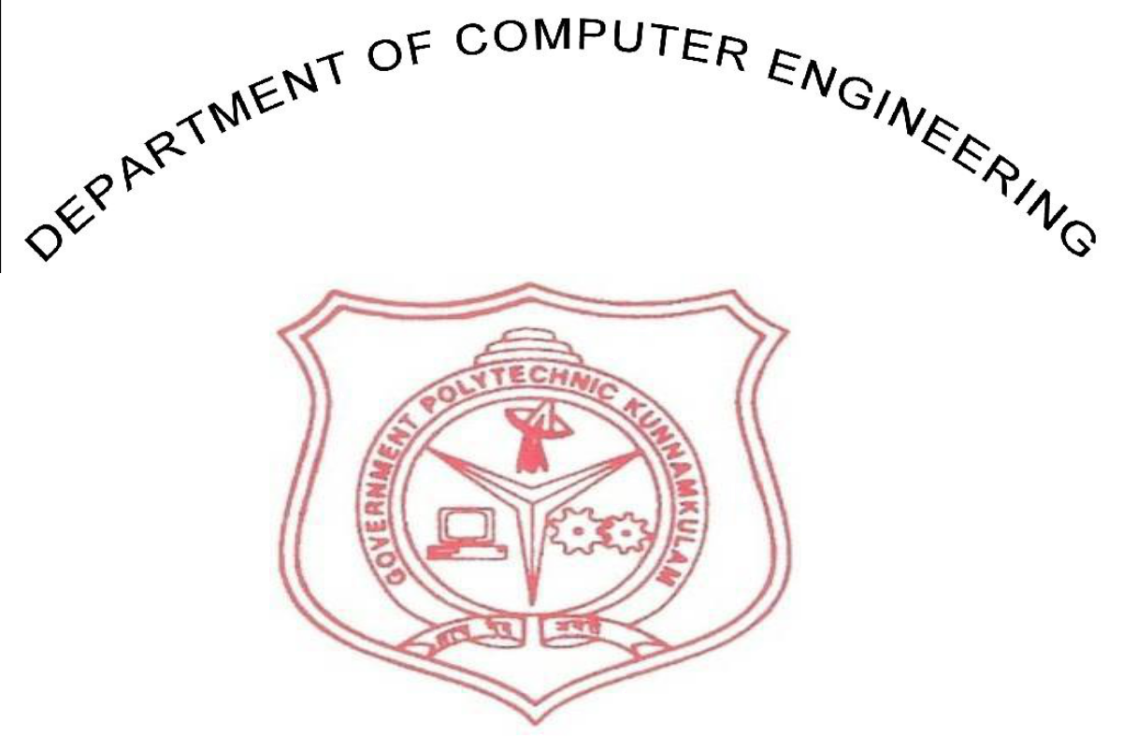

CERTIFICATE

This is to certify that the seminar report titled “ NON-FUNGIBLE TOKENS” was presented by Reg.No:20133031 in partial fulfillment of the requirement for the award of Diploma in Computer Engineering under the Technical Education Department during the academic year 2018-2019 at Govt. Polytechnic College Kunnamkulam.

Date:

Place:

Guide
Head of the Department

External Examiner

Internal Examiner

Page 3 of 23

ACKNOWLEDGEMENT

At first, I like to express my indebtedness to the almighty god who showered his abundant grace on me to make this seminar a success.

I wish to record our sincere thanks to Seema.K.N , our principal to provide us all necessary facilities. I take this opportunity to express our thanks to Mr. Bijoy George, our head of the department of computer engineering for his valuable guidance and support to shape this seminar in a systematic way. I am extremely thankful to our respected lecturers for their keen interest and valuable suggestions in this seminar.

In addition I would like to thank all the staff members of computer department and all my friends of CTS6 for their suggestions and constructive critics.

SHARON T S

Page 4 of 23

ABSTRACT:-

An NFT (Non-Fungible Token) is a unique digital asset that represents ownership of a specific item or piece of content, such as a piece of artwork, music, video, or other media. NFTs are stored on a blockchain, allowing for secure and transparent transfer of ownership and verification of authenticity. The ownership of an NFT is recorded on the blockchain, providing a permanent and immutable record of the asset. NFTs have become increasingly popular in recent years, as they offer a new way for creators to monetize their digital content and for collectors to own and trade unique, one-of-a-kind items
One of the key features of NFTs is that they are non-fungible, meaning that each NFT is unique and cannot be replaced or exchanged for something of equal value. This is in contrast to cryptocurrencies such as Bitcoin, which are fungible and can be divided and exchanged for an equivalent value. The non-fungibility of NFTs provides a level of scarcity and exclusivity,
making them highly sought after by collectors and investors.
Another important aspect of NFTs is that they offer greater control and ownership over digital assets. In the past, digital content such as artwork and music was often difficult to monetize and manage due to the ease of duplication and distribution. With NFTs, creators can sell their work as a unique and verifiable asset, giving them greater control over the distribution and value of their creations. This has the potential to revolutionize the way that digital content is created, distributed, and valued, providing a new and exciting opportunity for artists and creators to monetize their work.
Page 6 of 23

CONTENTS

Sl.NO | TOPICS | PAGE NO
1 | Introduction | 7
2 | What Is Cloud Computing | 8
3 | Architecture Of Cloud Computing | 9-10
4 | Types Of Cloud Computing | 11-14
5 | Components Of Cloud Computing | 15-16
6 | Advantages Of Cloud Computing | 17-19
7 | Disadvantages Of Cloud Computing | 20-21
8 | Conclusion | 22
9 | Reference | 23

Page 7 of 23

INTRODUCTION

NFT stands for Non-Fungible Token, which is a type of digital asset that represents ownership of a unique item or piece of content, such as a piece of artwork, music, video, or other media. NFTs are stored on a blockchain, a decentralized and distributed ledger, providing a secure and transparent record of ownership. The ownership of an NFT is recorded on the blockchain, allowing for verification of authenticity and transfer of ownership. NFTs offer a new way for creators to monetize their digital content and for collectors to own and trade unique, one-of-a-kind items, and have become increasingly popular in recent years. Unlike cryptocurrencies, which are fungible and can be divided and exchanged for an equivalent value, NFTs are non-fungible and provide a level of scarcity and exclusivity. The technology behind NFTs, including blockchain, digital signatures, and decentralized storage, allows for secure and verifiable ownership and transfer of these valuable digital assets.
The use of NFTs is not limited to just the art world, as they have the potential to disrupt and transform a variety of industries. For example, NFTs can be used to represent ownership of virtual real estate, in-game items, and collectibles. They can also be used for ticketing and event management, providing a secure and verifiable way to manage entry and attendance. NFTs have the potential to revolutionize the way that digital assets are created, managed, and valued, offering new opportunities for creators and owners to monetize their work and assets. With their unique features and the growth of blockchain technology, NFTs are poised to play an important role in the digital economy of the future

Page 8 of 23

What Is NFTs?

An NFT is like a special ticket that shows you own something special, like a rare toy or a one-of-a-kind drawing. It's kind of like a collector's card that proves you have something special that nobody else has. Instead of keeping the ticket in your pocket, it is kept in a big computer system called a blockchain, so everyone can see that you have it and no one else can take it away from you. And because it's on a computer, you can show it to your friends and family even if you're far away from each other. It's a cool way to own something special and show it off to the world!
Let's say you have a special drawing that you made, and you want to sell it to someone. Instead of just giving them the piece of paper, you can sell them an NFT to prove that they own the special drawing. And because it's stored in the blockchain, it's like a super safe and special lock box that only the owner can open.
And, because NFTs are unique, just like your special drawing, no one else can have an exact copy of the NFT. So, if you have an NFT for your special drawing, it's like having a one-of-a-kind treasure, and no one else in the world can have the same exact treasure. That's why people love to buy and collect NFTs!

Page 9 of 23

HOW NFTs WORKS

NFTs work by using blockchain technology to create a secure and transparent record of ownership. Here's a general outline of how it works:
Creation: An artist or creator creates a unique piece of digital content, such as a piece of artwork or a music track.
Tokenization: The digital content is tokenized, meaning that it is transformed into an NFT by assigning it a unique identifier and storing it on a blockchain. This allows the NFT to be treated as a unique and valuable digital asset.
Sale or Transfer: The NFT can then be sold or transferred to a new owner through a marketplace or platform that supports NFT transactions. The transfer of ownership is recorded on the blockchain, providing a secure and transparent record of the transaction.
Verification: The ownership and authenticity of an NFT can be easily verified by looking up the NFT's unique identifier on the blockchain.
Display: The NFT can be displayed and used to prove ownership of the original digital content. For example, the owner of an NFT for a piece of artwork can display the artwork on their website or social media, using the NFT as proof of ownership.
By using blockchain technology and smart contracts, NFTs provide a secure and verifiable way to manage and transfer digital assets, offering a new way for creators and collectors to monetize and trade unique and valuable items.

Page 11 of 23

Advantage of NFTs

NFTs offer several advantages compared to traditional methods of managing and owning digital assets. These advantages include:
Unique Ownership: NFTs provide a secure and transparent record of ownership, allowing for the verification of authenticity and transfer of ownership. This enables creators to monetize their digital content and provides collectors with the opportunity to own and trade one-of-a-kind items.
Verifiability: NFTs allow for easy verification of authenticity, as the ownership and history of each NFT is recorded on the blockchain. This provides peace of mind for buyers, who can be sure that the NFT they are purchasing is genuine and unique.
Immutable Record: The use of blockchain technology ensures that the record of ownership for an NFT is immutable and cannot be altered. This provides a secure and permanent record of ownership, protecting the value and authenticity of the NFT.
Liquidity:NFTs can be easily bought, sold, and traded on various platforms and marketplaces, providing a new level of liquidity for digital assets.

Efficient Storage: NFTs can be stored on the blockchain, eliminating the need for physical storage and reducing the risk of loss or damage. This makes it easier and more cost-effective to manage and transfer NFTs.
These advantages have made NFTs an increasingly popular solution for the management and transfer of digital assets, offering new opportunities for creators and collectors to monetize and trade unique and valuable items.
Page 15 of 23

Disadvantage of NFTs

Despite their many benefits, NFTs also have several disadvantages that should be considered before using or investing in them. Some of the main disadvantages include:
Complexity: NFTs and the underlying blockchain technology can be complex and difficult to understand for many people, which can be a barrier to adoption. This can make it difficult for creators, collectors, and buyers to navigate the NFT market and participate in NFT transactions.
Environmental Impact: The energy consumption and carbon footprint associated with NFT transactions can be significant, as blockchain networks require large amounts of energy to operate. This can make NFTs unsustainable from an environmental perspective, especially as the NFT market continues to grow.
Limited Use Cases: While NFTs have a wide range of potential uses, they are currently best suited for a limited number of use cases, such as the ownership and trade of digital art and collectibles. This limits the potential market for NFTs and may restrict their growth and adoption.
Lack of Regulation: The NFT market is largely unregulated, which can lead to issues with fraud, scams, and other forms of misconduct. This can reduce the trust in NFTs and make it difficult for buyers to protect their investments.
Page 17 of 23

Scalability: The current scalability of NFTs and blockchain technology is limited, which can result in slow transaction times and high transaction fees. This can make NFTs less practical for large-scale transactions and limit their potential use cases.
It is important to weigh these disadvantages against the benefits of NFTs and carefully consider whether they are a suitable solution for a particular use case or investment opportunity
Page 18 of 23

Technology used

NFTs are built on top of blockchain technology, which provides a secure and transparent method of managing and transferring digital assets. Here are some of the key technologies used in NFTs:

Blockchain: A blockchain is a distributed ledger that records transactions and provides a secure and transparent record of ownership. NFTs use blockchain technology to store and transfer ownership of digital assets, providing a secure and verifiable record of the asset's history.
Smart Contracts: Smart contracts are self-executing contracts that automate the transfer of ownership and other transactions related to NFTs. They are programmed to automatically enforce the terms of an NFT sale or transfer, providing a secure and transparent method of conducting NFT transactions.

Cryptography: Cryptography is used to secure the NFT and its ownership information, providing a high level of security for NFT transactions. This ensures that the NFT can only be transferred or sold by the owner and that the ownership information cannot be altered or tampered with.
Page 19 of 23

InterPlanetary File System (IPFS): IPFS is a distributed file system that allows for the decentralized storage of NFTs and their associated digital assets. IPFS provides a secure and scalable method of storing NFTs, reducing the risk of data loss or damage.
These technologies work together to provide a secure, transparent, and verifiable method of managing and transferring NFTs. By using blockchain technology, NFTs offer a new way to manage and trade unique and valuable digital assets, providing new opportunities for creators and collectors
Page 20 of 23

Environmental impact of NFTs

The environmental impact of NFTs is a growing concern, as the energy consumption and carbon footprint associated with NFT transactions and the underlying blockchain technology can be significant. Here are some of the ways in which NFTs can impact the environment:
Energy Consumption: NFT transactions require the use of large amounts of energy, as they rely on blockchain networks that require computational power to operate. This energy consumption can result in a significant carbon footprint and contribute to global warming.
E-waste: As NFTs are digital assets, they do not result in physical waste. However, the devices used to store and access NFTs, such as computers and smartphones, can generate e-waste as they reach the end of their life cycle and are discarded. This e-waste can have a negative impact on the environment, as it can release harmful chemicals and pollutants into the air, water, and soil.
Deforestation: The energy required to run NFT transactions and the underlying blockchain technology is often generated from non-renewable sources, such as coal and oil. The production of energy from these sources can result in deforestation, as large areas of land are cleared to make way for mining and drilling operations.
It is important to consider the environmental impact of NFTs when using or investing in them, and to take steps to minimize their carbon footprint. This may include using renewable energy sources to power NFT transactions, using energy-efficient devices, and recycling e-waste to reduce its impact on the environment.
Page 22 of 23

CONCLUSION

In conclusion, NFTs are a unique and innovative technology that provides a secure and transparent method of managing and transferring digital assets. With the ability to prove ownership and authenticity, NFTs have the potential to revolutionize the art, collectibles, and gaming industries. However, it is important to consider the environmental impact of NFTs, as their energy consumption and carbon footprint can have a significant impact on the environment. To ensure that NFTs are used in a responsible and sustainable manner, it is important to consider the energy sources used to power NFT transactions, minimize e-waste, and adopt environmentally-friendly practices. Overall, NFTs represent an exciting and rapidly-evolving technology with significant potential for the future
Page 23 of 23

REFERENCE

- A Beginner's Guide to NFTs" by ConsenSys

- Non-Fungible Tokens: A Complete Guide" by DappHub.

- The Rise of Non-Fungible Tokens" by Deloitte.

- What are NFTs and why are they important?" by Forbes.

- A Guide to Non-Fungible Tokens (NFTs) and their Uses" by Binance Academy.

- Non-Fungible Tokens: An Introduction" by the Ethereum Foundation .

- Non-Fungible Tokens: What They Are and How They Work" by CoinDesk.

