CIS6003 Advanced Programming
Coursework Report (WRIT1)
Sunrise Dental Clinic
Appointment & Patient Management System
Student Name: [STUDENT NAME]
Student ID: [STUDENT ID NUMBER]
Module Code: CIS6003 Assessment ID: WRIT1
Word count: [INSERT FINAL WORD COUNT]
GitHub repository: https://github.com/SharonAbi/sunrise-dental-clinic

Table of Contents

(Right-click the table above and choose "Update Field" in Microsoft Word once the document is finished, so page numbers are correct.)

1. Introduction
Sunrise Dental Clinic is a private dental centre in Colombo that currently manages patient appointments and treatment records using paper files and notebooks. This manual process has led to double bookings, lost patient records, long waiting times, and billing errors. This report documents the design, development, testing, and version control of a computerised Appointment and Patient Management System built to replace that manual process, developed as coursework for the CIS6003 Advanced Programming module.
The system allows authorised clinic staff to log in securely, register new patient appointments with a uniquely generated appointment number, search for and display existing appointment details, calculate and print a treatment bill, and access step-by-step help instructions. It is implemented in Java as a server-side web application using Servlets and JavaServer Pages (JSP) for the presentation and control layers, JDBC for data access, and MySQL as the persistent data store.
The report is organised around the four tasks set out in the assessment brief: Task A covers the system's design, expressed through UML Use Case, Class, and Sequence diagrams; Task B covers the development of the interactive system itself, including the design patterns and web service used; Task C covers the testing strategy, including a worked example of test-driven development and the automated test suite; and Task D covers the use of Git and GitHub for version control, including the workflow used to track and deploy changes.

2. Task A: System Design with UML Diagrams (20 marks)
This section presents the Use Case, Class, and Sequence diagrams produced for the system, together with the design decisions and assumptions behind each one. Diagrams were produced with PlantUML directly from the finished class and package structure, so each diagram is guaranteed to match the implementation discussed in Task B rather than drifting from it.

2.1 Use Case Diagram
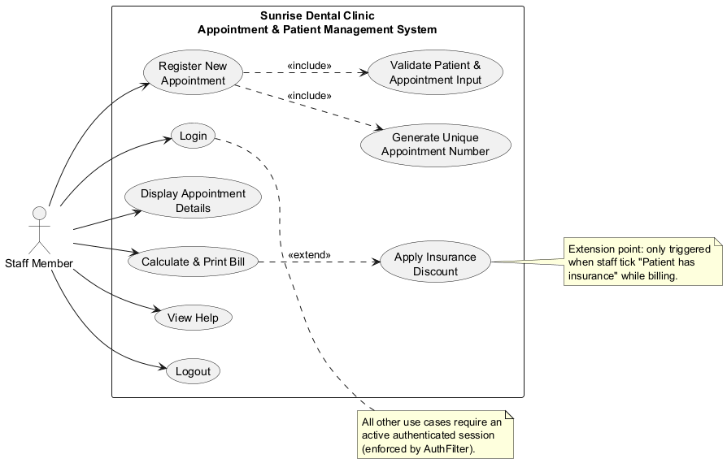
Figure 1: Use Case diagram for the Appointment & Patient Management System.
The system has a single actor, Staff Member, since the assignment scope restricts use of the system to authorised staff — patients are recorded by staff rather than interacting with the system themselves. Six primary use cases map directly onto the six functional requirements in the brief: Login, Register New Appointment, Display Appointment Details, Calculate & Print Bill, View Help, and Logout.
Two <<include>> relationships model behaviour that always happens as part of registering an appointment, regardless of outcome: Validate Patient & Appointment Input (every submission is checked before anything is saved) and Generate Unique Appointment Number (every successful registration must produce one, retried until no collision is found). One <<extend>> relationship models optional behaviour: Apply Insurance Discount only extends Calculate & Print Bill when staff tick "patient has insurance" — exactly the conditional case <<extend>> is intended for, as opposed to the unconditional <<include>>.
Assumption: all use cases other than Login require an authenticated session. Rather than repeat an <<include>> arrow from every use case to Login, this precondition is documented as a note and enforced in the implementation by a single Servlet filter (AuthFilter) applied to every protected URL.

2.2 Class Diagram — Domain Model
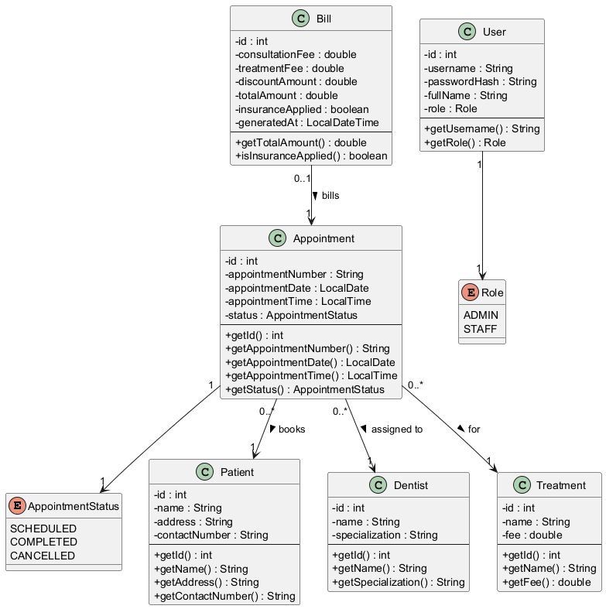
Figure 2: Class diagram showing the core domain entities, multiplicities, and navigability.
This diagram shows the core data entities and their relationships. One Appointment references exactly one Patient, one Dentist, and one Treatment, while a Dentist or Treatment can be referenced by many appointments over time; a Bill has a 0..1 relationship back to its Appointment, since an appointment may not yet have been billed. All associations are unidirectional, pointing from Appointment/Bill toward the entity they reference — the model classes are deliberately simple, encapsulated POJOs (private fields, public accessors) with no back-references, and lookups run the other direction through the DAO layer instead. AppointmentStatus (SCHEDULED / COMPLETED / CANCELLED) and Role (ADMIN / STAFF) are modelled as UML enumerations rather than plain strings, so invalid values are impossible at compile time.
Documented simplification: in the current implementation, PatientDAO.save() always inserts a new patient row on every registration rather than looking up an existing patient by contact number. The diagram shows the correct conceptual relationship (one patient, many visits over time); the code is a deliberate simplification of it, chosen to keep registration a single self-contained step that mirrors how the paper-based front desk works today. A natural extension — adding PatientDAO.findByContactNumber() and checking it before inserting — would upgrade this to genuine patient history tracking, at the cost of extra complexity that was judged out of scope for this iteration.

2.3 Class Diagram — Architecture and Design Patterns
[ INSERT NOTHING — SEE LANDSCAPE PAGE HERE ]
Figure 3 (the architecture diagram) is placed on its own landscape-oriented page immediately after this page so it remains legible; no action needed here.
This second diagram deliberately separates architecture from domain data so each stays readable. It shows how the four design patterns used in Task B are structured: the DAO pattern (interface + JDBC implementation per entity), the Factory pattern (DAOFactory and BillingStrategyFactory centralising object creation), the Singleton pattern (DBConnection, loaded exactly once), and the Strategy pattern (BillingStrategy with StandardBillingStrategy / InsuranceBillingStrategy implementations selected at runtime). Full discussion of each pattern's purpose and trade-offs is given in section 3.2, alongside the code that implements it.

2.4 Sequence Diagrams
Three sequence diagrams were produced, covering the most significant interaction flows in the system: authentication, the core "register an appointment" transaction, and billing — the point at which the Strategy pattern is actually exercised at runtime.

2.4.1 Login
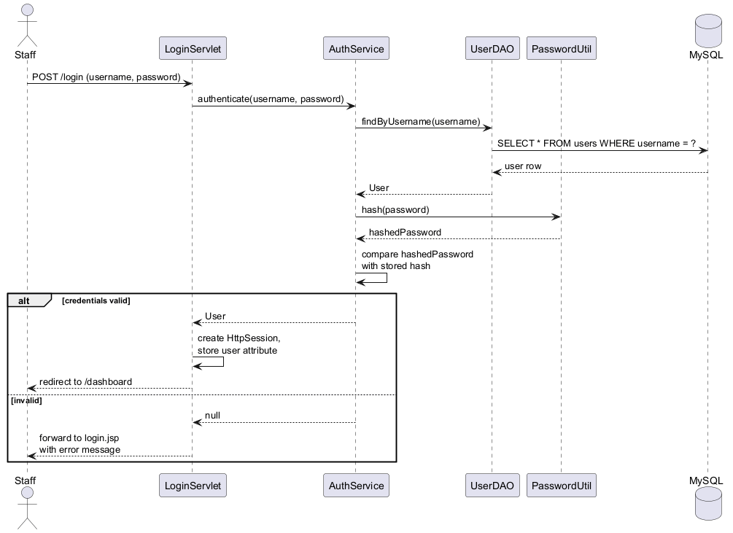
Figure 4: Sequence diagram for staff login.
Shows LoginServlet delegating to AuthService, which loads the User by username via UserDAO, hashes the submitted password with PasswordUtil (SHA-256), and compares it against the stored hash — the plain-text password is never persisted or compared directly, addressing the assignment's requirement to protect user data. The alt fragment shows both outcomes: a valid login creates an HttpSession and redirects to the dashboard; an invalid one re-displays the login form with an error message.

2.4.2 Register New Appointment
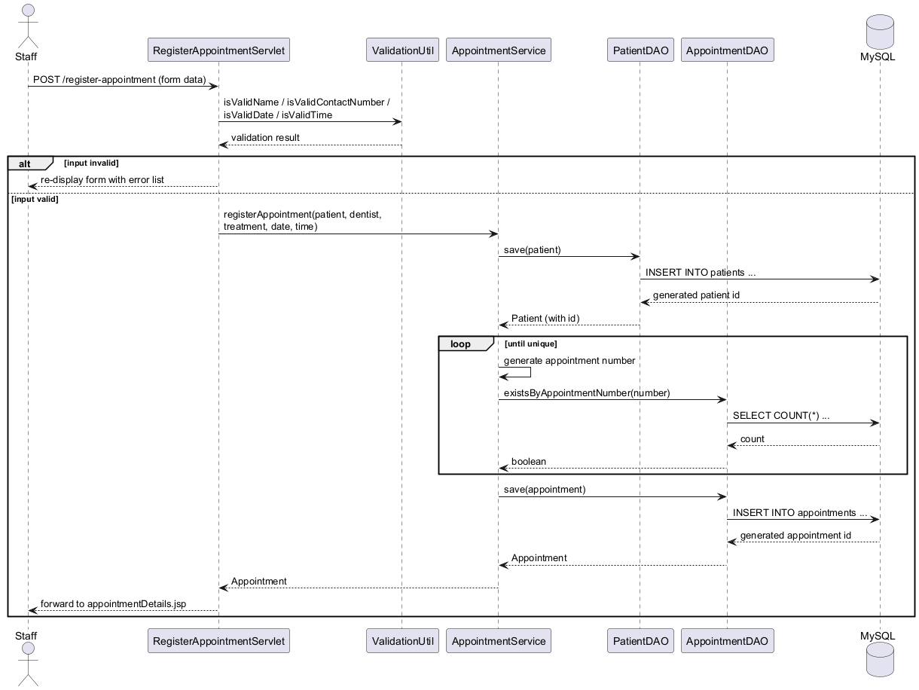
Figure 5: Sequence diagram for registering a new appointment.
Validation happens in the servlet before any service or DAO call is made, so invalid input never reaches the database. The loop fragment shows AppointmentService regenerating the appointment number until AppointmentDAO.existsByAppointmentNumber() confirms it is unique — this loop is what guarantees the "unique appointment number" requirement actually holds at runtime, rather than merely hoping collisions do not occur.

2.4.3 Calculate & Print Bill
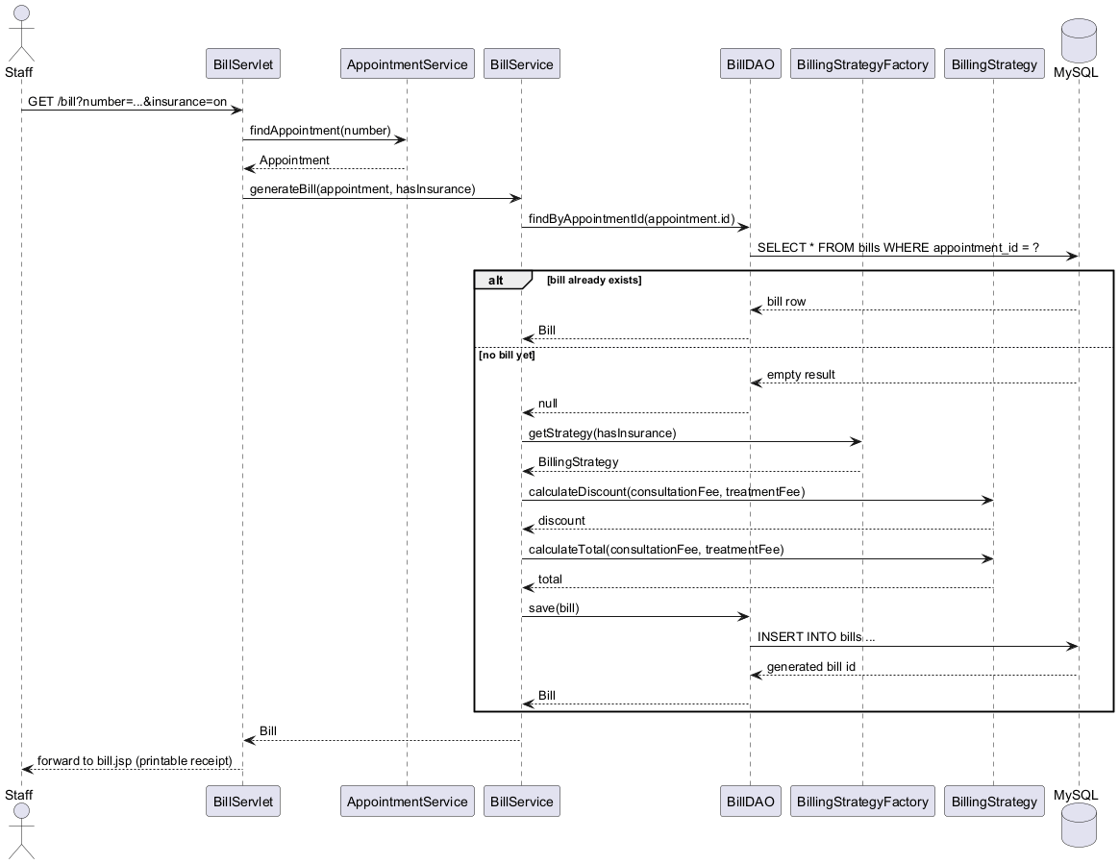
Figure 6: Sequence diagram for bill calculation and printing.
The alt fragment models idempotent billing: if a bill already exists for the appointment (e.g. the receipt is being reprinted), it is returned unchanged; only a first-time billing request goes through BillingStrategyFactory to obtain the correct BillingStrategy and calculate the discount and total. This diagram most directly demonstrates the Strategy pattern in motion, complementing the static view in Figure 3.

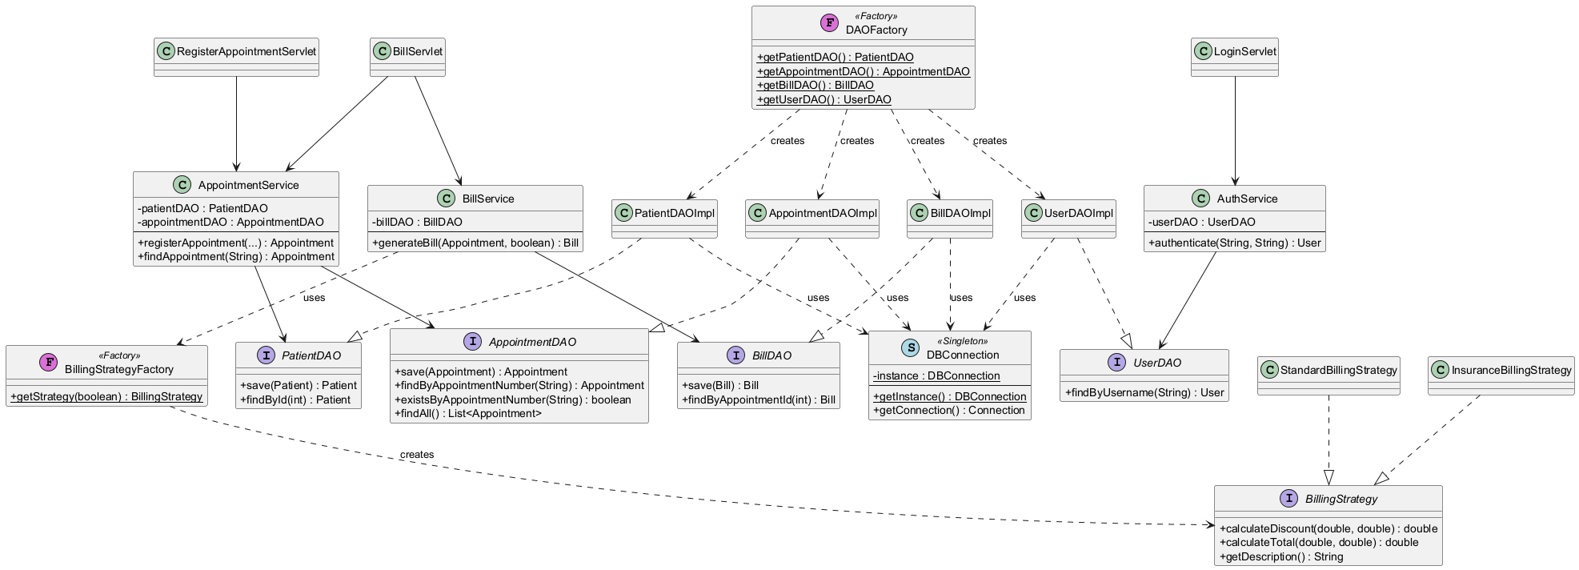
Figure 3: Class diagram showing the DAO, Singleton, Factory, and Strategy pattern structure.

3. Task B: System Development (40 marks)

3.1 Architecture Overview
The system follows a layered, three-tier architecture: a presentation tier of JSP views, a controller/business tier of Servlets and Service classes, and a data tier of DAO classes talking to MySQL over JDBC. This separation keeps each class focused on a single responsibility — Servlets only orchestrate HTTP request/response and delegate to Services; Services contain business rules and depend only on DAO interfaces, never JDBC directly; DAO implementations are the only classes that contain SQL.
The technology choices were plain Servlets + JSP + JDBC + MySQL rather than a framework such as Spring, deliberately: with a 4000-word budget that includes source code, and limited development time, a framework's configuration and boilerplate would have consumed time and words better spent on the design patterns and testing the brief explicitly asks for, without materially changing what the finished system demonstrates.

3.2 Design Patterns Implemented
Four design patterns were deliberately applied, each solving a specific problem rather than being included for its own sake.

Data Access Object (DAO) Pattern
Every entity has a DAO interface (PatientDAO, DentistDAO, TreatmentDAO, AppointmentDAO, BillDAO, UserDAO) and a single JDBC implementation. Services and Servlets depend only on the interfaces, so the persistence mechanism could be swapped (e.g. for JPA, or an in-memory fake for testing) without touching business logic. This is also what makes the Service-layer unit tests in Task C possible without a live database.
public interface AppointmentDAO {
Appointment save(Appointment appointment) throws SQLException;
Appointment findByAppointmentNumber(String appointmentNumber) throws SQLException;
boolean existsByAppointmentNumber(String appointmentNumber) throws SQLException;
List<Appointment> findAll() throws SQLException;
}

Singleton Pattern
DBConnection loads db.properties and the MySQL JDBC driver exactly once, guarded by double-checked locking on getInstance(). Every DAO implementation depends on it for connections, so configuration is read from one place rather than scattered across the codebase.
public static DBConnection getInstance() {
if (instance == null) {
synchronized (DBConnection.class) {
if (instance == null) {
instance = new DBConnection();
}
}
}
return instance;
}

Factory Pattern
DAOFactory centralises creation of every DAO (getPatientDAO(), getAppointmentDAO(), etc.), so callers never write "new PatientDAOImpl()" themselves; BillingStrategyFactory does the same for billing strategies. Both patterns keep object-creation decisions in one place, which matters most if a future requirement (e.g. switching to a connection-pooled DAO implementation) needs to change which concrete class is created — that change happens in one factory method, not at every call site.

Strategy Pattern
BillingStrategy is an interface with two interchangeable implementations, StandardBillingStrategy and InsuranceBillingStrategy. BillService never checks "if (hasInsurance)" itself — it asks BillingStrategyFactory for the correct strategy and calls it polymorphically. Adding a third billing rule (for example, a corporate-account discount) means adding one new class implementing BillingStrategy, with no existing code touched — a direct application of the Open/Closed Principle.
public interface BillingStrategy {
double calculateDiscount(double consultationFee, double treatmentFee);
double calculateTotal(double consultationFee, double treatmentFee);
String getDescription();
}
public class InsuranceBillingStrategy implements BillingStrategy {
private static final double INSURANCE_DISCOUNT_RATE = 0.20;
public double calculateDiscount(double consultationFee, double treatmentFee) {
return treatmentFee * INSURANCE_DISCOUNT_RATE;
}
public double calculateTotal(double consultationFee, double treatmentFee) {
return consultationFee + treatmentFee - calculateDiscount(consultationFee, treatmentFee);
}
}

3.3 Database Design
MySQL was used as the relational data store, with six tables: users, dentists, treatments, patients, appointments, and bills. Foreign keys enforce that an appointment cannot reference a non-existent patient, dentist, or treatment, and appointment_number carries a UNIQUE constraint as a database-level backstop to the application-level uniqueness check performed in AppointmentService. Seed data provides a default admin login and a realistic set of dentists and treatment types so the application is usable immediately after import.
[ INSERT SCREENSHOT — DATABASE SCHEMA HERE ]
Open the sunrise_dental schema in MySQL Workbench (or run "SHOW TABLES;" / "DESCRIBE appointments;" etc. in the MySQL CLI) and capture the table list and/or an ER diagram (Workbench: Database > Reverse Engineer).

3.4 Web Service (Distributed / Web Services Requirement)
To satisfy the requirement that the program be a distributed application with web services, AppointmentApiServlet exposes a small RESTful JSON endpoint at /api/appointments?number=<appointmentNumber>, independent of the JSP-rendered pages. It returns the appointment as JSON (serialised with Gson) on success, HTTP 404 with a JSON error body when the appointment does not exist, and HTTP 400 when the number parameter is missing — allowing another system (e.g. a front-desk kiosk, a mobile app, or an integration test) to query appointment data over HTTP without depending on the HTML views at all.
[ INSERT SCREENSHOT — WEB SERVICE RESPONSE HERE ]
With the app running, open http://localhost:8080/sunrise-dental-clinic/api/appointments?number=<a real appointment number> in a browser (or Postman) and capture the JSON response. Also capture the 404 response for a made-up number, to show error handling.

3.5 User Interfaces and Validation
Six screens were built to cover the required functionality: Login, Dashboard (main menu), Register New Appointment, Display Appointment Details, Calculate & Print Bill (a print-friendly receipt), and Help. All input is validated server-side in ValidationUtil before anything reaches the database — patient name (letters/spaces only), a 10-digit contact number starting with 0, a date that is not in the past, and (added via test-driven development, see section 4.2) a time within the clinic's 09:00–17:00 operating hours. Validation failures are collected and displayed together above the form, rather than one at a time, so the user can correct every problem in a single pass.
[ INSERT SCREENSHOTS — APPLICATION SCREENS (6+) HERE ]
Run the application locally (see Appendix D for setup steps) and capture: (1) the login screen, (2) the dashboard/main menu after logging in, (3) the register-appointment form filled in, (4) the appointment-details screen after a successful registration, (5) the same form re-submitted with an invalid contact number / past date / out-of-hours time, showing the validation error list, (6) the calculate-and-print-bill receipt screen, and (7) the help screen.

4. Task C: Testing, TDD, and Test Automation (20 marks)

4.1 Test Rationale
The system is layered, so tests target the layer where a defect is cheapest to catch and clearest to diagnose. util classes (ValidationUtil, PasswordUtil) and the billing strategies are pure functions with no dependencies, and are tested directly. Service classes (AppointmentService, BillService, AuthService) depend on DAOs; rather than requiring a live MySQL instance to run the test suite — slow, environment-dependent, and awkward in continuous integration — each service has two constructors: a no-arg constructor that wires real DAOs via DAOFactory for production use, and a DAO-accepting constructor used only by tests, with Mockito mocks standing in for the DAOs. This isolates each test from the database while still exercising the service's real logic. DAO implementations and Servlets are thinner JDBC/HTTP glue and are instead verified by manually exercising the running application (see the manual test log in section 4.4).

4.2 Test-Driven Development: A Worked Example
TDD (red → green → refactor) was used when adding a new business rule to existing code: enforcing that appointments can only be booked within the clinic's operating hours (09:00–17:00), a rule that was previously missing entirely.
Step 1 (RED) — a test was written before the implementation existed. Four cases were added to ValidationUtilTest: an in-hours time, the opening boundary, a time just before opening, and the closing boundary. Running the suite at this point fails to even compile, because isWithinClinicHours does not exist yet:
[ERROR] COMPILATION ERROR :
[ERROR] .../ValidationUtilTest.java:[62,34] cannot find symbol
[ERROR] symbol: method isWithinClinicHours(java.time.LocalTime)
[ERROR] location: class com.sunrise.dental.util.ValidationUtil
[INFO] BUILD FAILURE
[ INSERT SCREENSHOT — RED (FAILING BUILD) HERE ]
Reproduce this yourself: git checkout the commit before "Add failing test for clinic-hours validation" is implemented (or temporarily comment out the isWithinClinicHours method) and run "mvn test" in a terminal; screenshot the failure output shown above.
Step 2 (GREEN) — the minimum code needed to pass was written. ValidationUtil.isWithinClinicHours(LocalTime) was implemented as a simple boundary check (09:00 inclusive, 17:00 exclusive), and the same four tests were re-run:
[INFO] Tests run: 14, Failures: 0, Errors: 0, Skipped: 0 -- in ValidationUtilTest
[INFO] Tests run: 26, Failures: 0, Errors: 0, Skipped: 0
[INFO] BUILD SUCCESS
[ INSERT SCREENSHOT — GREEN (PASSING BUILD) HERE ]
Run "mvn test" on the current main branch and screenshot the BUILD SUCCESS output, ideally showing all 26 tests passing across the 5 test classes.
Step 3 (wire it in) — a passing unit test is only useful if the application actually enforces the rule. RegisterAppointmentServlet was updated to call isWithinClinicHours alongside the existing time-format check, adding the error message "Appointment time must be between 09:00 and 17:00." This step has no dedicated unit test of its own — it is a one-line delegation — and was instead confirmed by exercising the register-appointment screen manually with a 07:00 time and observing the validation error (see row M5 in section 4.4).
Honesty note: the rest of the codebase (DAOs, servlets, the original service methods) was written first and given characterisation tests afterwards, under the time constraints of this assignment — it was not built test-first from a blank file. The clinic-hours example above is the part of the codebase that genuinely followed red-green TDD, and is the one that should be reproduced live if asked to demonstrate the process, since it is small, self-contained, and reproducible directly from the Git history (see the two consecutive commits "Add failing test for clinic-hours validation (TDD red step)" and "Implement clinic-hours validation … (TDD green step)" on GitHub).

4.3 Test Plan
26 automated JUnit 5 test methods were written across 5 test classes. The table below summarises the scenarios covered; full source is in Appendix A.
ID | Class under test | Scenario | Test data | Expected result
T01–T03 | ValidationUtil | Patient name validation | "Kasun Perera" / "" / "Kasun123" | accepted / rejected / rejected
T04–T06 | ValidationUtil | Contact number validation | "0771234567" / "12345" / "077abc4567" | accepted / rejected / rejected
T07–T08 | ValidationUtil | Date format validation | "2026-09-05" / "not-a-date" | accepted / rejected
T09–T10 | ValidationUtil | Past vs. today's date | yesterday / today | rejected / accepted
T11–T14 | ValidationUtil | Clinic operating hours | 10:30 / 09:00 / 08:59 / 17:00 | accepted / accepted / rejected / rejected
T15–T16 | BillingStrategy | Standard vs. insurance billing | consult Rs.1500, treatment Rs.5000 | total 6500 / discount 1000, total 5500
T17 | BillingStrategyFactory | Strategy selection | hasInsurance = true/false | returns matching strategy type
T18–T19 | AppointmentService | Registration + number-collision retry | mocked PatientDAO/AppointmentDAO | patient & appointment saved; retries until unique
T20–T22 | BillService | Standard / insurance / re-billing | treatment fee Rs.3500 | total 5000 / discount 700, total 4300 / existing bill returned, no duplicate save
T23–T25 | AuthService | Login success / wrong password / unknown user | hashed password comparison | User returned / null / null

4.4 Manual / Exploratory Test Log (DAO + UI Layer)
Since DAOs and servlets are integration/UI glue rather than unit-tested, they were verified by hand against a running instance. The table below should be completed with Pass/Fail and a short note while exercising the running application, then screenshotted.
# | Action | Expected result | Pass/Fail
M1 | Log in with admin / admin123 | Redirected to dashboard
M2 | Log in with wrong password | Error shown, stays on login page
M3 | Visit /dashboard while logged out | Redirected to login (AuthFilter)
M4 | Register an appointment with all valid fields | Appointment number shown on confirmation
M5 | Register an appointment with a 07:00 time | "must be between 09:00 and 17:00" error
M6 | Register an appointment with a past date | "cannot be in the past" error
M7 | Search for the appointment number from M4 | Full appointment details displayed
M8 | Search for a non-existent appointment number | "No appointment found" message
M9 | Calculate bill, no insurance ticked | Total = consultation fee + treatment fee
M10 | Calculate bill again for the same appointment, ticking insurance | Returns the same bill as M9 (idempotent)
M11 | GET /api/appointments?number=<valid> | JSON body with appointment fields
M12 | GET /api/appointments?number=<invalid> | HTTP 404 with JSON error body
[ INSERT SCREENSHOTS — MANUAL TEST LOG (M1–M12) HERE ]
For each row above, perform the action against the running application and capture a screenshot proving the expected result occurred; fill in Pass/Fail. At minimum, screenshot M1, M4, M5, M9, M11, and M12.

4.5 Test Automation
Two layers of automation are in place. First, "mvn test" (Maven Surefire) runs all 26 JUnit 5 tests locally in a few seconds with no database required, as shown by the BUILD SUCCESS output in section 4.2. Second, a GitHub Actions workflow (.github/workflows/ci.yml) runs "mvn test" and then "mvn package" automatically on every push and pull request to the main branch. This is genuine continuous integration rather than a local habit: a broken commit is caught even if nobody remembers to run the tests by hand before pushing.
[ INSERT SCREENSHOT — GITHUB ACTIONS CI RUN HERE ]
Open the "Actions" tab at https://github.com/SharonAbi/sunrise-dental-clinic/actions and screenshot a green (passing) workflow run, ideally showing the expanded "Run unit tests" step.

4.6 Evaluation
What went well: isolating service-layer logic behind DAO interfaces (the DAO + Dependency Injection combination described in section 3.2) meant the whole business-logic test suite runs without any database, which is exactly what made adding GitHub Actions CI straightforward — there was no database service container to configure.
Limitations and lessons learned: the DAO implementations themselves (the actual SQL) and the servlets (HTTP wiring) are not covered by automated tests, only by the manual log in section 4.4. A more complete solution would add integration tests against a disposable database (for example, Testcontainers with a real MySQL container), which was judged out of scope given the assignment timeline but is noted here as reasonable further work. The clinic-hours TDD example also exposed a gap that had existed since the first working version of the system — appointments could previously be booked at any time of day or night — which shows that even a small, deliberate TDD pass over existing code can surface genuine, previously unnoticed requirements gaps.

5. Task D: Version Control with Git and GitHub (20 marks)

5.1 Repository Setup
The project is hosted in a public GitHub repository at https://github.com/SharonAbi/sunrise-dental-clinic, so it is accessible to markers without requiring an invitation. The repository contains the full Maven source tree, the SQL schema, the UML diagram sources and rendered images (docs/uml), the testing documentation (docs/testing), and the GitHub Actions CI workflow (.github/workflows).
[ INSERT SCREENSHOT — REPOSITORY HOME PAGE HERE ]
Open https://github.com/SharonAbi/sunrise-dental-clinic and screenshot the repository home page, showing the file listing and the "Public" label.

5.2 Commit History and Version Control Techniques
Rather than a single bulk upload, the project history is organised into logically separated commits, each covering one coherent unit of work: initial project scaffold; domain model classes; persistence layer (DBConnection singleton + DAOs); service layer with the Strategy pattern; web layer (servlets, filter, JSP views); SQL schema; unit tests; UML diagrams; a paired "red" then "green" commit demonstrating TDD; additional service test coverage; and the CI workflow itself. This mirrors how a real feature branch is built up incrementally, and makes the history itself readable evidence of the development process, rather than a single commit that hides how the system was actually built.
[ INSERT SCREENSHOT — COMMIT HISTORY HERE ]
Open https://github.com/SharonAbi/sunrise-dental-clinic/commits/main and screenshot the commit list, showing the sequence of descriptive commit messages and dates.
Standard version control practices used include: descriptive, imperative-mood commit messages explaining why a change was made, not just what changed; small, logically scoped commits rather than monolithic ones; a .gitignore excluding build output (target/) and IDE files from version control; and use of the default main branch with a linear history (no long-lived feature branches were needed given the project's size, but the same commit-message discipline would extend directly to a branch-and-pull-request workflow for a larger team).

5.3 Continuous Integration Workflow
A GitHub Actions workflow (see section 4.5 and Appendix C) runs automatically on every push to main, checking out the repository, installing JDK 11, and running the full Maven test suite, then building the WAR file. This gives an auditable, automatic record that a given commit actually builds and passes its tests — the workflow run history on GitHub is itself evidence of this, independent of anything claimed in this report.
[ INSERT SCREENSHOT — CI WORKFLOW FILE + PASSING RUNS LIST HERE ]
Screenshot the Actions tab showing the list of workflow runs (ideally several, from different commits) with green checkmarks.

5.4 Ongoing Version History
[STUDENT TO COMPLETE: this report was drafted with the repository history in place up to the commit that added this document. Before final submission, continue committing genuine incremental changes on subsequent days — for example, filling in the screenshot placeholders and committing the resulting documentation, or making a small, real code change with its own test. Briefly describe below what changed on each subsequent day, to give the marker a written trail alongside the commit history itself.]
[ INSERT LIST OF DAY-BY-DAY CHANGES (FILL IN AS YOU GO) HERE ]
e.g. "Day 2 (5 Sept): added clinic-hours screenshots, fixed a typo in bill.jsp, re-ran and confirmed CI still green (commit <hash>)."

6. Conclusion
This report has presented the design, development, testing, and version-controlled delivery of a computerised Appointment and Patient Management System for Sunrise Dental Clinic, replacing an error-prone manual process with a layered Java web application. The system satisfies the six functional requirements set out in the brief; its design is documented through Use Case, Class, and Sequence diagrams that match the implementation directly; four design patterns (DAO, Singleton, Factory, Strategy) are applied for identifiable reasons rather than for their own sake; a small REST endpoint satisfies the distributed/web-services requirement; and the system is backed by an automated test suite, a documented and reproducible TDD example, and continuous integration via GitHub Actions.
The main limitation, honestly stated, is integration-level coverage: DAO and Servlet behaviour is currently verified manually rather than by automated integration tests, and patient records are not yet deduplicated across repeat visits. Both are identified in this report as concrete, well-scoped next steps rather than left unacknowledged, which is itself intended to demonstrate the kind of critical self-evaluation the module's learning outcomes ask for.

References
Fowler, M. (2002) Patterns of Enterprise Application Architecture. Boston: Addison-Wesley.
Gamma, E., Helm, R., Johnson, R. and Vlissides, J. (1994) Design Patterns: Elements of Reusable Object-Oriented Software. Reading, MA: Addison-Wesley.
Beck, K. (2002) Test Driven Development: By Example. Boston: Addison-Wesley.
Oracle (2024) Java Servlet Technology Overview. Available at: https://www.oracle.com/java/technologies/java-servlet-technology.html (Accessed: [DATE ACCESSED]).
Oracle (2024) MySQL 8.0 Reference Manual. Available at: https://dev.mysql.com/doc/refman/8.0/en/ (Accessed: [DATE ACCESSED]).
GitHub (2024) GitHub Actions Documentation. Available at: https://docs.github.com/en/actions (Accessed: [DATE ACCESSED]).
JUnit Team (2024) JUnit 5 User Guide. Available at: https://junit.org/junit5/docs/current/user-guide/ (Accessed: [DATE ACCESSED]).
Mockito (2024) Mockito Framework Site. Available at: https://site.mockito.org/ (Accessed: [DATE ACCESSED]).
[ INSERT ADD YOUR OWN REFERENCES HERE ]
Add any further sources actually consulted while writing the report (Harvard style), and fill in the [DATE ACCESSED] placeholders above with the date you checked each site.

Appendices
Content in this section is excluded from the word count, per the assessment brief. Full source code for all 40+ classes is available in the GitHub repository linked on the title page and in section 5.1; the extracts below are the classes most central to the design-pattern discussion in section 3.2, included here for convenience.

Appendix A: Selected Source Code Extracts

A.1 DBConnection.java (Singleton)
package com.sunrise.dental.db;
import java.io.IOException;
import java.io.InputStream;
import java.sql.Connection;
import java.sql.DriverManager;
import java.sql.SQLException;
import java.util.Properties;
/**
* Singleton responsible for loading JDBC configuration once and handing out
* new connections on demand. A single shared Connection is not kept, since
* Servlets are multi-threaded and Connection is not thread-safe; each caller
* gets its own short-lived Connection (used in try-with-resources).
*/
public final class DBConnection {
private static volatile DBConnection instance;
private final String url;
private final String user;
private final String password;
private DBConnection() {
Properties props = new Properties();
try (InputStream in = DBConnection.class.getClassLoader().getResourceAsStream("db.properties")) {
if (in == null) {
throw new IllegalStateException("db.properties not found on classpath");
}
props.load(in);
} catch (IOException e) {
throw new IllegalStateException("Failed to load db.properties", e);
}
this.url = props.getProperty("db.url");
this.user = props.getProperty("db.user");
this.password = props.getProperty("db.password");
try {
Class.forName("com.mysql.cj.jdbc.Driver");
} catch (ClassNotFoundException e) {
throw new IllegalStateException("MySQL JDBC driver not found on classpath", e);
}
}
public static DBConnection getInstance() {
if (instance == null) {
synchronized (DBConnection.class) {
if (instance == null) {
instance = new DBConnection();
}
}
}
return instance;
}
public Connection getConnection() throws SQLException {
return DriverManager.getConnection(url, user, password);
}
}

A.2 DAOFactory.java (Factory)
package com.sunrise.dental.dao;
import com.sunrise.dental.dao.impl.AppointmentDAOImpl;
import com.sunrise.dental.dao.impl.BillDAOImpl;
import com.sunrise.dental.dao.impl.DentistDAOImpl;
import com.sunrise.dental.dao.impl.PatientDAOImpl;
import com.sunrise.dental.dao.impl.TreatmentDAOImpl;
import com.sunrise.dental.dao.impl.UserDAOImpl;
/**
* Factory pattern: centralises creation of DAO implementations so callers
* (services, servlets) depend only on the DAO interfaces, never on the
* concrete JDBC classes. Swapping the persistence technology later only
* means changing this one class.
*/
public final class DAOFactory {
private DAOFactory() {
}
public static PatientDAO getPatientDAO() {
return new PatientDAOImpl();
}
public static DentistDAO getDentistDAO() {
return new DentistDAOImpl();
}
public static TreatmentDAO getTreatmentDAO() {
return new TreatmentDAOImpl();
}
public static AppointmentDAO getAppointmentDAO() {
return new AppointmentDAOImpl();
}
public static BillDAO getBillDAO() {
return new BillDAOImpl();
}
public static UserDAO getUserDAO() {
return new UserDAOImpl();
}
}

A.3 BillingStrategyFactory.java and BillService.java (Strategy + Factory in use)
package com.sunrise.dental.service.billing;
/**
* Factory pattern: selects the correct BillingStrategy so callers never
* instantiate a concrete strategy class directly.
*/
public final class BillingStrategyFactory {
private BillingStrategyFactory() {
}
public static BillingStrategy getStrategy(boolean hasInsurance) {
return hasInsurance ? new InsuranceBillingStrategy() : new StandardBillingStrategy();
}
}
package com.sunrise.dental.service;
import com.sunrise.dental.dao.BillDAO;
import com.sunrise.dental.dao.DAOFactory;
import com.sunrise.dental.model.Appointment;
import com.sunrise.dental.model.Bill;
import com.sunrise.dental.service.billing.BillingStrategy;
import com.sunrise.dental.service.billing.BillingStrategyFactory;
import java.sql.SQLException;
import java.time.LocalDateTime;
public class BillService {
/** Flat consultation charge applied to every appointment, regardless of treatment type. */
private static final double CONSULTATION_FEE = 1500.00;
private final BillDAO billDAO;
public BillService() {
this(DAOFactory.getBillDAO());
}
public BillService(BillDAO billDAO) {
this.billDAO = billDAO;
}
/**
* Returns the existing bill for this appointment if one was already
* generated, otherwise calculates and persists a new one. This keeps
* billing idempotent - reprinting a receipt does not create duplicate
* bill records.
*/
public Bill generateBill(Appointment appointment, boolean hasInsurance) throws SQLException {
Bill existing = billDAO.findByAppointmentId(appointment.getId());
if (existing != null) {
existing.setAppointment(appointment);
return existing;
}
BillingStrategy strategy = BillingStrategyFactory.getStrategy(hasInsurance);
double treatmentFee = appointment.getTreatment().getFee();
double discount = strategy.calculateDiscount(CONSULTATION_FEE, treatmentFee);
double total = strategy.calculateTotal(CONSULTATION_FEE, treatmentFee);
Bill bill = new Bill();
bill.setAppointment(appointment);
bill.setConsultationFee(CONSULTATION_FEE);
bill.setTreatmentFee(treatmentFee);
bill.setDiscountAmount(discount);
bill.setTotalAmount(total);
bill.setInsuranceApplied(hasInsurance);
bill.setGeneratedAt(LocalDateTime.now());
Bill saved = billDAO.save(bill);
saved.setAppointment(appointment);
return saved;
}
}
[ INSERT OPTIONAL: PASTE ADDITIONAL FILES HERE ]
If your marker wants more of the source in the PDF itself rather than via the GitHub link, paste further classes here (e.g. the Servlets, or ValidationUtil) in the same code-block style.

Appendix B: MySQL Schema (sql/schema.sql)
-- Sunrise Dental Clinic - schema and seed data
-- Run this once against a fresh MySQL server:
-- mysql -u root -p < sql/schema.sql
CREATE DATABASE IF NOT EXISTS sunrise_dental;
USE sunrise_dental;
CREATE TABLE IF NOT EXISTS users (
id INT AUTO_INCREMENT PRIMARY KEY,
username VARCHAR(50) NOT NULL UNIQUE,
password_hash VARCHAR(255) NOT NULL,
full_name VARCHAR(100) NOT NULL,
role VARCHAR(20) NOT NULL DEFAULT 'STAFF'
);
CREATE TABLE IF NOT EXISTS dentists (
id INT AUTO_INCREMENT PRIMARY KEY,
name VARCHAR(100) NOT NULL,
specialization VARCHAR(100)
);
CREATE TABLE IF NOT EXISTS treatments (
id INT AUTO_INCREMENT PRIMARY KEY,
name VARCHAR(100) NOT NULL,
fee DECIMAL(10,2) NOT NULL
);
CREATE TABLE IF NOT EXISTS patients (
id INT AUTO_INCREMENT PRIMARY KEY,
name VARCHAR(100) NOT NULL,
address VARCHAR(255),
contact_number VARCHAR(20) NOT NULL
);
CREATE TABLE IF NOT EXISTS appointments (
id INT AUTO_INCREMENT PRIMARY KEY,
appointment_number VARCHAR(30) NOT NULL UNIQUE,
patient_id INT NOT NULL,
dentist_id INT NOT NULL,
treatment_id INT NOT NULL,
appointment_date DATE NOT NULL,
appointment_time TIME NOT NULL,
status VARCHAR(20) NOT NULL DEFAULT 'SCHEDULED',
FOREIGN KEY (patient_id) REFERENCES patients(id),
FOREIGN KEY (dentist_id) REFERENCES dentists(id),
FOREIGN KEY (treatment_id) REFERENCES treatments(id)
);
CREATE TABLE IF NOT EXISTS bills (
id INT AUTO_INCREMENT PRIMARY KEY,
appointment_id INT NOT NULL,
consultation_fee DECIMAL(10,2) NOT NULL,
treatment_fee DECIMAL(10,2) NOT NULL,
discount_amount DECIMAL(10,2) NOT NULL DEFAULT 0,
total_amount DECIMAL(10,2) NOT NULL,
insurance_applied BOOLEAN NOT NULL DEFAULT FALSE,
generated_at DATETIME NOT NULL,
FOREIGN KEY (appointment_id) REFERENCES appointments(id)
);
-- Seed data -------------------------------------------------------------
-- Default staff login: admin / admin123
-- SHA2(x, 256) here matches PasswordUtil.hash() in the Java code.
INSERT INTO users (username, password_hash, full_name, role)
VALUES ('admin', SHA2('admin123', 256), 'System Administrator', 'ADMIN');
INSERT INTO dentists (name, specialization) VALUES
('Dr. Nimal Perera', 'General Dentistry'),
('Dr. Amaya Silva', 'Orthodontics'),
('Dr. Ruwan Fernando', 'Oral Surgery');
INSERT INTO treatments (name, fee) VALUES
('Consultation Only', 0.00),
('Scaling & Polishing', 3500.00),
('Tooth Extraction', 5000.00),
('Root Canal Treatment', 15000.00),
('Filling', 4000.00),
('Braces Fitting', 45000.00);

Appendix C: GitHub Actions CI Workflow (.github/workflows/ci.yml)
name: CI
on:
push:
branches: [ "main" ]
pull_request:
branches: [ "main" ]
jobs:
test:
runs-on: ubuntu-latest
steps:
- name: Check out repository
uses: actions/checkout@v4
- name: Set up JDK 11
uses: actions/setup-java@v5
with:
distribution: temurin
java-version: '11'
cache: maven
- name: Run unit tests
run: mvn -B test
- name: Build WAR (no tests, already run above)
run: mvn -B package -DskipTests

Appendix D: How to Run the Application Locally
- Install JDK 11+, Maven, MySQL 8, and a Servlet container such as Apache Tomcat 9.
- Create the database and load the schema: mysql -u root -p < sql/schema.sql
- Edit src/main/resources/db.properties with your local MySQL username/password.
- Build the WAR: mvn clean package
- Deploy target/sunrise-dental-clinic.war to Tomcat's webapps folder (or use an IDE's built-in server).
- Open http://localhost:8080/sunrise-dental-clinic/ and log in with admin / admin123.

