**Front-End UI/UX Mini Project**

**Project report**

**Landing Page for a Product**

• Submitted By:

o Team Members- Aderu Raghavendra bhanu teja ,Sharon Cheriyan, Sreedev Binoj

o Register Number- 2462014 ,2462146 , 2462152

o College-E-mail id- [aderu.raghavendra@btech.christuniversity.in](mailto:aderu.raghavendra@btech.christuniversity.in), [Sharon.cheriyan@btech.christuniversity.in](mailto:Sharon.cheriyan@btech.christuniversity.in), [sreedev.binoj@btech.christuniversity.in](mailto:sreedev.binoj@btech.christuniversity.in) .

• Course: UI/UX Developer

• Instructor Name: MS.NAGAVEENA

• Institution: Christ University

• Date of Submission: 26/09/2025

• Abstract:

The *SmartHydrate Bottle Landing Page* is a responsive, single-page website designed using **HTML5, CSS3, JavaScript, jQuery, and Bootstrap 5**. The landing page showcases the SmartHydrate Bottle product, its features, customer reviews, and purchase options.

The primary goal of this project is to create a visually appealing and user-friendly marketing webpage that promotes a fictional smart water bottle. With a clean hero section, feature highlights, testimonials, and call-to-action buttons, the landing page provides an effective demonstration of front-end UI/UX principles.

This project emphasizes layout design, responsive scaling, semantic structure, and smooth navigation, reflecting both branding consistency and modern web practices.

• Objectives :

* To design a **responsive and visually appealing landing page** for a fictional product.
* To use **semantic HTML5 elements** (<header>, <main>, <section>, <footer>) for structured layout.
* To implement **full-screen hero image with overlay text** for strong visual impact.
* To highlight **key features of the product** in a structured grid layout.
* To integrate **customer reviews/testimonials** for credibility.
* To add **call-to-action buttons** ("Learn More", "Buy Now") to simulate e-commerce interaction.
* To use **Bootstrap grid and utilities** for responsiveness.
* To provide **smooth scrolling and interactivity** with JavaScript/jQuery.

Scope of the Project :

The scope of this project is limited to developing a **front-end promotional landing page** for the fictional *SmartHydrate Bottle*.

It demonstrates how a modern product page can:

* Present product details attractively.
* Engage users with interactive features.
* Provide a clean navigation structure without requiring backend functionality.

The landing page can serve as:

* A template for real-world product promotions.
* An academic exercise in UI/UX and front-end development.
* A foundation for future integration with **e-commerce systems** and **databases**.

• Tools & Technologies Used :

| **Tool / Technology** | **Purpose** |
| --- | --- |
| **HTML5** | Structures the form elements semantically and ensures accessibility. |
| **CSS3** | Styles the form, error messages, layout, and improves visual appeal. |
| **JavaScript** | Handles validation logic, event handling, and form submission control. |
| **jQuery** | Simplifies DOM manipulation, event handling, and error message display. |
| **Bootstrap 5** | Provides a responsive layout, prebuilt components, and consistent styling. |
| **Web Browser** | Used for testing, debugging, and displaying the form during development. |

• HTML Structure Overview :

* **Header (Hero Section):** Full-screen background image (sbottle.jpg) with overlay text introducing the product, tagline, and call-to-action buttons.
* **Features Section:** A responsive Bootstrap grid showcasing four product features (hydration reminders, temperature display, eco-friendly design, smart tracking).
* **Customer Reviews Section:** Two short testimonials from fictional users displayed with styled blockquotes.
* **Call-to-Action Section:** Encourages users to take action with large buttons ("Sign Up" and "Buy Now").
* **Footer:** Contains copyright information.

• CSS Styling Strategy :

* Full-screen **hero background** image with dark overlay for text readability.
* **Bootstrap grid** for responsive feature cards.
* **Hover effects** on feature cards for interactivity.
* **Blockquote styling** with left border highlights for customer reviews.
* Consistent color scheme (green for call-to-action, yellow for highlights, dark footer for contrast).

• **JavaScript Overview :**

* **Smooth scroll effect** for navigation buttons using jQuery.
* Ensures that clicking “Learn More” or “Buy Now” scrolls to the respective section smoothly.
* Provides basic interactivity to enhance user experience.

• Key Features :

* Full-screen hero section with product image and text overlay.
* Four key product features displayed in a grid layout.
* Two customer testimonials to build trust.
* Clear call-to-action buttons (“Learn More” and “Buy Now”).
* Responsive design for desktop and mobile.
* Semantic structure with modern HTML5 tags.

• Challenges Faced & Solutions :

* **Challenge:** Making text readable over a full-screen background image.

**Solution:** Added a semi-transparent dark overlay.

* **Challenge:** Maintaining responsiveness across devices.  
  **Solution:** Used Bootstrap grid system and img-fluid classes.
* **Challenge:** Smooth navigation between sections.  
  **Solution:** Implemented jQuery scroll animation

• Outcome :

The *SmartHydrate Bottle Landing Page* successfully demonstrates a modern and responsive front-end design for product marketing. It integrates visual design, interactivity, and structured content presentation. The page effectively simulates a real-world product website and highlights front-end development skills.

• Future Enhancements :

* Adding an **e-commerce checkout system** with shopping cart functionality.
* Integrating **star ratings and more detailed customer reviews**.
* Including **product video demos** in the hero section.
* Adding **multi-language support** for global audiences.
* Expanding the layout to support **multiple product categories**.

**HTML structure** :

<!DOCTYPE html>

<html lang="en">

<head>

  <meta charset="UTF-8">

  <meta name="viewport" content="width=device-width, initial-scale=1.0">

  <title>Product Landing Page</title>

  <!-- Bootstrap CSS -->

  <link href="https://cdn.jsdelivr.net/npm/bootstrap@5.3.2/dist/css/bootstrap.min.css" rel="stylesheet">

  <!-- Custom CSS -->

  <link rel="stylesheet" href="style.css">

</head>

<body>

  <!-- Hero Section -->

  <!-- Hero Section -->

<header class="hero-section d-flex flex-column justify-content-center align-items-center text-center text-white">

  <div class="overlay"></div>

  <div class="content">

    <h1 class="display-3 fw-bold">SmartHydrate Bottle</h1>

    <p class="lead">Stay healthy, stay hydrated – smarter!</p>

  <!-- Product Image -->

  <img src="sbottle.jpg" alt="SmartHydrate Bottle" class="img-fluid mb-3" style="max-width:200px; border-radius:12px;">

  <!-- CTA Buttons -->

    <div class="mt-3">

      <a href="#features" class="btn btn-warning me-2">Learn More</a>

      <a href="#buy" class="btn btn-success">Buy Now</a>

    </div>

  </div>

</header>

  <!-- Features Section -->

  <main>

    <section id="features" class="py-5 bg-light">

      <div class="container text-center">

        <h2 class="mb-4">Features</h2>

        <div class="row">

          <div class="col-md-4">

            <div class="card p-3 shadow-sm">

              <h5>Hydration Reminders</h5>

              <p>Built-in alerts remind you when its time to drink water.</p>

            </div>

          </div>

          <div class="col-md-4">

            <div class="card p-3 shadow-sm">

              <h5>Temperature Display</h5>

              <p>LED display shows real-time water temperature.</p>

            </div>

          </div>

          <div class="col-md-4">

            <div class="card p-3 shadow-sm">

              <h5>Smart Tracking</h5>

              <p>Syncs with your phone to track water intake.</p>

            </div>

          </div>

        </div>

      </div>

    </section>

    <!-- Testimonials -->

    <section id="testimonials" class="py-5">

      <div class="container text-center">

        <h2 class="mb-4">What Our Customers Say</h2>

        <blockquote class="blockquote">

          <p>"“The SmartHydrate Bottle motivates me to drink more water every day — love the smart reminders!”"</p>

          <footer class="blockquote-footer">Sophia L</footer>

        </blockquote>

        <blockquote class="blockquote mt-4">

          <p>“Stylish, durable, and the temperature display is super handy. Best bottle I’ve ever owned!”</p>

          <footer class="blockquote-footer">Daniel M</footer>

        </blockquote>

      </div>

    </section>

    <!-- Call-to-Action -->

    <section id="buy" class="cta-section text-center text-white py-5">

      <h2>Ready to Get Started?</h2>

      <p>Take action today and experience the benefits.</p>

      <a href="#" class="btn btn-lg btn-light">Sign Up</a>

      <a href="#" class="btn btn-lg btn-dark">Buy Now</a>

    </section>

  </main>

  <!-- Footer -->

  <footer class="footer bg-dark text-white text-center py-3">

    <p>&copy; 2025 Amazing Product. All rights reserved.</p>

  </footer>

  <!-- Bootstrap & jQuery -->

  <script src="https://code.jquery.com/jquery-3.6.0.min.js"></script>

  <script src="https://cdn.jsdelivr.net/npm/bootstrap@5.3.2/dist/js/bootstrap.bundle.min.js"></script>

  <!-- Custom Script -->

  <script src="script.js"></script>

</body>

</html>

**CSS structure**

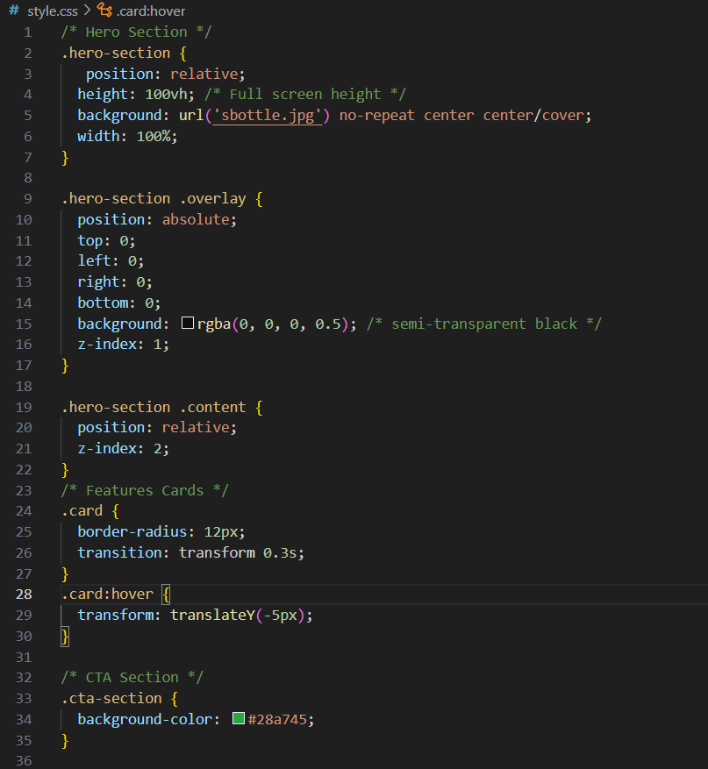

• Java script/Jquery code :

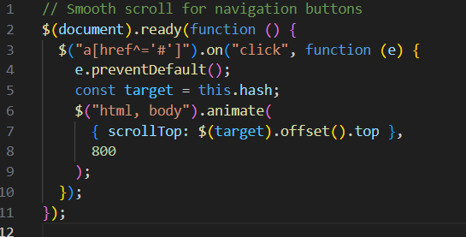

• Screenshot of output :

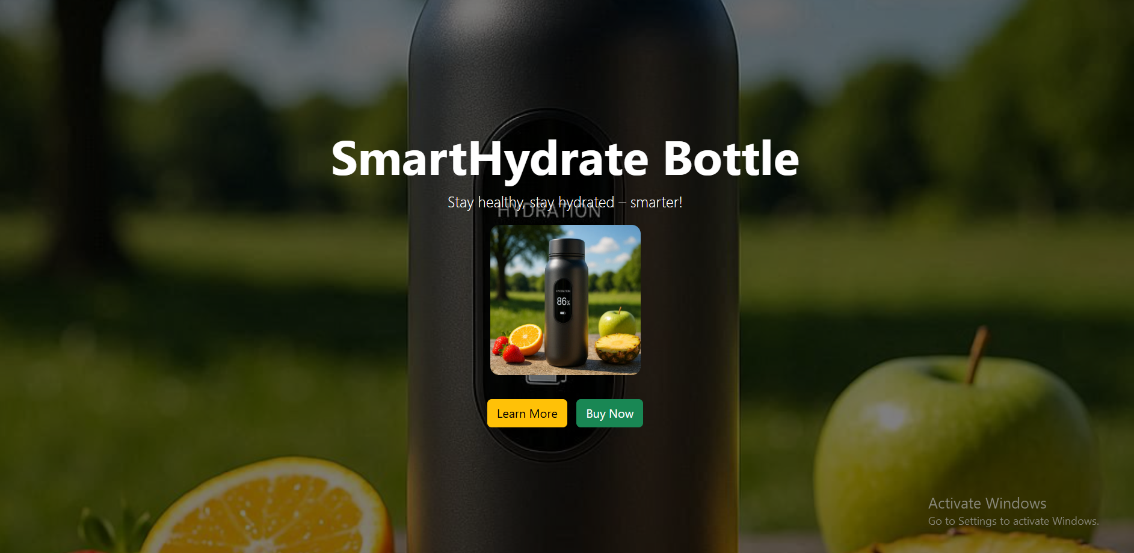

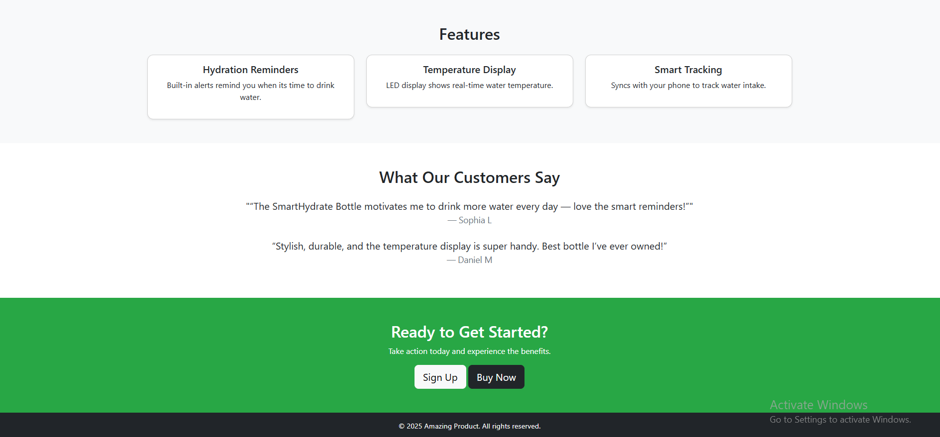

• Conclusion :

The project demonstrates how HTML5, CSS3, Bootstrap, and JavaScript/jQuery can be combined to create a visually appealing and interactive product landing page. The *SmartHydrate Bottle Landing Page* fulfills its goal of being a user-friendly, modern, and responsive website that promotes a product effectively.

This mini-project not only showcases design and technical skills but also provides a template for building real-world landing pages.

• References :

L&T LMS : https://learn.lntedutech.com/Landing/MyCourse