**San Francisco Bay University**

**CS483 - Fundamentals of Artificial Intelligence**

**Homework Assignment #4**

**Due day: 7/21/2022**

**Instruction:**

1. **Push the source code to Github**
2. **Overdue homework submission could not be accepted.**
3. **Take academic honesty and integrity seriously (Zero Tolerance of Cheating & Plagiarism)**
4. Re-calculate the entropy for the feature selection in the example of file “*Gini Impurity Cal in Decision Tree*” rather than Gini impurity method. And then, compare the results from two different criteria

*Hint: taking the reference at the following link for your calculation*

*<https://towardsdatascience.com/entropy-how-decision-trees-make-decisions-2946b9c18c8>*

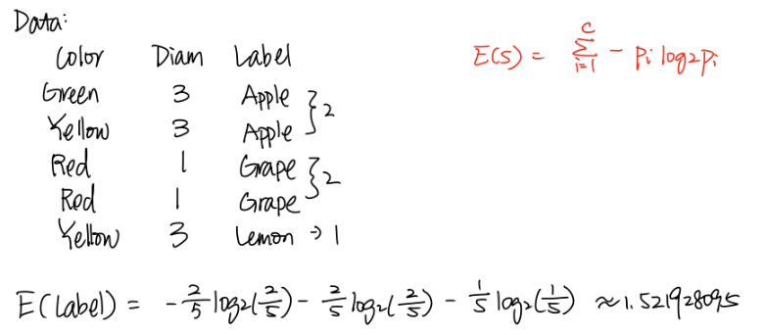

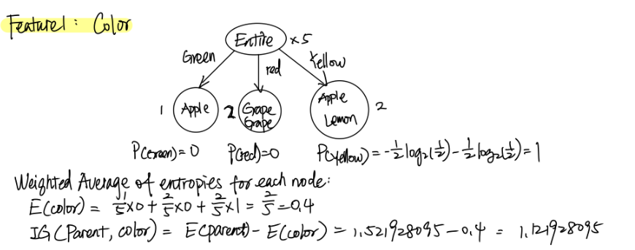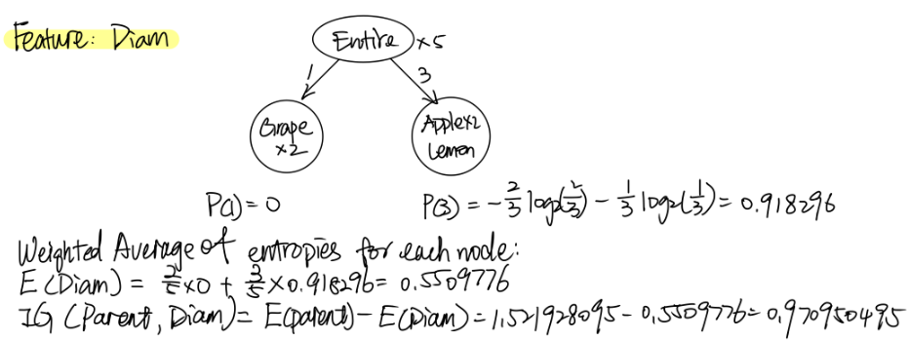

1. Given a dataset as follows, please buildup a decision tree with max information gain comparing the different condition checking features by hand calculation **Gini impurity and information gain.** And predict "Profit" in the new data. After that, write Python program to verify your design through calling existing functions from the library

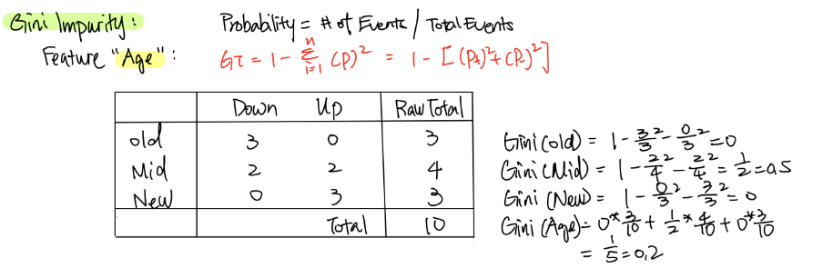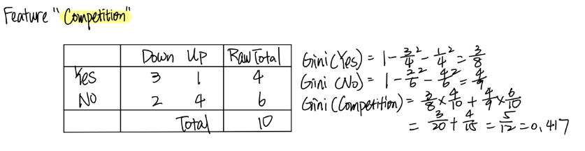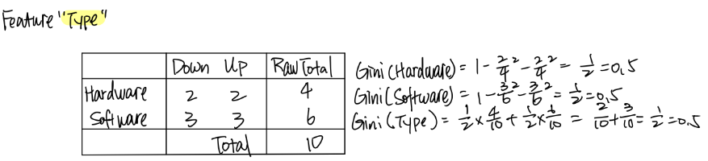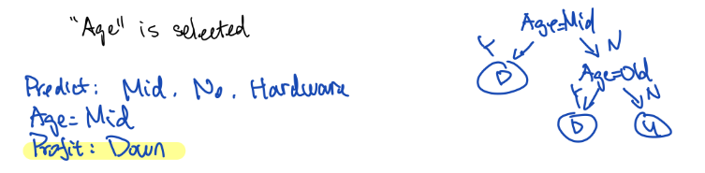

<https://github.com/SharonCao0920/AI/blob/main/CS483_Lecture_HW_4.ipynb>

|  |  |  |  |
| --- | --- | --- | --- |
| **Age** | **Competition** | **Type** | **Profit** |
| Old | Yes | Software | Down |
| Old | No | Software | Down |
| Old | No | Hardware | Down |
| Mid | Yes | Software | Down |
| Mid | Yes | Hardware | Down |
| Mid | No | Hardware | Up |
| Mid | No | Software | Up |
| New | Yes | Software | Up |
| New | No | Hardware | Up |
| New | No | Software | Up |
| Mid | No | Hardware | ? |