Use Bellman Ford’s Algorithm to find the shortest path of a maze.
- Step 1: Similar to the previous question of finding the shortest path of the a maze. But instead of using Dijkstra’s Algorithm, you will use Bellman Ford’s Algorithm.
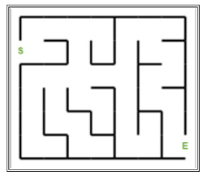
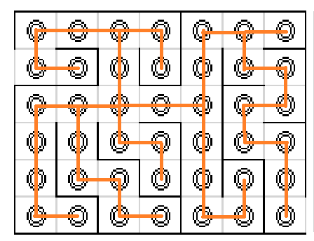
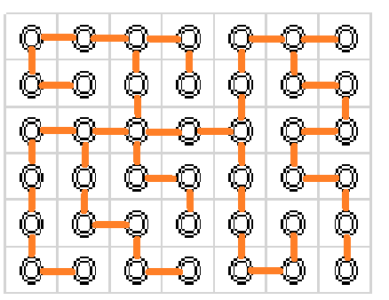
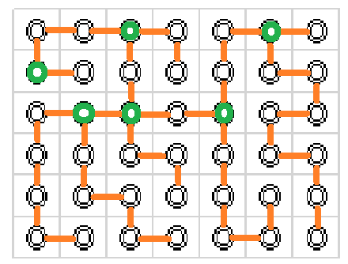
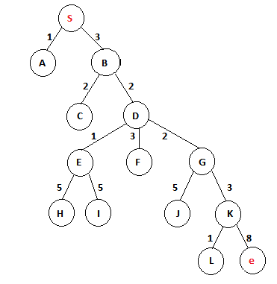
1 ^{st} iteration
S | A | B | C | D | E | F | G | H | I | J | K | L | e
0 | ꝏ | ꝏ | ꝏ | ꝏ | ꝏ | ꝏ | ꝏ | ꝏ | ꝏ | ꝏ | ꝏ | ꝏ | ꝏ
0 | 1 | 3 | ꝏ | ꝏ | ꝏ | ꝏ | ꝏ | ꝏ | ꝏ | ꝏ | ꝏ | ꝏ | ꝏ
0 | 1 | 3 | 5 | 5 | ꝏ | ꝏ | ꝏ | ꝏ | ꝏ | ꝏ | ꝏ | ꝏ | ꝏ
0 | 1 | 3 | 5 | 5 | 6 | 8 | 7 | ꝏ | ꝏ | ꝏ | ꝏ | ꝏ | ꝏ
0 | 1 | 3 | 5 | 5 | 6 | 8 | 7 | ꝏ | ꝏ | 12 | 10 | ꝏ | ꝏ
0 | 1 | 3 | 5 | 5 | 6 | 8 | 7 | ꝏ | ꝏ | 12 | 10 | 11 | 18
0 | 1 | 3 | 5 | 5 | 6 | 8 | 7 | 11 | 11 | 12 | 10 | 11 | 18

2nd iteration
S | A | B | C | D | E | F | G | H | I | J | K | L | e
0 | ꝏ | ꝏ | ꝏ | ꝏ | ꝏ | ꝏ | ꝏ | ꝏ | ꝏ | ꝏ | ꝏ | ꝏ | ꝏ
0 | 1 | 3 | ꝏ | ꝏ | ꝏ | ꝏ | ꝏ | ꝏ | ꝏ | ꝏ | ꝏ | ꝏ | ꝏ
0 | 1 | 3 | 5 | 5 | ꝏ | ꝏ | ꝏ | ꝏ | ꝏ | ꝏ | ꝏ | ꝏ | ꝏ
0 | 1 | 3 | 5 | 5 | 6 | 8 | 7 | ꝏ | ꝏ | ꝏ | ꝏ | ꝏ | ꝏ
0 | 1 | 3 | 5 | 5 | 6 | 8 | 7 | ꝏ | ꝏ | 12 | 10 | ꝏ | ꝏ
0 | 1 | 3 | 5 | 5 | 6 | 8 | 7 | ꝏ | ꝏ | 12 | 10 | 11 | 18
0 | 1 | 3 | 5 | 5 | 6 | 8 | 7 | 11 | 11 | 12 | 10 | 11 | 18
Shortest path is 18.

- Step 2: Comparing the performance of Dijkstra’s Algorithm and Bellman Ford’s Algorithm in solving this question by
  - Big-O comparison
  - comparing how many steps are required to find a graph that has the shortest path.
    - Note:
      - A step is defined as either comparing two numbers or replacing a number.
      - You can count how many steps for Dijkstra’s Algorithm on the created table.
      - Refer this example on counting the steps for Bellman Ford’s Algorithm.
Algorithm: Dijkstra’s-Algorithm (G, w, s)
for each vertex v Є G.V
v.d := ∞
v.∏ := NIL
s.d := 0
S := Ф
Q := G.V
while Q ≠ Ф
u := Extract-Min (Q)
S := S U {u}
for each vertex v Є G.adj[u]
if v.d > u.d + w(u, v)
v.d := u.d + w(u, v)
v.∏ := u
Time complexity: O(E logV) 15 steps
Bellman-Ford-Algorithm (G, w, s)
for each vertex v Є G.V ==> O(V)
v.d := ∞
v.∏ := NIL
s.d := 0
for i = 1 to |G.V| - 1 ==> O(V)
for each edge (u, v) Є G.E ==> O(E)
if v.d > u.d + w(u, v)
v.d := u.d +w(u, v)
v.∏ := u ====>O(V)*O(E) = O(VE)
for each edge (u, v) Є G.E ==>O(E)
if v.d > u.d + w(u, v)
return FALSE
return TRUE
===> O(V)+ O(VE) + O(E)
===> Time complexity: O(VE) 14 steps*2 iterations

