Q 25. Use Prim’s Minimum Spanning Tree algorithm and Kruskal’s Minimum Spanning Tree algorithm to find the shortest path of a maze.
- Step 1: Similar to the previous question of finding the shortest path of the a maze. But instead of using Dijkstra’s Algorithm, you will use Minimum Spanning Tree Algorithm.
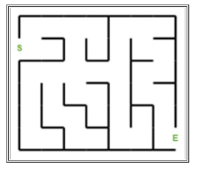
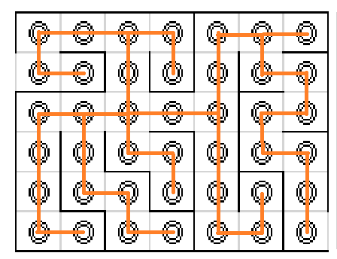
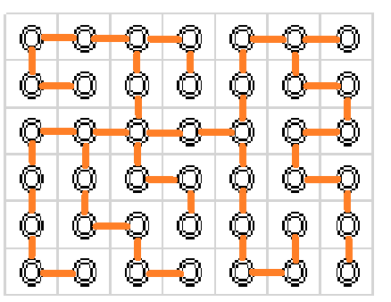
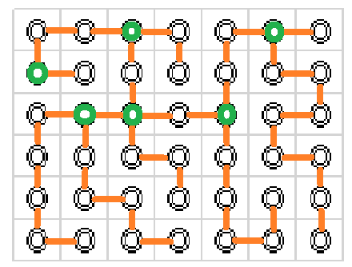
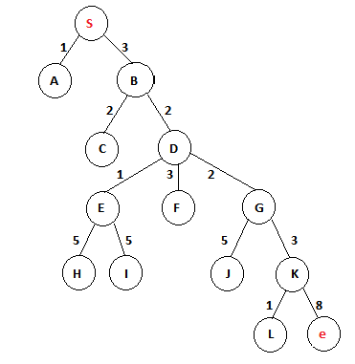

Prim’s Minimum Spanning Tree
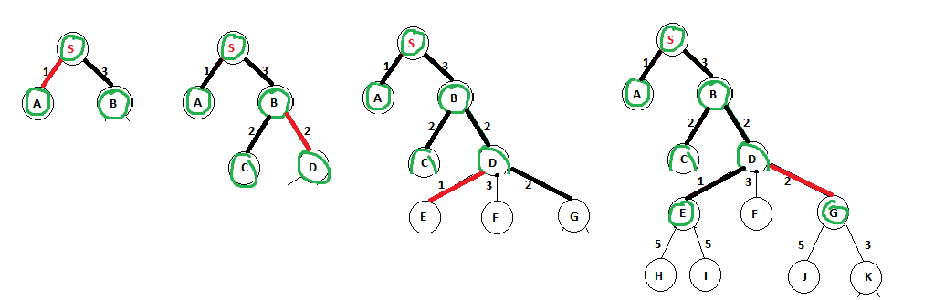
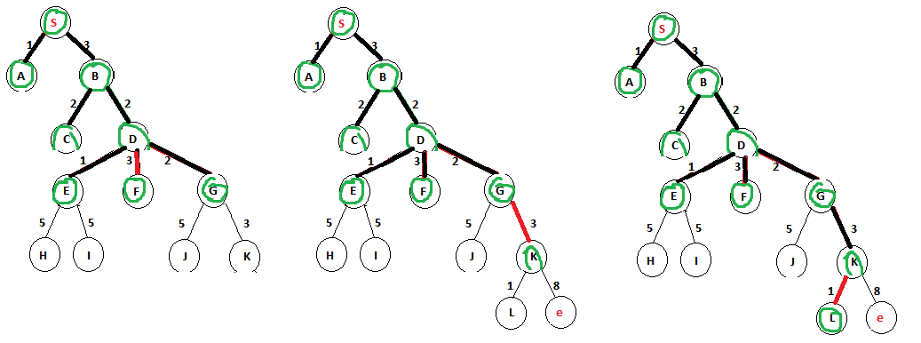
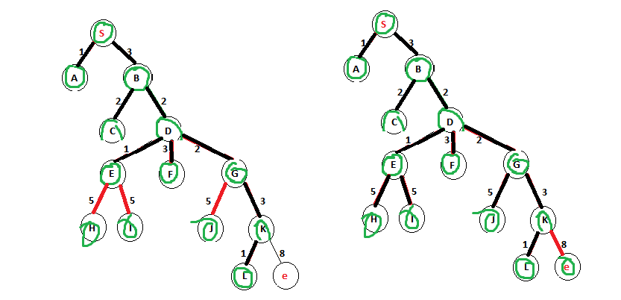

Kruskal’s Minimum Spanning Tree
Weight | Src | Dest
1 | S | A
1 | D | E
1 | K | L
2 | B | C
2 | B | D
2 | D | G
3 | S | B
3 | D | F
3 | G | K
5 | E | H
5 | E | I
5 | G | J
8 | K | e
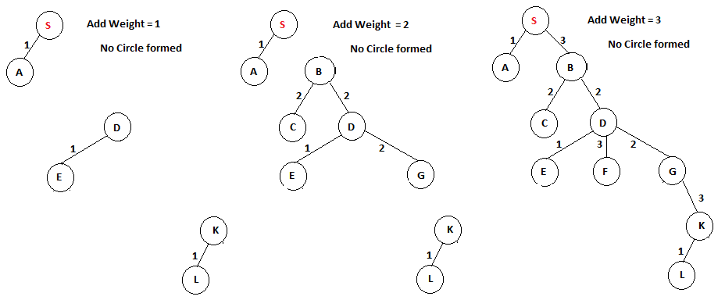

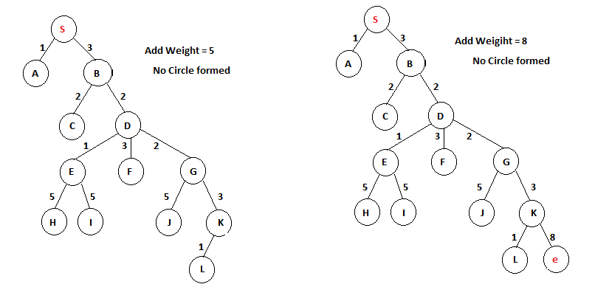

- Step 2: Comparing the performance of these two algorithm in solving this question by
  - Big-O comparison
Prim’s Minimum Spanning Tree
O((v + E)logV)
Kruskal’s Minimum Spanning Tree
O(E * logV)
- Step 3: Update your portofolio about the Maze project

