Instructions for setting an account on GitHub

By Sharon D. Kenny (R3)

1. Opening an Account on github.com
   1. Visit [https://github.com](https://github.com/)
   2. Click the “[**Sign up**](https://github.com/join?source=header-home)**”** button at upper right corner
   3. Fill the form (see below), selecting a username, password, and an email address; then press the “**Create an Account**” button.

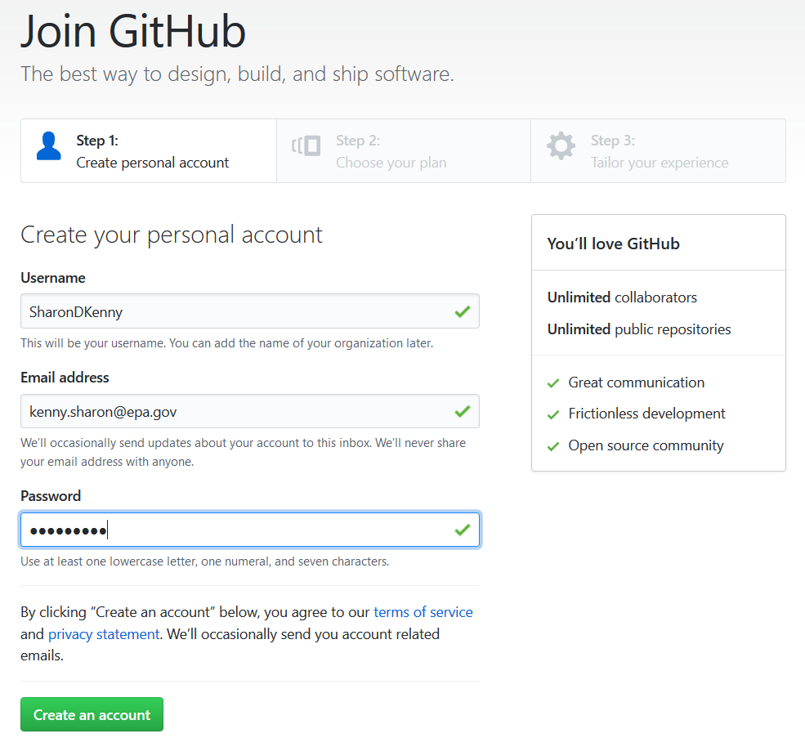

* 1. Another page will open. Choose the personal plan “Unlimited public repositories for free”, then press “**Continue**”.

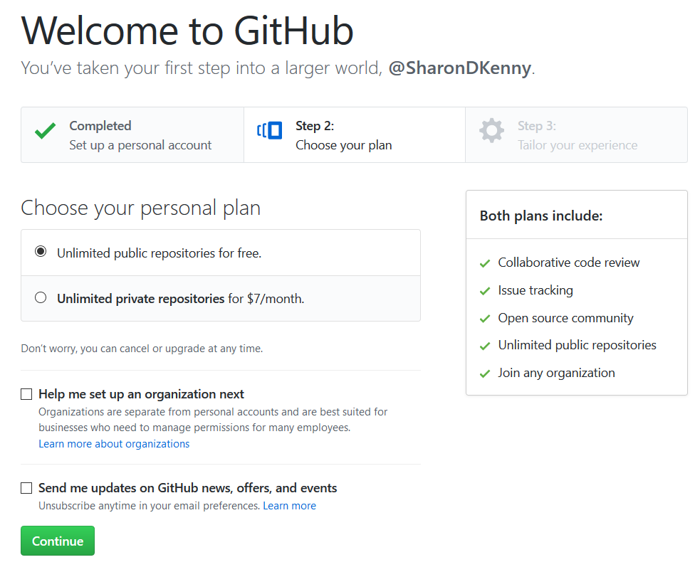

* 1. The page that opens next can be skipped. Scroll all the way to the bottom (unless you are want to share more information about yourself with Microsoft) to select “**skip this step**”, which is located to the right of the green button “Submit”.



* 1. That’s it. You are inside GitHub.

1. Creating a Repository
2. Right click on the “**Read the Guide**” button and select “**Open in new tab**”. This will create another “page” in your internet browser at this URL: <https://guides.github.com/activities/hello-world/>. I strongly recommend you go through the guide titled “[Hello World](https://guides.github.com/activities/hello-world/)” at a later time to reinforce the exercise we will do in this tutorial.

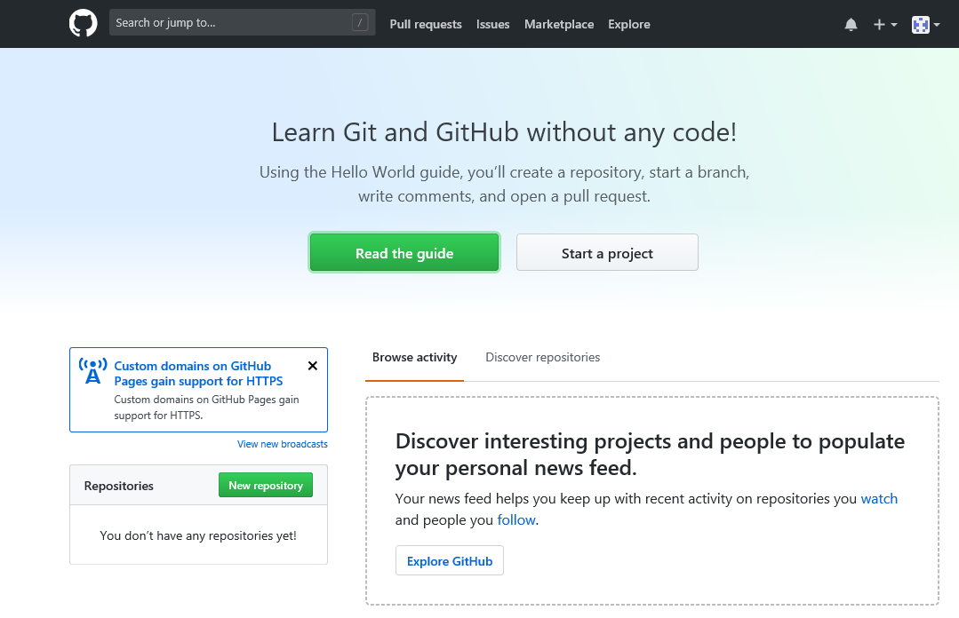

1. Now click the button next to the one you clicked on step II.2, named “**Start a Project**”
2. A page will open, where you will be asked to confirm your email.

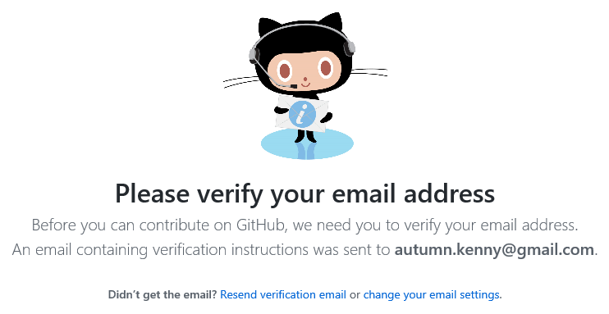

1. Log in to the email server that you used to register, and you will see an email from GitHub (see below). Click on the blue button “Verify email address”. This will take you back to the page illustrated in step II.1

