# Web and Mobile Technologies B9IS124

# Lecturer Ehtisham Yasin

# CA1 Develop a responsive web application, optimised for mobile, tablets and desktop devices

# Group (2 members)

Student Name and Number: Sharon Farrell 10581193

# Description:

On initial choosing of the group members, Sharon Farrell suggested to set up a GitHub repository so the work completed on the project could be tracked and updated when changes where made to the site. Chinedu had difficulty accessing the repository and any changes he made needed to be manually imported to the repository.

We chose to use Visual Studio Code the complete the code. A folder was set up and all the files were laid out in an easy to read manner.

## Layout

### Fonts

We looked at several fonts which have been designed specifically for use with sports and fitness websites including Proxima Nova, Avenir, Grot 10, Uniform, Brandon, Grotesque and Mollen. [typ.ie] We choose Mukta font. the main font colour chosen is white smoke, antique white and grey on dark backgrounds and black and blue on white backgrounds.

### Colour scheme

When we researched fitness websites and designed we noticed a lot of fitness and sports website used static dark colours, we decided to use a gradient colour scheme for the header and footer of the site and a mix of these colours through out the body of the page.

We used [colorspace.com](http://colorspace.com) to generate the gradient. the mix of colours we used are purple, royal blue and tiffany blue. the gradient code is “background-image: linear-gradient(to right top, #361b85, #311e88, #2b218a, #23238d, #1a268f, #10379c, #0547a8, #0056b3, #0074c4, #008ec6, #00a5bf, #0abab5);”

The hex base colours are #361B85, #042992, #0ABAB5.

On review of the gradients we found that css gradient generator gave a nicer effect and with less code. This tool generated the gradient we chose to use on the webpage nabber header and footer. background: rgb(70,6,244);

background: linear-gradient(90deg, rgba(70,6,244,1) 0%, rgba(111,2,241,1) 53%, rgba(124,34,195,1) 100%);

<https://cssgradient.io>

Physiological research has shown that the colour blue represents trust and stability while purple can symbolise power, luxury and ambition. A combination of these two colours into a gradient including the colour neon would give the users a feel of trust for the site.

We decided on a plan which background for the main section of the pages to allow the products to be clearly shown and with a sleek approach.

The products could be selected by the click of button which brought the user to the products page where the user could view the description of the products see customer reviews, star ratings and prices.

### Layout of the website

Using Adobe XD we designed the first initial style. This design will be tweaked as we go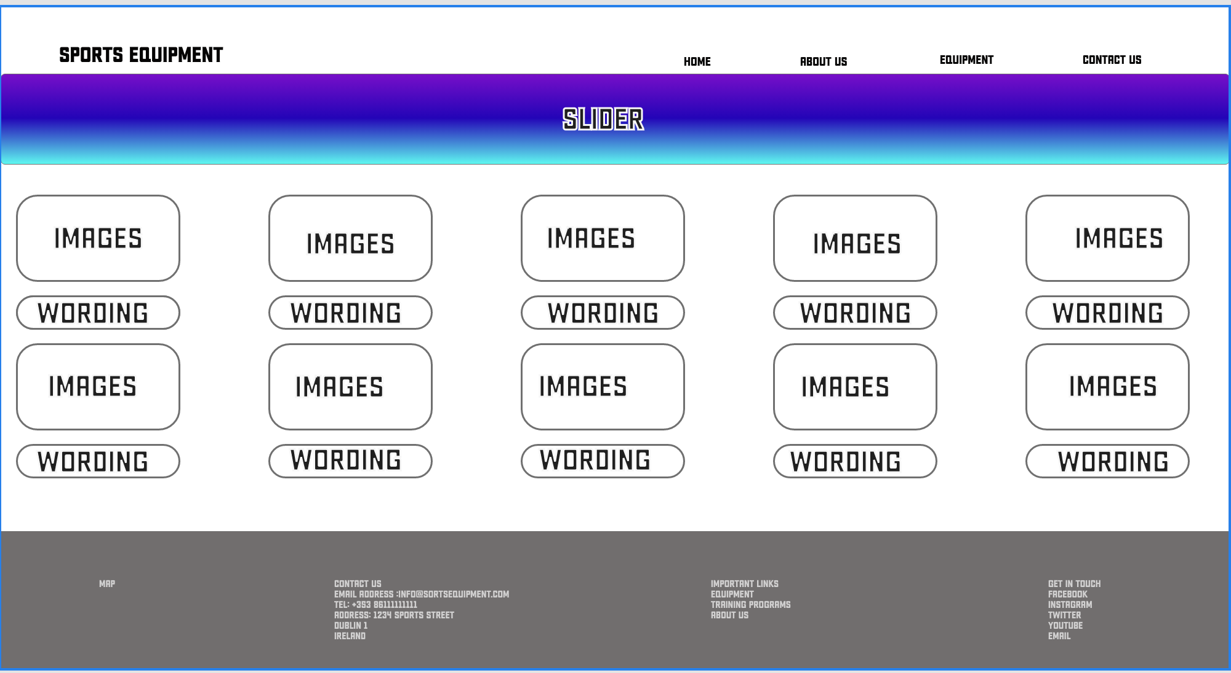 through our design phase and layout of the website.

On reflection it was decided week the layout into the following sections

* Navbar - with the company logo to the left, this is clickable with a pointer to bring the users back to the main page of the site. On the left of the nabber there are the site pages when shown on a smaller screen an icon showing a hamburger menu icon which is clickable to show the list of pages. It was decided to have the back ground colour as a gradient of blue and purples mix. The navbar has a “Sticky” function which allows the user the scroll down the website and the navbar visible through the scroll.
* Header - included in the header is an image symbolising a fitness centre. this is placed just above the header. In the main body of the header we have used the same gradient as the navbar but changed the direction of the gradient. We have included the company tagline “FITNESS EQUIPMENT FOR THOSE SERIOUS ABOUT GETTING FIT. - TAILORED MADE FITNESS FROM THE EXPERTS”. we have used a fade in function from AOS.css this is an open source product. We have also improved the visibility of the header with a tool to allow us the cut the bottom off the background colour giving it s skewed effect. This was achieved with the “Clip-path functions and giving the block of colour a polygon value of (0% 0%, 100% 0%, 100% 80%, 0% 100%)
* Main - the background is being kept white to give the page a sleek look to allow the products to become more visible. We choose to place the images and description with a link button in a card element. This was then placed into the container to hold the cards whiting a grid of 3. We also used the fade-up with a duration of 3000 effect on the cards when opening the webpage and scrolling down the products. The link on the products bring the user to the product page.
* Footer - Once again we used the gradient colour here and column function within a container to allow the footer be divided into 4 blocks each block has a header description and links to relevant pages once the site is complete. The products link takes the user to the products page and the about us and contact link to the index.html page for now. In the footer we have included a subscribe to our Newsletters tag. This allows the user to enter their email address to subscribe. If they don’t enter an email it will give a pop up asking for an email address.
* Dropdown - We have placed a dropdown button with links to some of the popular items.

The navbar, header and footer is placed on all pages and is the same throughout the site.

Products Page

On the products we have a similar layout of main pages with the navbar, header, background image and footer all the same. The products have been placed into a container in a 3 grid layout. They have details of the products, customer reviews, ratings and pricing of the items. There is an option to click on the reserver button which gives the user a message telling them that the items have been reserved for them. A further function for this page would be to enable to user to follow up on the reserved item and purchase it. This is an additional page and would include a checkout and payment option.

Testing

Sharon set up a “testing.html” for functions on the site that did not work correctly to check each line of the code while deploying it on the live server in Visual Studio Code. This helped with checking different functions of the code on certain elements.

Student Name: Sharon Farrell Group Member 1:

Student Number: 10581193

Student Name: ___________________ Group Member 1:___________________

Student Number: __________________

Contribution to the project (200 words max):

Sharon Farrell

I set up a GitHub repository to work from which enabled us to track changes on the visual studio code. I used Adobe illustrator to design a very simple logo for the site and we both decided to call it “Fit House” just so we had something to go from. I reseated the colours and fonts used on other fitness/sports sites and made some suggestion of these. Once this was decided I went and created a nice gradient effect for the header and footer. I mad a simple mockup on adobe XD to see what the layout might look like. This was modified once we set about writing the code and developing the site.

I set up the folders and files on GitHub and imported all the images which were downloaded from open source sites. This gave us the basis to follow the code and update it as we worked on the project. I implemented all the javascript elements and tested the functionality of these to make sure they worked. I used developer tools on safari, firefox and chrome to view the web pages on different devices. Finally I tested that the site would be visible on different browsers.

Signature Member 1: _________________________ Signature Member 2: _________________________

Reference

* <https://typ.io/tags/fitness>
* <https://mycolor.space>
* <https://cssgradient.io>
* <https://advantagefitness.com>
* <https://michalsnik.github.io/aos/>
* https://codewithmosh.com