Seed(7353)

Simulation time:5000, N=200, each sequence 100, independent

|  |  |  |  |
| --- | --- | --- | --- |
|  |  |  |  |
| 0.3 | 0 | 0.5 | 0.1 |
|  |  |  |  |
| 0.2955 | 0 | 0.5021 | 0.1010 |

|  |  |  |  |  |  |  |
| --- | --- | --- | --- | --- | --- | --- |
|  |  |  |  |  |  |  |
| 0 | 0 | 0.0056 | 0.0057 | 0.0057 | 0.8795 | 0.8769 |

|  |  |
| --- | --- |
| Simulation time：5000 | N=200 |
| Wald Test naive | 0.0518 |
| Wald Test robust | 0.0498 |
| Score Test naive | 0.2368 |
| Score Test robust | 0.2408 |

Seed(7353)

Simulation time:5000, N=200, each sequence 100, correlated

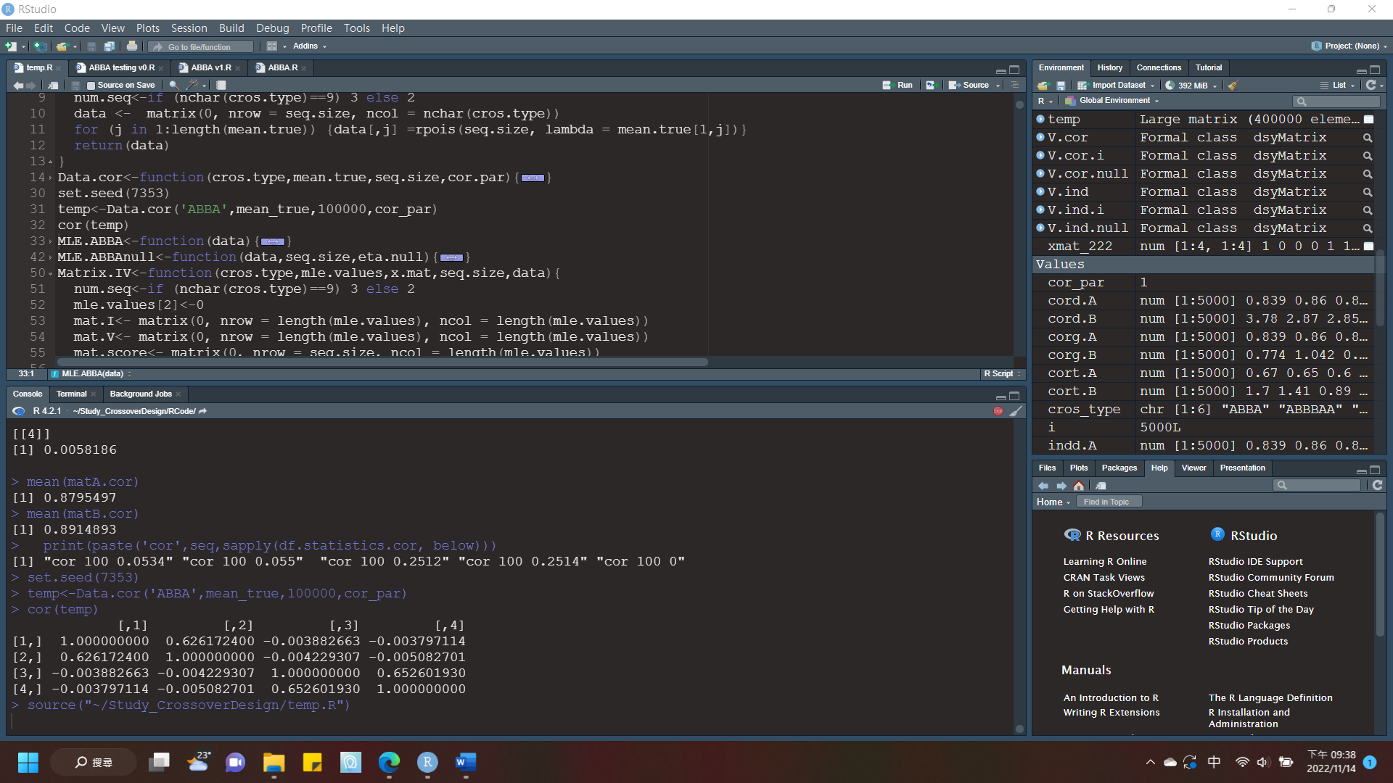

|  |  |  |  |
| --- | --- | --- | --- |
|  |  |  |  |
| 0.3 | 0 | 0.5 | 0.1 |
|  |  |  |  |
| 0.2920 | -0.0015 | 0.5004 | 0.1005 |

|  |  |  |  |  |  |  |
| --- | --- | --- | --- | --- | --- | --- |
|  |  |  |  |  |  |  |
| 0 |  | 0.0058 | 0.0057 | 0.0058 | 0.8795 | 0.8915 |

|  |  |
| --- | --- |
| Simulation time：5000 | N=200 |
| Wald Test naive | 0.0534 |
| Wald Test robust | 0.0550 |
| Score Test naive | 0.2512 |
| Score Test robust | 0.2514 |

