|  |  |  |
| --- | --- | --- |
|  | Period1 | Period2 |
| AB |  |  |
| BA |  |  |

|  |  |  |
| --- | --- | --- |
|  | Period1 | Period2 |
| AB |  |  |
| BA |  |  |

*X*(treatment):



*Z*(period):



*S*(sequence):



































Define:



Information matrix:



Variance matrix:



模擬 (無相關性):

真值: ，，，

|  |  |  |
| --- | --- | --- |
|  | Period1 | Period2 |
| AB | 0.6225 | 0.6682 |
| BA | 0.7858 | 0.8176 |

, repeat 1000 times

mle: ，，，

Information matrix:

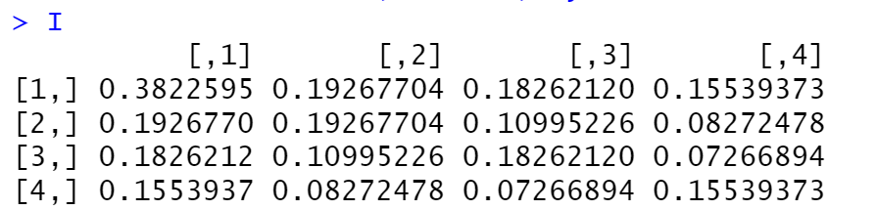

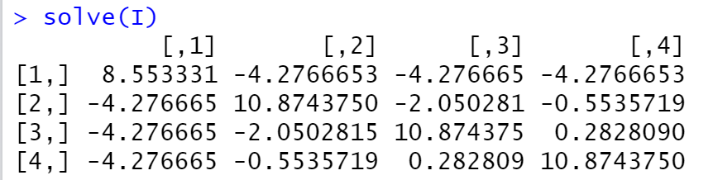

Variance matrix:

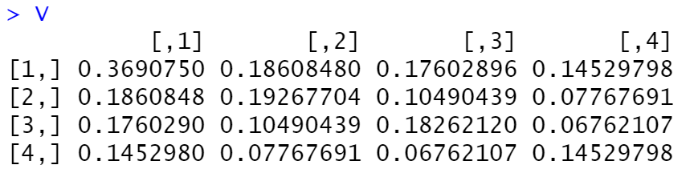

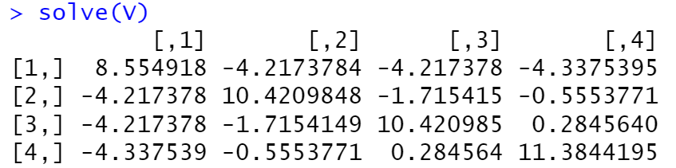

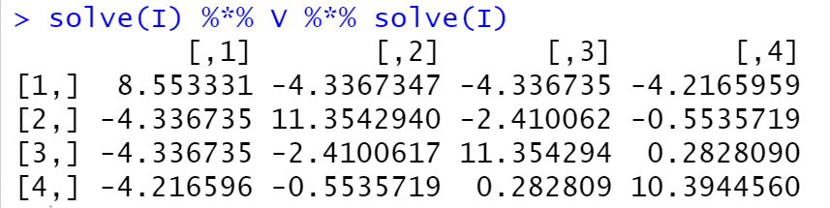

Sample covariance:

|  |  |  |  |  |
| --- | --- | --- | --- | --- |
|  |  |  |  |  |
|  | 9.0327 | -4.7942 | -4.3675 | -4.2459 |
|  | -4.7942 | 12.3535 | -2.5647 | -0.7830 |
|  | -4.3675 | -2.5647 | 11.6591 | 0.5295 |
|  | -4.2459 | -0.7830 | 0.5295 | 11.9669 |

模擬 (有相關性):

真值: ，，，

|  |  |  |
| --- | --- | --- |
|  | Period1 | Period2 |
| AB | 0.6225 | 0.6682 |
| BA | 0.7858 | 0.8176 |

, repeat 1000 times

如果，則

，所以，

是標準常態分配的cdf

演算法:

1. 生成二元常態分布，期望值，共變異數矩陣
2. 生成二元常態分布，期望值，共變異數矩陣
3. 令，
4. 令，

mle: ，，，

Information matrix:

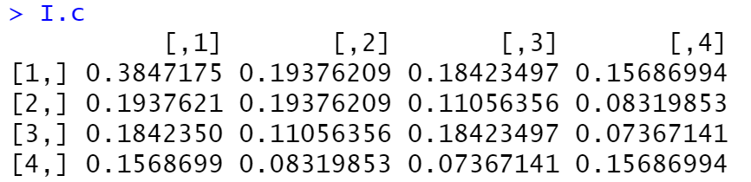

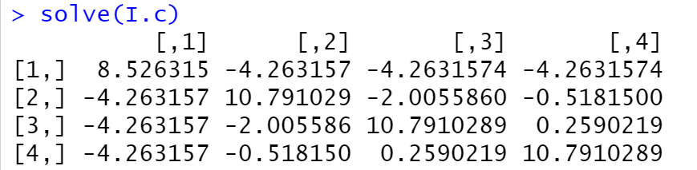

Variance matrix:

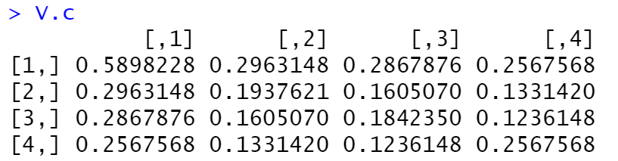

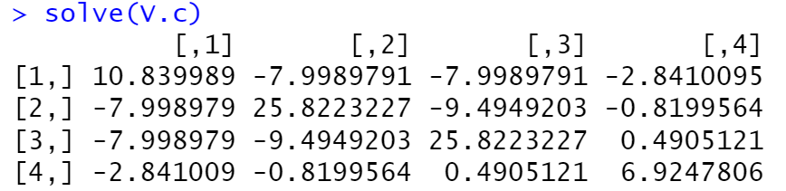

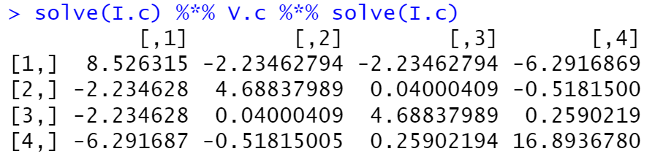

Sample covariance:

|  |  |  |  |  |
| --- | --- | --- | --- | --- |
|  |  |  |  |  |
|  | 9.4985 | -2.4194 | -2.3153 | -7.4339 |
|  | -2.4194 | 4.4333 | 0.3198 | -0.0538 |
|  | -2.3153 | 0.3198 | 4.4833 | 0.1528 |
|  | -7.4339 | -0.0538 | 0.1528 | 18.6297 |

樣本共變異數:



mle:



模擬 (無相關性):

真值: ，，，

|  |  |  |
| --- | --- | --- |
|  | Period1 | Period2 |
| AB | 0.6225 | 0.6682 |
| BA | 0.7858 | 0.8176 |

, repeat 10000 times

mle: ，，，

Information matrix:

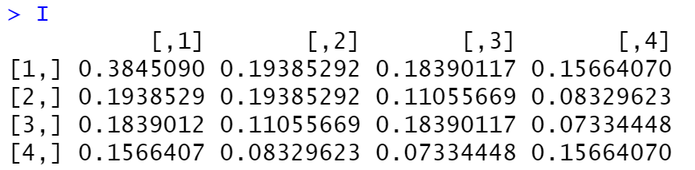

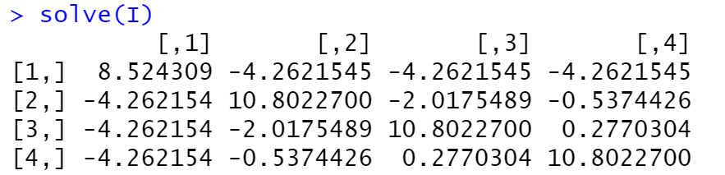

Variance matrix:

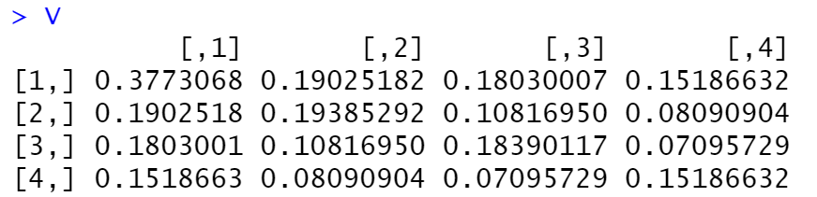

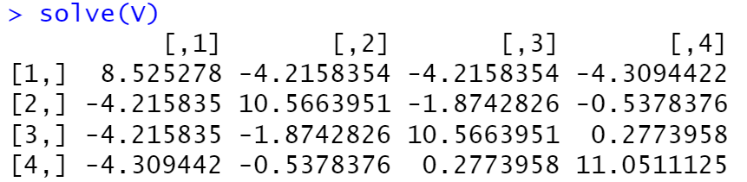

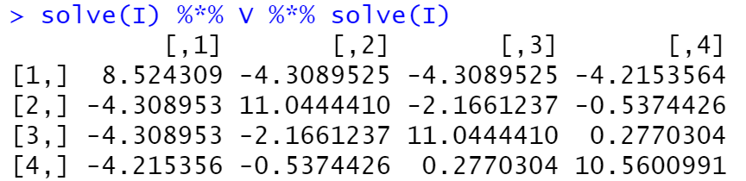

Sample covariance:

|  |  |  |  |  |
| --- | --- | --- | --- | --- |
|  |  |  |  |  |
|  | 8.5439 | -4.1932 | -4.3542 | -4.3482 |
|  | -4.1932 | 10.9761 | -2.1225 | -0.5783 |
|  | -4.3542 | -2.1225 | 11.2072 | 0.3098 |
|  | -4.3482 | -0.5783 | 0.3098 | 11.1440 |

模擬 (有相關性):

真值: ，，，

|  |  |  |
| --- | --- | --- |
|  | Period1 | Period2 |
| AB | 0.6225 | 0.6682 |
| BA | 0.7858 | 0.8176 |

, repeat 10000 times

mle: ，，，

演算法:

1. 生成二元常態分布，期望值，共變異數矩陣
2. 生成二元常態分布，期望值，共變異數矩陣
3. 令，
4. 令，

Information matrix:

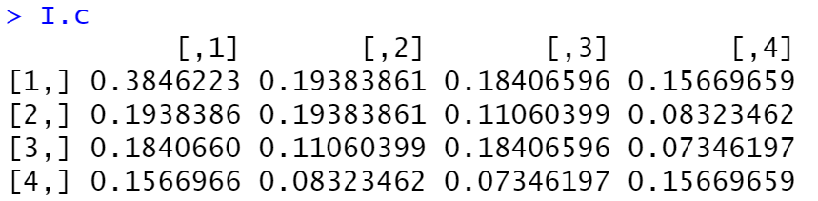

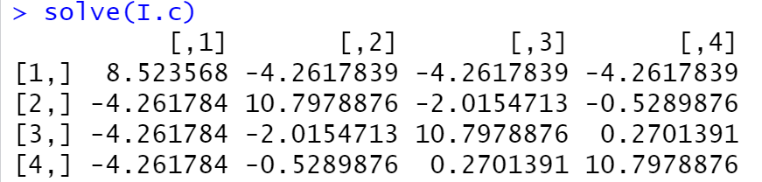

Variance matrix:

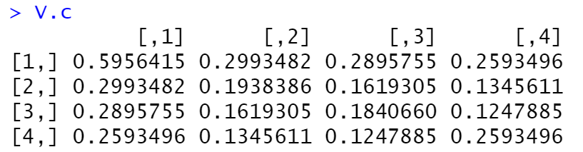

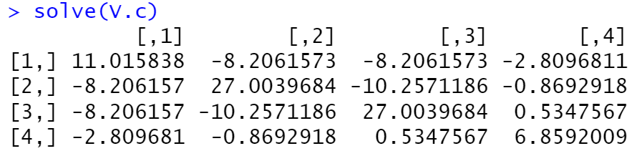

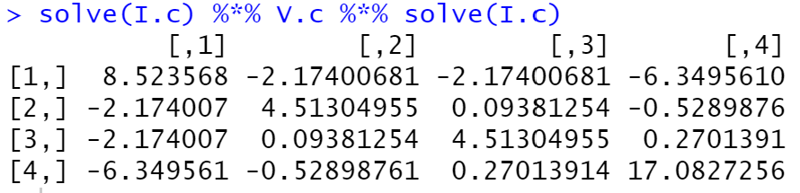

Sample covariance:

|  |  |  |  |  |
| --- | --- | --- | --- | --- |
|  |  |  |  |  |
|  | 8.5641 | -2.1614 | -2.1296 | -6.4983 |
|  | -2.1614 | 4.4752 | 0.1271 | -0.6528 |
|  | -2.1296 | 0.1271 | 4.4813 | 0.2881 |
|  | -6.4983 | -0.6528 | 0.2881 | 18.3027 |

樣本共變異數:



mle:



Test:

 v.s. 

Likelihood ratio test:







Solve:







根據b式，







代入a-b-c式，









代入a式，



因為此方程式內不包含，所以



  




當為真:



If , accept







當為真:



If , accept

95% confidence interval for :

Naïve:



Robust:



模擬: 10000次，

無相關性:

Naïve:

信賴區間:

Robust:

信賴區間:

有相關性:

Naïve:

信賴區間:

Robust:

信賴區間:

Wald test:





模擬: 10000次，

無相關性:

Naïve: 

Robust: 

有相關性:

Naïve: 

Robust: 

Score test:





模擬: 10000次，

無相關性:

Naïve:

Robust:

有相關性:

Naïve:

Robust: