Survival extrapolation and network meta-analysis for HTA
  - Project report, Sharon Okolo
Code, data outputs and the Excel model: https://github.com/SharonOkolo/hta-survival-nma
Two analyses that sit behind almost every NICE submission, done end to end in R from a pre-written statistical analysis plan (Appendix):
- How much longer do patients live on a new treatment? Survival analysis of a 929-patient colon cancer trial, extrapolated beyond trial follow-up to estimate life-years gained.
- Which intervention works best when no single trial compares them all? Frequentist and Bayesian network meta-analysis of 24 smoking-cessation trials.
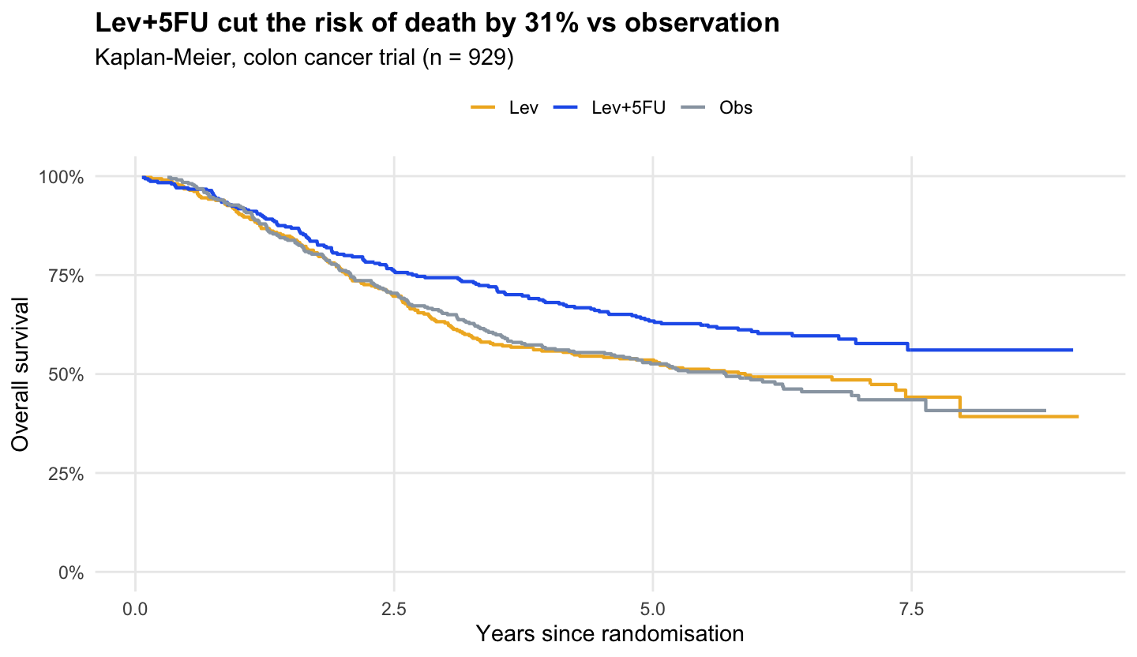
Kaplan-Meier

The problem I solved
Reimbursement bodies such as NICE decide on costs per life-year, but trials stop after a few years and rarely compare every option head to head. A statistician therefore has to (a) extrapolate survival curves far beyond the data, and (b) combine direct and indirect evidence from many trials. Both are judgement-heavy, and both can swing a decision.

The process I optimised
Usually | Here
Analysis decisions made as the work goes | A statistical analysis plan written first (Appendix), with deviations recorded afterwards
One “best” extrapolation picked by AIC alone | Six distributions per arm compared on AIC/BIC, visual fit and plausibility, and the spread of results shown openly
Frequentist or Bayesian NMA | Both, with convergence checks (Gelman–Rubin), DIC model choice, node-splitting for inconsistency, and the results compared
Survival model rebuilt by hand in Excel | Excel model generated from the R estimates (model selector, monthly cycles, life-years), checked to match R within 1%
Results checked by eye | 10 automated tests (8 in R, 2 in Python), including one that reproduces the published NICE DSU TSD 2 example, run on every push

The results I got

1. Survival (colon cancer, 929 patients)
Arm | Patients | Deaths | Median survival | 5-year survival
Observation | 315 | 168 | 5.7 years (4.5–7.6) | 52.6%
Levamisole | 310 | 161 | 5.9 years | 53.5%
Levamisole + 5-FU | 304 | 123 | not reached | 63.4%
- Lev+5FU cut the risk of death by 31%: HR 0.69 (95% CI 0.55–0.87, p = 0.002); 0.68 (0.54–0.87) after adjusting for 8 prognostic factors. Levamisole alone had no effect (HR 0.97, 0.78–1.21).
- Proportional hazards held for treatment (Schoenfeld p = 0.28).
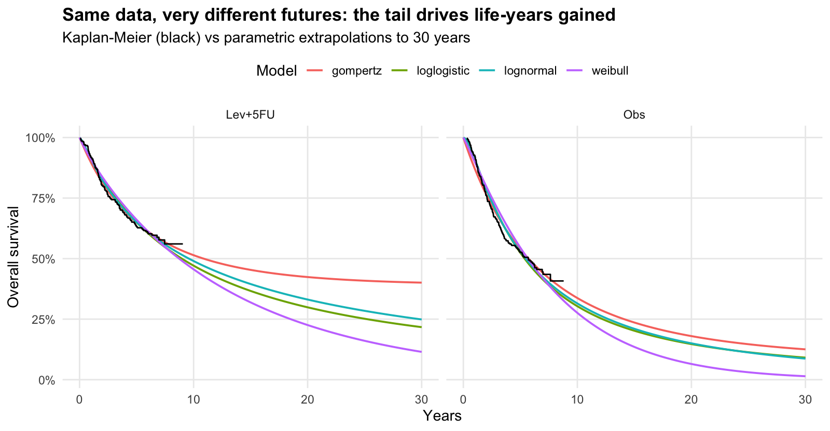
Extrapolation
Extrapolation is where the judgement lies. All six models fit the 8 years of data well, but over 30 years they give 2.9 to 5.8 life-years gained. AIC favours the generalised gamma for observation and the log-normal for Lev+5FU. I chose log-normal for both arms as the base case: it’s the best fit for the treated arm, the second best for observation (ΔAIC 9), and using one family across arms keeps the comparison consistent (NICE DSU TSD 14). Base case: 9.1 vs 13.7 mean life-years, a gain of 4.6 life-years, with the Gompertz (5.8) and generalised gamma (2.9) as scenario analyses.
Subgroups (exploratory). Benefit looked larger in men (HR 0.52, 0.37–0.74) than in women (0.86, 0.63–1.19); interaction p = 0.04. With three subgroup tests and no multiplicity adjustment, this is a hypothesis to test, not a reason to treat men and women differently.
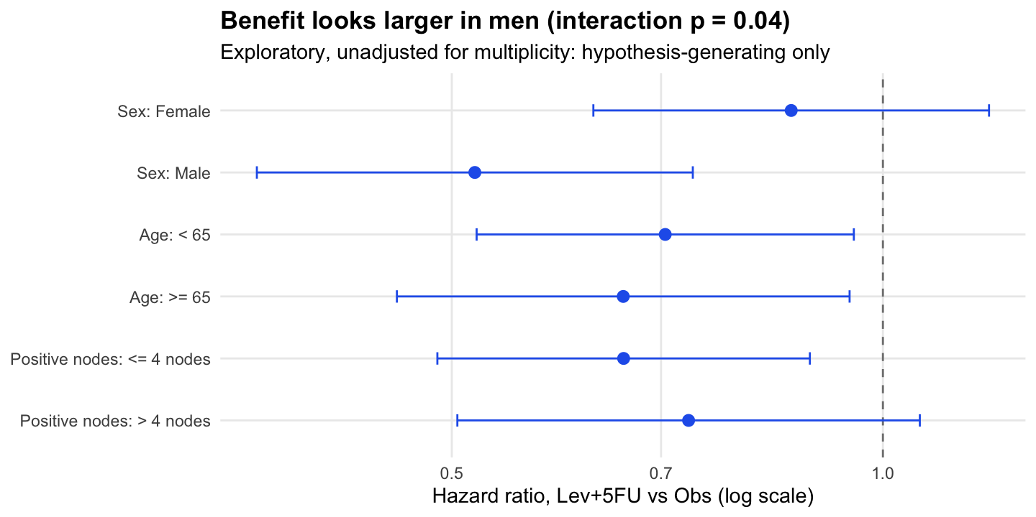
Subgroups

2. Network meta-analysis (24 trials, 4 interventions)
Odds ratio of quitting vs no contact | Frequentist (95% CI) | Bayesian (95% CrI) | SUCRA
Self-help | 1.52 (0.74–3.12) | 1.62 (0.76–3.67) | 39%
Individual counselling | 2.08 (1.36–3.20) | 2.31 (1.49–3.83) | 69%
Group counselling | 2.47 (1.10–5.52) | 2.99 (1.29–7.27) | 88%
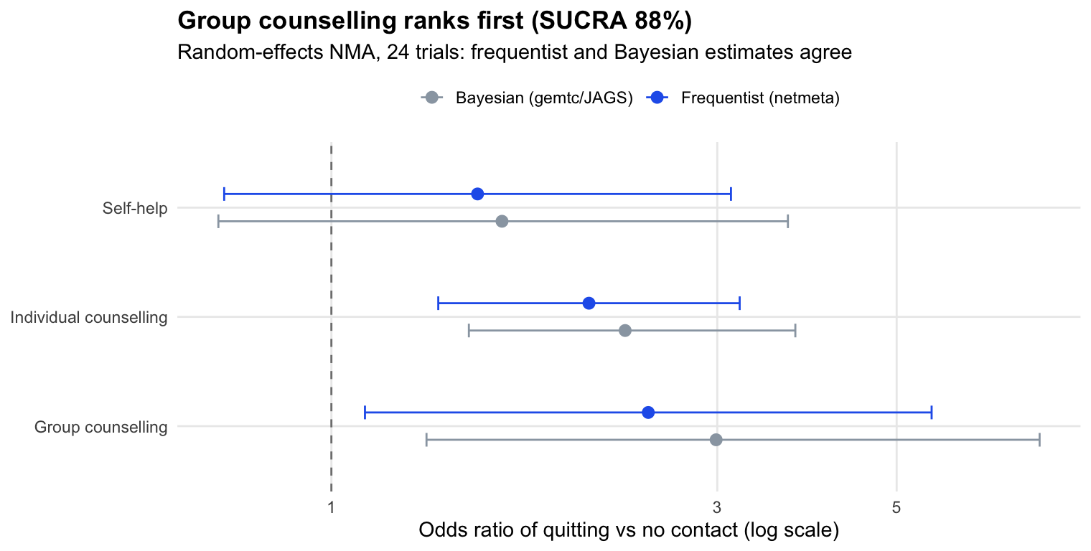
NMA
- Group counselling ranks first (71% probability of being best), then individual counselling. Self-help is not clearly better than no contact.
- Heterogeneity is high (I² = 89%; Bayesian between-study SD 0.82 on the log-odds scale), so random effects are essential: DIC 97.6 against 294.0 for fixed effects, and residual deviance 53.9 for 50 data points.
- Consistency: the global design-by-treatment test is borderline (p = 0.03), but no node-split shows direct and indirect evidence disagreeing (all p > 0.27).
- Validated: the Bayesian log odds ratios (0.49, 0.84, 1.10) and SD (0.82) reproduce the published NICE DSU TSD 2 worked example; a test checks this on every run. All chains converged (Gelman–Rubin ≤ 1.002).

Recommendations (as I would write them for a client)
- Base the economic model on the log-normal extrapolation (4.6 life-years gained) and present the Gompertz and generalised gamma as scenarios, because the choice moves the result by up to 1.6 life-years.
- Add general-population mortality to the extrapolation before submission, so no curve implies patients outlive people of the same age without cancer.
- Treat the sex interaction as a hypothesis for future trials, not a basis for restricting treatment.
- For smoking cessation, prioritise group then individual counselling, and report the ranking with its uncertainty: the credible intervals overlap.

Limitations
- colon is a 1980s trial; it shows the methods, not current practice.
- No background mortality, cure models or spline models (Royston–Parmar) yet: the natural next steps.
- Covariate proportional-hazards violations (differentiation, obstruction, nodes) weren’t addressed with stratification.
- The NMA uses study-level data, so effect modifiers can’t be adjusted for (network meta-regression would need covariates).

How to run
# R 4.5 with JAGS installed (brew install jags, or conda install -c conda-forge jags r-rjags)
Rscript -e 'install.packages(c("survival","flexsurv","netmeta","gemtc","rjags","testthat","ggplot2"))'
Rscript analysis/01_survival.R # -> outputs/, screenshots/01-03
Rscript analysis/02_nma.R # -> outputs/, screenshots/04-06 (about 1 minute of MCMC)
Rscript -e 'testthat::test_dir("tests/testthat")'
pip install -r requirements.txt
python excel/build_model.py # -> excel/survival_extrapolation_model.xlsx

Appendix: statistical analysis plan
Written before the analysis was run. Deviations are listed at the end.

1. Objectives
A. Survival (single trial, individual patient data). For patients with resected stage C colon cancer, estimate the effect of adjuvant levamisole + 5-fluorouracil (Lev+5FU) and levamisole alone (Lev) on overall survival against observation (Obs), and extrapolate survival beyond trial follow-up to estimate the mean life-years gained, as an economic model submitted to NICE would need.
B. Network meta-analysis (aggregate data). Compare four smoking-cessation interventions (no contact, self-help, individual counselling, group counselling) using all direct and indirect trial evidence, and rank them.

2. Data
- A: survival::colon (Moertel et al., 1990; 929 patients, 3 arms; death records only, etype == 2). Time in days, converted to years.
- B: netmeta::smokingcessation (Hasselblad 1998; 24 studies, 4 treatments; arm-level counts of quitters).

3. Analyses: survival
- Kaplan–Meier estimates by arm; median survival with 95% CI; log-rank test (3 arms and Lev+5FU vs Obs).
- Cox proportional hazards: unadjusted, then adjusted for pre-specified prognostic factors (age, sex, obstruction, perforation, adherence, extent, more than 4 positive nodes, differentiation). Report HR (95% CI).
- Proportional hazards check: Schoenfeld residuals (cox.zph), global and per covariate, and log(−log) plot.
- Parametric extrapolation, fitted separately per arm (NICE DSU TSD 14): exponential, Weibull, Gompertz, log-normal, log-logistic, generalised gamma. Select by AIC/BIC and visual fit and clinical plausibility of the long-term tail.
- Restricted mean survival time (RMST) at 5 years from KM, and mean survival over 30 years from the selected models; life-years gained = difference between arms.
- Subgroups (pre-specified, exploratory): sex, age (< 65 / ≥ 65), more than 4 positive nodes. HR for Lev+5FU vs Obs with interaction p-values. No multiplicity adjustment; interpreted as hypothesis-generating only.

4. Analyses: network meta-analysis
- Network plot; check connectivity.
- Frequentist random-effects NMA on the log odds ratio scale (netmeta), reference = no contact. Report ORs (95% CI), league table, P-scores, between-study heterogeneity (tau², I²).
- Inconsistency: design-by-treatment interaction test and node-splitting (direct vs indirect).
- Bayesian NMA (gemtc, JAGS = BUGS language): binomial likelihood, logit link, fixed and random effects; vague priors; 4 chains, 20,000 iterations after 5,000 burn-in. Convergence: Gelman–Rubin PSRF < 1.05 and trace plots. Model choice by DIC. Report ORs (95% credible intervals), rank probabilities and SUCRA.
- Compare frequentist and Bayesian estimates.

5. Software and quality
R 4.5; packages survival, flexsurv, netmeta, gemtc, rjags. Seeds fixed. Functions unit-tested with testthat against known values; tests run in GitHub Actions. All numbers in the README come from outputs/.

6. Deviations from plan
- Adjusted Cox model is complete-case (906 of 929 patients): 23 patients have missing tumour differentiation. Not imputed.
- Proportional hazards: holds for treatment (p = 0.28) but not globally (p < 0.001), driven by differentiation, obstruction and > 4 nodes. The treatment HR is reported as planned; a stratified or time-varying sensitivity analysis for those covariates was not run and is listed as a next step.
- No general-population mortality cap on the extrapolations (needs ONS life tables by age and sex). Planned for a later version.
- R 4.5 was used instead of R 4.4 (the version available for Apple Silicon at the time).

